University of
Southern Mississippi

Business Process Scripts

GM – Salary Verification

Salary Verification

If you are trying to access SOARFIN off campus, you must use the VPN: https://eaglenet.usm.edu/ Log in before proceeding to https://soarfin.usm.edu/ .

Navigation: USM Procedures General Reporting Salary Verification

OR

Click on the Grants tile on the homepage:
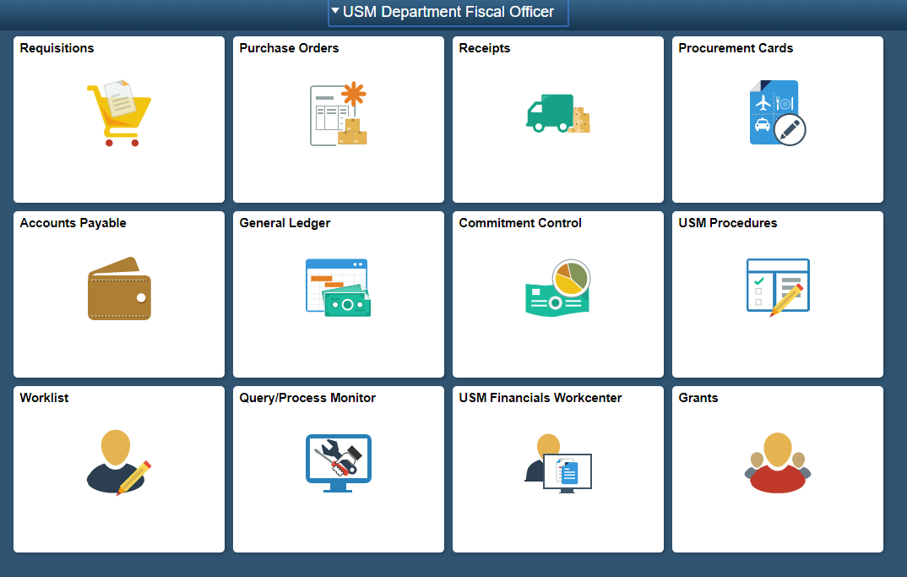

Click on Salary Verification on the left side of the page and then Salary Verification once more in the drop down menu:
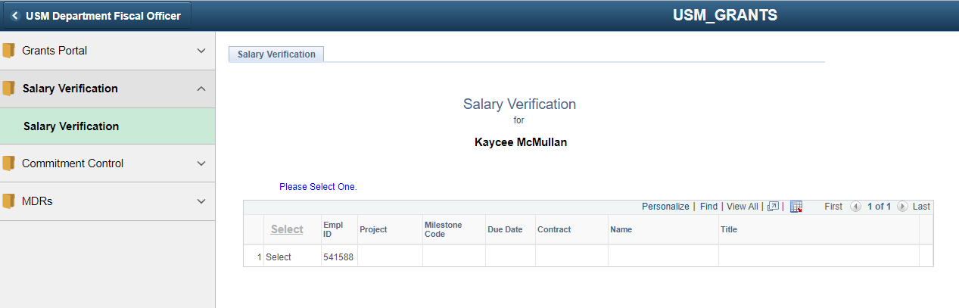

All grants with Salary Verification due will be located on this page.

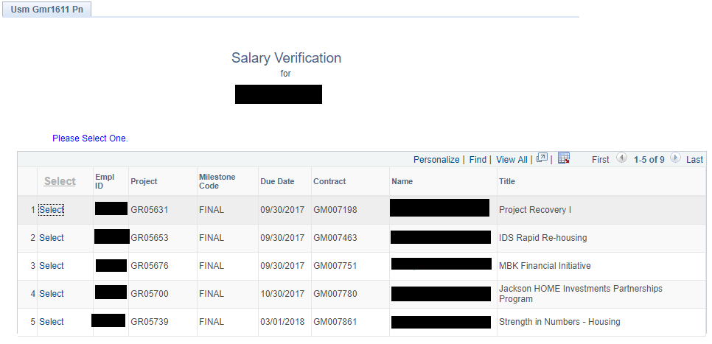

Be sure to click “View All” so all of your projects show, not just the first 5.

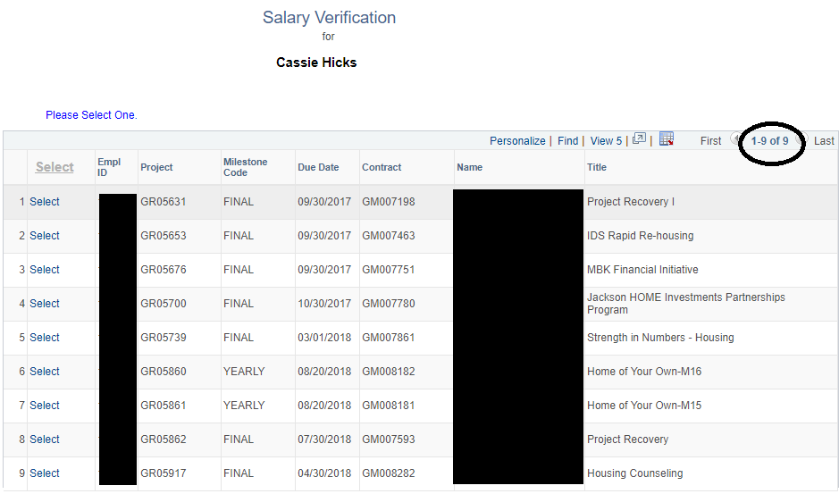

Note: The Milestone Code will tell you if it is a yearly verification (will show one year of the grant) or final verification (will show the life of the grant).

Click the blue “Select” button by the correct Project Number.

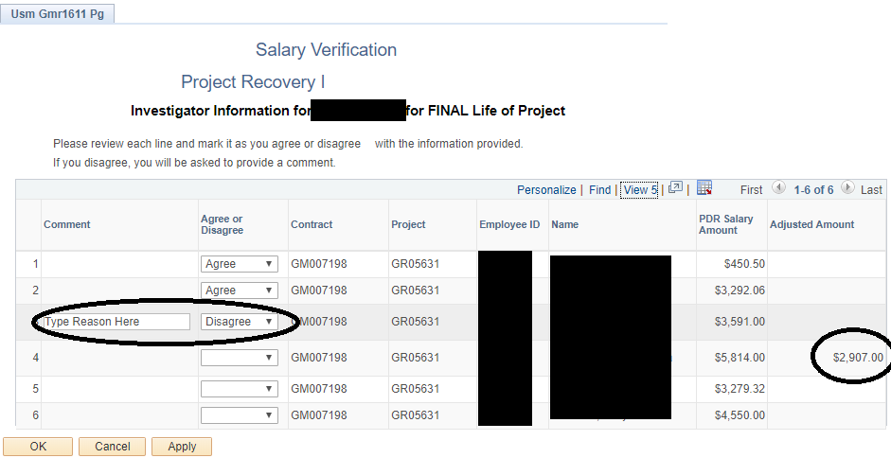

This view shows a grant that has final salary verification due for the life of the grant.

You will see all employees paid on the grant you chose with their ID and Name. You will see under “PDR Salary Amount” the budget amount and any “Adjusted Amount” from an interdepartmental submitted will show after. Again, make sure that you click “View all” so you do not miss any employees.

You will choose “Agree” or “Disagree” for each employee paid on that grant for the time period shown (life of grant or one year time period). If you “Disagree” a comment box will appear in the “Comment” column for your notes.

You can click the Apply and OK buttons to save your progress until you are ready to submit.

Once you choose “Agree” or “Disagree” for each employee, you will need to click Apply and OK. When you click the “Select” button for that grant again, a new button will appear.

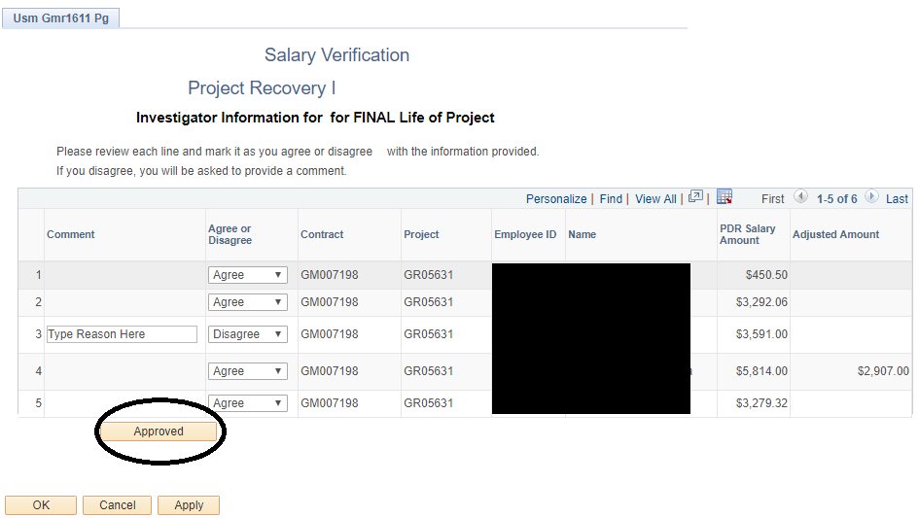

Once you click the “Approved” button, that grant will no longer show on your list. You will no longer be able to access that grant, so use the Apply and OK keys to save your progress until you are completely finished.

You can see a Yearly Salary Verification example below.

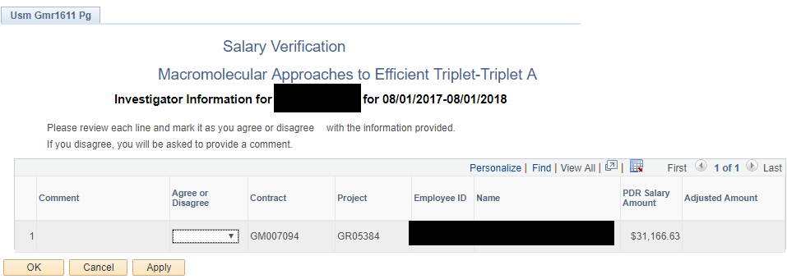

Once all projects have been approved, your base screen will look like this. That is how you know you are finished.

