June 11, 2021

Dear USM IRB:

On behalf of The University of Southern Mississippi, I hereby agree to allow Seymour D. Campus [researcher name] to conduct his study entitled “Interactions between Mascots and Students” at our institution. This school complies with the requirements of the Family Education Rights and Privacy Act (FERPA) and will ensure that this and other pertinent requirements are followed in the conduct of this research.

Signed,
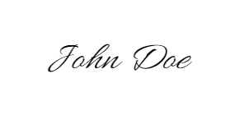
Dr. John Doe, PhD
[role, e.g. school president]

