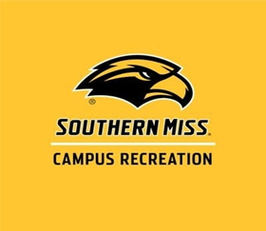
2021 Southern Miss Regional Flag Football Tournament
Open Team Entry Form

Team Name: ________________________________

Team Captain: ____________________ Address: ______________________________

Phone #: ____________________ Email: _____________________________

Roster
Player Name (First, Last) | Last 4 of SS # | Email
1.
2.
3.
4.
5.
6.
7.
8.
9.
10.
11.
12.
13.
14.
15.

Fee: $200 per open team Captain’s Signature: _________________________________
Deadline: Friday, November 26, 2021
Team Contact: __________________________
Phone:_________________________________
E-Mail:________________________________
Alternate Contact: __________________________
Phone: _____________________________________
Credit Card: (Circle One) E-mail: _____________________________________
VISA Master Card

Card #: ____________________________ Return with check or money order to:
Expiration: _____________ Southern Miss Campus Recreation
Attn: Joshua Brunson
Signature: __________________________ USM Box 5155
Hattiesburg, MS 39406

Please make check (certified or business, no personal checks or PO’s) or money order payable to:
Southern Miss Campus Recreation

*Non-refundable, unless entry into the tournament is denied. In the event that the tournament is cancelled due to circumstances beyond control, entry fees will not be refunded.

