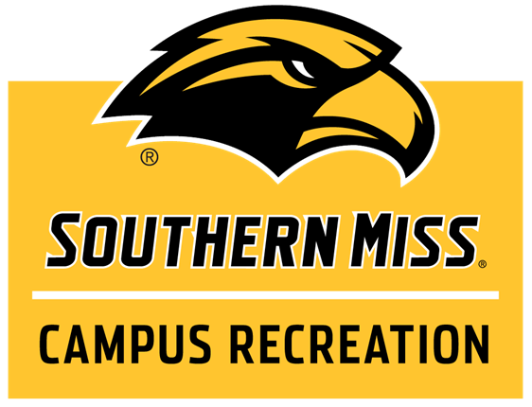

Participant Handbook
2019-2020
Campus Recreation Office: 601.266.5405
Email: intramurals@usm.edu
Register Teams Online: imleagues.com/usm
Twitter: @USM_Intramurals
facebook.com/SouthernMissIntramuralSports

Section 1: Recreational Sports --- P _
1. Mission Statement 1
2. Programs and Service 1
3. University Community 1
Section 2: Intramural Sports____ _ _
1. Program Objectives 2
2. Participation 2
3. Assumption of Risk Statement 2
4. Photo Disclaimer 2
5. Intramural Sports Staff 2
6. Employment 3
Section 3: Eligibility_____ _
1. Identification 4
2. University Status 4
3. Summer Eligibility 4
4. Co-Rec 4
5. Varsity Athletes 4
6. Club Sports Members 4
7. Fraternity and Sorority 4
8. Professional Athletes 4
9. Ineligible Players 5
10. Eligibility Protests 5
Section 4: Scheduling……--------- -
1. League Sports 6
2. Divisions 6
3. Tournament Sports 6
4. Major Sports 6
5. Minor Sports 6
6. Individual/Dual Sports 6
7. Levels of Competition 7
8. Rescheduling Games 7
9. Inclement Weather 7
10. Rescheduling due to weather 7
.Section 5: Registration__...... ...
1. Online Registration 8
2. New Participants 8
3. Returning Participants 8
4. To Create a Team 8
5. To Join a Team 9
6. Free Agency 9
7. Team Roster 9
8. Competing on Two Teams 9
9. Signed into the Team Roster 9
Section 6: Participation_......
1. Attire and Equipment 10
2. Jewelry and Accessories 10
3. Blood Rule 10
4. Injury 10
5. Equipment Checkout 10
6. Photograph Policy 10
7. Free Agency 10
Section 7: Captain’s Responsibilities
1. Captain’s Responsibilities 11
2. Captain’s Meetings 11
3. Playoffs Draw Meetings 11
4. Spectators and Equipment 11
5. Team Roster 11
6. Team Name 11
Section 8: Defaults and Forfeits ..._
1. Advanced Defaults 12
2. Forfeit Policy 12
Section 9: Code of Conduct_..
1. Protest of Rule 13
2. Prohibited Conduct 13
3. Fighting 13
4. Mandatory Penalties 13
5. Disciplinary Cases 14
6. Disciplinary Appeals 14
7. Verbal Abuse 14
8. Alcohol, Drugs and Tobacco 15
Section 10: Sportsmanship _.... __
1. Sportsmanlike Conduct 15
2. Sportsmanship Rating 15
3. Sportsmanship Scale 15
4. Post-Season Sportsmanship 16
5. Rating for Defaults and Forfeits. 16
Section 11: Awards…………………`
1. Championship T-Shirts 17
2. All-Campus Champion 17
3. Sportsmanship Awards 17
4. Fraternity / Sorority Cup 17
5. The Golden Eagle Trophy 17
6. How to Achieve Points 17
7. University Cup Points 18
8. Extramural Tournaments 18

Section 1: Recreational Sports Overview_____?>>>> Participant Handbook [1]
Article 1: Mission Statement
The mission of Southern Miss Campus Recreation is to provide safe, quality and comprehensive programs, services and facilities that enhance recreation and wellness for the university community while supporting the educational mission of the university through student learning and development.
Article 2: Programs and Services
Through the Department of Campus Recreation, students, faculty and staff are provided an opportunity to take advantage of a variety of recreational and wellness programs and services. Programs currently available through Campus Recreation are Intramural Sports, Aquatics, Fitness, Sport Clubs and Informal Recreation; facilities include the Payne Center, Loyalty Field, Intramural Sports Complex and Pride Field.
Article 3: University Community
The Department of Campus Recreation programs and services are more than peripheral support for the mission of The University of Southern Mississippi. Campus Recreation play a significant role in achieving the mission of the university. While the recruitment of students, faculty, staff, alumni and friends of the university is an important objective of Campus Recreation staff, it is the programs and services offered and the exposure to the department’s staff that are of key significance in the retention of these populations. By providing over 200 different programs and employing more than 400 students, Campus Recreation creates an avenue for the diverse university community to enhance its individual and collective lifestyles.
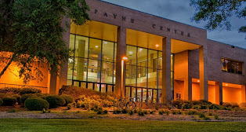

Section 2: Intramural Sports _____________ Participant Handbook [2]
Article 1: Program Objectives
The Southern Miss Campus Recreation staff invites you to participate in an Intramural Sports program with more than 30 sports offered, featuring team and individual/dual competitions. The goal of Campus Recreation is to be diverse and to offer each student the opportunity to participate, regardless of ability.
Article 2: Participation
The Intramural Sports program is recreational in nature. It attempts to match equally skilled teams and individuals so that all participants can enjoy the opportunity to participate. Intramural Sports are offered so the campus community has the opportunity to recreate and have fun in an organized, structured and safe environment. Team and individual competition will take place in the following divisions: fraternity, men’s independent, sorority, women’s independent, co-recreational, or residence hall.
Article 3: Assumption of Risk Statement
Participants are encouraged to have a physical examination and obtain adequate insurance prior to participation in Campus Recreation activities. Individuals who participate in Campus Recreation activities will be doing so at their own risk. Participation in Campus Recreation is voluntary, and The University of Southern Mississippi is not responsible for any injury that may occur to participants. Student health and accident insurance information may be obtained through Student Health Services (601.266.5390).
Article 4: Photo Disclaimer
The Campus Recreation department may photograph or videotape participants and use these items in promotional materials. If you choose not to be photographed or filmed, please notify the staff.

Section 2: Intramural Sports _____________ Participant Handbook [3]
Article 5: Intramural Sports Staff
Joshua Brunson, Coordinator of Intramural and Club Sports, manages the competitive Intramural Sports and Sport Clubs program. Organizes program and personnel development such as in-service training, meetings, and evaluations for student employees. Supervises Intramural and Sport Clubs Graduate Assistant, Intramural student staff and officials. Manages Intramural Sports Complex.
Email: Joshua.Brunson@usm.edu
Phone: 601-266-5520

Michael Mass, Graduate Assistant for Intramural and Club Sports, Michael assists with the daily operations of the Intramural and Club Sports programs.
Email: Michael.Mass@usm.edu
Phone: 601-266-5409

Intramural Sports supervisors, representatives of Recreational Sports, oversee the nightly administration of the Intramural Sports program. They are responsible for upholding Intramural Sports policies and procedures, as well as providing risk management and overseeing officials and scorekeepers.
Intramural officials and scorekeepers are responsible for overall game management and rules knowledge for Intramural Sports contests. In coordination with Intramural Sports supervisors, they are representatives of Recreational Sports and are responsible for the nightly administration of the Intramural Sports program.
Article 6: Employment
Intramural Sports is a student-run program that actively recruits students as officials, scorekeepers and supervisors. No experience is required, and we provide all training necessary. We work with your schedule so that you can work, play and attend class. Interested individuals must attend officials’ clinics at the beginning of each sport.

Section 3: Eligibility________________________ ___ Participant Handbook [4]
Article 1: Identification
Participants who appear on the IMLeagues.com team roster by noon of the day of their event may check into intramural activities with any form of a government picture ID.
Participants who wish to check in to an event but do not appear on the IMLeagues.com team roster must present their Southern Miss ID or REC Card.
Article 2: University Status
All undergraduate and graduate students currently enrolled at the university are eligible for Intramural Sports activities. All faculty and staff are required to purchase a REC Card to participate in Intramural Sports. Spouses of eligible participants are also allowed to participate through the purchase of a Rec Card. Spouses must be on the same roster.
Article 3: Summer Eligibility
All undergraduate and graduate students enrolled in summer courses at the university are eligible to participate. Students enrolled in the previous spring semester, who have not graduated, and intend to enroll in the fall, are eligible to participate provided that they purchase a REC Card.
Article 4: Co-Rec
All students, faculty, staff and their spouses are eligible to participate. All spouses must purchase a REC Card and be on the same roster as the student/faculty/staff member to whom they are married in order to participate in Intramural Sports.
Article 5: Varsity Athletes
Any current varsity athletes who practice with a college during the current academic year will be ineligible to participate in their or a related sport. This includes prop team members, redshirt athletes and transfer students from any college or university. University rosters will be consulted in dealing with player eligibility.
Only two former players who participated on a collegiate level in a sport related to the intramural activity they are attempting to participate in may be on the same roster.
Article 6: Club Sports Members
Intramural Sports team rosters may include up to two sport club members for a sport related to their club for sports that require five or fewer players, and teams can have three sport club members if the sport requires six or more players. This shall include anyone who participates in any club game or practice.

Article 7: Fraternity and Sorority Participant Handbook [5]
Each Greek organization must be officially registered and in good standing with the Greek Life Office in order for that team to participate in the fraternity or sorority division. Any individual playing under a fraternity or sorority name must be registered under that organization through the Greek Life Office.

Article 8: Professional Athletes
Students ineligible for varsity competition because of professional rank are prohibited from competition in the intramural sport(s) or related sport(s) in which they have professional standing.
Any eligible participant who played a sport professionally is ineligible for the intramural activity related to the sport in which he/she was a professional.
Article 9: Ineligible Players
Upon submission of a Player Eligibility Protest, the Intramural Sports staff will investigate the eligibility of the participant(s) in question. The follow criteria classify an ineligible player:
- Any person participating without his or her name and ID number on a roster, or found in violation of the rules and regulations of Intramural Sports, is an ineligible player.
Any ineligible person participating in an Intramural Sports activity shall be suspended from all Intramural Sports activities and reinstated only after a meeting with the Intramural Sports coordinator.
Any games in which an ineligible player participated shall be forfeited.
A player competing under an assumed name will be suspended from Intramural Sports competition for the remainder of the school year and will be placed on probation for the following school year.
If a team knowingly plays with an ineligible player or intentionally attempts to break the rules, that team will be dropped from the league and will not be eligible for playoffs.
Article 10: Eligibility Protests
Protests concerning player eligibility must be submitted to an Intramural Sports supervisor before or during the contest in question. The protest will be ruled on by the Intramural Sports coordinator the following day.

Section 4: Scheduling_______________ Participant Handbook [6]
Article 1: League Sports
Major team sports are scheduled into leagues based on level of competition and organizational affiliation. Leagues consist of a regular season followed by a single elimination tournament. The size of each league is determined by the number of teams registered. Leagues may be combined based on the number of teams.
Article 2: Divisions
Each league consists of divisions which correspond with a specific time of play. There are a limited number of team spots in each division, so register early.
Article 3: Tournament Sports
Individual/dual and various team sports are scheduled into tournaments based on the level of competition. Based on the activity, teams will be placed in a single or double elimination bracket that will be posted online. Tournament schedules and structure will be based on number of teams, facilities available.
Article 4: Major Sports
Major sports include, basketball, flag football, soccer, softball, and volleyball.
Article 5: Minor Sports
Minor sports include, 3-on-3 basketball, 4-on-4 flag football, bowling, dodgeball, battleship, pool volleyball, kickball, sand volleyball, ultimate frisbee, wallyball, wiffleball and battleship.
Article 6: Individual/Dual Sports
Individual sports include tennis, badminton, racquetball, air hockey, billiards, corn-hole, N-64 Mario Kart and Smash Brothers, NBA 2K, Madden, 5K runs and track and field.

Participant Handbook [7]
Article 7: Levels of Competition
Two divisions within the Independent and Fraternity divisions will be offered:
“A” Division –higher skill level “B” Division –intermediate skill level
Article 8: Rescheduling Games
A scheduled contest may be rescheduled only through the agreement of both teams and the Intramural Sports coordinator who must be notified in person 72 hours prior to the scheduled game. Tournament games must be played as scheduled.
Article 9: Inclement Weather
During inclement weather, intramural sports activities may be delayed, postponed or canceled. The intramural sports staff will make every reasonable effort to inform participants of cancellations.
If at any point during the contest there is a lightning strike and thunder clap separated by less than 30 seconds, games will be immediately halted and fields must be evacuated. These games will be cancelled if they have not reached the minimum requirement for an official game (if they have, the games will be recorded as they stand).
Article 10: Rescheduling due to Weather
Games cancelled due to poor field or weather related conditions will be rescheduled at the discretion of the Intramural Sports coordinator. If the game cannot be rescheduled, the game will be recorded as no contest, meaning the game will be removed from team results, and neither team will receive a win or a loss.

Section 5: Registration______________ ____________ Participant Handbook [8]
Article 1: Online Registration
In order to add a team, join a team, or sign up as a free agent, you must first register online at www.imleagues.com/usm.
Article 2: New Participants
- Click on Create an Account in the right-hand corner of the page.
- Fill in all requested information.
- Click on the Sign Up button at the bottom of the page.
- You should be signed in. If not, click on Sign In at the top right corner of the page and fill out your information.
Article 3: Returning Participant
For returning participants, visit www.imleagues.com/usm and follow the directions below:
- Click on the Sign In link at the top right-hand corner of the page and enter your information.
- Click on the Sports tab.
Article 4: To Create a Team
- Click on the icon labeled Create a Team.
- Click on the division within the proper league and enter your team name and password. You need to enter a password to enter a team.
- Click Add Team.
- You will then be shown the teams for which you are a captain.
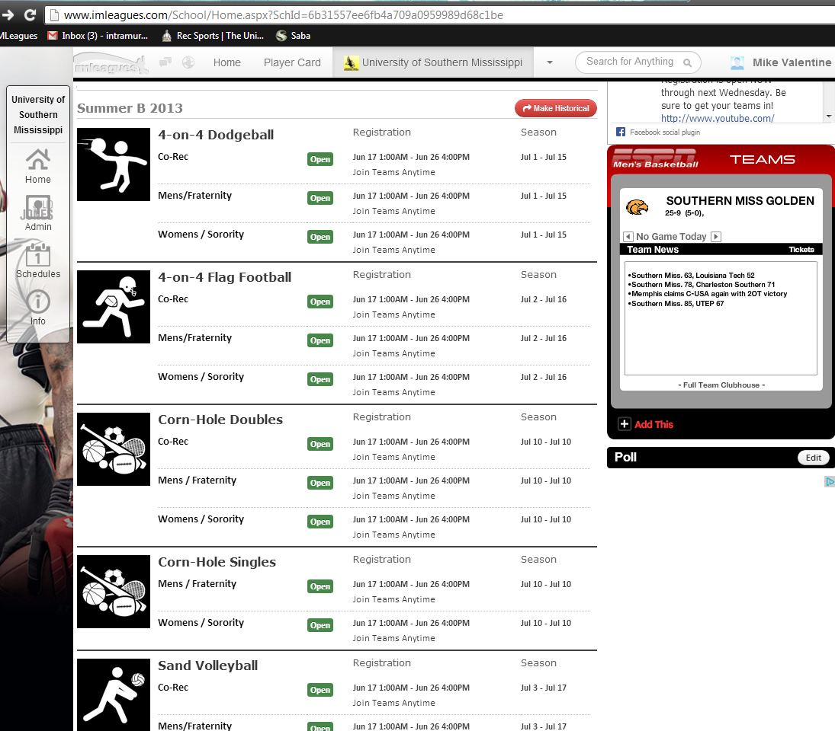

Participant Handbook [9]
Article 5: To Join a Team
- Click on the icon labeled Join a Team.
- You can either search for the team through the leagues and divisions, or you can find the team name in the dropdown menu.
- You will need to enter the team password to add yourself to the team. Enter the team password, and click on Join Team.
Article 6: Free Agency
- Click on Free Agency in User Links.
- Click on the icon labeled Set Free Agent Status for any sport listed under Sports Open for Free Agent Sign-Ups.
- To add to the list for a specific league or division, either click on the plus sign next to the listing, or choose from the options listed on the right.
- To cancel any request, click on the minus sign.
- Click Add Free Agent Request.
Article 7: Team Roster
In order for an individual to be considered eligible for Intramural Sports competition, his or her name and Southern Miss ID number must appear on the team roster.
Article 8: Playing on Two Teams
Participants may only compete on one single-sex team and one coed team per sport. Therefore, a male participant may not play on a men’s independent team and a men’s fraternity team.

Article 9: Signed into the Team Roster
Once a player has signed into the team roster, they are considered to have played for that team and may not switch rosters or play for another team. Participants may only transfer rosters if they have never signed in with the team on whose roster their name originally appears.

Section 6: Participation________ _______ _ Participant Handbook [10]
Article 1: Attire and Equipment
Participants must wear the appropriate athletic attire as prescribed in the rules for each activity. For team sports, teams must wear matching jerseys with visible and individual numbers. Please use proper judgment in selecting uniform artwork that is inoffensive.
Article 2: Jewelry and Accessories
Jewelry and ridged unyielding accessories are not permitted. The Intramural Sports staff has the right to ban the use of any equipment.
Article 3: Blood Rule
When a player is bleeding, has an open wound or has blood on his / her uniform, that player will be directed to leave the game. That player may not return until the bleeding has stopped, the wound is covered and the bloody uniform is changed.
Article 4: Injury
Whenever a player sustains an injury that merits a stoppage of play, they must sit out until the next stoppage of play that allows them to return to the game.
Article 5: Equipment Checkout
A variety of equipment will made available at the game site. Participants must exchange their student ID cards for equipment.
Article 6: Photograph Policy
To better serve and protect the privacy of our participants, the use of photography equipment is not permitted during any activity without prior permission from the Marketing and PR coordinator. This includes video cameras and cell phones.
Article 7: Free Agency
The free agency allows individuals who are interested in participating in intramural sports but do not have a team to be recruited by existing teams. Free agents should create a profile on imleagues.com and sign up under the free agency link. Also, free agents are encouraged to attend the captain’s meetings to find a team. Note: Registering as a free agent does not guarantee placement on a team.

Section 7: Captain’s Responsibilities_______________ Participant Handbook [11]
Article 1: Captain’s Responsibilities
Each team must select a captain to be responsible for the team. Captains must attend the captain’s meeting at the start of each sport and are responsible for relaying all information to their team members, as well as paying any forfeit fees.
Article 2: Captain’s Meetings
Captain’s Meetings are intended to provide teams with a familiarity of rules, rule changes, Southern Miss Intramural Sports policies and procedures and team schedules or brackets for the event in question. These meetings are provided to enhance the quality and safety of the program and to offer teams an opportunity to ask questions concerning the event. Failure to have a representative at the captain’s meeting can result in their team being replaced by another team on the waitlist.
Article 3: Playoffs Draw
All playoff draws will take place online at imleagues.com/usm. Similar to a fantasy draft, teams will be assigned a specific time to select their position in the bracket. During that time, the team captain must log in and choose their position in the bracket. The seeding and draw schedule will be communicated to each team captain prior to the draw.
Article 4: Spectators and Equipment
Team captains are responsible for their spectators, coaches, sidelines and equipment. Spectators are held to the same Intramural Sports policies as participants and coaches.
Article 5: Adding Players to Your Team Roster
Each captain is encouraged to login to imleagues.com/usm and add players to their roster by 2:00 p.m. the day of their game. Players can also be added to their team roster at the game site by presenting their active Southern Miss ID Card to the intramural sports staff.
Article 6: Team Name
The Intramural Sports program has the right to change any team name that is deemed inappropriate or offensive to participants (includes names involving profanity or of a sexually explicit nature). If you are unsure if a team name is inappropriate, please call the Intramural Sports office.

Section 8: Defaults and Forfeits___________________ Participant Handbook [12]
Article 1: Advanced Defaults
If a team captain knows that his or her team will be unable to field the minimum number of players for a game, he or she should advance default the game. This will save the team from the forfeit fee. An advance default will be recorded as a loss, and the defaulting team will receive a “B” sportsmanship rating. Teams wishing to advance default should do so by contacting the Intramural Sports office by 3:00 pm the day of their game. Teams are allowed one default or forfeit per sport. The second infraction will result in that team being dropped from the league.
NOTE: For events scheduled during a weekend, advance defaults must be reported by 5 p.m. on the Friday before the weekend.
Article 2: Forfeit Policy
Game time is forfeit time. If a team fails to appear at the scheduled location by game time with participants signed in and ready to play, the Intramural Sports supervisor will declare the contest a forfeit, thus resulting in the following:
- The forfeiting team must pay $15 to Recreational Sports Office.
- The captain of the forfeiting team will be suspended from play until the $15 forfeit fee has been paid.
- In the event of a double forfeit, both teams will have losses recorded against their record, and both teams must pay the $15 forfeit fee.
- A team will be dropped from competition once they forfeit their second game and must pay both forfeit fees.
- The non- forfeiting team must have the minimum number of players for that sport, present, signed in and ready to play. If they fail to sign in or to have the minimum, the game will be recorded as a double forfeit.

Section 9: Code of Conduct_____________________ _ Participant Handbook [13]
Article 1: Protest of Rule Interpretations
Protests involving rule interpretations will be considered immediately following the incident in question. Play will be suspended until an Intramural Sports supervisor rules on the protest. If a team continues to play without calling the supervisor to the game site, then that team forfeits its right to a protest. Protests will not be honored after play has resumed. Judgment calls cannot be protested. If the protest is not approved, the protesting team is charged with a time out. If the protest is upheld, the delay shall count as an official’s time out.
Article 2: Prohibited Conduct
No player, coach or spectator shall do the following:
- Use abusive language, threaten or abuse any other player or Intramural Sports employee before, during or after any Intramural Sports contest
- Participate in a game for which he or she is ineligible
- Argue with the game official. Only the captain may address the game official concerning the interpretation of a rule
- Intentionally strike, shove or commit any other unsportsmanlike conduct toward another player or employee of Intramural Sports
- Mistreat the facility, equipment or supplies of Recreational Sports
Article 3: Fighting
Under no circumstances will fighting be tolerated. Participants involved in any fighting shall be immediately removed from the facility and suspended from participation in Intramural Sports for one full year.
Article 4: Mandatory Penalties
The following mandatory penalties shall occur whenever an individual is ejected:
- Any individual who is ejected from a contest must leave the facility immediately upon notification by the Intramural Sports supervisor.
- Ejected players must provide a written statement of the events surrounding the ejection prior to meeting with the Intramural Sports coordinator. Only after the statement is supplied and the meeting held will the Intramural Sports coordinator decide on suspension and reinstatement.
- Ejected participants are suspended from participation in all Recreational Sports activities and entry into all Recreational Sports facilities.
- Individuals or teams that display inappropriate conduct in any extramural tournament, or any event that utilizes Recreational Sports staff, facilities or equipment, may be placed on probation or suspended from Recreational Sports.

Participant Handbook [14]
Article 5: Disciplinary Cases
Cases involving individuals or teams violating the rules and regulations of the Intramural Sports program will be heard by the Coordinator of Intramural and Sport Clubs. The individuals or teams involved will be suspended from Intramural Sports competition pending a decision.
Article 6: Procedure of Disciplinary Appeals
1. To appeal, all individuals or teams must submit a letter of appeal
within 24 hours after the decision to the Intramural Sports coordinator.
2. The coordinator will then notify all parties involved within 24 hours after the submission. At this time, the parties will be notified of the charges and brought into the Recreational Sports office.
3. At the completion of the meeting, the parties will be notified of the coordinator’s decision. Within 24 hours after the decision will be communicated to all parties.
4. Within 24 hours after the decision is made, a written appeal may be made to the director of Recreational Sports.
The Director of Campus Recreation will rule on further penalties to be prescribed as a result of unsportsmanlike conduct: profanity; unnecessary delay of game; striking or shoving an opponent; threatening, shoving or striking an official; arguing with officials; derogatory or abusive remarks toward an opponent or officials; and any action with the intent to physically injure an opponent or official. The captain may be held responsible for the actions of any individual member of the team and for spectators directly related to his or her team. The conduct of the player and spectators before and after games is as important as the conduct during the game.
Article 7: Verbal Abuse
Verbal abuse of Intramural Sports employees or participants will not be tolerated. The University of Southern Mississippi specifically prohibits the use of abusive language that insults, taunts or challenges another person. This includes swearing, obscenities, epithets directed at an individual’s race, color, ethnic identity, religion, sex or that which is personally abusive, degrading or insulting.
Article 8: Alcohol, Drugs and Tobacco
Alcohol, drugs and tobacco are not permitted on or in the vicinity of intramural contests or facilities on university property. Participants who are considered to be under the influence of alcohol or drugs will not be permitted to participate in the intramural contests and may be removed from the facility.

Section 10: Sportsmanship__ __ Participant Handbook [15]
Article 1: Sportsmanlike Conduct
A part of the philosophy of the Intramural Sports program is that good sportsmanship is vital to every Intramural Sports contest. In order to encourage proper conduct during games, officials, supervisors and administrative personnel shall make decisions to warn, penalize or eject players, teams and spectators for poor sportsmanship. These decisions are final. In addition, the Intramural Sports program has adopted a sportsmanship code and rating system in order to improve sportsmanlike behavior in Intramural Sports contests. The following rules of sportsmanship will be enforced.
Article 2: Sportsmanship Rating System
A sportsmanship rating will be given to teams after each contest by the Intramural Sports supervisor and officials. These ratings reflect behavior before, during and after the contest.
Article 3: Sportsmanship Scale
A (4.0) – Excellent Conduct and Sportsmanship: Players cooperate with the Intramural Sports staff and officials and other team members. The captain calmly converses with the Intramural Sports staff and officials and also has full control of his or her teammates and spectators.
B (3.0) – Good Conduct and Sportsmanship: Team members complain about decisions made by Intramural Sports staff or officials, or show minor dissent, but may or may not receive an unsportsmanlike penalty. Teams that receive one unsportsmanlike penalty will receive no higher than a “B” rating.
C (2.0) – Mediocre Conduct and Sportsmanship: Teams shows verbal dissent toward Intramural Sports staff, officials or the opposing team, which may or may not merit an unsportsmanlike penalty. Captains exhibit minor control over their teammates
and spectators. Teams receiving two unsportsmanlike penalties will receive no higher than a “C” rating.
D (1.0) – Poor Conduct and Sportsmanship: Teams constantly commenting to the Intramural Sports staff and officials or the opposing team from the field or sidelines. The team captain exhibits little or no control over teammates and spectators. Teams receiving more than two unsportsmanlike penalties or having a player ejected due to sportsmanship will receive no higher than a “D” rating.
F (0.0) – Unacceptable Conduct and Sportsmanship: Team is completely uncooperative. Captain has no control over teammates or himself or herself. Any
Participant Handbook [16]
team causing a game to be forfeited by result of unsportsmanlike behavior, or having multiple unsportsmanlike penalties or more than one player ejection, will receive an “F” rating.
Note: For any non-forfeit “D or F” rating, the team captain will be brought in to discuss actions with the Intramural Sports coordinator before the team is allowed to participate in any Intramural Sports activity. For any grade “D” or below, the Intramural Sports coordinator may drop the team from the league if necessary.
Article 4: Post-Season Sportsmanship
Once bracket play has begun, a team must maintain a “B” rating each game to continue in the tournament. Any team that receives a non-forfeit “F” rating will automatically be suspended until the team captain meets with the Intramural Sports coordinator prior to participating in any additional Intramural Sports contests.

Article 5: Sportsmanship Ratings for Defaults, Forfeits and Cancelations
If a game is canceled and not rescheduled due to weather or other unforeseen circumstances, both teams will receive an “A” rating.
- A team winning a game by forfeit or default will receive an “A” rating.
- A team that defaults a game will receive a “B” rating.
- A team that forfeits a game will receive a “C” rating.

Section 11: Awards and Opportunities>>>>> >> Participant Handbook [17]
Article 1: Championship T-Shirts
The Intramural Sports program will offer T-shirts to league and all-university champions in each sport. One team will also be selected as the sportsmanship champion from each division by Intramural Sports staff. These teams will be given a maximum number of shirts. Example 1.5 * a full team, e.g. 1.5 * 10 players on a full softball team = 15 shirts maximum.
Article 2: All-Campus Champion
At the conclusion of indoor volleyball, flag football, basketball, soccer and softball, champions from each division will compete against each other for the All-Campus Championship. This will be a single elimination tournament.
Article 3: Sportsmanship Awards
The team from each major sport with the highest sportsmanship will receive sportsmanship T-shirts. At the conclusion of the year, the team with the highest overall sportsmanship will receive the team sportsmanship award and T-shirts for each team member. If the is a tie the intramural staff will vote on a winner.
Article 4: Fraternity and Sorority Cup
The Fraternity Cup and the Sorority Cup will be awarded to the Greek letter teams that accumulate the most points through participation and success in each Intramural Sports event throughout the year. Fraternities and sororities will earn points by participating in the leagues and events listed each semester. Points are awarded based on the team’s place in the standings and the division the event or league is classified in.
Article 5: The Golden Eagle Cup
The Golden Eagle Cup is awarded to men’s, women’s and co-rec independent team that accumulate the most points through participation and success in each Intramural Sports event.
Article 6: How to Achieve Points
Team’s wishing to compete for a trophy shall contact the Intramural Sports office to register. Each team entered must participate under the same team name within the same division for the whole year. The awards will be presented at the Intramural Sports banquet at the end of the year and displayed in the Intramural Sports trophy case in the Payne Center. Sports will be divided into three categories (Major, Minor and Individual/Dual) and will be awarded points respectively for each.
Article 7: University Cup Points Participant Handbook [18]
MAJOR SPORTS (DIVISION A) |  |  |  |  |  | MINOR SPORTS
POSITIVE |  |  | NEGATIVE |  |  | POSITIVE |  |  | NEGATIVE
ACTIVITY | POINTS |  | ACTIVITY | POINTS |  | ACTIVITY | POINTS |  | ACTIVITY | POINTS
Team Registered | 10 |  | Forfeit | -10 |  | Team Registered | 10 |  | Forfeit | -10
1st Place | 40 |  | Default | -3 |  | 1st Place | 15 |  | Default | -3
2nd Place | 20 |  | Sp. Rating ( < 3.0) | -10 |  | 2nd Place | 7 |  | Sp. Rating ( < 3.0) | -10
3-4 place | 10 |  | Ejection | -2 |  | 3-4 place | 3 |  | Ejection | -2
Wins | 3 |  |  |  |  | Wins | 3
Losses | 1 |  |  |  |  | Losses | 1
Sp. Rating ( > 3.5) | 10 |  |  |  |  | Sp. Rating ( > 3.5) | 10
Sp. Award | 15 |  |  |  |  | Sp. Award | 15
MAJOR SPORTS (DIVISION B) |  |  |  |  |  | INDIVIDUAL/DUAL SPORTS
POSITIVE |  |  | NEGATIVE |  |  | POSITIVE |  |  | NEGATIVE
ACTIVITY | POINTS |  | ACTIVITY | POINTS |  | ACTIVITY | POINTS |  | ACTIVITY | POINTS
Team Registered | 10 |  | Forfeit | -10 |  | Team Registered | 5 |  | Forfeit | -5
1st Place | 20 |  | Default | -3 |  | 1st Place | 5 |  | Default | -3
2nd Place | 10 |  | Sp. Rating ( < 3.0) | -10 |  | 2nd Place | 3 |  | Ejection | -2
3-4 place | 5 |  | Ejection | -2 |  | 3-4 place | 1
Wins | 3 |  |  |  |  | Wins | 3
Losses | 1 |  |  |  |  | Losses | 1
Sp. Rating ( > 3.5) | 10
Sp. Award | 15

Article 8: Extramural Tournaments
Participation in Intramural Sports can lead to opportunities to represent Southern Miss in various state, regional and national extramural tournaments. These tournaments allow participants from Southern Miss to compete against other intramural teams from across the country. Contact the intramural sports office for more information regarding extramural opportunities.
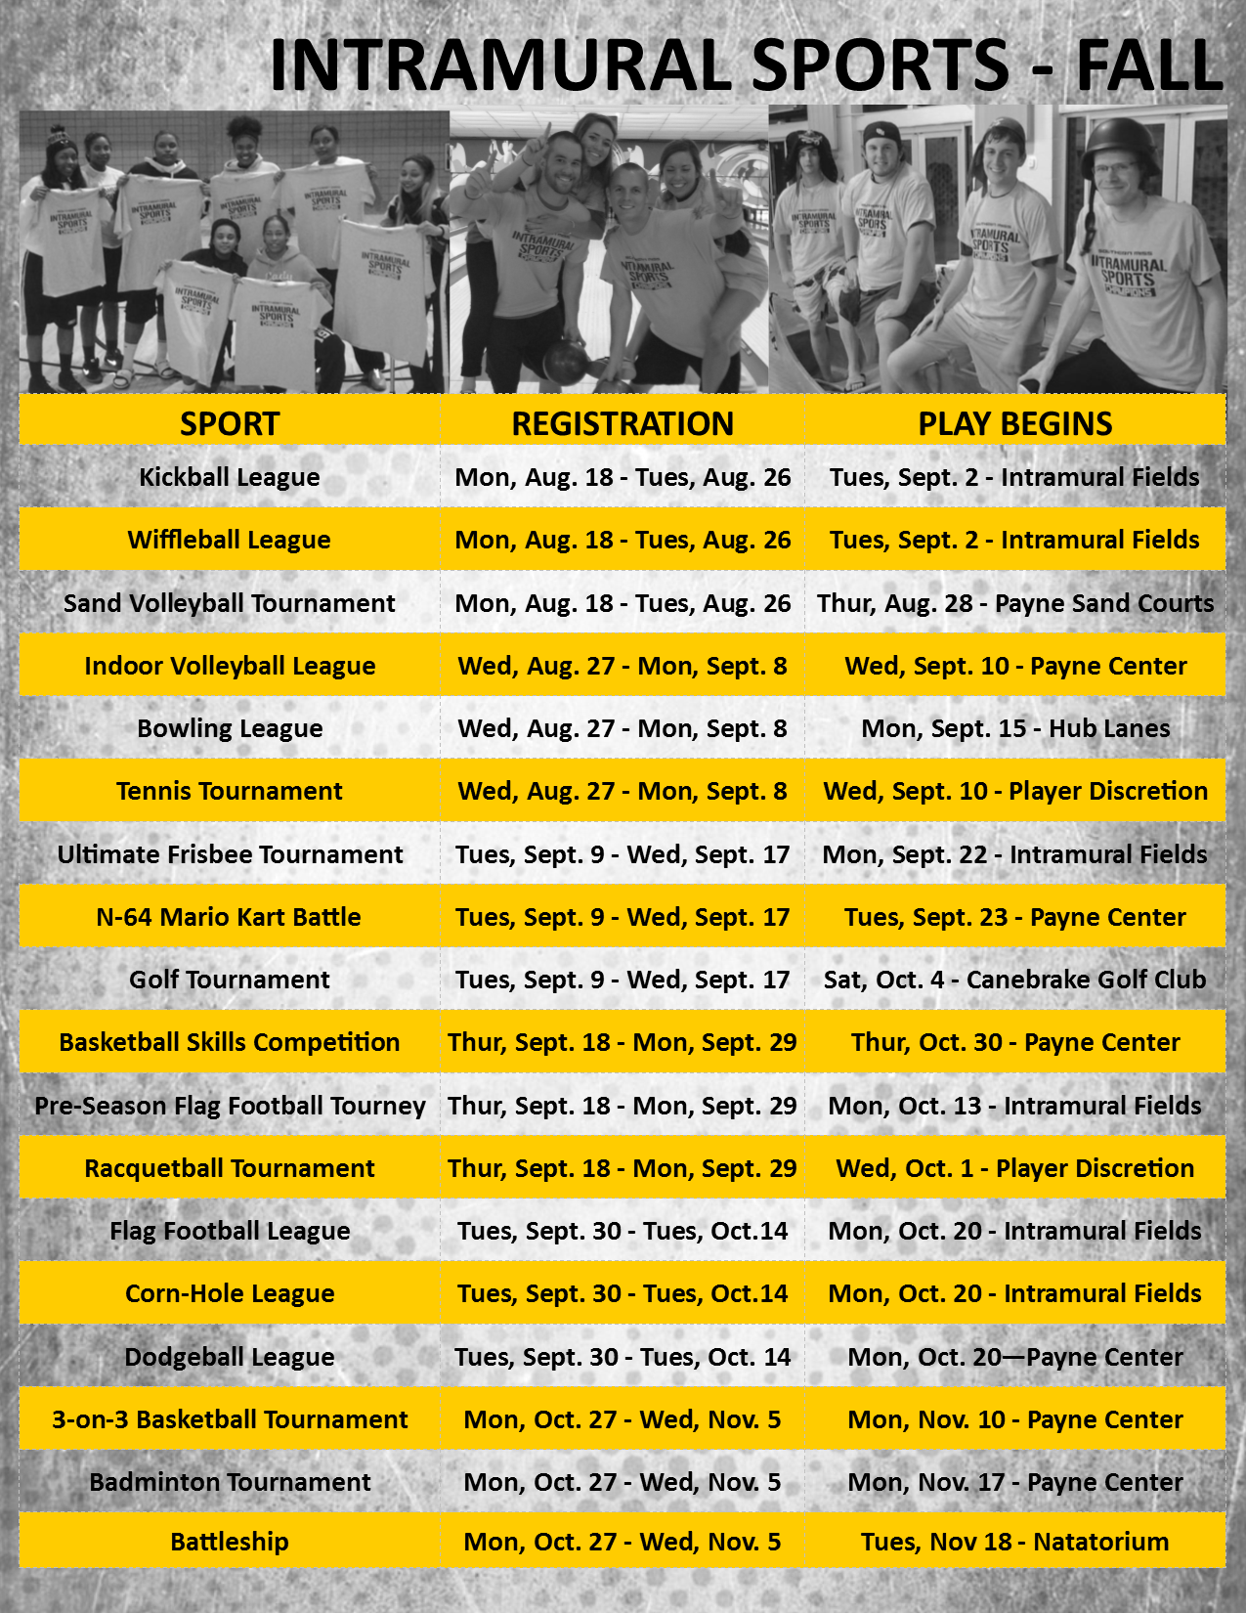
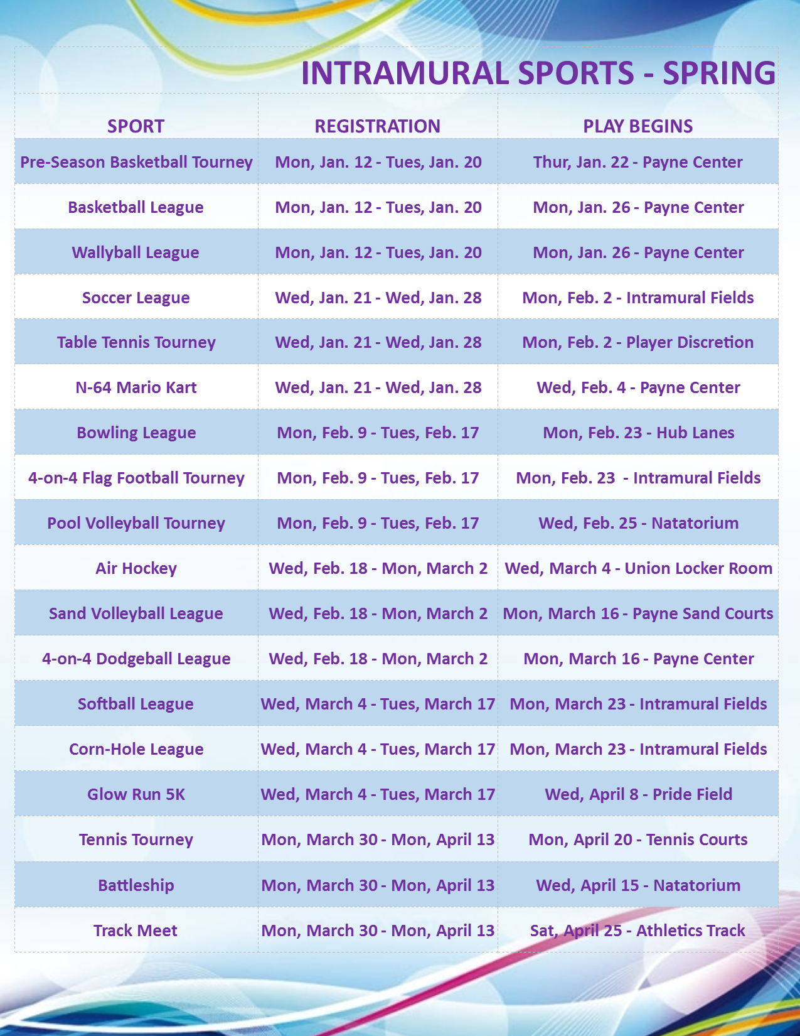
Don’t Forget to like us on FACEBOOK
Facebook.com/southernmissintramuralsports


AND

FOLLOW US ON TWITTER
@USM_Intramurals



