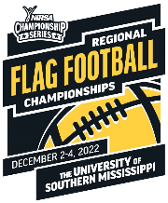
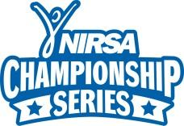
2022 NIRSA Regional Flag Football

The University of Southern Mississippi – December 2-4, 2022
Unified Division

Special Olympics Athlete Certification Form

College/University Name: Team Name:
Team Rep: ___ Division: Unified
Phone: ___ Email Address:
Address: City: State: ____ Zip:
By signing this statement of eligibility understanding, I ________________________________ (name of Special Olympics State Program representative), have conferred with the team captain to attest that each member of this roster are currently registered Special Olympics Athletes within the State Program that the team/institution is representing. All names listed on this roster should meet all NIRSA Championship Series Unified Division eligibility guidelines as defined in the tournament rules and procedures.

Email: Phone:
Signature of Special Olympics State Program representative approving team entry

This original player certification form with Special Olympics State Program representative signature must be received by the entry deadline of 11/28/2022.

Please print player’s names

Roster limit – Players listed on this form in addition to players listed Unified Partner Certification form cannot exceed 15 total
Player | Participant Name  (please print) | Participant Signature | Student ID # | Completed by Registrar  Fall 2022: Semester or Quarter  UG or GR # of Credits
1 |  |  |  | UG/GR
2 |  |  |  | UG/GR
3 |  |  |  | UG/GR
4 |  |  |  | UG/GR
5 |  |  |  | UG/GR
6 |  |  |  | UG/GR
7 |  |  |  | UG/GR
8 |  |  |  | UG/GR

Student Partner Certification: All student partners on the Unified team roster are to be listed on a separate Player Certification form that certifies they are current students of the institution they are competing under. All student partners must register on their team’s roster under the Regional Flag Football Championship Unified Division found at www.imleagues.com.

To be completed by Registrar’s Office

By drawing a line under the last participant verified and by signing below, I certify that the ______ (#) Special Olympic Athletes listed above are currently registered and up to date with documentation.

Signature Date Phone

