# Cornerstone Requisition Approval Steps

**Step 1:** Hover over “Recruit” and select Recruiting Approvals

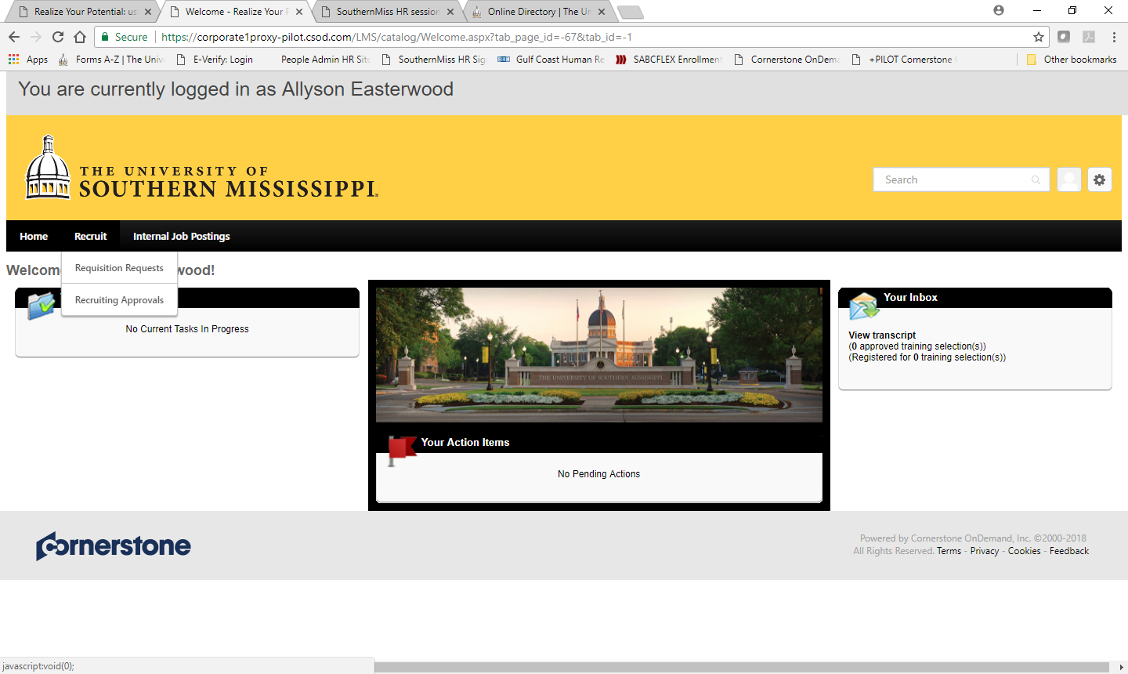

**Step 2:** To view the requisition details click on the job title

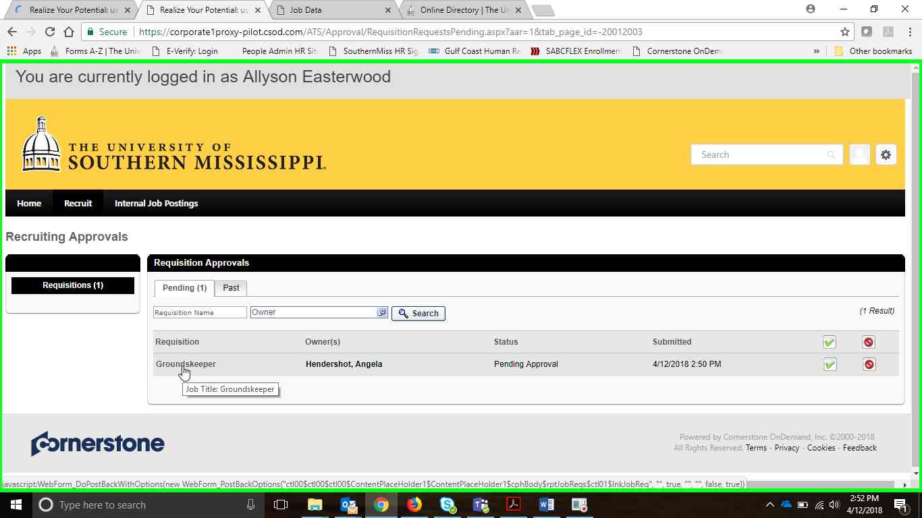

**Step 3:** The Requisition now has 4 tabs (General, Job Ad, Application Workflow & Applicant Review). These fields are not editable during the approval process. If an approver approves the requisition with only minor edits to the details fields, we recommend approving with a comment. If substantial changes are needed, for example, changes to the description/qualification content or to any of the tabs beyond general then the recommendation is to decline the requisition request so that a new version can be routed for approvals.

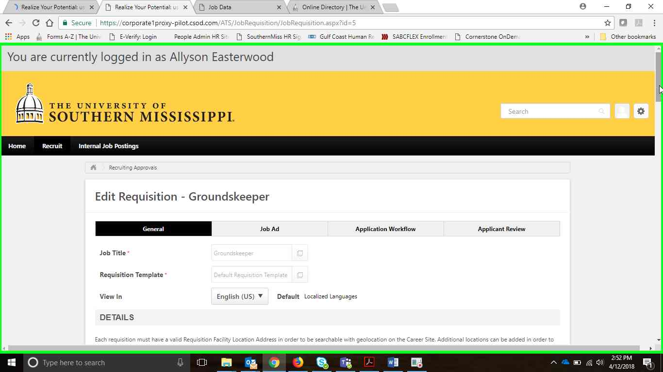

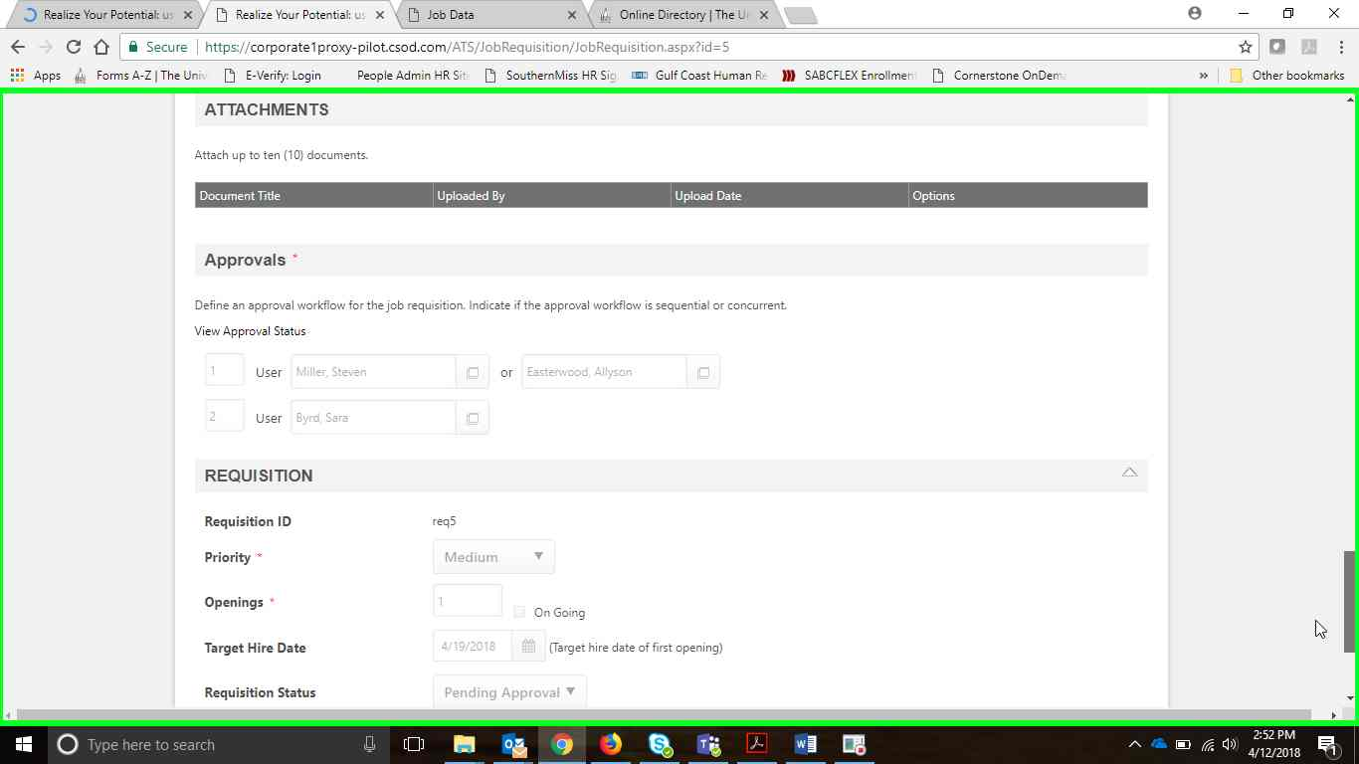

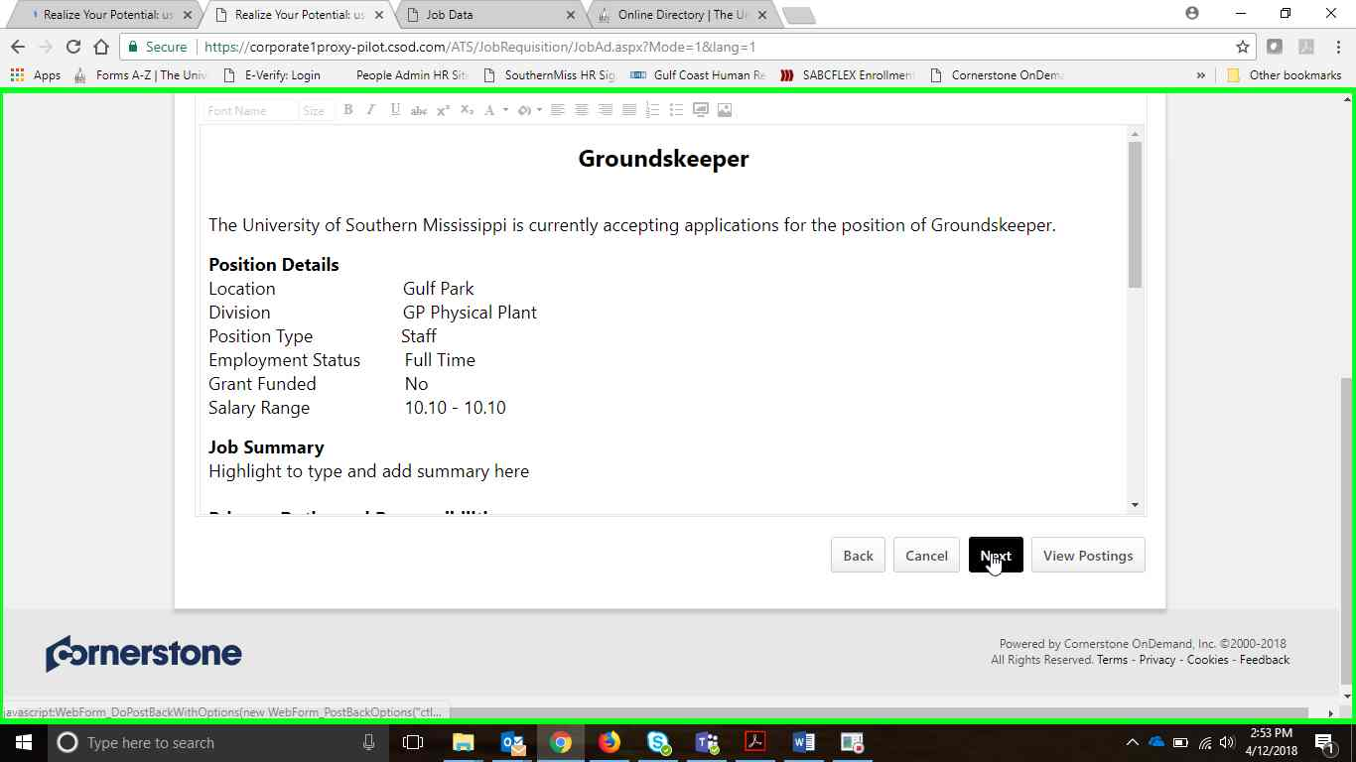

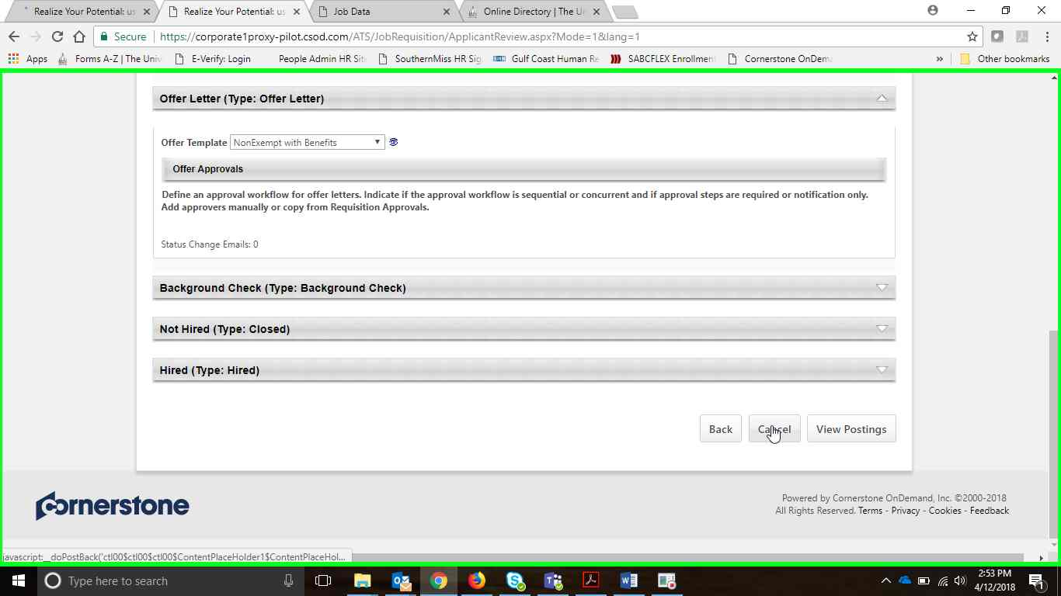

**Step 4:** Click Green Check Mark to approve or Red Stop sign to Decline. Once you select your decision the screen will refresh and allow you to add a comment and a submit button will appear.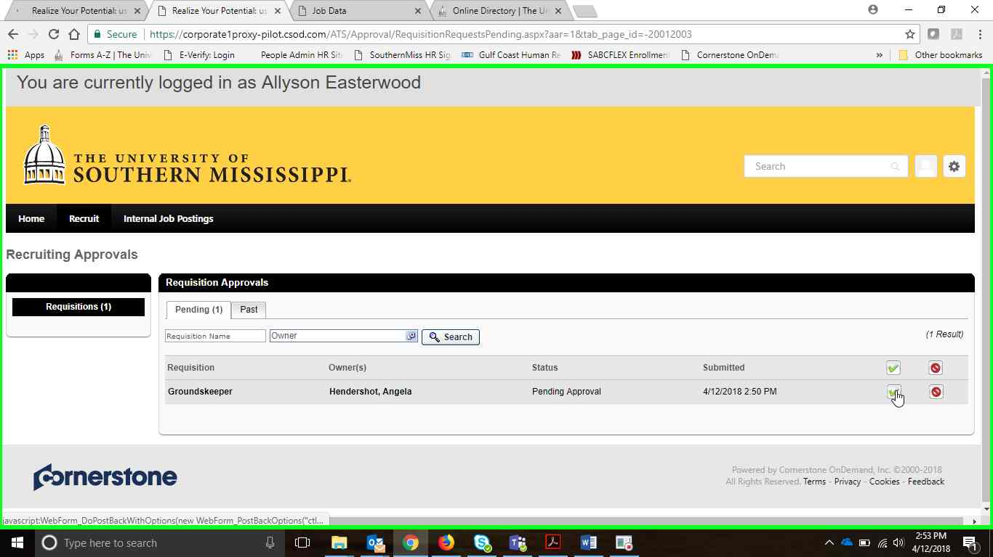

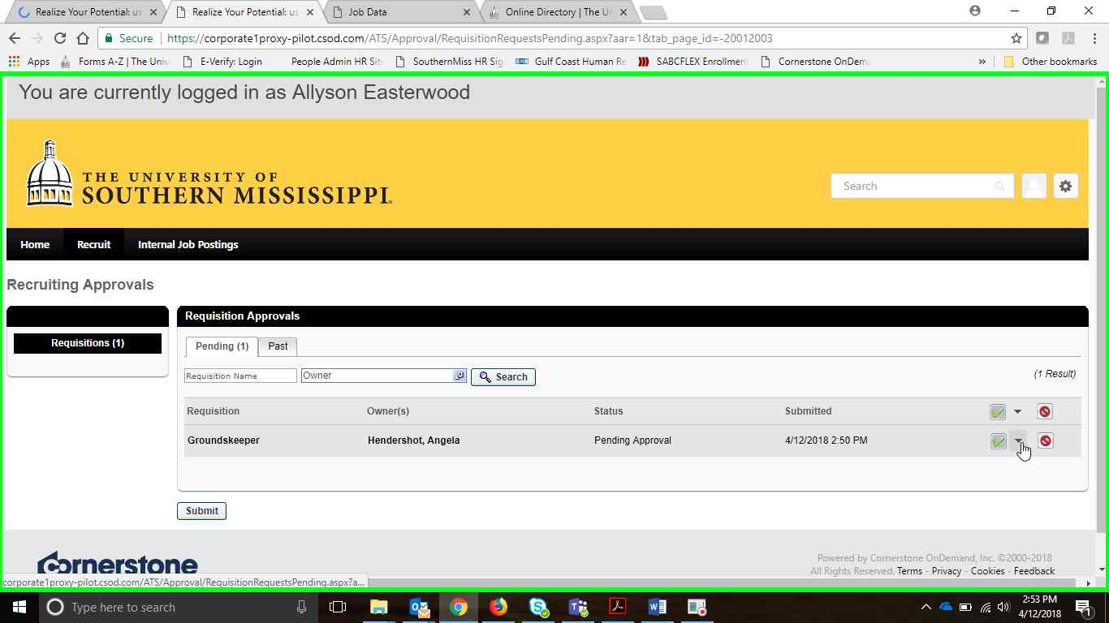

**Step 5:** Add comment if changes are needed before posting or if you need to supply a reason for declining the requisition.

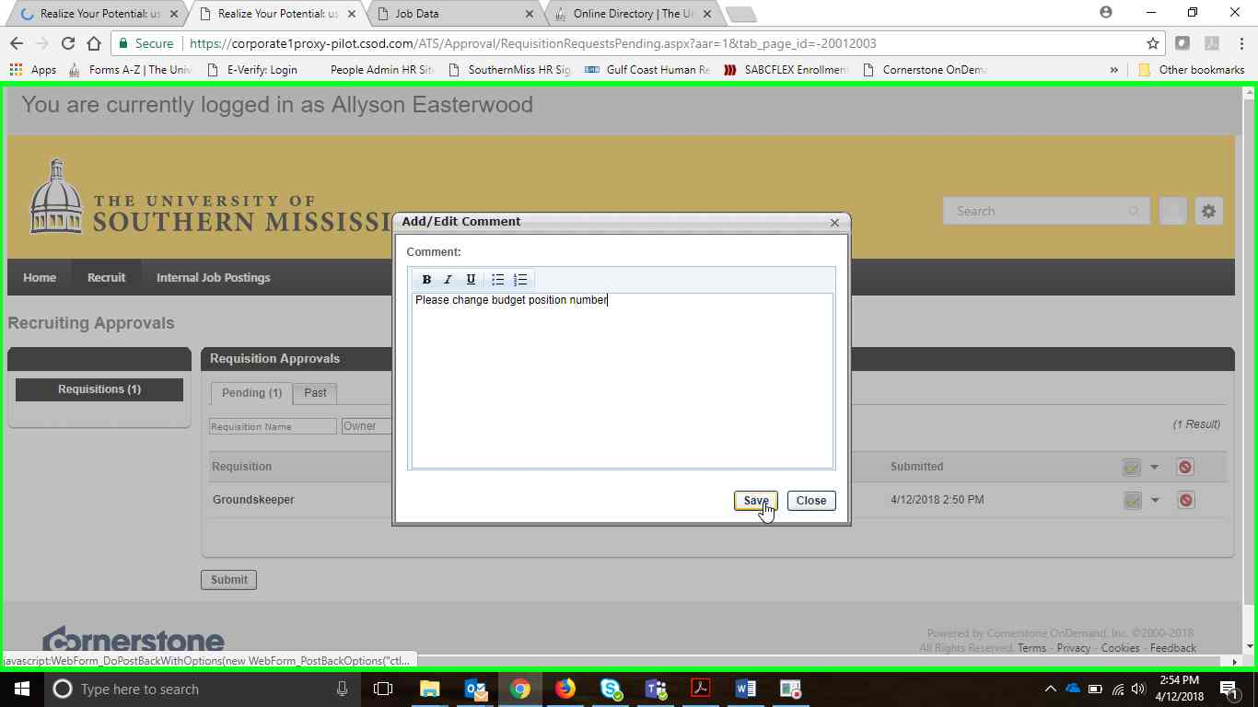

**Step 6:** Don’t forget to click “Submit”

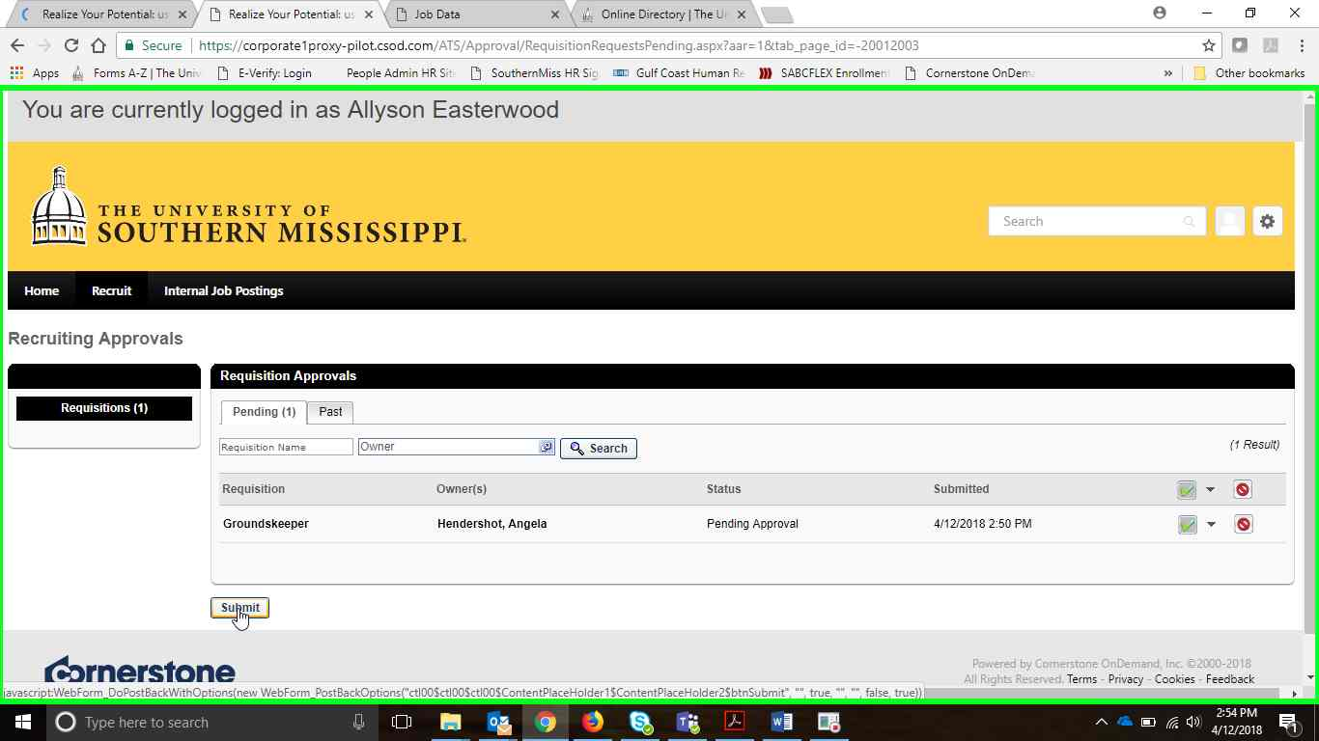

If additional approvals are needed requisition will automatically move on to next step.