# ATS Steps – Offer Letter to Background Check

**Step 1:** Starting from the Manage Applicants screen you will need to verify that the candidate’s status is changed to Offer Letter before you can begin the offer letter process. To change the status, select the candidate, then drop down the Actions box and select “Change Status”, select the new status of “Offer Letter” and click submit.

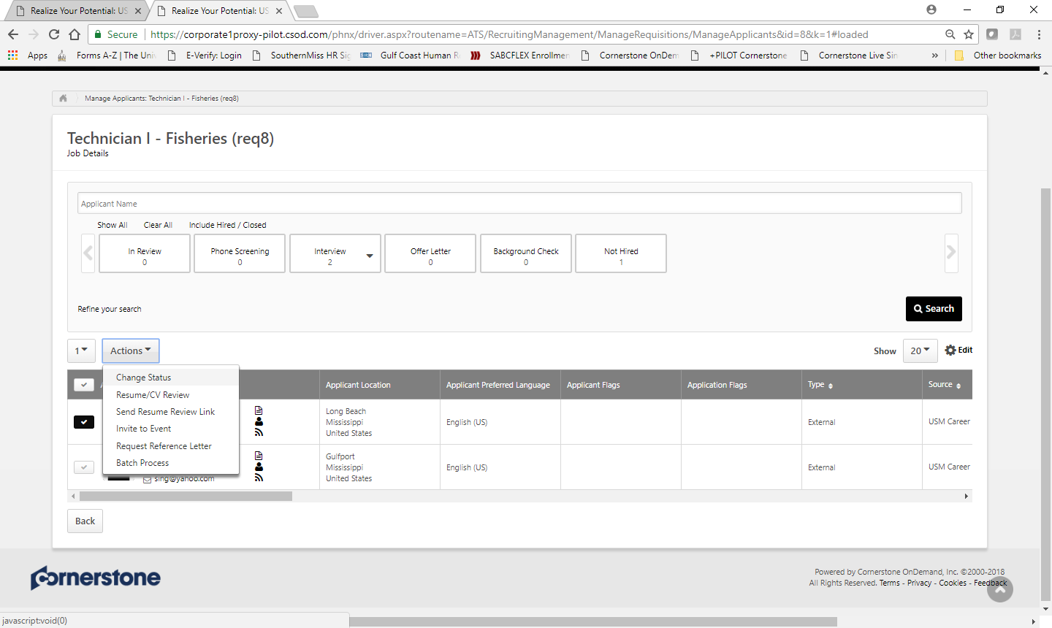

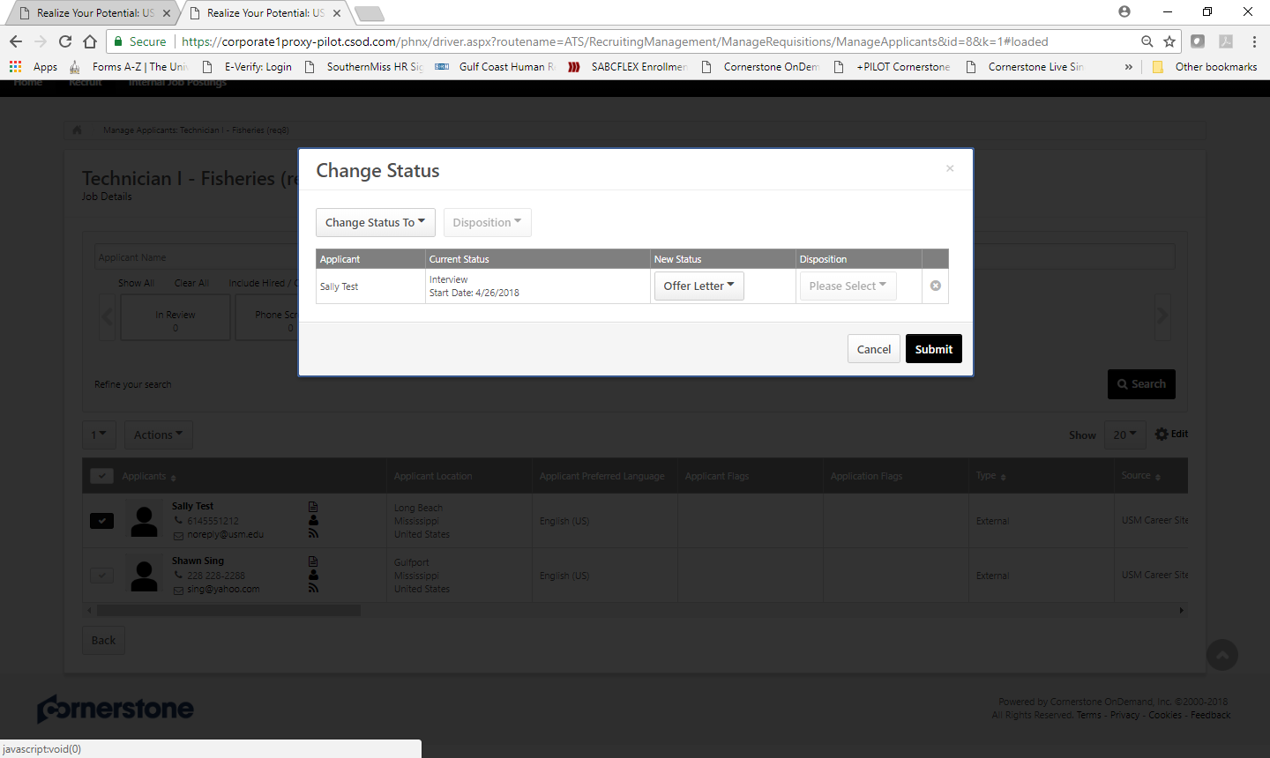

**Step 2:** Go into the candidate record by clicking on their name and then go to the “Statuses” tab. Offer Letter Details will now be displayed. Some items are linked to the Requisition Details and will prepopulate, others will need to be entered by you. Only enter the fields that are relevant to the offer that you are making (if it doesn’t apply leave it blank). If the position is exempt and paid monthly please divide the annual pay by 12 and insert a monthly amount with only 2 decimal places. Once all details are entered, click “Save and Create New Letter”.

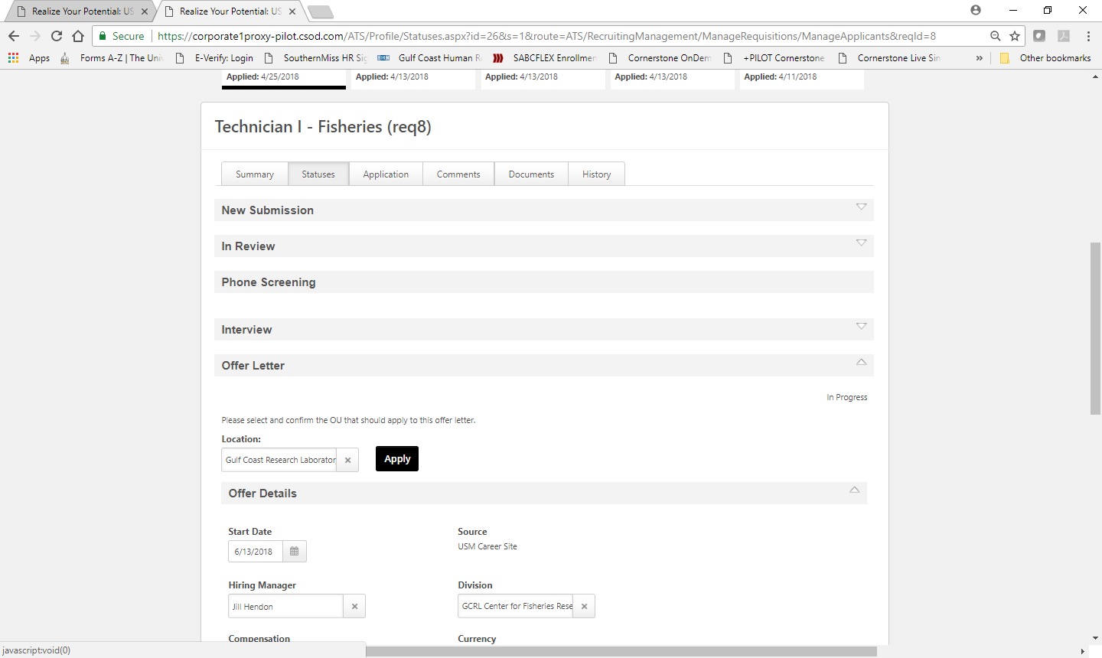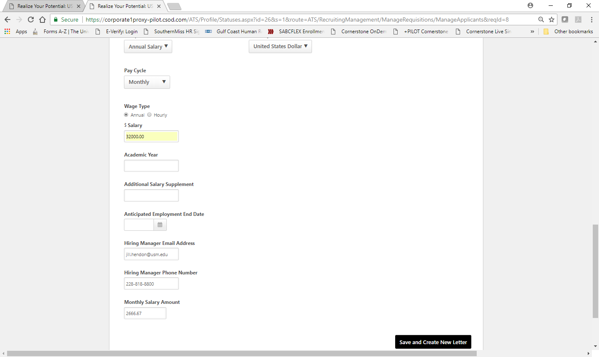

**Step 3:** The Create Offer box will pop up, populated with the offer template selected by the HR Partner at the time the Requisition was requested. If the offer template is incorrect then you can click on the template title and select the correct option. This offer template shows you the “tags” that are used to pull the information you input on the Offer Details page into the Offer Letter Template in “Design” view.

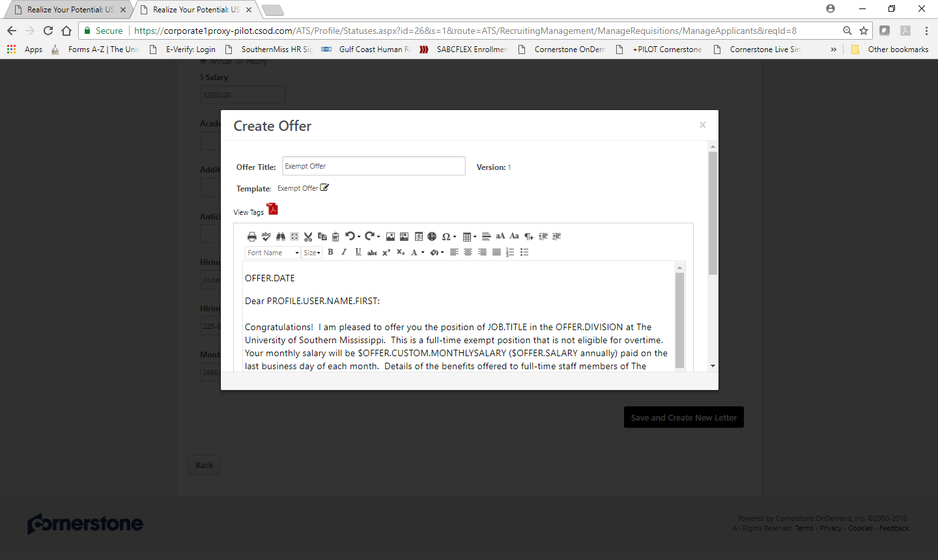

**Step 4:** Scroll down in the Create Offer pop up window and change the view to “Preview” in order to see what the letter will actually look like with the details inserted. Please keep in mind that you can edit this offer letter, however, you should not change any of the details regarding terms or conditions of employment. Once you are complete and good with the information in the offer letter click “Save and Create Offer”.

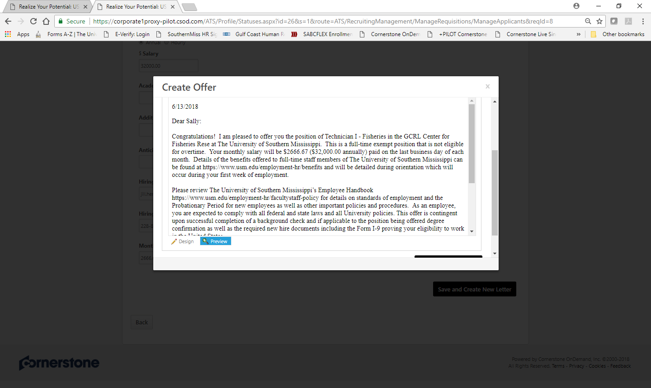

**Step 5:** This will take you back to the applicant record on the “Statuses” tab. You can now send the offer letter for approval, edit the offer details, or generate a new offer letter as needed. Remember that it is recommended that at least one other person reviews and approves an offer letter before it is sent to a candidate. If changes where made to the offer letter than HR review and approval is necessary.

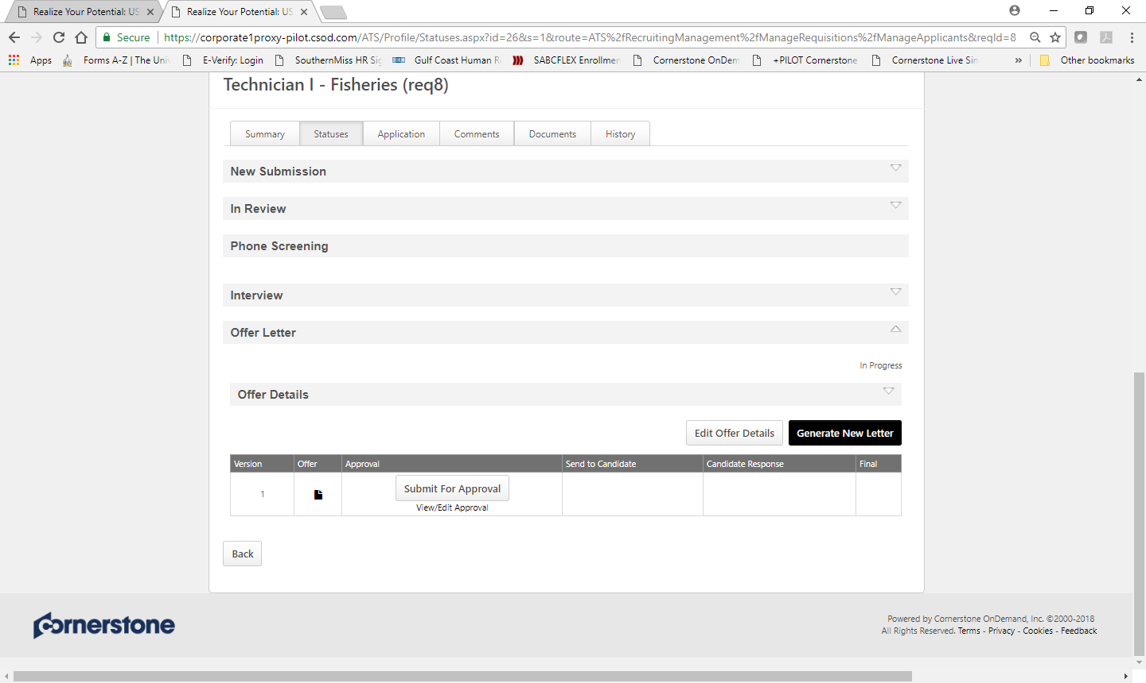

**Step 6:** To add approvers to the offer letter click the “View/Edit Approval” link as shown in the picture above in Step 5. The View/Edit Approvals box will pop up, click the “+ Add Approvals” then click the “+ User”, adding the number of users you plan to send the offer to for approval. Then click “Add.” It is the department’s decision and discretion on the number of people or who would be the most appropriate person to approve offer letters. Best practice is that at least one person above the person who created the offer letter should review and approve it.

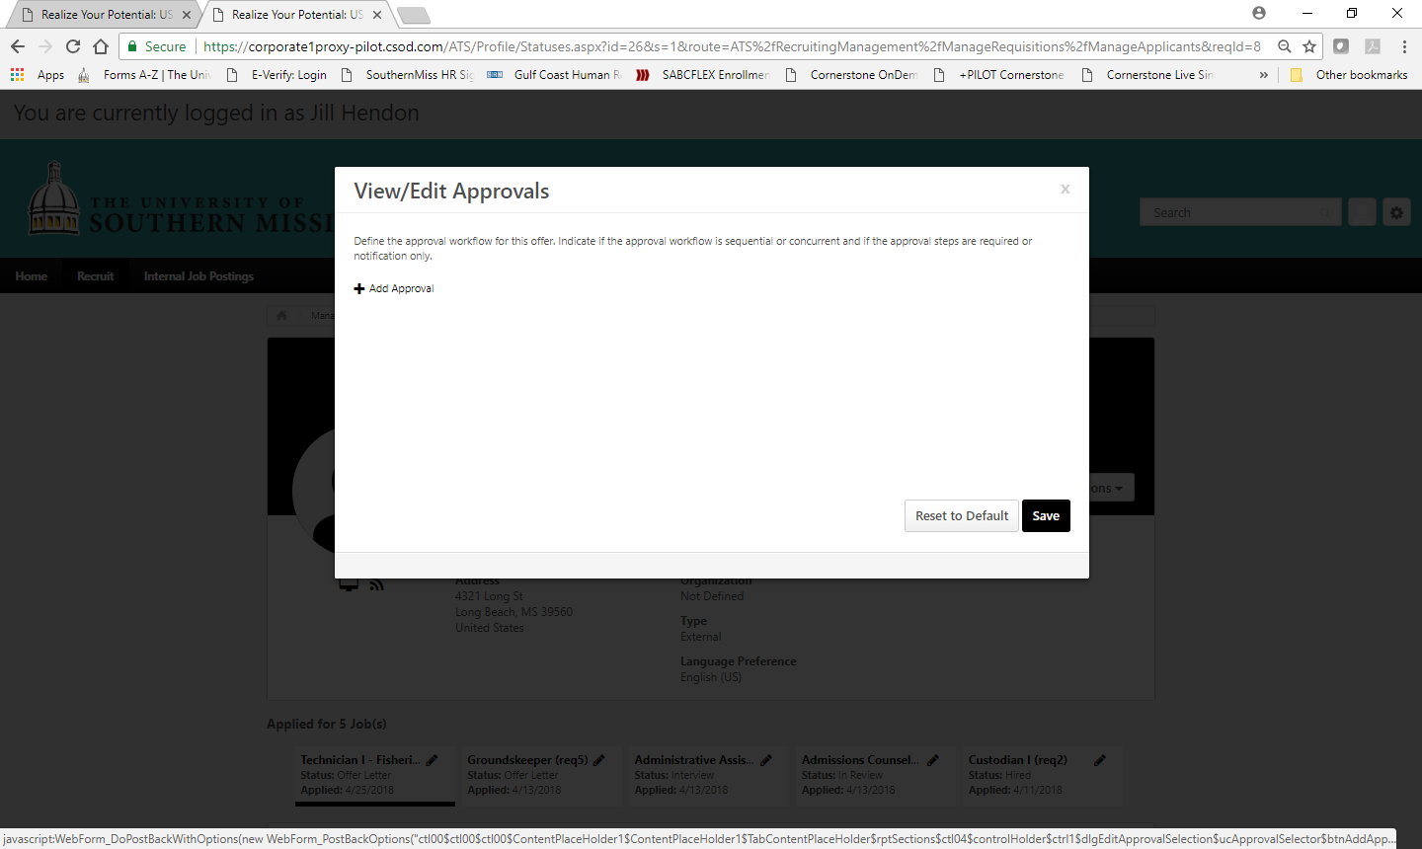

**Step 7:** Offer Letter approvals allow for “Approval Required” (active approval) or “Notification Only” (passive approval) options. After selecting the appropriate users and approval option click “Save”.

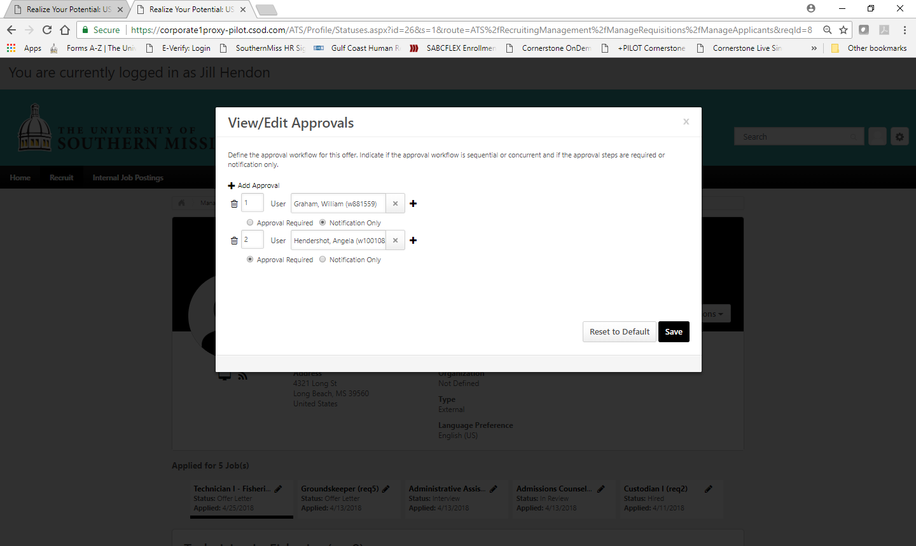

**Step 8:**  You are now ready to click “Submit For Approval” on the Offer Letter. For those who need to approve an offer letter you can follow the same steps to approve a requisition. (Recruit > Recruiting Approvals > Offer Letters).

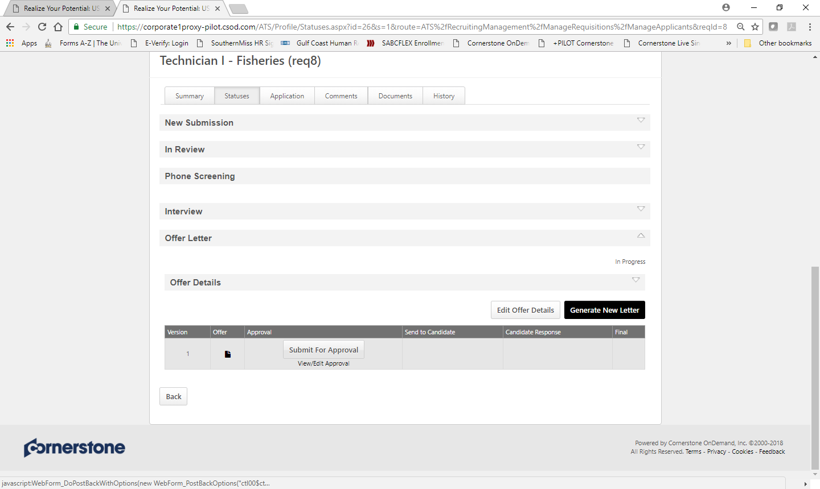

View below shows the Offer Letter Approval screen. 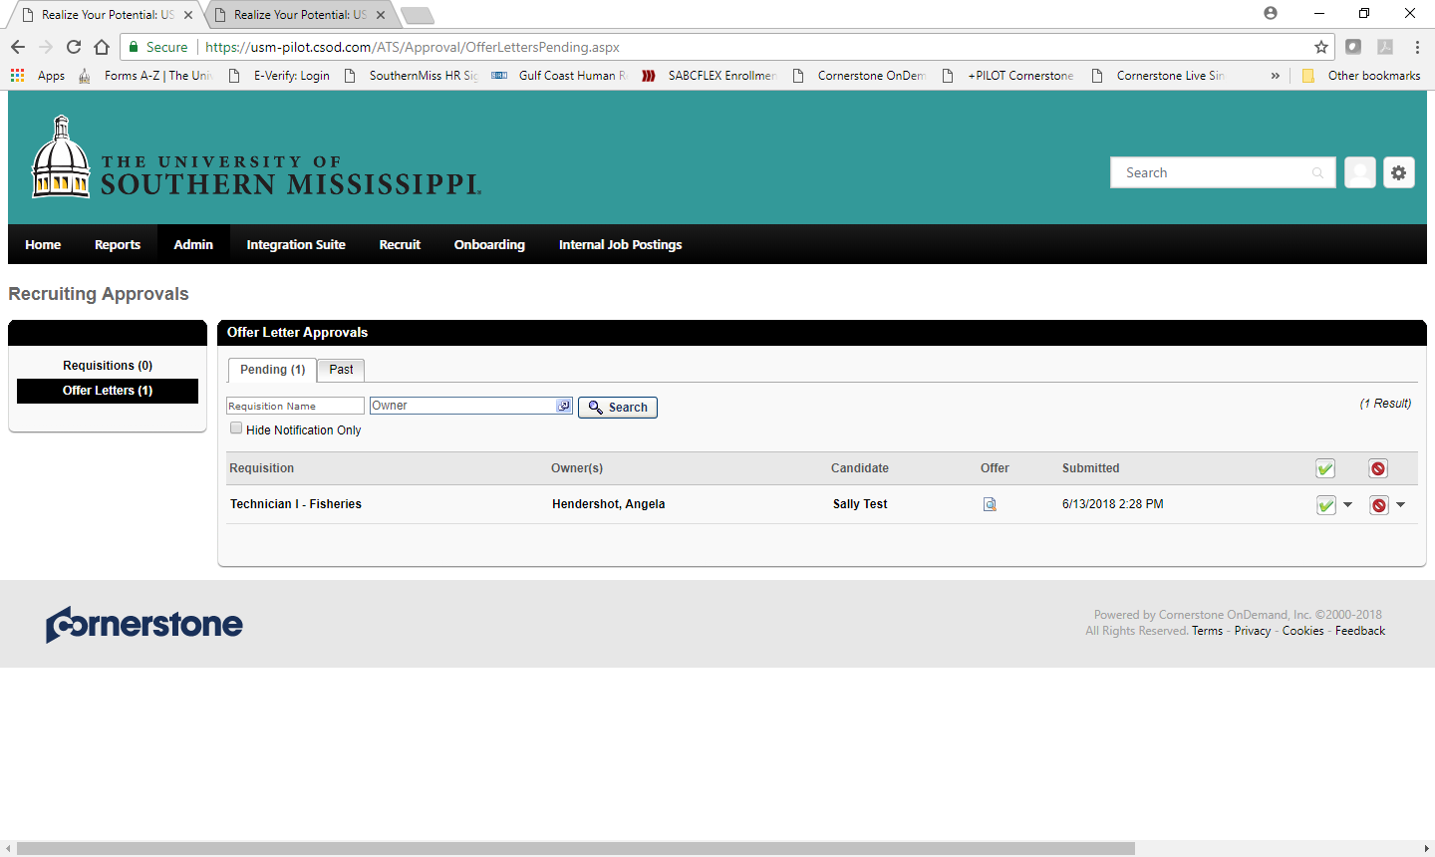

**Step 9:** Once the Offer Letter is approved you are ready to send it to the candidate. If the offer letter was not approved or needs edits, you can make necessary changes and start approvals again by repeating the steps above.

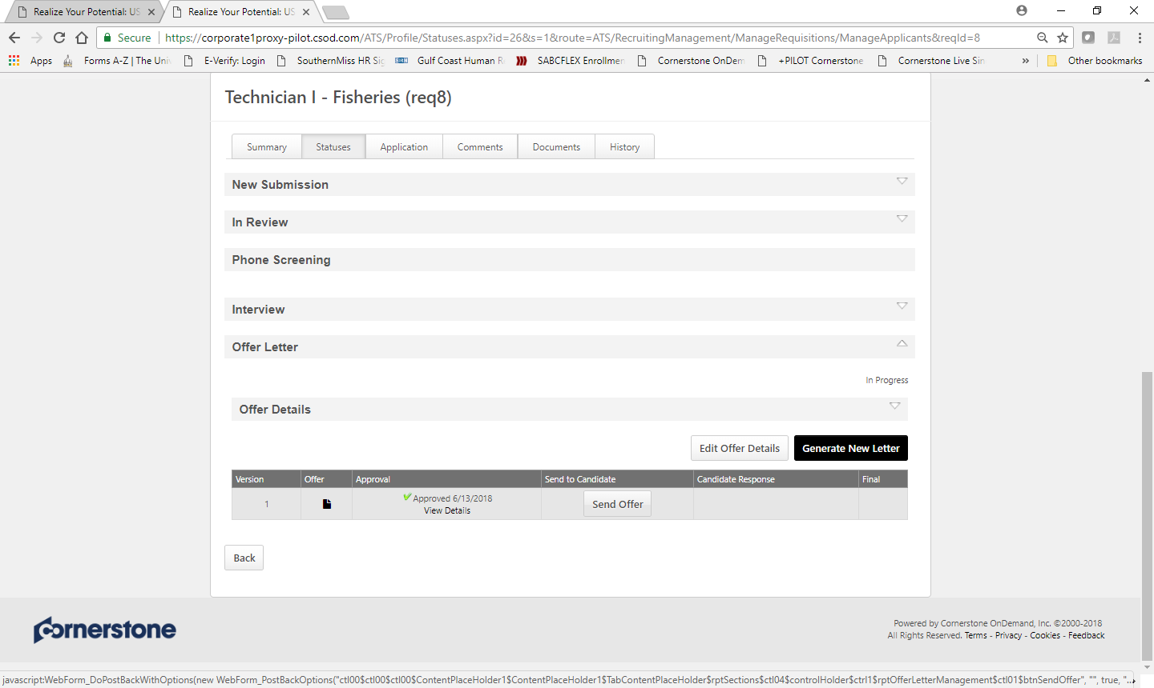

**Step 10:** Include with the Offer Letter, the Welcome Letter and the Benefit Highlights (available in your Hiring Toolkit). The instruction box is limited to 500 characters. Keep that information short, for example. “Please review the attached Offer Letter and informational documents. Indicate your acceptance of the offer letter through the candidate portal and contact our office if you have any questions. SMTTT!” Once your attachments and message are complete click “Send to Candidate Profile”.

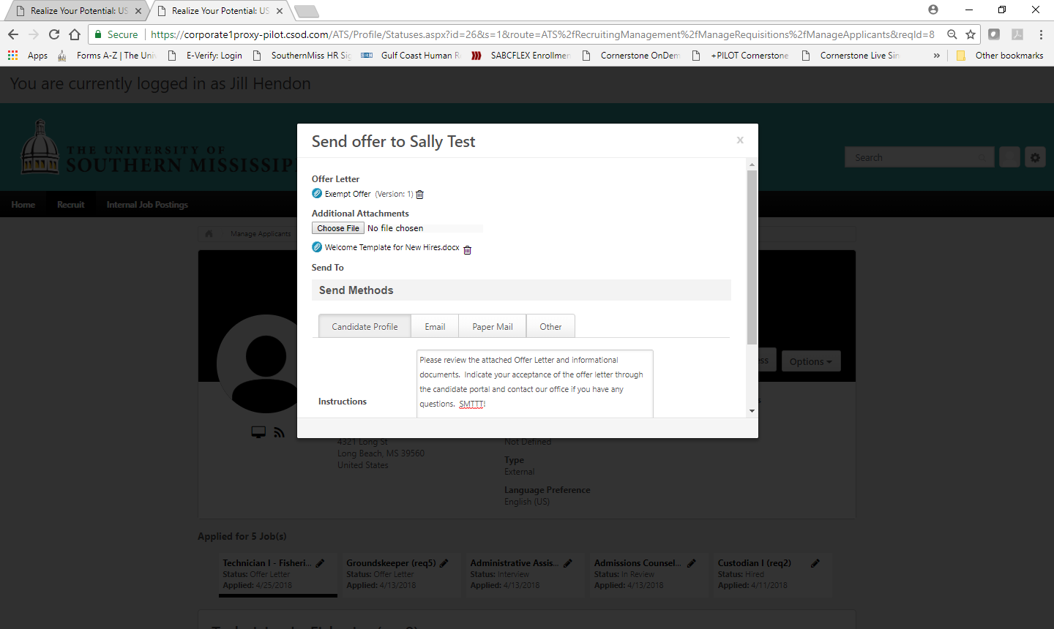

**Step 11:** Once the Candidate has accepted the offer, confirm that the response is recorded in the ATS.

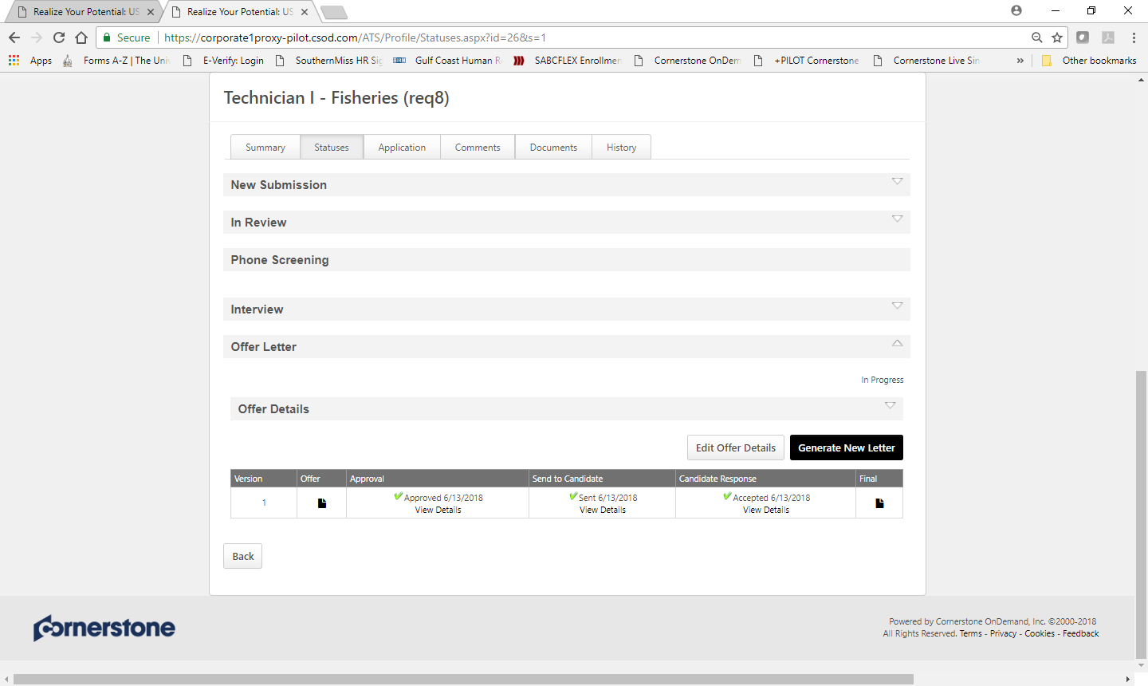

**Step 12:** After the offer acceptance has been confirmed, change the candidate status to “Background Check”. This action can be taken from several places (Applicant Record – Summary Tab or Manage Applicants – Actions). Below we show the Applicant Record Summary Tab. Click on the status “Offer Letter” and change the status to “Background Check”.

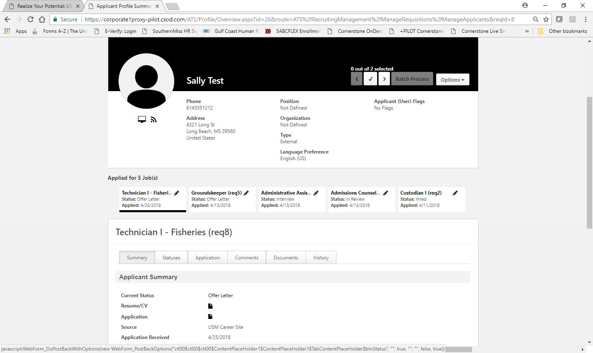

**Step 13:** Confirm Minimum Qualifications for this position. If the minimum qualifications required a degree at any level above high school you must now “Assign” the recruiting form requesting that the candidate upload their diploma or transcript. Please note that this is only for staff positions where unofficial confirmation is acceptable. Faculty positions must follow credentialing processes defined by The Office of the Provost. Select “Degree Verification” and then click “Assign”.

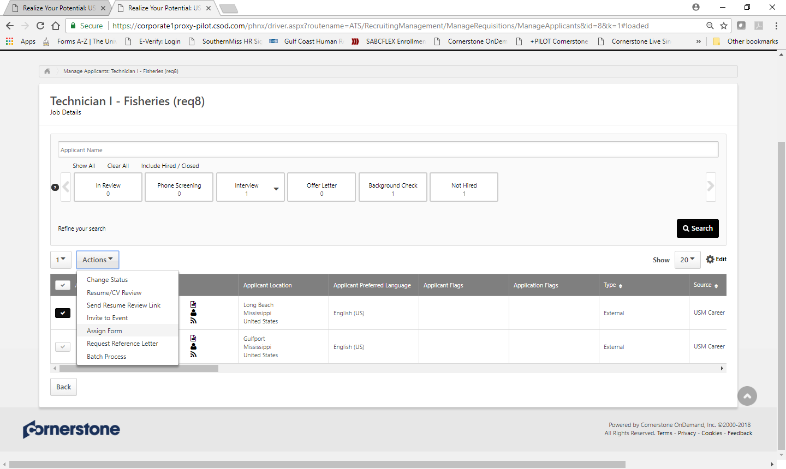

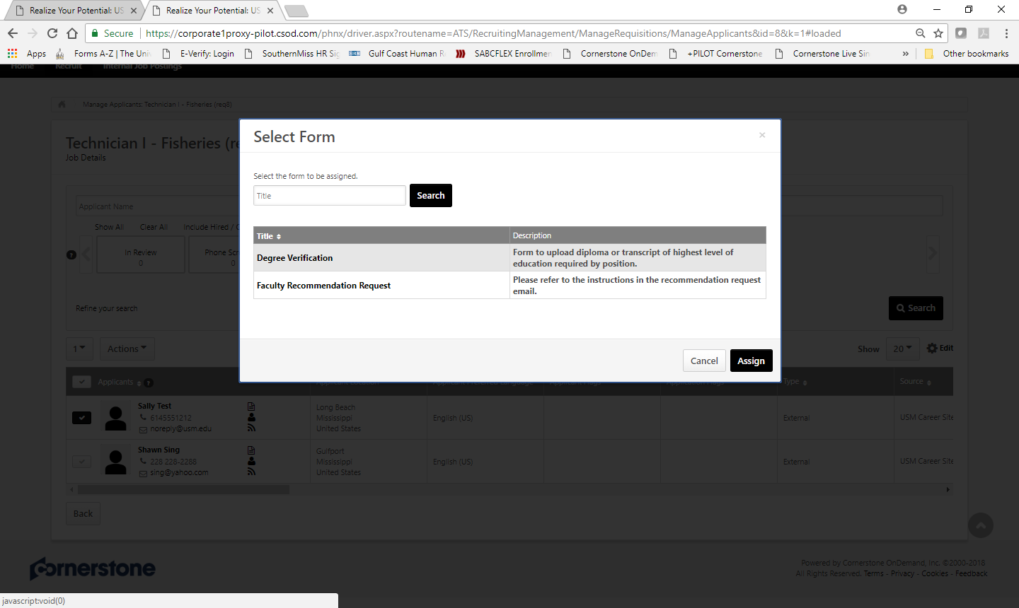

**Step 14:**  After these steps are completed your candidate should be completing the New Employee Forms with University Human Resources. Consult the Hiring Toolkit for additional process assistance. Once everything is cleared and the official start date is confirmed, please update the status of all applicants who were not selected giving them a final disposition in the ATS. The final step is to move your selected candidate to the status of “Hired”. This will close the requisition, once closed you will not be able to go back to edit candidates or take further action in this requisition.