# Faculty Recommendation Request Steps

**Step 1:** From the Manage Applicants screen, select the candidates you wish to receive the Faculty Recommendation Request task.

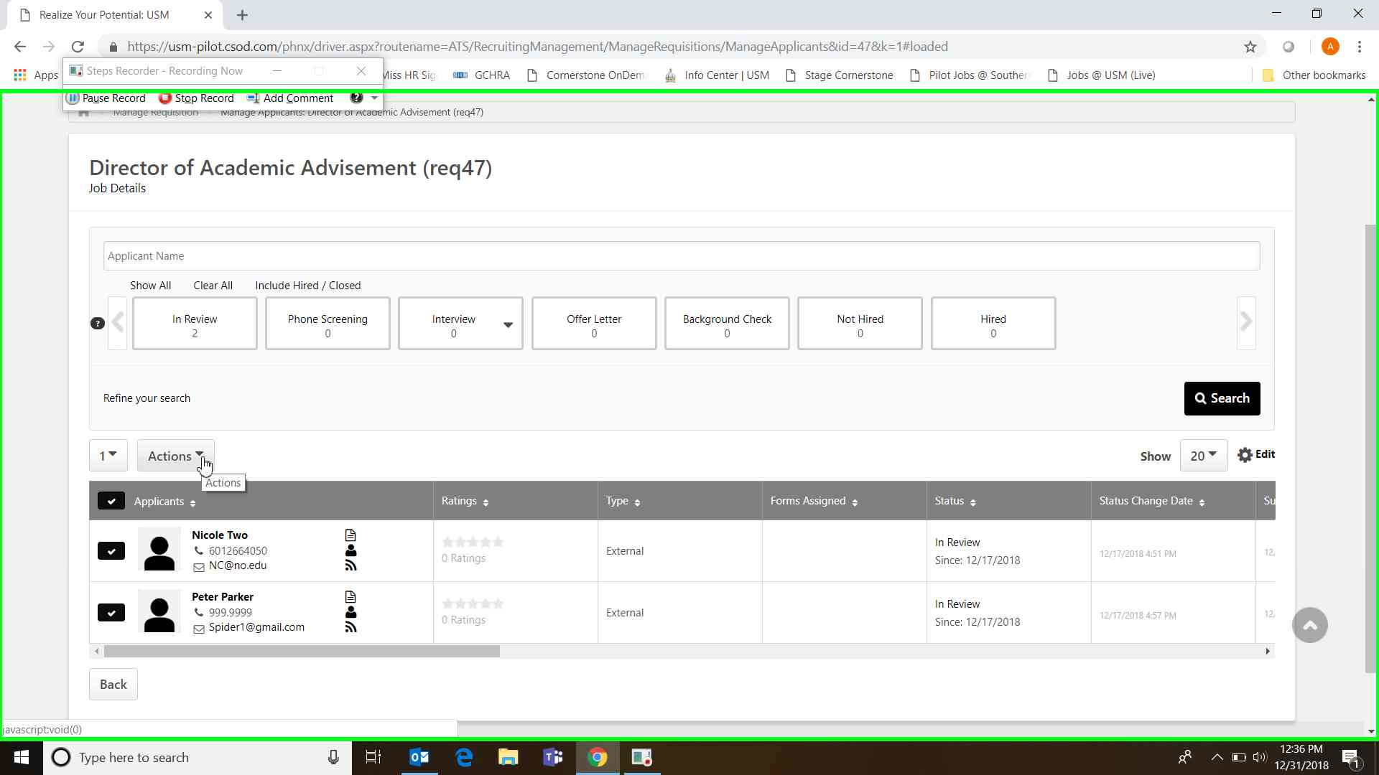

**Step 2:** Click on the Actions drop down menu and select Request Reference Letter.

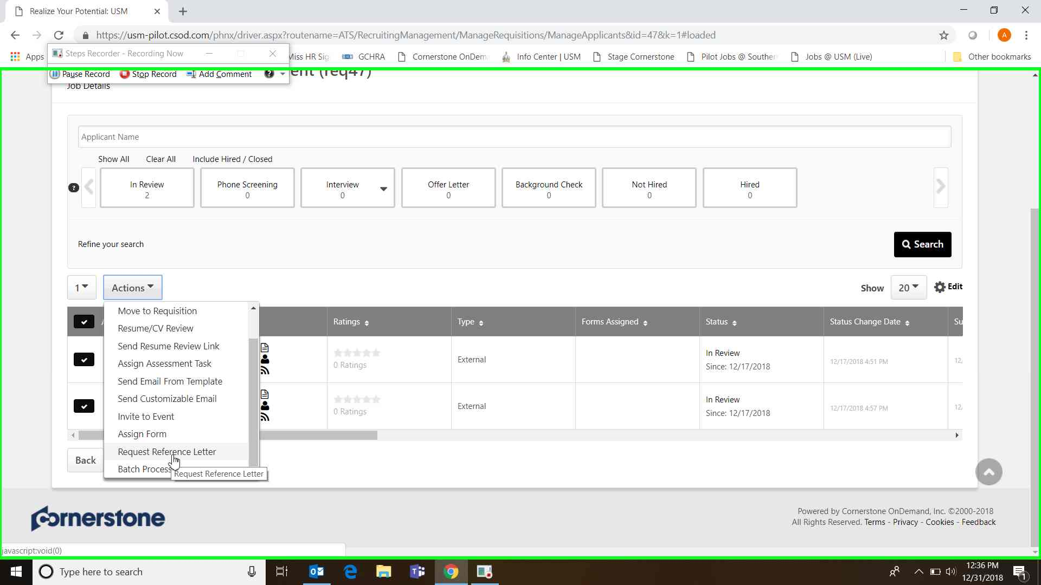

**Step 3:** Select the “Faculty Recommendation Request” form and then click Request References. You will then get a pop up telling you if your request was successful. This action triggers an email to the selected candidate(s) to enter their references’ contact information into the candidate portal. Once they enter their reference contact information, Cornerstone will send the reference writer an email asking them to upload a letter of recommendation. The requisition’s Hiring Manager and Reviewers will receive an email notification when letters are uploaded for each candidate. Email samples are included at the end of this document.

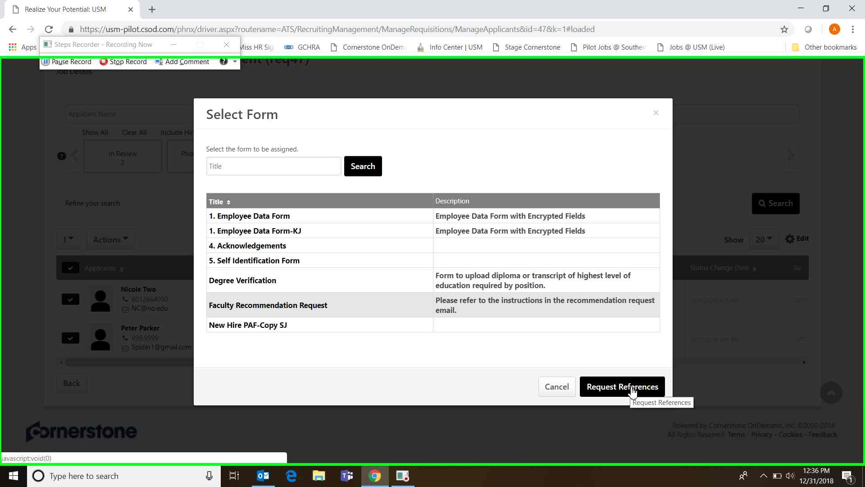

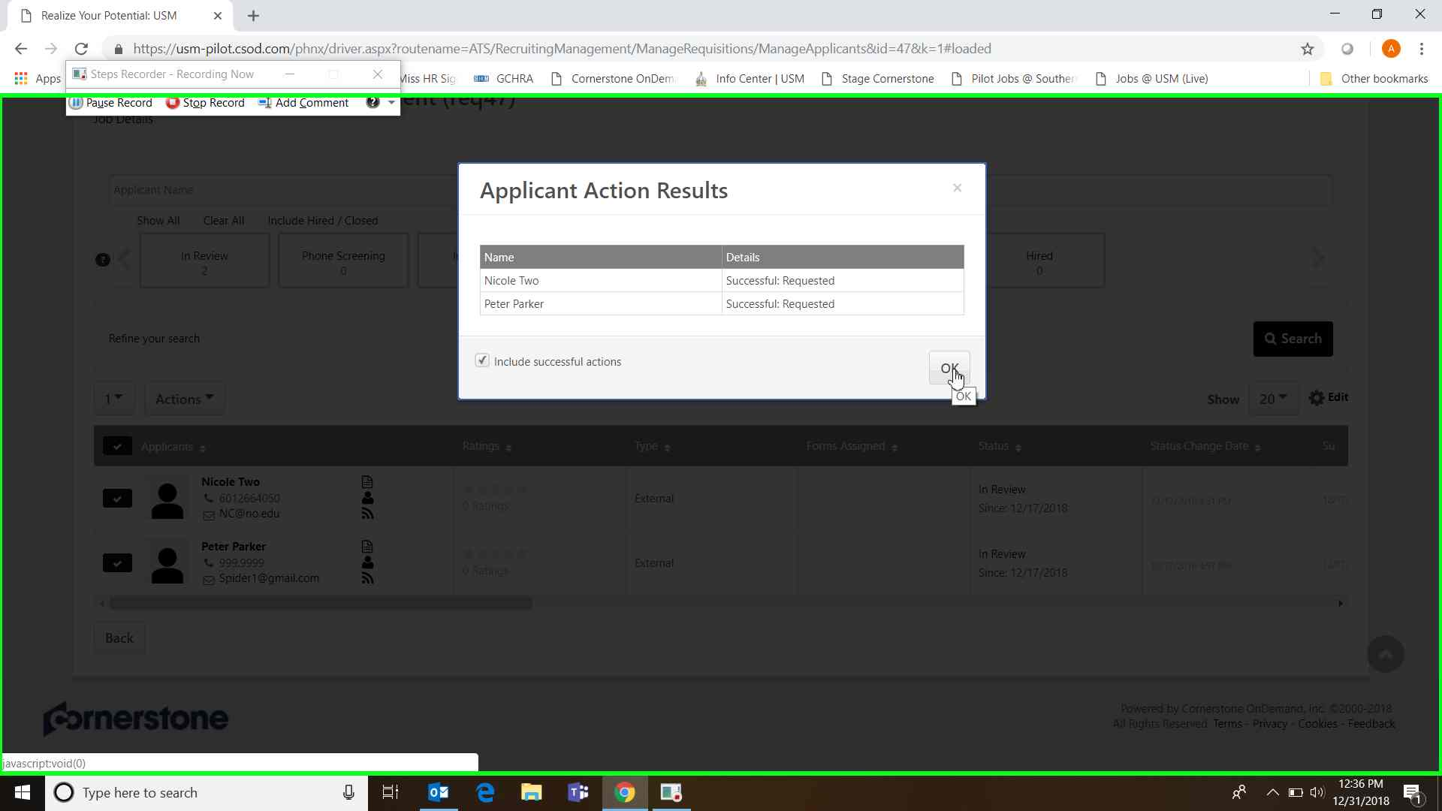

**Viewing Recommendation Letters in Cornerstone:**

Letters are stored in the candidate’s profile on the Documents tab under Reference Forms.

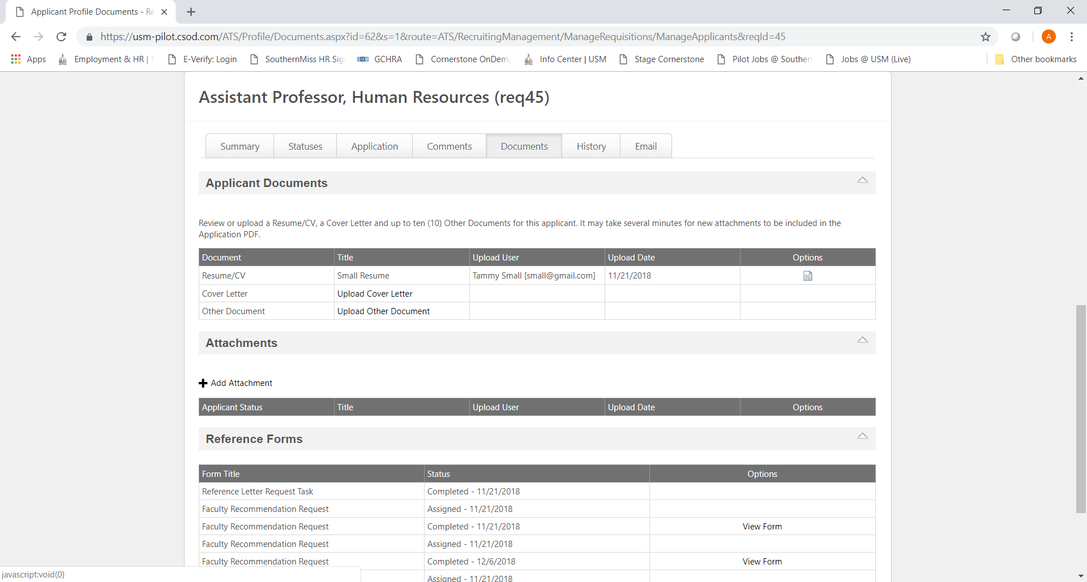

**Sample Email to applicants requesting reference contact information:**

Dear Nicole,

Please visit your applicant profile at USM Careers and complete the Reference Request Form to be considered for further review. Submit contact information for at least **three** references. **To add reference contact information, please click on the "+" symbol at the end of the reference fields (as pictured below).** Applicants should note that by submitting the information requested below you are waiving your right to view the recommendation letters submitted by these individuals.

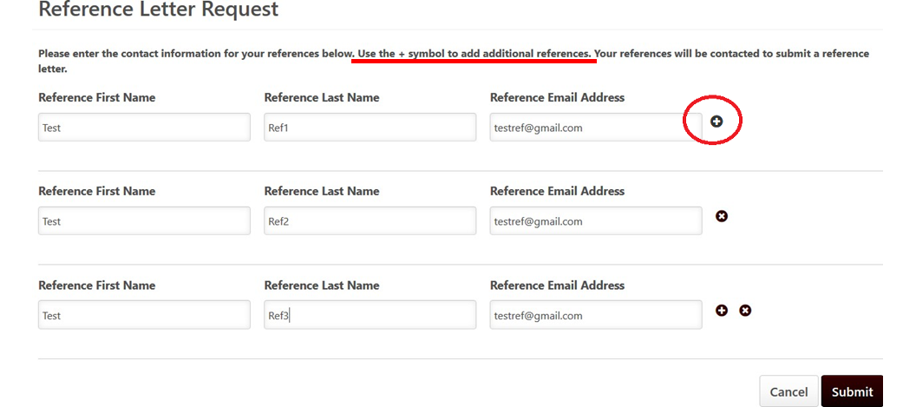

**Position:** Director of Academic Advisement

**Department/Reporting Unit:** Provost and Sr VP for Academic Affairs

**Requisition ID:** req47

Sincerely,

University HR

**Sample email sent to the Reference Writer after applicant provides the email address.**

Dear Quentisha:   
  
Jessica Simple, a candidate for a position at The University of Southern Mississippi, has indicated that you would be able to provide a letter of recommendation supporting his/her candidacy.  We ask that you please submit a frank assessment of the candidate’s professional standing, qualifications and experience. The information you provide will assist us in evaluating whether their accomplishments warrant appointment to the position detailed below.  This recommendation letter will be kept as a part of the candidate's confidential application materials and will not be shared with the candidate.

Please click on this link to complete the reference: Reference for Jessica Simple

<https://usm-pilot.csod.com/ats/landing/referencelanding.aspx?rfqs=%5e%5e%5e2GydbNmgxEPzGlZStaKzPQ%3d%3d>

We greatly appreciate your time and assistance is in this matter. If you have any questions, please email [jobs@usm.edu](mailto:jobs@usm.edu).

Thank you,  
  
University HR