Instructions:
Simply drag and drop the appropriate sign/symbol/number for your lab in the correct area on the publisher document. An example is below.
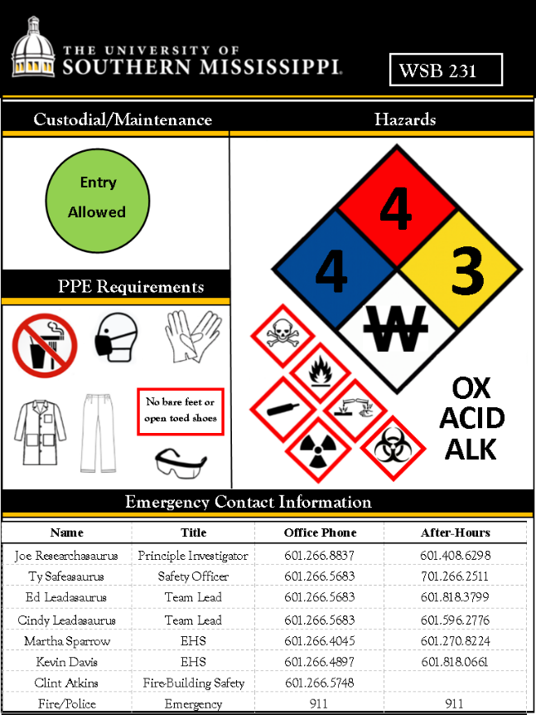

- Building name and room number
Type building abbreviation ( JST, WSB, PSRC, etc,..) and room number here

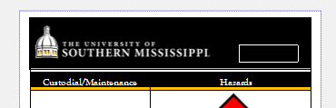

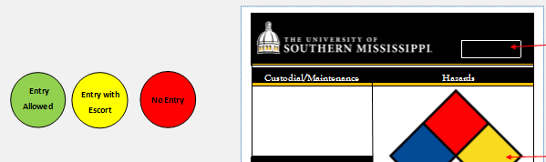
- Custodial/Maintenance

Drag Custodial/Maintenance entry circles here
Note: if you place the red “no entry” Custodial will not clean or empty trash in the lab

- NFPA/Hazards Instructions
The symbol denotes the total lab hazards so use the highest hazard symbols for each category
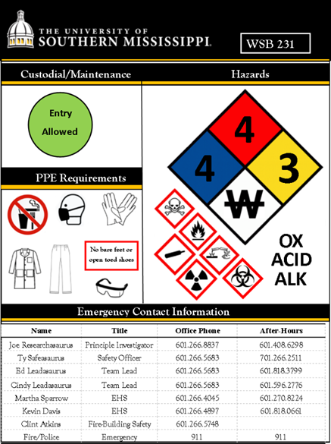
Use the numbers for the NFPA symbol (example below). This denotes the chemical hazards in your specific lab. See the provided list of chemicals (end of document) and their NFPA hazard rating to make this decision. Drag the appropriate hazard symbols for your lab to the area below the NFPA symbol

NFPA symbol

Hazard symbols

Some labs will have just a few symbols. In this case use the larger symbol size

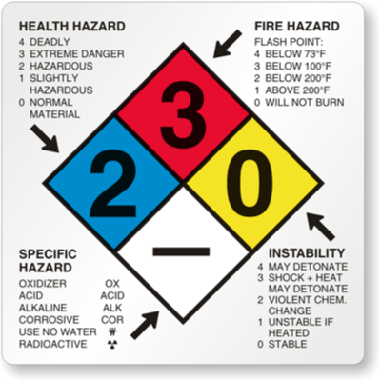
The diamond represents the total hazards so use the highest values for each hazard section
Red = flammability
Blue = health
Yellow = reactivity
White = special/specific hazards


An example: a lab that contained only acetone would look like the example below:
3
1
0

If the lab contained potassium cyanide:
0
3
0

A lab that had both Acetone and potassium cyanide would be:
3
3
0

NFPA Special/Specific Hazard symbols:
OX
Oxidizer
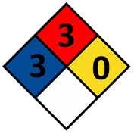
ALK
Alkaline
ACID

Acids

No water

Hazard symbols:
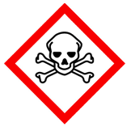
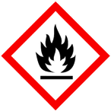
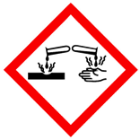
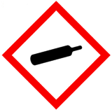

Toxic Flammable Corrosive Gas cylinders
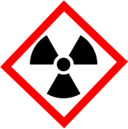
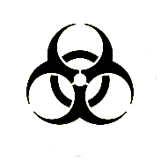

Radioactive Biohazard

- Personal Protection Equipment (PPE) requirements

Place PPE symbols here

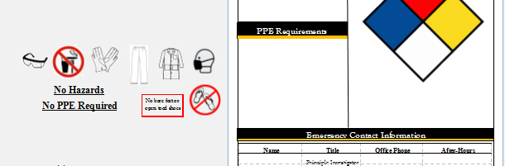

- Contact Information
Type in contact information for the PI, safety officer and any other relevant contact. At least one after hours contact for the specific lab should be included.

