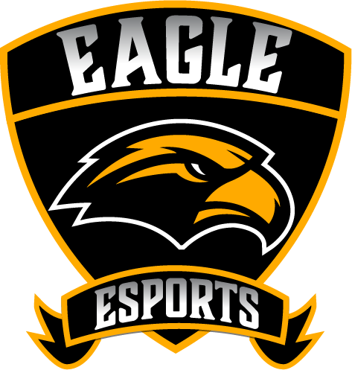 Communications and Promotion (c/p) Internship Opportunities
USM ESports invites students to apply for unpaid internships with the program to help develop their skill sets in a number of functional areas related to the esports industry and programmatic development. The responsibility outline for the c/p internship opportunities are as follows:

- Internship Responsibilities
  - Work alongside the Graduate Assistant of Marketing and Communications to perform daily tasks
    - Scheduling, posting social media posts
    - Gathering information for newsletters
    - Developing content ideas for livestream broadcasting
- Develop graphic overlays, player cards, and other graphic centric material for usage in presentations, social media, live broadcasts and any medium as needed.
  - Connect with team coaches for highlights, pictures, and information that should be broadcasted to the public.
  - When the production studio goes “live”; assist as capable with production

- Expectations
  - Five to ten hours a week

