CARES Act Emergency Financial Aid Grants (posted at usm.edu/covid-19-May 5, 2020)
• The University of Southern Mississippi will receive $6,753,021 in CARES Act funding designated for Emergency Financial Aid Grants for students. University officials are finalizing a process for distributing those funds directly to students, in consultation with the State Institutions of Higher Learning system office and the United States Department of Education. Although institutions have been given a one-year time frame to distribute all funds, USM’s goal is to distribute CARES Act funds as soon as possible.
- Students must meet eligibility requirements determined by the United States Department of Education and have a 2019-2020 Free Application for Federal StudentAid (FAFSA) on file to confirm eligibility for CARES emergency funds.

- Specific eligibility requirements and FAFSA filing instructions have been sent to students via email.

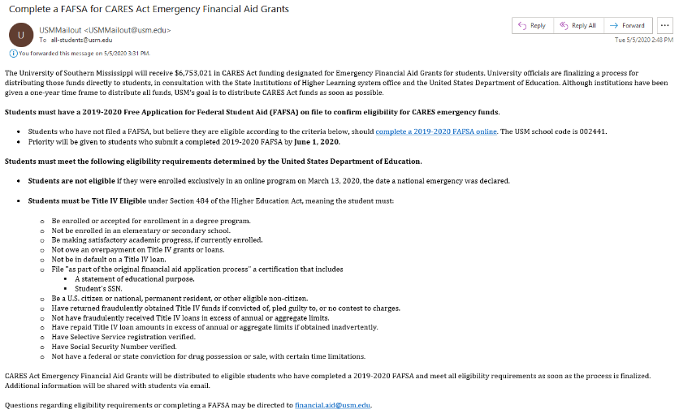
CARES Act Emergency Financial Aid Grants (posted at usm.edu/covid-19-May 8, 2020)
• The University of Southern Mississippi has finalized the process for distributing $6,753,021 in CARES Act funding designated for Emergency Financial Aid Grants for students.
- Students who believe they are eligible to receive CARES emergency funds must complete an online application to certify that they have incurred qualifying expenses related to the disruption of campus operations due to COVID-19, in accordance with United States Department of Education guidelines.
- Reminder: Students must also complete a 2019-2020 Free Application for Federal Student Aid (FAFSA) to confirm eligibility for CARES emergency funds.
- Specific application instructions and eligibility requirements have been sent to students via email.
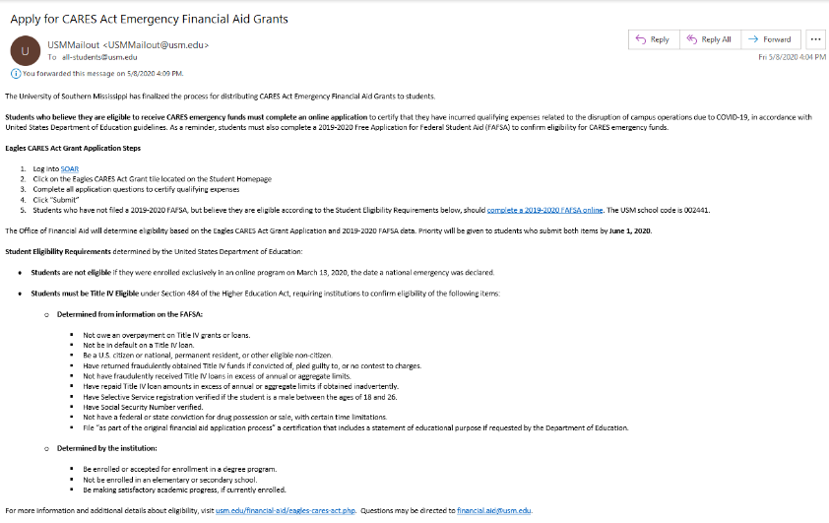
Eagles CARES Act webpage was published May 8, 2020
https://www.usm.edu/financial-aid/eagles-cares-act.php
