TYPE YOUR DOCUMENT TITLE INTO THIS TEXT BOX IN 12pt. TIMES NEW ROMAN ALL CAPS. REFER TO THE DOCUMENT GUIDELINES FOR ADDITIONAL FORMATTING INSTRUCTIONS

by

Click here to enter text.
A Choose an item.
Submitted to the Graduate School,
the College of Choose an item.
and the Choose an item. Choose an item.
at The University of Southern Mississippi
in Partial Fulfillment of the Requirements
for the Degree of Choose an item.
Committee:

Name of Committee Chair, Committee Chair
Name of Committee Member
Name of Committee Member
Name of Committee Member
Name of Committee Member
Name of Committee Member
Name of Committee Member

Choose an item.2025

COPYRIGHT BY
Click here to enter text.
2025
Published by the Graduate School



ABSTRACT
An abstract is a concise account of the thesis or dissertation and should state the problem, describe the procedure or method used, and summarize the conclusions reached. An abstract is required for all papers. Do not use any special symbol/characters that are not found on a standard keyboard (super- and subscripts are allowed). Abstract should start at page number ii.
Abstracts for dissertations and doctoral projects are limited to 350 words and for theses the Abstract is limited to 250 words.

ACKNOWLEDGMENTS
The Acknowledgments page is used to recognize any special contributors that helped make the work possible. This page includes a brief, sincere, professional acknowledgment of the assistance received from individuals, advisor, faculty, and/or the institution. Personal remarks should be limited to the optional Dedication page that follows, if the author chooses to include it.
The page number on this page follows the same style as that found on the Abstract and should be either “iii” or “iv,” depending on the length of the Abstract.

DEDICATION
As an optional page, the author may choose to add a Dedication page as a means to recognize individual people, groups, and/or organizations that supported/inspired the author. The Dedication immediately follows the Acknowledgments and continues page numbering. If the Dedication page is not used, delete the contents of this page including the section break.
DO NOT TYPE on the Table of Contents and list pages which follow. Instead, update the Table of Contents, List of Tables, and List of Illustrations after applying the appropriate styles to headings within your document. Chapter 4 of the document guidelines explains what role each style plays and how to update the fields for preliminary pages after applying styles.

TABLE OF CONTENTS
ABSTRACT ii
ACKNOWLEDGMENTS iii
DEDICATION iv
LIST OF TABLES vi
LIST OF ILLUSTRATIONS vii
LIST OF ABBREVIATIONS viii
CHAPTER I – INTRODUCTION 1
Example 1st level heading 1
Example 2nd level heading 1
Example 3rd level heading (in paragraph) 2
Example 4th level heading 2
CHAPTER II – UNIQUE PLACEHOLDER CHAPTER II TITLE 6
CHAPTER III – INDIVIDUAL PLACEHOLDER CHAPTER III TITLE 7
CHAPTER IV – UNIQUE PLACEHOLDER CHAPTER IV TITLE 8
CHAPTER V – PLACEHOLDER CHAPTER V TITLE 9
APPENDIX A – Placeholder Appendix Title 10
APPENDIX B – IRB Approval Letter 13
REFERENCES 14

LIST OF TABLES
Table 1 Example Table Title 3
Table A1. Appendix Table Title Example 10

LIST OF ILLUSTRATIONS
Figure 1. Example Figure Title. 4
Figure A1. Example Appendix Figure Title. 11

LIST OF ABBREVIATIONS
IRB Institutional Review Board
USM The University of Southern Mississippi
WCU William Carey University

This list must be manually typed in and cannot be updated like the lists above

- – INTRODUCTION
Margins throughout the document should be set at 1” top, 1” bottom, 1” left, and 1” right. Beginning on this page, the page numbering style changes from Roman numerals in the preliminary pages to Arabic numerals that should be placed 1” from the bottom of this page. This page should be page 1 and all the pages that follow should continue from that point through the last page of the document.

Example 1st level heading
Here I would begin writing or copy and pasting from another document the first paragraph of the first chapter of my dissertation. I would want to make sure that I applied the style “paragraphs” to this paragraph. Otherwise, if I accidentally applied the style “chapter title” or “1st level heading” then this paragraph would populate into my Table of Contents after updating, which I don’t want.

Example 2nd level heading
Here I would write a paragraph relevant to the second level heading – which should be relevant to the preceding first level heading, see Chapter 2 of the document guidelines for more information on headings – above this paragraph. Headings must be in sequential order and should not skip around. This means that I can have as many second level headings under a first level heading as I want, but I cannot skip from a first level heading to a third or fourth without a second level heading in between. I can return to a first level heading at any time.
When copy and pasting from another document, sometimes the line spacing defaults to include extra space between the lines, so I want to make sure that my line spacing throughout my entire document is 2.0 spaced with no extra lines between paragraphs. I do this by highlighting text, opening the paragraphs options (either by right clicking on text or opening it in the Home tab’s paragraphs section), going into line spacing options, then indents and spacing options, and setting spacing to 2.0 with 0 points of extra space before and after paragraphs.
Example 3rd level heading (in paragraph). Example paragraph with heading in line with paragraph. You must consistently punctuate and space headings, so if you add a period, colon, or dash after a third-level heading, all third level headings throughout the document must have the same punctuation.

Example 4th level heading
Tables must be formatted to fit within the 1” left, 1” right, 1” top, 1” bottom margins. Refer to the document guidelines for instructions to turn on the ruler to see the margins.
In order for table titles to populate in the List of Tables, you will need to highlight your table title and select “Table Title” style which is located under “Styles” in the Home Row. You will then need to update your List of Tables. See Chapter 4 of the Document Guidelines.
If your table is longer than one page, insert a “Table # (Continued).” for each additional page that the table goes over. The “Table # (Continued)” heading should be styled as “normal” and should not appear in your List of Tables. See the example below and refer to page 11 of the document guidelines for instructions.
            - Example Table Title

Table 1 (continued)
Note: Here is an example of table notes in the table note style. If the table has a note, and continues to a second page (or beyond) the note only appears at the end of the table. Do not place the note at the end of each section of the table. The table notes should be formatted according to your style guide and are used to explain the table above or discuss information that is too detailed to include in the title or table.
See below for an example of a figure. In order for your figure to populate in the List of Illustrations you will need to highlight the figure title and select the “Figure Title Style.” You will then need to update your List of Illustrations. Figures must be within the 1” left, 1” right, 1” top, and 1” bottom margins.
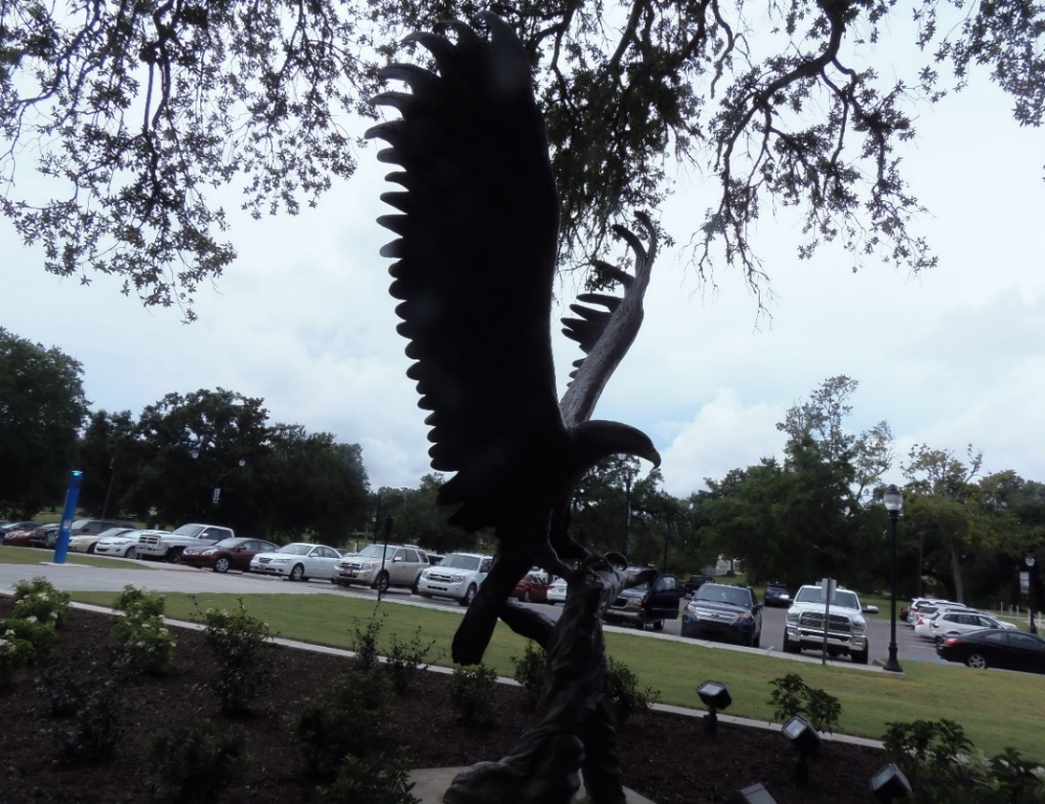
              - Example Figure Title.
Use Figure notes to explain what the figure is, add a citation for work that is not your own, etc. Figures are used for Photos, Figures, Graphs, etc. (Lofty Return, USM Gulf Park, photography by Jeanne Stewart, 2015).

Sample landscape page. If your tables, figures, etc. do not fit within the portrait size designated by the template, you will need to landscape it. See page 13 of the Guidelines and/or Instructions page for more information on Landscaped pages.
If landscaped pages are not used, delete the contents of this page including the section break. If landscaped pages need to be inserted elsewhere, copy this page and insert where needed.

- – UNIQUE PLACEHOLDER CHAPTER II TITLE
The template is set up with five chapters. If you do not require five chapters, then delete the extra chapters. If you need more than five, it is best to insert the additional chapter(s) between the current Chapter IV and V. Insert a “section break (next page)” and then at the top of the new page use the Chapter style to create a new chapter heading. Each chapter should begin on a new page.
To insert an additional chapter(s) in this template follow these steps:
- Place your cursor between the last line of the content of this chapter and the “section break (next page).”
- Click on “Page Layout”
- Click on “Section Break (next page).”
- Place your cursor at the top of the new page created by the last step and then click on “Chapter” in the style ribbon.
- The last step will insert the new Chapter heading with the appropriate chapter number and will renumber the chapter that follows to correspond with this change.
- After CHAPTER V (or VI, etc.) – insert an “en dash” (CTRL+MINUS SIGN) and the new chapter title (in all caps. Match the spacing shown at the top of the previous page (in the pre-built chapter)

- – INDIVIDUAL PLACEHOLDER CHAPTER III TITLE
Begin a new chapter here.

- – UNIQUE PLACEHOLDER CHAPTER IV TITLE
Begin a new chapter here.

- – PLACEHOLDER CHAPTER V TITLE
Begin a new chapter here.

- – Placeholder Appendix Title
Tables, figures, etc. in the Appendix will need to have the “Appendix style” applied to it. See USM Guidelines for more details. If you had to have IRB/IACUC approval, your letter must be put into the appendix. Also, you should place any permissions that you had to obtain in the appendix. Delete Appendix if this section is not required.
- Appendix Table Title Example

Table A1 (continued)


- Example Appendix Figure Title.

To insert an additional appendix/appendices in this template follow these steps:
- Place your cursor between the last line of the content of this appendix and the “section break (next page).”
- Click on “Page Layout”
- Click on “Section Break (next page).”
- Place your cursor at the top of the new page created by the last step and then click on “APPENDIX” in the style ribbon.
- The last step will insert the new APPENDIX heading with the appropriate letter and will reletter the appendix that follows to correspond with this change.
- After APPENDIX A (or B, etc.) – insert an “en dash” (CTRL+MINUS SIGN) and the new appendix title. Match the spacing shown at the top of the previous page (in the pre-built Appendix)

- – IRB Approval Letter
(Remove if not required)

REFERENCES
Example reference. Change heading to Bibliography or Works Cited, depending
on your chosen style manual.
If using a citation manager you should be able to copy and paste all of your references here as a group. If the references were typed manually, it is better to copy/paste them onto this page in groups of 3-6. This will help to preserve the formatting of your references.
If you are placing the references at the end of each chapter, delete this page Highlight the heading through the section break (next page) and then click on delete. At the end of each chapter, use a first level heading and type the word References.

