Formatting Page numbers on landscape pages in Microsoft Word (v 16.54) on MacOS

These instructions are for formatting theses/dissertations which have both portrait and landscape pages, with page numbers that must be oriented the same direction.

Resources:
https://libguides.lib.fit.edu/formattingyourthesisanddissertationtoolstipstroubleshooting/wordformaclandscapepagenumbers

https://answers.microsoft.com/en-us/msoffice/forum/all/rotate-page-numbers-in-word-for-mac/32663632-9410-4e1c-9a7d-481a589c68c0

1. Insert page numbers as usual for whole document (bottom, center). Make sure text font and size matches rest of document (12 pt Times New Roman).

2. On landscape pages, open the footer (“View” dropdown menu, then select “Header and Footer”). Under the Header & Footer tab, deselect “Link to Previous”. On the landscape page, change the font color to white- this will also change every page number below this page to white, so find the next portrait page, highlight the white page number, deselect “Link to Previous”, and change font color to black.

3. Back on the landscape page: Click “Insert” tab, then “Text Box”, then “Draw Vertical Text Box”. Type in the number, center it, and change the text to the appropriate font, size, color (Times New Roman, 12 pt, black). Under the “Shape Format” tab, set the “Shape Outline” to “No Outline”, and make the size of the text box 0.38” x 0.38”.

4. To get the page number centered vertically on the page within the required margins for landscape pages (Top: 1”, Bottom: 1”, Left: 1”, Right: 1”): select text box, click on the “Layout” tab, then “Position”, then “More Layout Options…”. Set parameters as below:

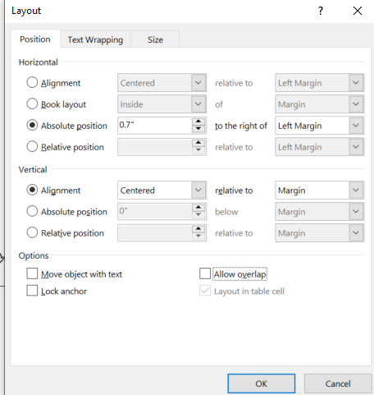

At this point, you should have the page number set correctly for the landscape page you are currently on. To save a lot of time for additional landscape pages, follow additional steps below.

5. Select vertical text box with page number. Click “Insert” dropdown menu, then “AutoText”, then “New…”. A popup box as below should come up; you can assign a name if you’d like:


6. To add the vertical page number for any additional landscape pages, just go to “Insert”, then “AutoText”, then “AutoText…”, search for whatever you named the entry (“Landscape Page Number”), click “Insert”, and it will automatically insert the vertical text box for the page number with all the correct settings for your document. All you should have to do is type in the correct page number.

