Binding:
USM no longer requires dissertations, theses, or doctoral projects to be bound, nor does USM bind dissertations, theses, or doctoral projects on campus. However, we suggest using either Thesis on Demand or ProQuest if students would like to bind their projects individually. USM is not affiliated with these sites, but we find that these are good quality options for bound copies! Each site has a price list on their website with a variety of prices based on the services you choose (e.g. color versus black and white, type of binding, etc.). You can also search the internet for dissertation binding services if you would like a wider variety of options and prices.

Example of Thesis on Demand’s Quick Calculator of Printing Costs:
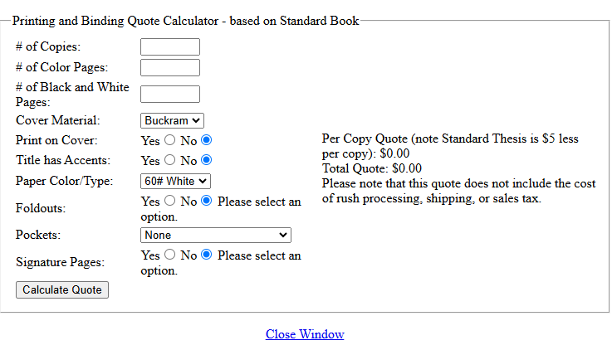

Example of ProQuest Quote of Printing Costs:
