Copyright:
The United States Copyright Office defines copyright as "a form of protection grounded in the U.S. Constitution and granted by law for original works of authorship fixed in a tangible medium of expression. Copyright covers both published and unpublished works" (Retrieved from Copyright.gov). The Copyright Act of 1976 is the law governing United States copyright. The law has been amended since 1976, refining the scope of the act. USM libraries provides an overview of the law’s basics and protections at https://libguides.lib.usm.edu/copyright/basics.

By publishing in Aquila and/or ProQuest, your document is copyrighted as your intellectual property. You can see this copyright on your Aquila submission form.
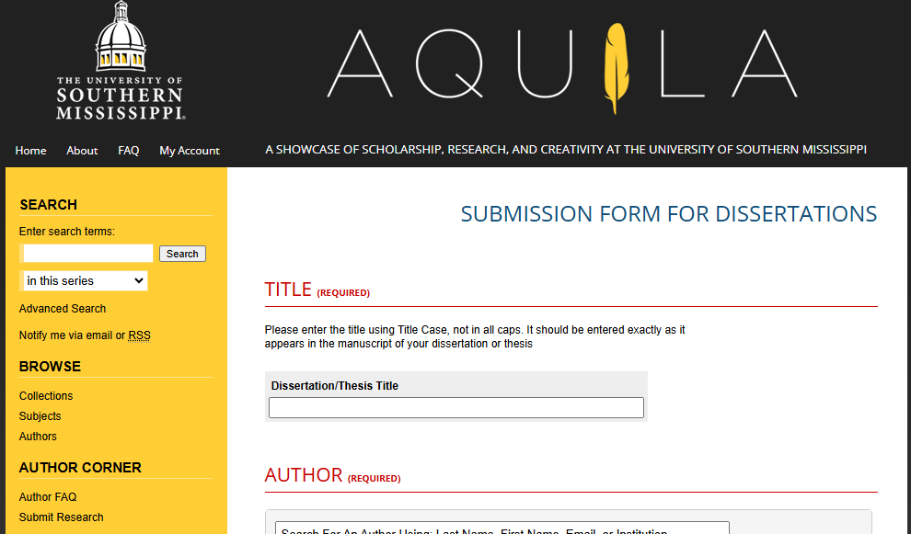

However, students might choose to file for additional copyright protections on their work. The Graduate School does not file for this copyright on behalf of students or cover fees. Copyright can be filed directly with the U.S. Copyright office at https://www.copyright.gov/, or ProQuest offers services to file on behalf of students.

Students choosing to publish and register their copyright in ProQuest will need to create an account on ProQuest in order to do so. Go to USM’s ProQuest webpage or read the “Submitting to ProQuest” instructional document for more information on how to submit to ProQuest.

There is a tab labeled “Register U.S. Copyright” in the “submission and payment” section near the end of ProQuest submission process. Under “Register U.S. Copyright," you will be provided information regarding copyright protection and registering your copyright.
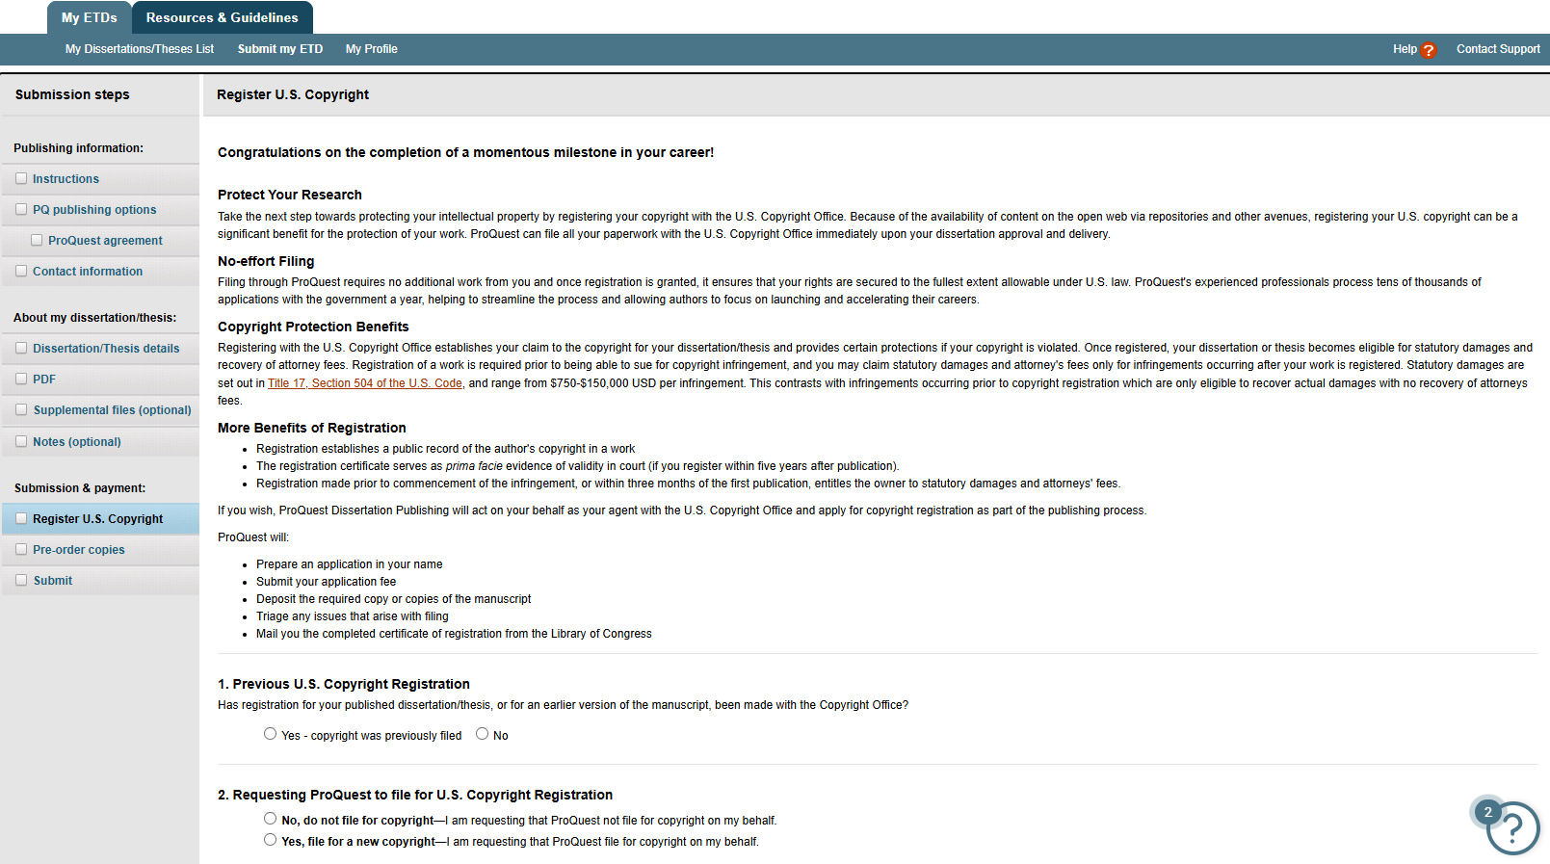
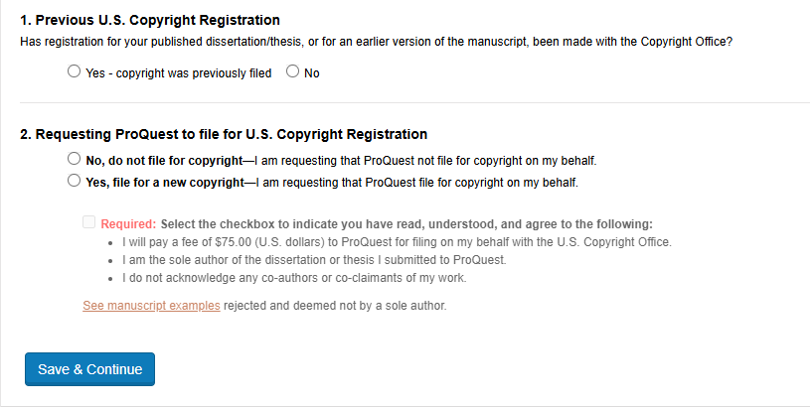

Additional information, including about your existing copyright and why registering your copyright might or might not benefit you, can be found on the FAQs page, as well as on the “Resources and Guidelines” page. That information includes the following:
What are my copyright options on ProQuest?
- Copyright and Your Dissertation or Thesis: Ownership, Fair Use, and Your Rights and Responsibilities
- Why register your Copyright
- Copyright and ProQuest

Binding:
Bind Personal Copies
USM does not offer binding services for this any longer, but we suggest using either Thesis on Demand or ProQuest. USM is not affiliated with these sites, but we find that these are your best options for bound copies! Each site has a price list on their website with a variety of prices based on the services you choose (e.g. color versus black and white, type of binding, etc.).

  - The Graduate School does not require a bound copy. The Graduate School used Thesis on Demand when we required bound copies. The quality was always good, so we usually recommend them. You can also search the internet if you would like a wider variety of options and prices.
  - As for bound copies, USM does not actually offer any services for this, but we do suggest either using Thesis on Demand or ProQuest if you are seeking these services. I will link their websites below if you are interested. USM is not affiliated with these sites, but we find that these are your best options for bound copies!
USM does not offer binding services any longer, but we suggest either Thesis on Demand or ProQuest. USM is not affiliated with these sites, but we find that these are your best options for bound copies! When we did print copies of dissertations, we used to use Thesis on Demand, and found the quality to be good.

