How to insert a landscaped page using PC:
- Add a Section Break on the portrait-oriented page before and after the page you want to landscape
  - Put your cursor at the end of the page before the page you want to landscape.
  - In the “Home” tab’s “Paragraph” section, turn on your paragraph marks
  - Open “Layout” in the menu bar. Select “Breaks”.
  - From the “Breaks” dropdown menu, select “Next Page”
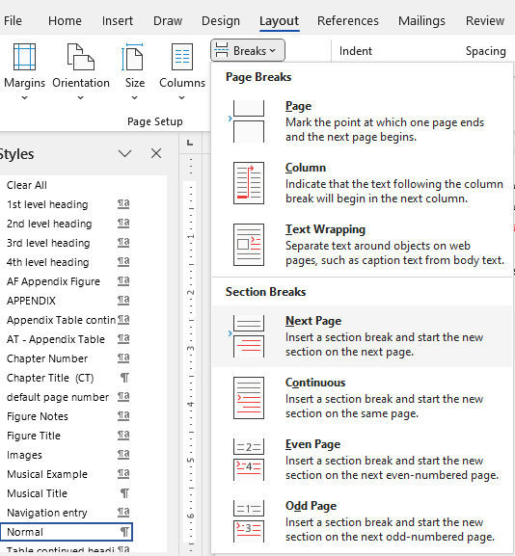
  - Repeat steps C and D to insert another section break at the end of the landscaped page. (This will allow you to change the orientation of just the section you want, and to have page numbers in different margins).

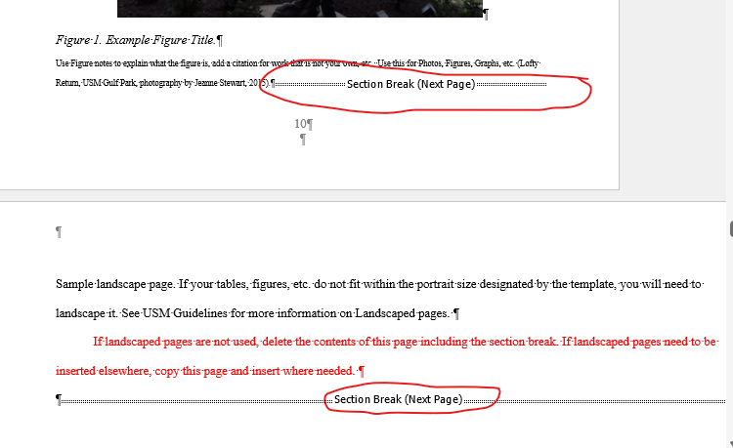
landscape-oriented page
Portrait-oriented page
  - Next, deselect “Link to previous” in both the Header and the Footer on the landscaped page(s) and the page after the landscaped page(s).
  - In the landscaped page(s) you will want to move the page number from the bottom margin to the left margin. To do so, you will first delete the page number.
  - To format page numbers for a landscaped page, select “Insert” > “Page number” from the main menu. From the dropdown menu, select “page margins” and then “vertical, left.” This will create a text box with the page number inside.
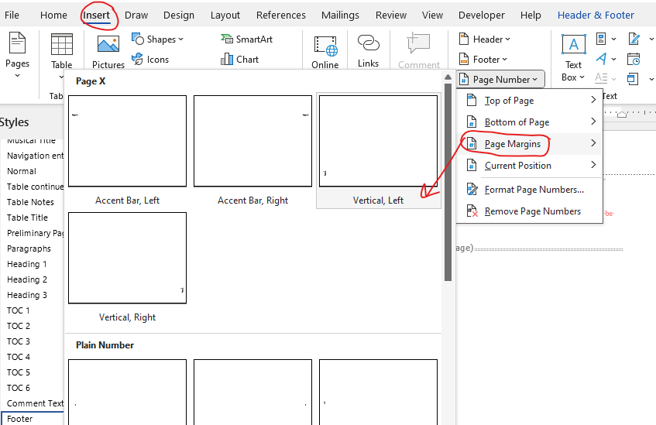
  - Next, select the page number and make the font uniform at 12pt Times New Roman. If it doesn’t automatically, adjust the text box to only be as large as the page number.
  - Then, click the text box and select “format shape.” Select the following:
    - Vertical Alignment: Center
    - Text direction: If the text is facing inward, select “rotate all text 90 degrees” so that the page numbers face outward.
    - Deselect “wrap text in shape”
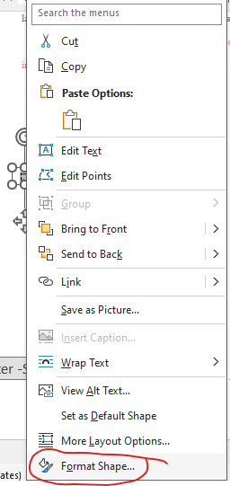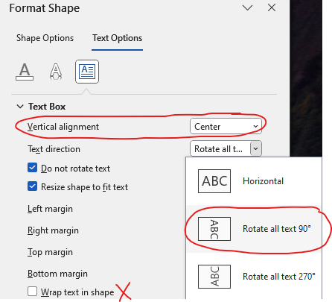
  - Select “More Layout Options” and set
    - the horizontal absolute position to just outside of the left margin (e.g if left margin is one inch set Absolute position at 0.7” to the right of the Left Margin if left margin is)
    - the vertical alignment at centered relative to the margin
    - Deselect “Allow Overlap” and select “OK”

