Publishing on ProQuest

The option to submit to ProQuest is available for both master’s and doctoral students. You can sign up and upload your document on USM’s ProQuest webpage: https://www.proquest.com/.
You will want to wait until after your document has been approved by your committee and the Graduate School (i.e. for Aquila approval) before you submit to ProQuest. There is a free and paid option - you can choose which one best suits your needs. See example price charts below. Note that the Graduate School does not cover any of the fees or handle ProQuest submission on behalf of students, but the Document Specialist will review and approve your document for publication on ProQuest. Below are screenshots of what that submission process looks like. At the end of this document are Frequently Asked Questions with links to the answers.

To Submit to ProQuest, follow the below steps.
*Note that steps 1-3 may differ depending on whether you have previously set up your ProQuest account

- When you follow the link to sign up and upload your document on USM’s ProQuest webpage: https://www.etdadmin.com/main/home?siteId=313 you will see a screen that looks like this:
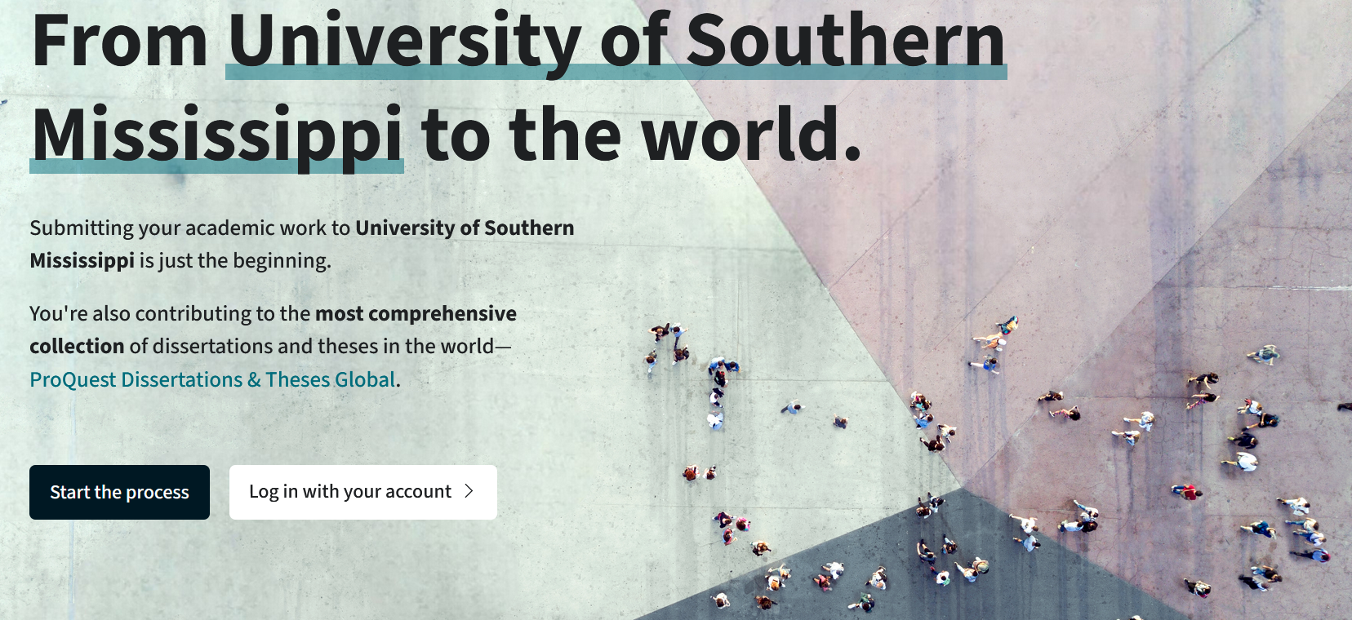

- Select “Start the Process” to create a new account, or “Log in with your account” if you have used ProQuest before.

- When you “Start the Process” you will be asked for your name, email, and a password. Once you enter your information, select “Create Account”
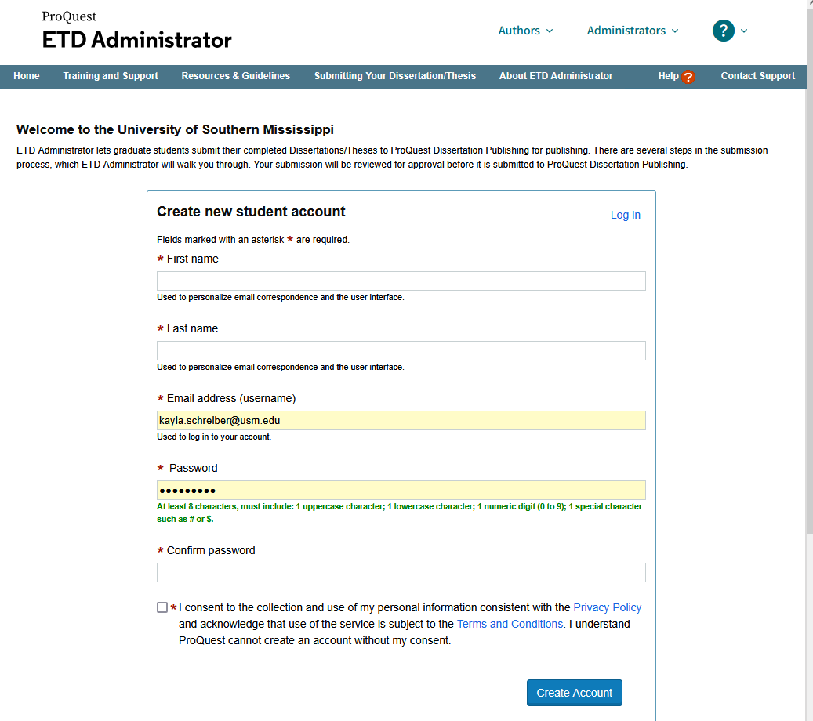

Note: After creating your account, if you ever log out and back in, you will select “Continue the Process”

- Once you log in, your account will look like this. Under the “Instructions” tab in the lefthand menu, ProQuest will provide an overview of the process
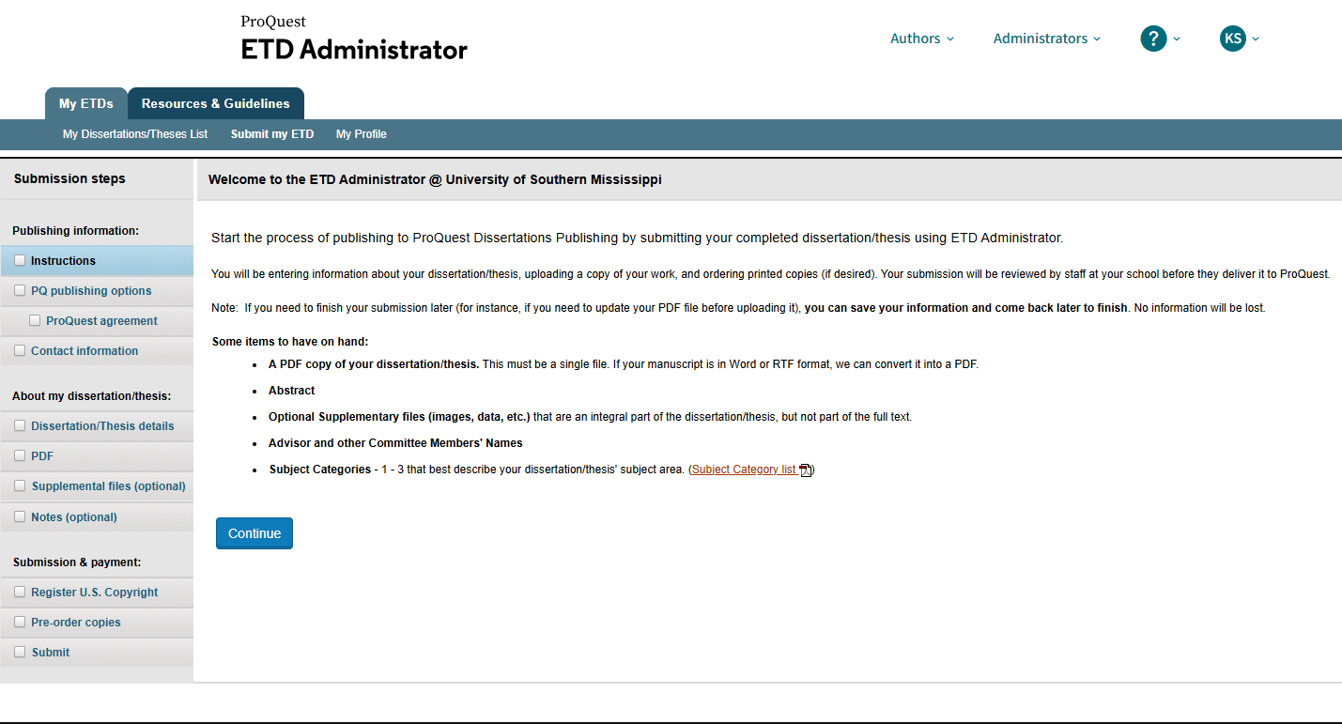

- Under “PQ publishing options” you will choose whether you want to publish traditionally or open access. Under FAQs, you can read more about the difference between these two publication options. There is also additional information about royalties, copyright protections, etc. under the “Resources & Guidelines” tab at the top of your ProQuest screen
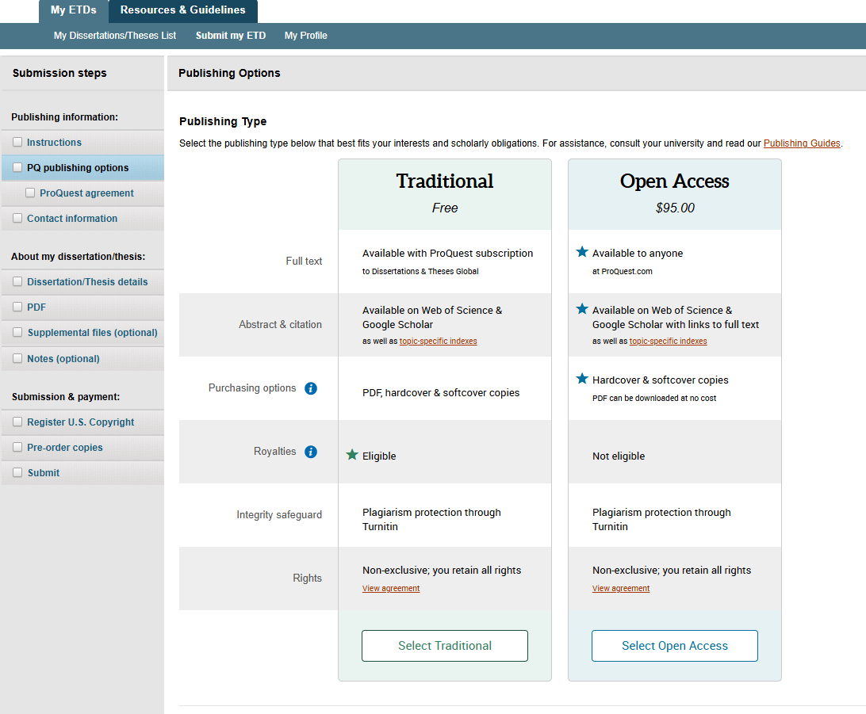

- On the “contact information” section, you will fill in the boxes with the appropriate information.
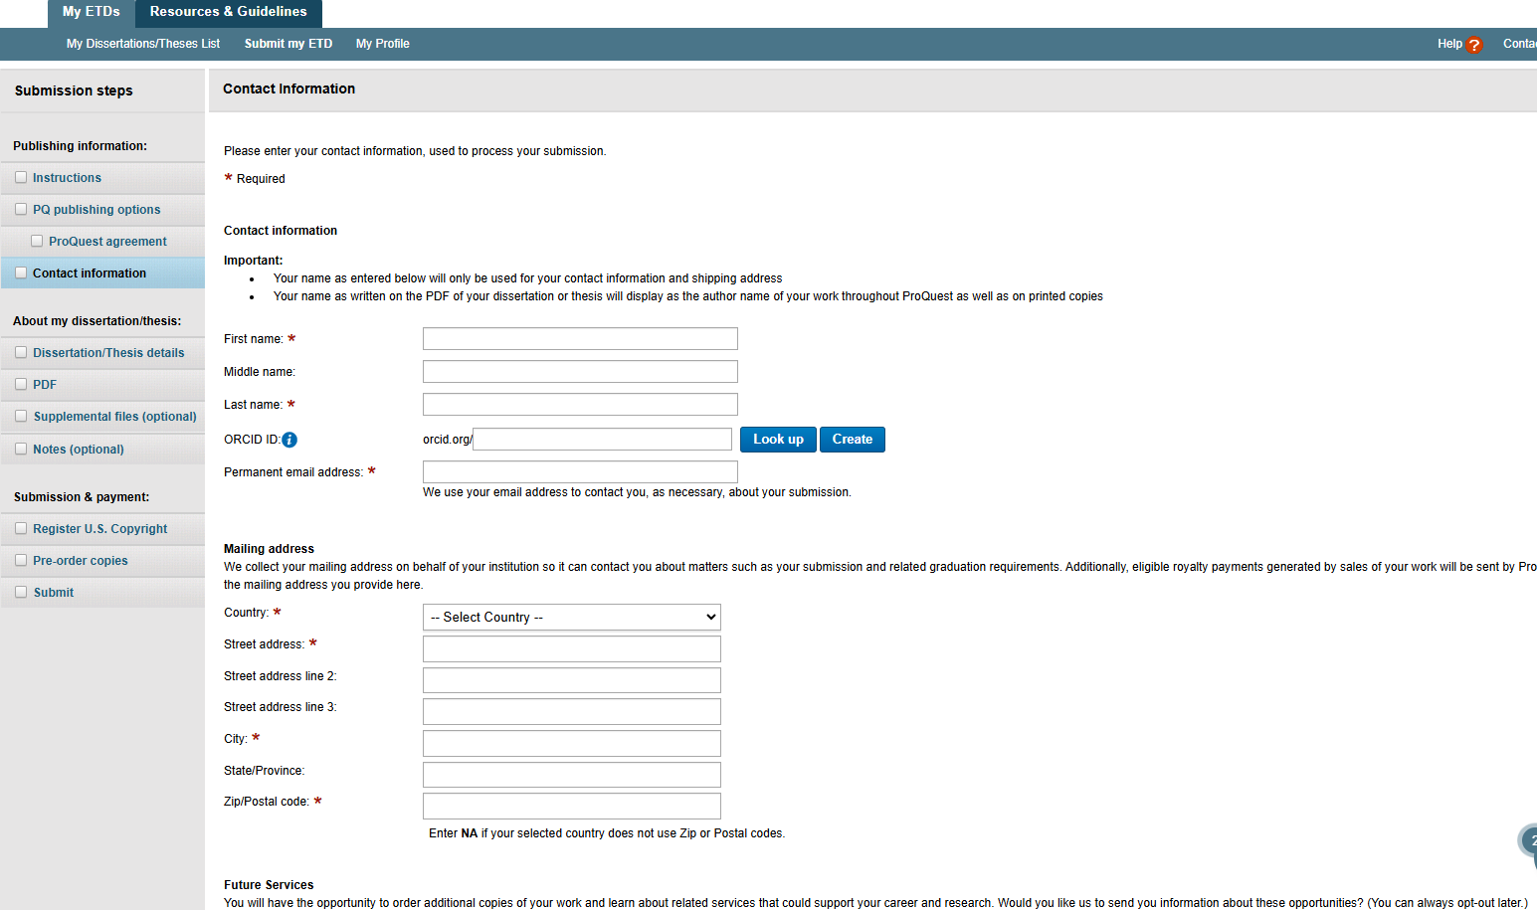
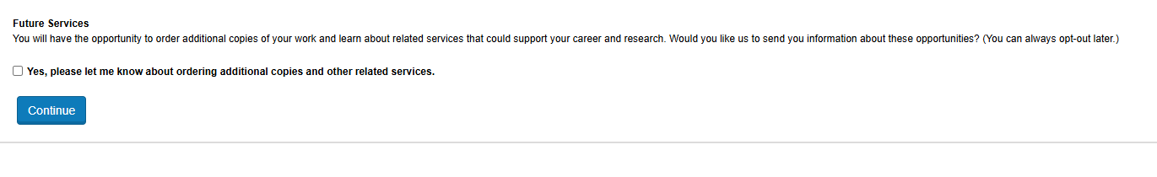

- Under “Dissertation/Thesis Details” you will fill in the boxes with the appropriate information about your Dissertation or thesis, just as you did on the Aquila submission form. Use the Aquila submission form as your guide for this.
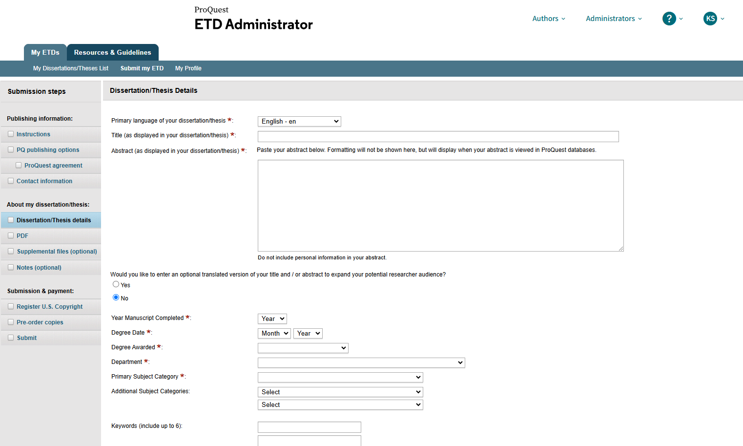
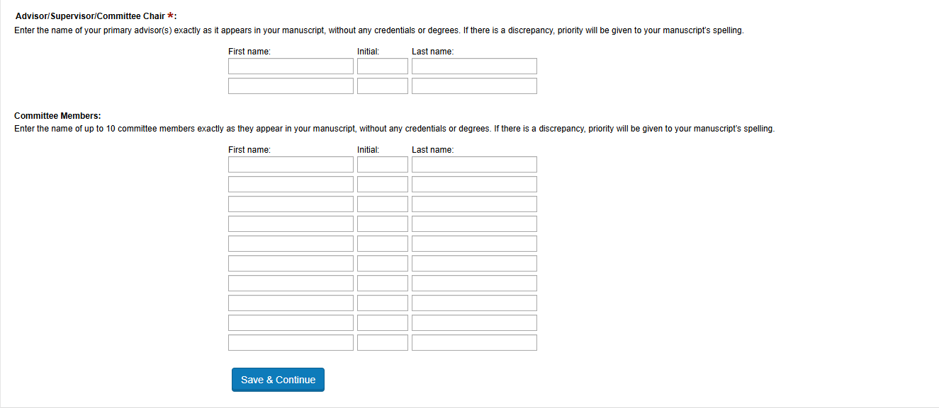

- For the “PDF” section, simply upload a PDF copy of your thesis, dissertation, or doctoral project, then check the appropriate box.
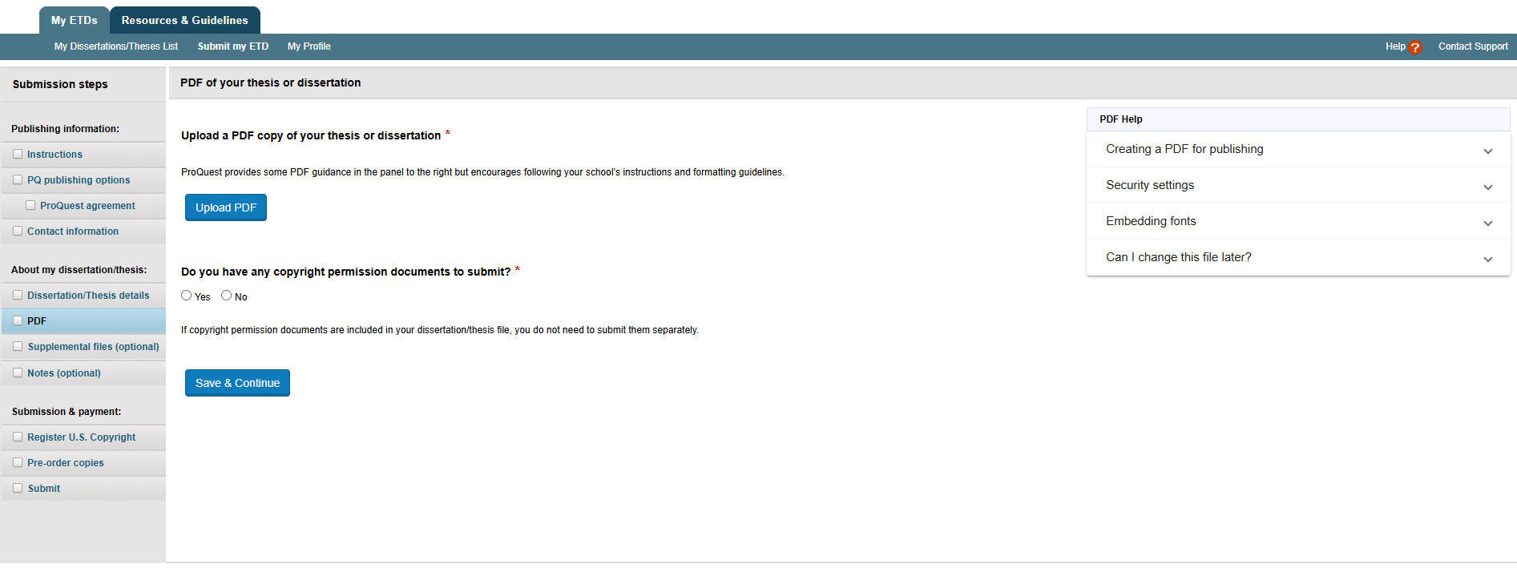

- The “supplemental files” section is optional. Supplemental files might include graphs or data that were kept in a separate file from your dissertation/thesis due to size limitations. If you do not have supplemental files, you can skip this section.
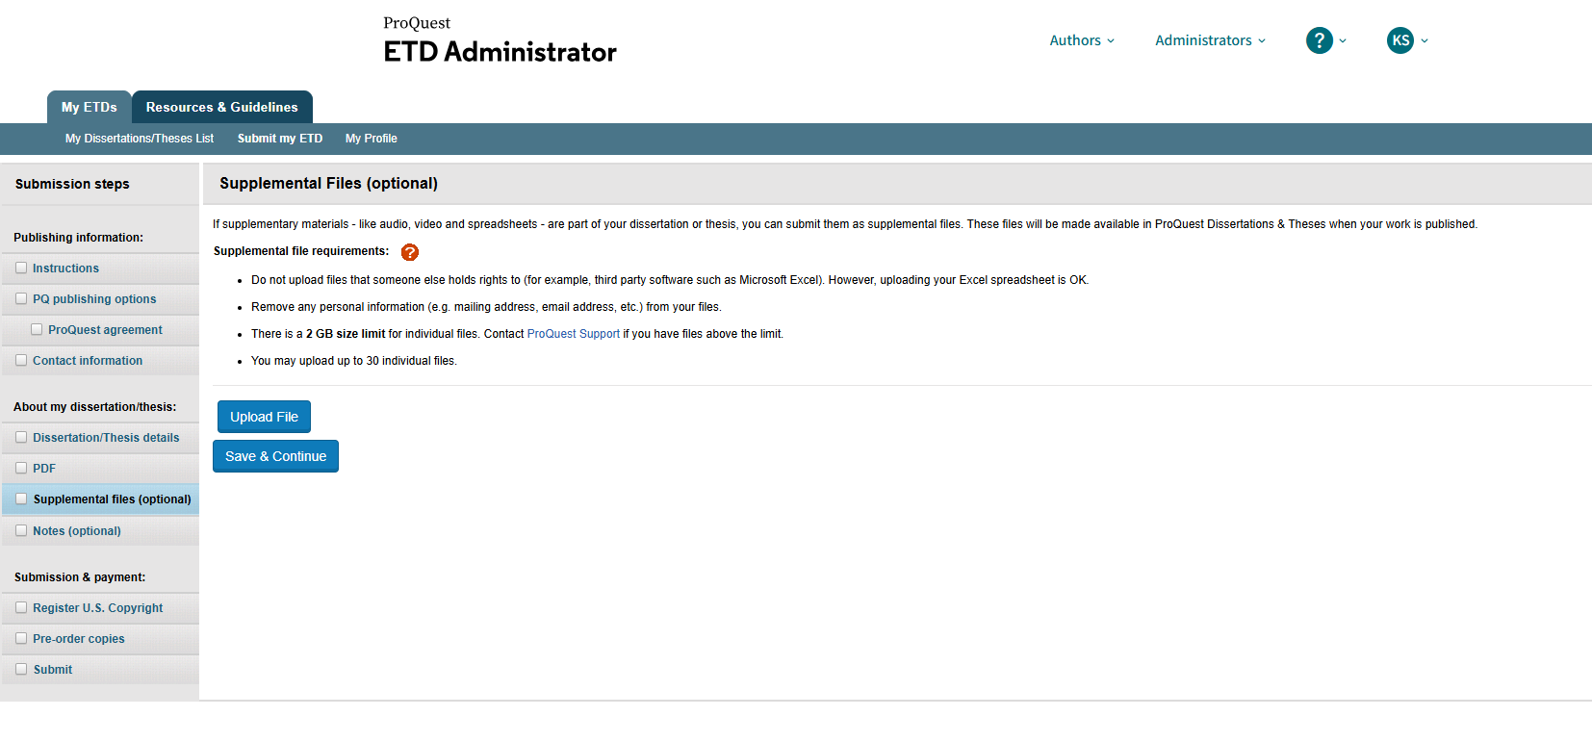

- Under “Register U.S. Copyright,” you will be provided information regarding copyright protection and registering your copyright. Additional information, including about your existing copyright and why registering your copyright might or might not benefit you, can be found on the FAQs page, as well as on the “Resources and Guidelines” page.
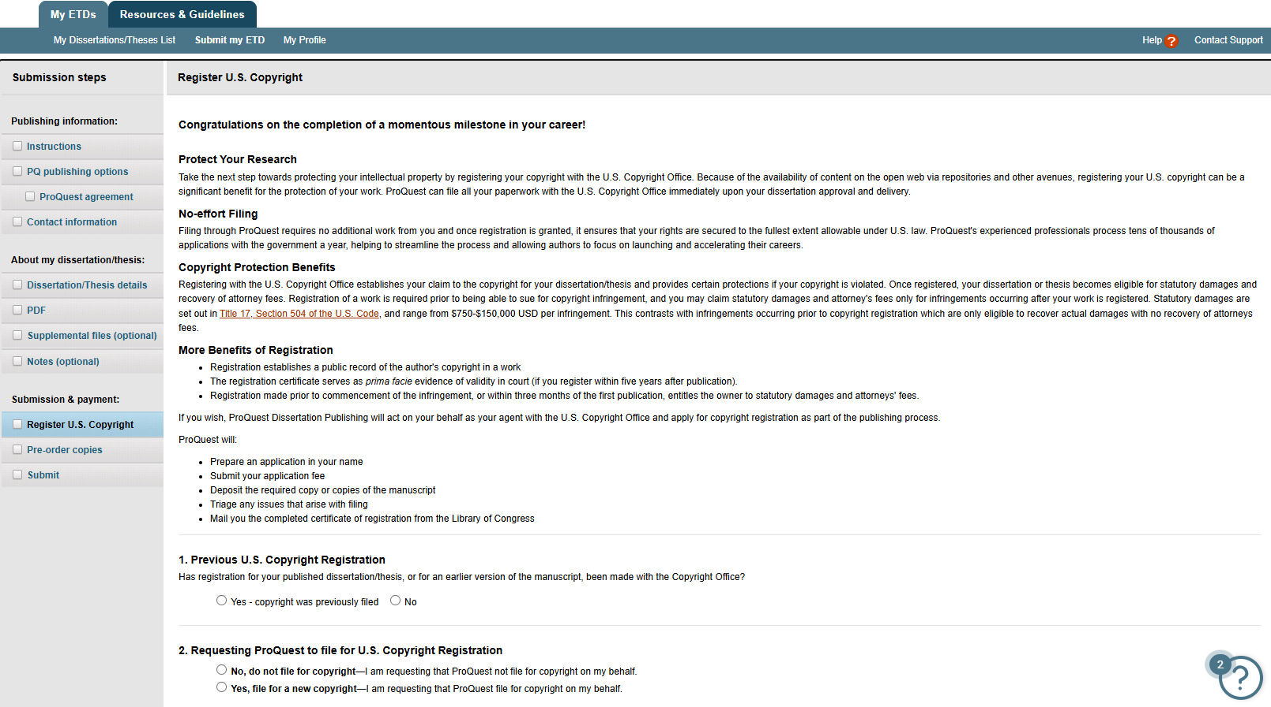
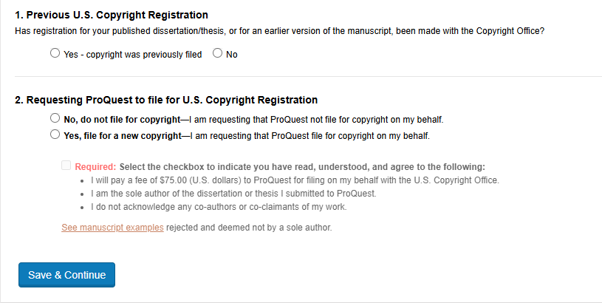

- Under “Pre-order copies” students have the option to order physical copies of their dissertation, thesis, or doctoral project. There are many different options available, including different covers, papers, sizes, inks, etc.
Note that if you wish to purchase hard copies elsewhere, you can compare these services with those available via Thesis on Demand and other services you can find online.
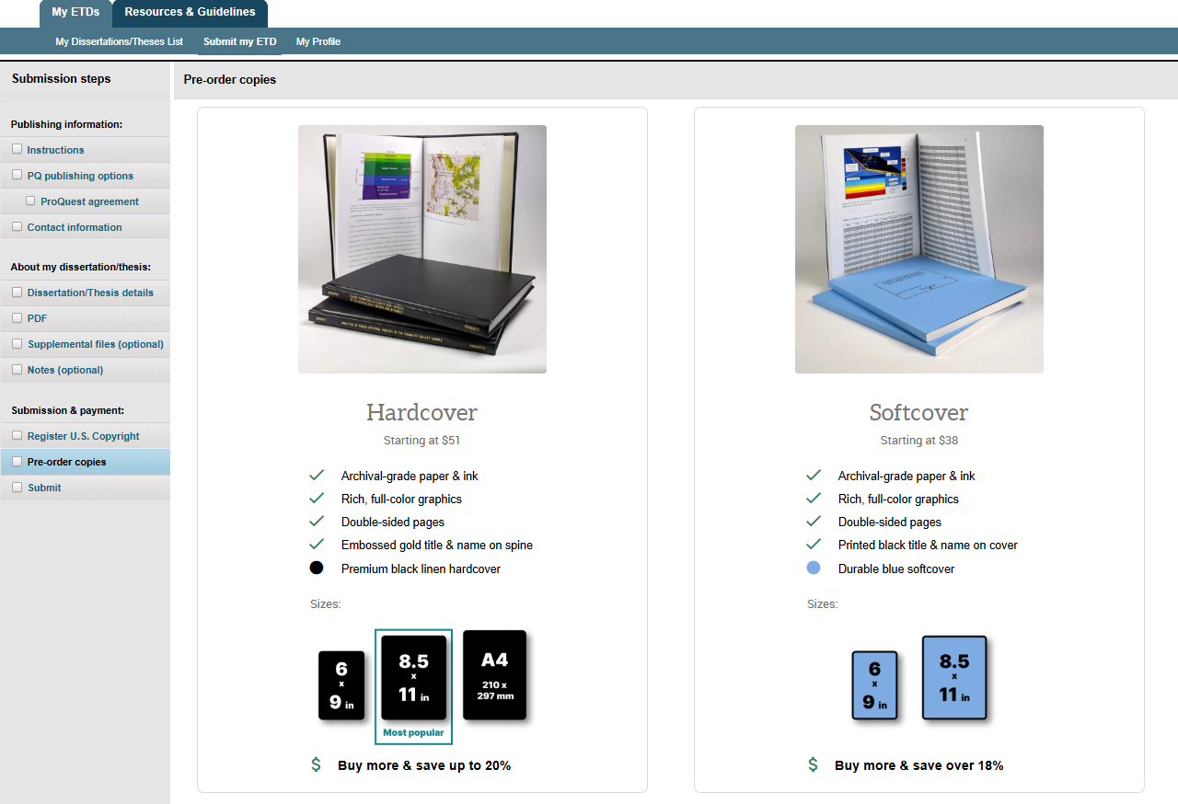
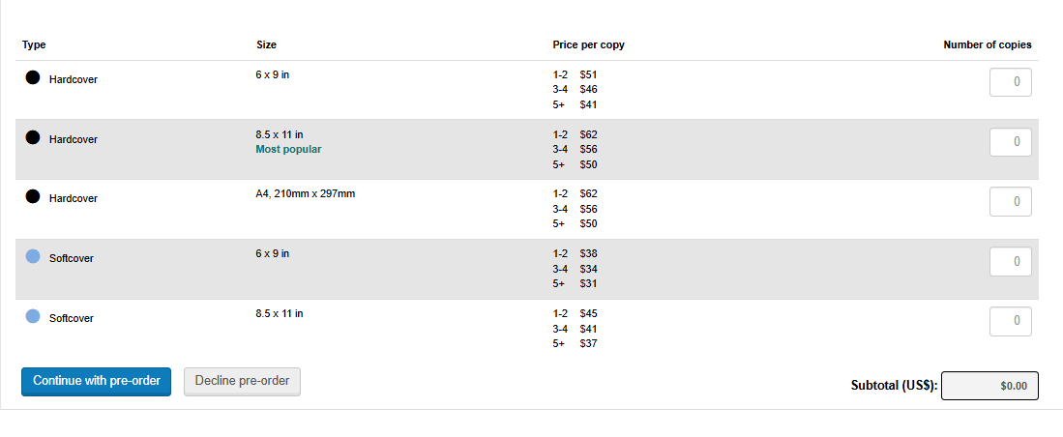
Price Zoom: 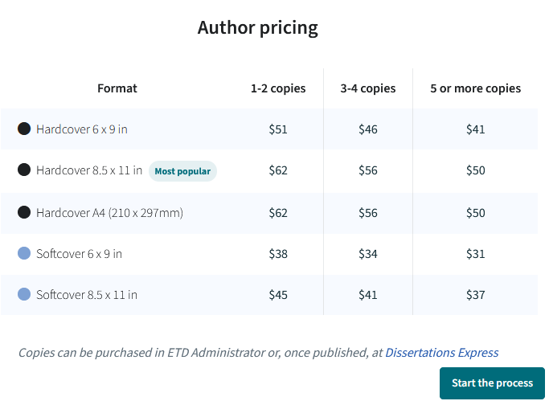
- Lastly, in the “Submit” tab, you will review all of the information you have entered. Anything you have skipped will be listed in red under “Steps to complete.” You can always save your progress and select “finish your submission later.” 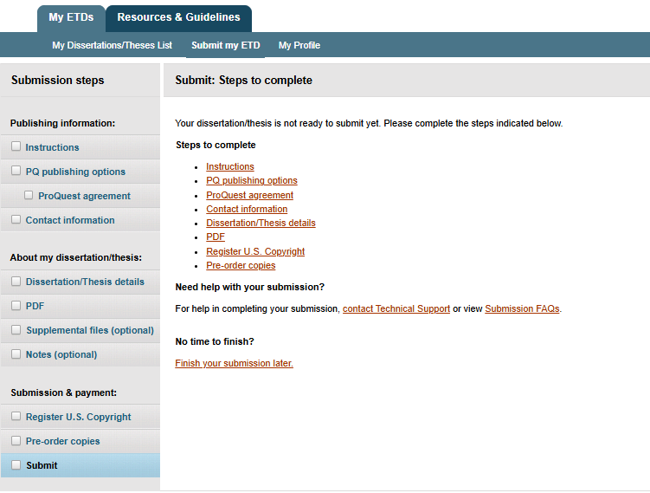
- Once you have completed all of the steps, you will submit for the Document Specialist to review and approve into the ProQuest database. If you have any questions while you are submitting or waiting for approval, contact DocumentSpecialist@usm.edu.

ProQuest FAQs

ETD Administrator FAQ - How do I submit a Thesis or Dissertation?
- Go to https://www.etdadmin.com and choose "Start the Process".
- Select your school from the list provided. (Don't see your school? Learn more)
- Create an account or login using an existing account.
- Once you create an account, the ETD Administrator will walk you through a simple process that involves accepting the publishing agreement and uploading the relevant files and information about your submission.
- After you complete your submission, your graduate school administrator will review the submission before sending it to ProQuest Dissertation Publishing.
- Note that all dissertations and theses must be submitted as a PDF document.

How soon after I submit my dissertation or thesis will it be available via ProQuest?
- After you submit your manuscript, it must be approved by your graduate school before the site administrator sends it to ProQuest Dissertation Publishing. Once we receive the manuscript from your school, it can take 8-12 weeks before it is available online.
- If you would like to inquire about the status of your submission after it has been approved and sent by the graduate school, you may contact our Author and School Relations group at https://support.proquest.com/s/submit-a-case? or 800-521-0600, option 2, option 1. Please include your manuscript ID with your query; the ID was included in the confirmation email sent to you by the ETD Administrator.

ETD - What are my ownership rights to my thesis/dissertation?
- As the author, you retain sole and complete ownership over your dissertation or thesis.

ETD - Does ProQuest Dissertation Publishing require exclusive distribution rights?
- No, submission to ProQuest Dissertation Publishing is done on a non-exclusive basis

ETD - If I am asked to make changes by the Graduate School or my committee, is there an option to resubmit?
- You should only submit to ProQuest after you have received approval from your committee and the Graduate School Document Specialist

ETD - Where can I learn more about the ProQuest Dissertations & Theses (PQDT) database?
- Go to ProQuest's website to learn more about PQDT, the most comprehensive collection of dissertations and theses in the world.

ETD - How can I order additional bound copies?
- If you have already completed the submission process and you have received a confirmation email that publication of your work is complete, you may place an order for copies directly through ProQuest. To place your order online via ProQuest and receive an author discount, refer to the "Order Copies" button on your submission details page.
- If you are experiencing difficulty with the order button, contact our Customer Service Department.

ETD Administrator FAQ - Who to contact for Technical Support
- For assistance using ETD Administrator, please contact Dissertations Support. If you have trouble formatting your Microsoft Word document, please contact the USM Document Specialist

ETD Administrator FAQ - When I copy and paste abstracts into the Submit form, some text is missing, quotes look odd, or strange characters appear in the abstract. What's going on?
- When copying abstracts from a word processing file or a PDF file, and pasting the text into the submission form, you are taking text from an environment that may support fonts, and special characters like symbols or "smart quotes". Please read through any abstract that you copy and paste from a word processing file or PDF file. Look for how single and double quotes appear, usage of special symbols, and incorrect conversion of glyphs from PDF files (e.g. "ff", "fl", or "fi" might disappear causing a word like "difficult" to change to "di cult").

What does the open access publishing option on ProQuest mean?
- ProQuest’s overview of open access vs traditional publishing services

Who can access my document on ProQuest?
- Third Party Discovery and Access to your Dissertation/Thesis

Can I embargo my document on ProQuest?
- Embargoes and restrictions

What are my copyright options on ProQuest?
- Copyright and Your Dissertation or Thesis: Ownership, Fair Use, and Your Rights and Responsibilities
- Why register your Copyright

