TYPE THE TITLE OF YOUR THESIS, DISSERTATION, OR DOCTORAL PROJECT IN 12PT TIMES NEW ROMAN EXACTLY AS YOUR COMMITTEE HAS APPROVED IT

by

Click here to enter text.
A [Choose an item.]
Submitted to the Graduate School,
the College of Choose an item.
and the School of Choose an item.
at The University of Southern Mississippi
in Partial Fulfillment of the Requirements
for the Degree of Choose an item.
Committee:

Name of Committee Chair, Committee Chair
Name of Committee Member
Name of Committee Member
Name of Committee Member
Name of Committee Member
Name of Committee Member
Name of Committee Member

Choose an item.2025

COPYRIGHT BY
Click here to enter text.
2025
Published by the Graduate School



ABSTRACT
An abstract is a concise account of the thesis or dissertation and should state the problem, describe the procedure or method used, and summarize the conclusions reached. An abstract is required for all papers. Do not use any special symbol/characters that are not found on a standard keyboard (super- and subscripts are allowed). Abstract should start at page number ii.
Abstracts for dissertations and doctoral projects are limited to 350 words and for theses the Abstract is limited to 250 words.

ACKNOWLEDGMENTS
The Acknowledgments page is used to recognize any special contributors that helped make the work possible. This page includes a brief, sincere, professional acknowledgment of the assistance received from individuals, advisor, faculty, and/or the institution. Personal remarks should be limited to the optional Dedication page that follows, if the author chooses to include it.
The page number on this page follows the same style as that found on the Abstract and should be either “iii” or “iv,” depending on the length of the Abstract.

DEDICATION
As an optional page, the author may choose to add a Dedication page as a means to recognize individual people, groups, and/or organizations that supported/inspired the author. The Dedication immediately follows the Acknowledgments and continues page numbering. If the Dedication page is not used, delete the contents of this page including the section break.
DO NOT TYPE on the Table of Contents and list pages which follow. Instead, update the fields after applying the appropriate styles to headings within your document. Chapter 4 of the document guidelines explains what role each style plays and how to update the fields for preliminary pages after applying styles.

TABLE OF CONTENTS
ABSTRACT ii
ACKNOWLEDGMENTS iii
DEDICATION iv
LIST OF TABLES vii
LIST OF ILLUSTRATIONS viii
LIST OF SCHEMES ix
LIST OF MUSICAL EXAMPLES x
LIST OF MUSICAL FIGURES xi
LIST OF ABBREVIATIONS xii
CHAPTER I – INTRODUCTION TO DISSERTATION 1
1st level heading Bach 1
Another first level heading here 1
Example 2nd level heading here 1
2nd example of a 2nd level heading here 2
Example 3rd level heading (in paragraph) 2
Example 4th level heading 2
Tables 2
CHAPTER II – PLACEHOLDER CHAPTER TITLE 8
CHAPTER III – PLACEHOLDER CHAPTER TITLE 9
CHAPTER IV – PLACEHOLDER CHAPTER TITLE 10
CHAPTER V – PLACEHOLDER CHAPTER TITLE 11
CHAPTER VI – DESCRIPTIVE TITLE IS IN CAPS LOCK 12
APPENDIX A – Placeholder Appendix Title 13
APPENDIX B – IRB Approval Letter (Remove if not required) 16
REFERENCES 17

LIST OF TABLES
Table 1 Example Table Title (be concise) 2
Table 2 Example of a Second Table Title 3
Table A1. Appendix Table Title Example (be concise) 13

LIST OF ILLUSTRATIONS
Figure 1. Example Figure Title. 4
Figure A1. Example Figure Title 14

LIST OF SCHEMES
Scheme 1. Example Scheme Title 5

LIST OF MUSICAL EXAMPLES
Musical Example 1 Musical Example Title. 6

LIST OF MUSICAL FIGURES
Musical Figure 1. Musical Figure 7

LIST OF ABBREVIATIONS
IRB Institutional Review Board
USM The University of Southern Mississippi
WCU William Carey University

- – INTRODUCTION TO DISSERTATION
Here I would begin writing or copy and pasting from another document the first paragraph of the first chapter of my dissertation. I would want to make sure that I applied the style “paragraphs” to this paragraph. Otherwise, if I accidentally applied the style “chapter title” or “1st level heading” then this paragraph would populate into my Table of Contents, which I don’t want.

1st level heading Bach
Here I would write a paragraph about Bach and whatever I wanted to write about Bach. This could be typed or copy and pasted from another document, as long as I made sure to apply the style “paragraphs” to this paragraph. I can have multiple paragraphs under this 1st level heading. I can also have multiple 1st level headings before I have a 2nd level heading.

Another first level heading here

Example 2nd level heading here
Here I would write a paragraph relevant to the second level heading above this paragraph. The best way to do this is to type directly into this document’s paragraph section using the “paragraph” style. However, if I had typed in a different document previously, I could copy and paste that information here, then highlight the information and select “paragraph” to apply that style to this and all other paragraphs. I would also want to make sure that the line spacing is set to double spaced throughout my document, including between all of my paragraphs.
When copy and pasting from another document, sometimes the line spacing defaults to include extra space between the lines, so I want to make sure that my line spacing throughout my entire document is 2.0 spaced with no extra lines between paragraphs. I do this by highlighting text, opening the paragraphs options (either by right clicking on text or opening it in the Home tab’s paragraphs section), going into line spacing options, then indents and spacing options, and setting spacing to 2.0 with 0 points of extra space before and after paragraphs.

Another example of a 2nd level heading here
Paragraph will begin here.

Example 3rd level heading (in paragraph). Example paragraph with heading in line with paragraph.

Example 4th level heading
Here I would begin a paragraph relevant to the fourth level heading above.

Tables
Tables must be formatted to fit within the 1” left, 1” right, 1” top, 1” bottom margins. In order for table titles to populate in the List of Tables, you will need to highlight your table title and select “Table Title” style which is located under “Styles” in the Home Row. You will then need to update your List of Tables. See Document Guidelines

          - Example Table Title (be concise)
Note: Here is an example of table notes in the table note style. The table notes should be formatted according to your style guide.
If your table is longer than one page, the table will need a “Table Continued” for each additional page that the table goes over. See example on next page.
Table 1 (Continued)

          - Example of a Second Table Title
Note: If the table has a note, and continues to a second page (or beyond) the note only appears at the end of the table. Do not place the note at the end of each section of the table.

See next page for an example of a figure. In order for your figure to populate in the List of Illustrations you will need to highlight the figure title and select the “Figure Title Style.” You will then need to update your List of Illustrations. Figures must be within the 1” left, 1” right, 1” top, 1” bottom margins.
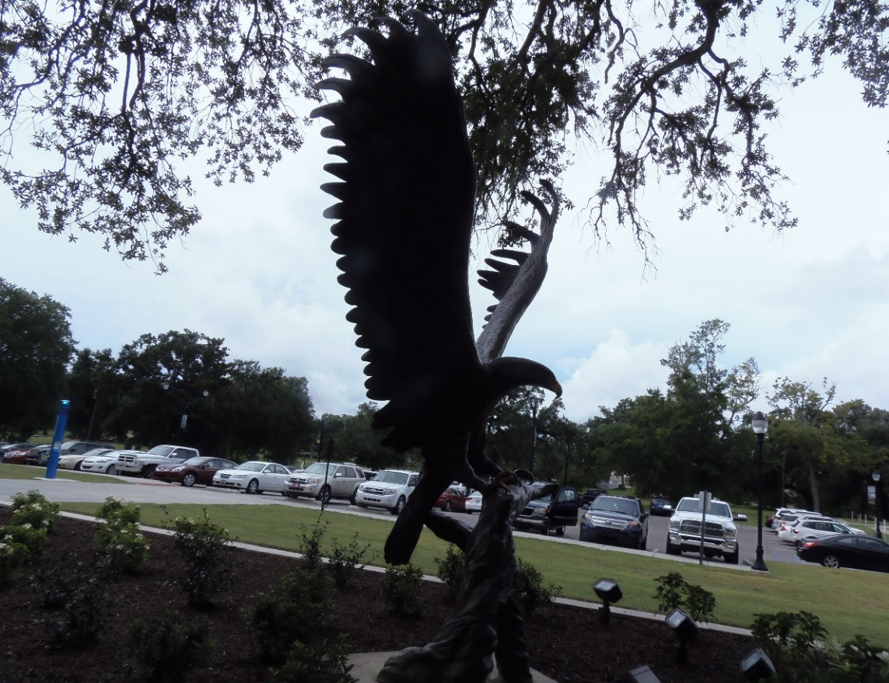
              - Example Figure Title.
Use Figure notes to explain what the figure is, add a citation for work that is not your own, etc. Use this for Photos, Figures, Graphs, etc. (Lofty Return, USM Gulf Park, photography by Jeanne Stewart, 2015).

See below for an example of a scheme. In order for your scheme title to populate in the List of Schemes you will need to highlight the scheme title and select the “Scheme Title Style.” You will then need to update your List of Schemes. Schemes must be within the 1” left, 1” right, 1” top, and 1” bottom margins.

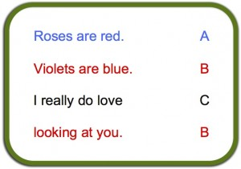
- Example Scheme Title
Note. Use Scheme notes to explain what the scheme is and to add any needed citations.

See next page for an example of a Musical Example. In order for your example title to populate in the List of Musical Examples you will need to highlight the example title and select the “Scheme Title Style.” Musical examples must be within the 1” left, 1” right, 1” top, and 1” bottom margins.

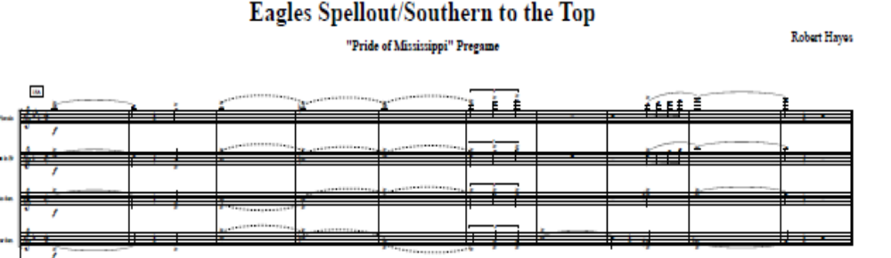
                - Musical Example Title.
Note. Use Musical notes to explain what the musical example is and to add any needed citations.

Sample landscape page. If your tables, figures, etc. do not fit within the portrait size designated by the template, you will need to landscape it. See USM Guidelines and/or Instructions page for more information on Landscaped pages.
  - Musical Figure
Note. Use Musical notes to explain what the musical figure is and to add any needed citations.
If landscaped pages are not used, delete the contents of this page including the section break. If landscaped pages need to be inserted elsewhere, copy this page and insert where needed.

- – PLACEHOLDER CHAPTER TITLE
The template is setup with five chapters. If you do not require five chapters, then delete the extra chapters. If you need more than five, it is best to insert the additional chapter(s) between the current Chapter IV and V. Insert a “section break (next page)” and then at the top of the new page use the Chapter style to create a new chapter heading. By working in Chapter IV to add or remove chapters, you avoid “interfering” with the formatting in the first Appendix.
To insert an additional chapter(s) in this template follow these steps:
- Place your cursor between the last line of the content of this chapter and the “section break (next page).”
- Click on “Page Layout”
- Click on “Section Break (next page).”
- Place your cursor at the top of the new page created by the last step and then click on “Chapter” in the style ribbon.
- The last step will insert the new Chapter heading with the appropriate chapter number and will renumber the chapter that follows to correspond with this change.
- After CHAPTER V (or VI, etc.) – insert an “en dash” (CTRL+MINUS SIGN) and the new chapter title (in all caps. Match the spacing shown at the top of the previous page (in the pre-built chapter)

- – PLACEHOLDER CHAPTER TITLE
Begin a new chapter here.

- – PLACEHOLDER CHAPTER TITLE
Begin a new chapter here.

- – PLACEHOLDER CHAPTER TITLE
Begin a new chapter here.

- – DESCRIPTIVE TITLE IS IN CAPS LOCK
Begin a new chapter here.

- – Placeholder Appendix Title
Tables, figures, etc. in the Appendix will need to have the “Appendix style” applied to it. See USM Guidelines for more details. If you had to have IRB/IACUC approval, your letter must be put into the appendix. Also, you should place any permissions that you had to obtain in the appendix. Delete Appendix if this section is not required.

            - Appendix Table Title Example (be concise)

Table A1 (continued)


              - Example Figure Title

To insert an additional appendix/appendices in this template follow these steps:
- Place your cursor between the last line of the content of this appendix and the “section break (next page).”
- Click on “Page Layout”
- Click on “Section Break (next page).”
- Place your cursor at the top of the new page created by the last step and then click on “APPENDIX” in the style ribbon.
- The last step will insert the new APPENDIX heading with the appropriate letter and will re-letter the appendix that follows to correspond with this change.
- After APPENDIX A (or B, etc.) – insert an “en dash” (CTRL+MINUS SIGN) and the new appendix title. Match the spacing shown at the top of the previous page (in the pre-built Appendix)

- – IRB Approval Letter (Remove if not required)

REFERENCES
Example reference. Change heading to Bibliography or Works Cited, depending
on your chosen style manual.
If using a citation manager you should be able to copy and paste all of your references here as a group. If the references were typed manually, it is better to copy/paste them onto this page in groups of 3-6. This will help to preserve the formatting of your references.
If you are placing the references at the end of each chapter, delete this page Highlight the heading through the section break (next page) and then click on delete. At the end of each chapter, use a first level heading and type the word References.

