Instructions for the Honors Thesis Template

BEFORE YOU BEGIN:
- Complete your thesis in a separate Word document! Be sure that your manuscript is written in the formal writing style that is appropriate for your discipline, that you have thoroughly proofread your manuscript, and that all grammar, spelling, punctuation and organizational mistakes have been eliminated.
- Read through ALL instructions carefully before you populate the template with the final version of your thesis.
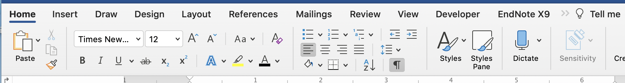
- Save a copy of the template and TURN ON PARAGRAPH MARKS (see red arrow below). Turning on these marks will enable you to see all instructions and remarks in the template (in red font), along with critical formatting (e.g., section breaks).

- Copy and paste your thesis, section by section, into the template. DO NOT DELETE SECTION BREAKS between chapters and other sections you want to keep in your manuscript. As you proceed, you need to use the styles ribbon to format chapter titles, subheadings, etc. This will enable your Table of Contents, List of Illustrations, and List of Tables to be automatically populated (see instructions below).
- Save regularly as you populate the template!
- Remove instructions and remarks (red font) from the template as you progress.

FORMATTING REQUIREMENTS:
- Use Times New Roman, 12 pt. font for the main text and Times New Roman font no smaller than pt. 10 for Figure legends and Table footnotes.
- Left-align all text (text must not be justified).
- Double-space the main text. Block quotes, references, endnotes, footnotes, table notes, figure notes, scheme notes, etc. may be single spaced, if desired or conventional in your discipline.
- Use tabs to create paragraph indents (up to 0.5“) for the first line of each paragraph.
- DO NOT MODIFY OR DELETE ANY TITLES OR FORMATTING IN THE TEMPLATE.
- Use the styles ribbon on the Home toolbar (see red arrows below) to format chapter titles, headings/subheadings, Table and Figure titles, etc. To format, simply select the title or heading text and click the appropriate style.
- Should your text reformat (e.g., from plain to bold font) when you paste from Word into the template, please use the style ribbon (red arrow below) or the styles pane (blue arrow below) to the right of the ribbon to change the font to Paragraph style.
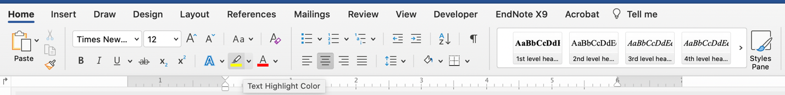

POPULATING THE TABLE OF CONTENTS, THE LIST OF ILLUSTRATIONS, AND THE LIST OF TABLES:

- DO NOT MANUALLY ENTER ANYTHING into your Table of Contents (ToC), the List of Tables, or the List of Illustrations! These lists are automatically populated as long as you have used the styles ribbon to format titles and headings beforehand as instructed above.
- To generate these lists on a Mac: Highlight the entire ToC or list. Choose the References toolbar (red arrow below) and click “Update Table” (blue arrow below). A box will appear that asks whether you want to update page numbers only or the entire table. Choose to update the entire table.
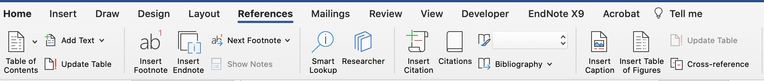

- To populate these lists on a PC: Right-click on the ToC or list; in the box that appears, click “update field”; in the next box that will appear, click “update entire table” and press OK.
- If you decide to add a chapter, section, table or illustration, be sure to choose the appropriate style in the style ribbon to format the titles/headings, then update the relevant list as described.

FORMATTING TABLES AND ILLUSTRATIONS:

- Illustrations and Tables must fit within the pre-set margins. If your table or illustration is longer than one page, you will need to have a “Table/Figure (continued)” heading for each additional page of the table/illustration.

Example:
Table 1 (continued).

- To test if your tables/illustrations fall within the pre-set margins, choose the View toolbar and turn on the ruler (red arrows below). The locations of the margins are indicated by the small white triangles (blue arrows below). If you click on a margin mark, a line will appear on the page that indicates the location of the margin.

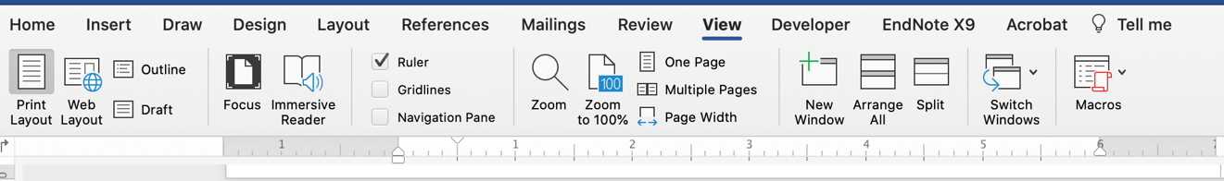

- If your Tables, Figures, etc. do not fit within the portrait size designated by the template, you will need to change the page orientation to landscape. The landscape margins are top 1.5“; left, right and bottom 1”. To convert a single page to landscape format, insert a Section Break (Next Page) after the last line of the previous page, choose landscape format for the new page, and insert another Section Break (Next Page) following the last line of the Figure legend or Table footnote. Choose portrait format again for the following pages.
- Please note: If you plan to generate a bound copy of your thesis, you will need to place the page number into the correct position on the landscape format page, following the instructions in this tutorial.

APPENDICES:

- If your project did NOT require IRB or IACUC approval, remove the sample IRB appendix. If your project DID require IRB or IACUC approval, insert the relevant approval letter.
- To insert additional appendices in the template, follow these steps:
- Place your cursor between the last line of the content of this appendix and the Section break (next page).
- Click on “Page Layout” (or “Layout” on a Mac; red arrow below)
- Click on “Section Break (Next Page).”
- Place your cursor at the top of the new page created by the previous step and then click on “APPENDIX” in the styles ribbon (blue arrow below).

- The previous step will insert the new APPENDIX heading with the appropriate letter and will re-letter the appendix that follows accordingly.
- After APPENDIX A (or B, etc.), insert a colon and a space, then type the new appendix title.

BEFORE YOU SUBMIT YOUR THESIS TO THE HONORS COLLEGE:

- Check that you have appropriately formatted all titles, headings and sub-headings, all are included in your ToC or other list, and all page numbers are listed correctly. If you detect errors, simply choose the correct style for a title or heading as instructed above and update your ToC or list. DO NOT attempt to update those lists manually.
- Check your document for empty pages you may have introduced inadvertantly. The only blank page in your thesis should be the one following the title page (i.e., page ii).

Honors Thesis Formatting Checklist for Student and Thesis Advisor

Please turn on the paragraph marks and make sure all instructions have been followed.

I use Times New Roman, 12 pt. font for the main text

I use Times New Roman font no smaller than pt. 10 for Figure legends and Table footnotes.

The text is left-aligned (text must not be justified).

The thesis is double spaced (block quotes, references, endnotes, footnotes, table notes, figure notes, scheme notes, etc. may be single spaced, if desired or conventional in the student’s discipline).

The first line of each paragraph is tabbed to create paragraph indents (up to 0.5”).

All red text is cleared from the document.

The table of contents and lists of tables and illustrations are NOT manually entered.

All titles, headings, and sub-headings are included in my table of contents, and Figure titles and Table numbers are included in their respective lists.

All page numbers are listed correctly and match the table of contents.

Tables and Illustrations fit within the pre-set margins.

If the tables do not fit within the pre-set margins, I have changed the orientation to landscape for that single page.

If a table or illustration is longer than one page, I have a “Table/Figure (continued)” heading for each additional page of the table/illustration.

IRB or IACUC approval is included in the appendix OR the sample IRB appendix is removed.

There are no empty pages in the thesis (except the page following the title page, page ii).

All titles and formatting are maintained in the document.

