William Wilberforce: Reform of the Slave Trade

Bradley Curtis
Junior Division
Paper

What drives one person to enslave another? There are several possible motives: a desire for wealth, a hunger for power, a need for workers, or a hatred of others. Whatever the reason for its existence, slavery is morally unjust because it robs a person of his or her freedom and sense of self-worth. Through the eighteenth century and into the nineteenth century, slavery experienced international growth from West Africa to the West Indies and into America (Curtin 154). People like plantation owners, merchants, and slave traders profited through the suffering of others. One man, leading many others, stood to fight this evil. Influenced by an Evangelical Christian conversion, William Wilberforce (1769-1833) led a revolution in the English House of Commons to abolish the slave trade—believing that abolishment of slavery would naturally follow. Although he and his fellow advocates faced a reaction of fierce challenges, the Slave Trade Act was passed in 1807. Reformation of slavery through the British Empire followed with the Slavery Abolition Act of 1833. Wilberforce’s hard-fought success was an encouragement to American abolitionists in their struggle against slavery.
Wilberforce was born in Hull in 1759 to a wealthy merchant. He attended Cambridge where he met future Prime Minister William Pitt. This friendship was important because Pitt would later provide support to Wilberforce in his fight to persuade the House of Commons to pass the Slave Trade Act (“William Wilberforce”). After becoming a member of Parliament in 1780, Wilberforce began having religious discussions with Isaac Milner. His conversion to Christianity soon followed (Better Hour). He took his religious beliefs very seriously and considered leaving Parliament for full-time ministry. As he struggled with this decision, he consulted John Newton, a former slave trader turned pastor. Newton encouraged Wilberforce to stay in politics and to serve God in the House of Commons (Aitken 61). Wilberforce accepted Newton’s advice. In October 1787, he made the following declaration: “God Almighty has placed before me two great offices: the suppression of the slave trade and the reformation of manners.” These words guided his life’s work which he saw as a mission from God (Better Hour). Fortunately, he was not alone in this fight. There were others, like Thomas Clarkson and Granville Sharp, who shared his anti-slavery convictions. Together they formed the Clapham Sect. This association was important because they encouraged each other in the long struggle and provided motivation to continue (“William Wilberforce”).
Encouragement was needed for the daunting task ahead. The plantation system in both the West Indies and America depended on slave labor. Resistance to ending the trade was strong because abolition would threaten the plantation owners’ success (Curry 50). England’s strong involvement in the slave trade made it all the more difficult to pass legislation against it. England accounted for over half of the trade (Meltzer 50). According to shipping records, from 1731 to 1807, 1,613,800 slaves were exported from Africa by English ships (Curtin 136). With 160 slave ships and 5,500 sailors on these vessels, many Englishmen were connected to the trade (Windschuttle 17). The trade was extremely profitable to Liverpool, England, where it brought in £17 million annually (Coles P14).
Wilberforce and his supporters were not driven off course by the fact that so many of their countrymen were involved in the trade. They understood that the atrocities the slaves faced were far greater than any challenges they would encounter. Accounts from former slave traders and ship surgeons revealed some of the trade’s horrors. The ships were so crowded that the slaves could not lie down without lying down on top of each other. On the slave ship Brookes, 600 slaves were regularly packed into a space designed for 451. Not only were the ships crowded, but they were also filthy. Dr. Alexander Falconbridge reported there were open containers of human waste that children would often fall into. The slaves whose chains prevented them from reaching the tubs had to relieve themselves where they lay (Haskins, Benson, and Cooper 30-31). In addition to suffering crowded and filthy conditions, slaves were often treated like animals. For example, on one trip, 132 slaves were cast overboard due to a water shortage. In this way, slave traders could file insurance for property lost. The judge on the case compared the incident to throwing horses overboard. Another inhumane practice was force feeding slaves who had lost weight on the trip before unloading them to be sold (Better Hour). Upon arrival in the West Indies or America, their suffering did not cease. Hardships and cruel treatment provoked slaves to attempt escape. Court documents from Dominica showed that slaves faced brutal punishments, such as receiving 100 lashes, for attempting escape or assisting runaways (“Court records”).
Because of these horrendous practices, Wilberforce and fellow abolitionists could clearly see it was time for a revolt. To convince others to join their cause, abolitionists held rallies and petition drives, published posters and pamphlets, and participated in boycotts (“William Wilberforce”). During the years before the Slave Trade Act was passed, Thomas Clarkson traveled 35,000 miles giving speeches and holding rallies. Abolitionists sent 519 petitions to Parliament with half a million signatures (Windschuttle 17). In further attempts to educate the public, abolitionists distributed 700 posters of the overcrowded slave ship Brookes (“Breaking” 71). They also published a map that showed the triangular cycle of the slave trade. This map depicted the movement of goods and guns from Europe to Africa where they were traded for slaves, the transportation of slaves from Africa to the West Indies and America, and then the shipment of cotton, sugar, and tobacco to Europe. This map was effective because it showed Europeans that their desire for such items was a driving force of the slave trade (“Wilberforce’s Influence”). This realization moved some Europeans to boycott these items. According to the Clapham Sect, 300,000 boycotted sugar produced from slave labor (Windschuttle 17). English people had only seen ships delivering products, never people. The efforts of the abolitionists shed light on the terrors of the slaves’ journey from Africa to the West Indies and America (Curry 50).
While speeches, publications, and boycotts raised public awareness of the need for abolition, Wilberforce’s role in the revolt was representing abolitionists’ interests in Parliament. In fact, he presented anti-slavery motions for eighteen years before the Slave Trade Act was passed in 1807 (“William Wilberforce”). Indeed, Wilberforce was known as a powerful orator. His speeches of May 1789 and April 1791 are listed among his principal literary works (Stableford 1). According to abolitionist Granville Sharp, Wilberforce was chosen for this task because of “the respectability of his position as member for the largest county, the great influence of his personal connexions, added to an amiable and unblemished character.” In his estimation, these qualities would “secure every advantage to the cause” (Teabeau 90).
In presenting abolitionist arguments, Wilberforce’s speeches focused on several key points. His primary argument was that the slave trade went against the ideas of human decency, justice, and morality and thus should be ended. To Parliament, he posed this question: “When we think of eternity and the future consequences of all human conduct, what is there in this life that should make any man contradict the dictates of his conscience, the principles of justice, the laws of religion, and of God?” (Teabeau 134-35) In his view, Britain should be an example to other countries, and the slave trade was a blight on British character (Teabeau 229). Another point that Wilberforce made concerned danger. He reminded his audience that many slaves lost their lives during the harsh trip across the Middle Passage and through the mistreatment by plantation owners. The slave trade was also deadly for sailors who contracted tropical diseases and who encountered slave revolts (Teabeau 172). In addition to presenting the arguments based on morality and danger, Wilberforce argued that ending the slave trade would not ruin Britain’s economy because the West Indies could be farmed without slave power (Teabeau 229). It disturbed him that merchants in Liverpool and Bristol who received and sold goods produced through slave labor were profiting through the suffering of others. He continued to argue that moral concerns should outweigh greed. Furthermore, Wilberforce countered that only a small portion of their business depended on the slave trade (Teabeau 203). Wilberforce was passionate and felt that if people only knew the facts they would support abolition too. He claimed that “it was impossible for a feeling mind to survey the picture without indignation, sympathy, and disgust” (Teabeau 234).
Wilberforce’s confidence would be tested by the challenges. Some of those challenges were physical. He suffered from a digestive disorder and failing eyesight. At times these ailments forced him to bed and made his work difficult (Gibbins 103). At night he was haunted by images of slaves in chains. Another challenge was the length of the fight. Year after year, he refiled motions to abolish the slave trade, and year after year, they were defeated. For a time, beginning in 1793, England’s war with France shifted attention to national security and prolonged the abolition process (Curry 52). It was a twenty-year struggle to pass the abolition act, and another twenty-six years passed before the slaves were freed. During this lengthy fight, Wilberforce encountered formidable opponents. At times threats were even made on his life. His enemies sought to discourage his success. In 1796 abolitionists had enough votes in the House of Commons to pass a slave trade act. Realizing that the act was close to passage, Wilberforce’s opponents offered free opera tickets to members of Parliament. Members who were wavering in their decision attended the opera instead of staying to vote. As a result, the bill failed by four votes. Wilberforce persevered for eleven more years before the slave trade bill finally passed (Better Hour).
Not only was Wilberforce working in the revolt against the slave trade at home, but he was also influential in encouraging its progress abroad. He recognized that Britain’s ceasing to participate in the slave trade would not end the practice, so he worked to persuade other countries to cease participation (Mason 811). For instance, to encourage America’s progress in abolition, he wrote such politicians as James Monroe and Thomas Jefferson. In May 1803, he wrote a letter to ask Monroe, who would one day be President, if some of the Union states had once again allowed slavery. Monroe responded that the rumor was not true. Happy to learn the truth, Wilberforce encouraged Monroe by writing, “Without having had so much light thrown on the subject as has been cast on it here, you have seen enough to induce you to do your utmost to put a stop to this unjust traffic” (Pollock 188). In 1807, after Wilberforce heard that an abolition bill was making its way through Congress, he wrote again to Monroe to celebrate “the concurrence of our two countries in carrying into execution this great work of beneficence” (Pollock 208). This statement shows that Wilberforce had a global view of abolition efforts and understood that countries needed to work together to achieve reform. One year later in 1808, he expressed again the importance of countries’ combined efforts in a letter to Jefferson. He believed the two nations could work together to end the slave trade by allowing each country to seize the other’s slave ships. Even though at this time both countries had enacted anti-slave trade legislation, some slave traders were continuing to transport slaves illegally. Wilberforce wrote that a pact to stop each other’s slave ships “may lead to similar agreements with other countries, until at length all civilized nations on earth have come into this concert of benevolence” (Wilberforce 374).
His conviction that all people should be free pushed him to fight for their rights until the end of his life. Shortly before his death in 1833, Wilberforce signed the protest against the American Colonization Society. This was his final abolition act. This group pretended to be charitable toward African Americans in sending them back to Africa, but Wilberforce believed that their motive came from their belief that African Americans had no right to be free Americans (Clark). Even though the American Colonization Society claimed to be working toward abolition, Wilberforce and other signers felt that the society was widening the gap between the two races (“Remarks” 36). His signing the protest was not an action that pleased all Americans, but it was something that Wilberforce felt he must do. While some Americans criticized his actions, others came to his aid. In a letter to the editor of The Liberator, C. Stuart attested that Wilberforce was a man of solid character who had signed the protest a few days before his death in good conscience. Wilberforce continued to fulfill his calling at home and abroad until the end of his life.
Two days before his death, hearing that the Emancipation Act was certain to pass, Wilberforce declared, “Thank God that I have lived to witness a day in which England is willing to give 20 millions sterling for the abolition of slavery.” He was referring to the settlement that England gave the plantation owners to supplement their losses (Coles P14). Final success came one month after Wilberforce’s death in 1833 when Parliament passed the act. After 26 years of challenging work, Wilberforce and other abolitionists were finally victorious. This great feat had an international impact. When America heard that Britain had voted to free its 800,000 slaves, members of the American Anti-Slavery Society were encouraged to begin fighting for emancipation (“Wilberforce’s Influence”). In fact, in 1833 this group, sparked by England’s success, wrote their constitution which stated that the group’s goal was the “entire abolition of Slavery in the United States” (“American Anti-Slavery”). Although more than thirty difficult years would pass before the Thirteenth Amendment was ratified, American abolitionists were motivated by the perseverance and victory of their English colleagues.
Along with this hope came a deep admiration for Wilberforce among Americans. African Americans in Philadelphia gathered to express gratitude for Wilberforce and to offer a eulogy in his honor. The speaker at this event declared that the light of Wilberforce’s influence would cover the globe (Whipper 35). Likewise, he was honored in a sonnet, published in The Liberator in 1834. The writer urged Wilberforce to “enjoy what thou has won, esteem and love from all the just on earth” (Cowper). In his tribute, Frederick Douglas best expressed the magnitude of Wilberforce’s accomplishment and influence:
It was the faithful, persistent, and enduring enthusiasm of William Wilberforce and his noble co-workers that finally thawed the British heart…Let no American, especially no colored American, be without a generous recognition of this stupendous achievement. Though it was not American, but British, it was a triumph of right over wrong, of good over evil, and a victory for the whole human race.” (Better Hour)
Wilberforce’s efforts helped to achieve reformation of slavery through the British Empire and eventually in America. One man, standing to fight evil, changed the world.

Appendix A

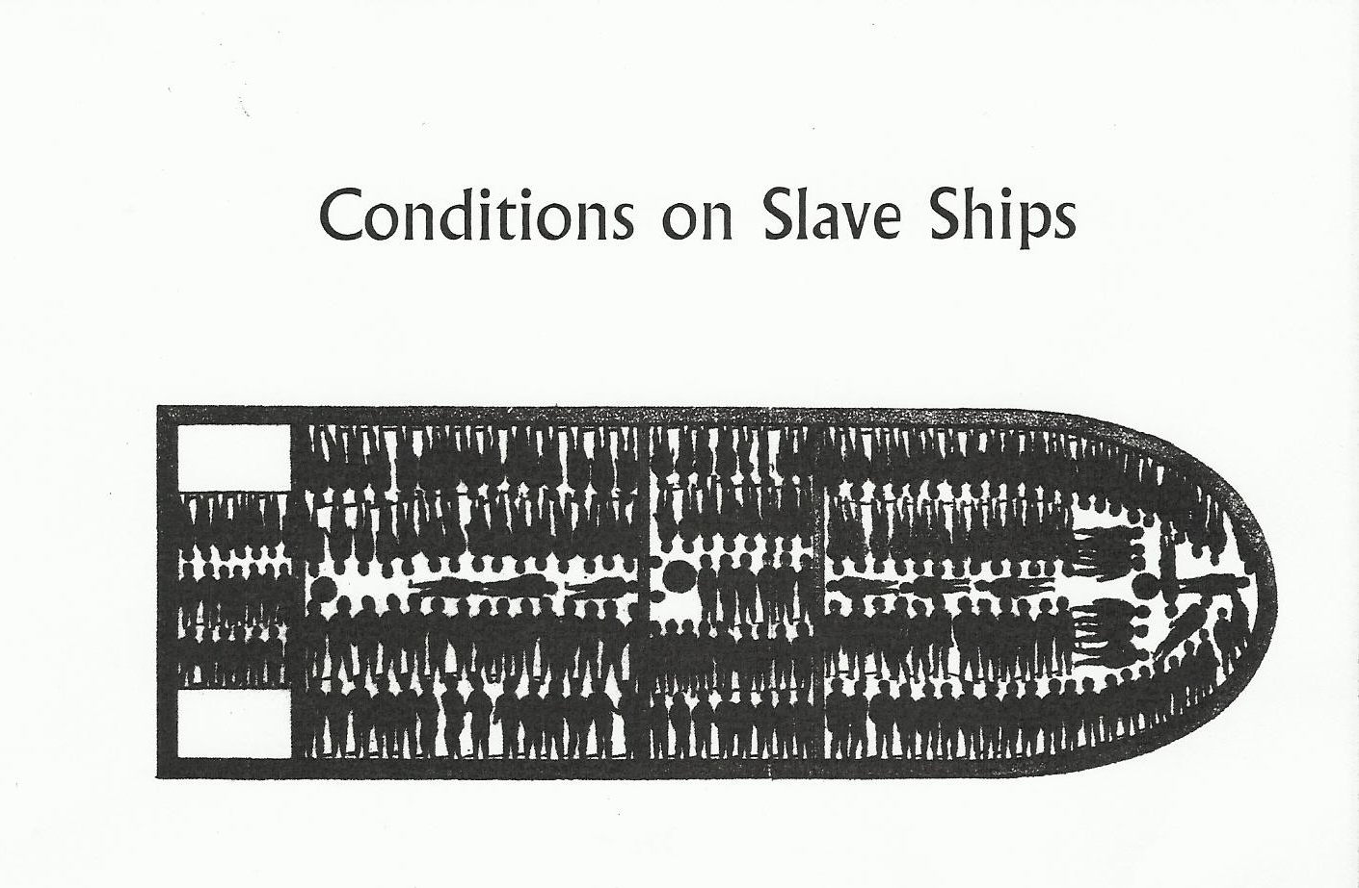

This diagram of a deck of the slave ship Brookes shows the crowded conditions slaves were forced to travel in as they crossed the ocean. Abolitionists used diagrams like this one to raise public awareness of the horrors of the slave trade. From Bound for America.

Appendix B

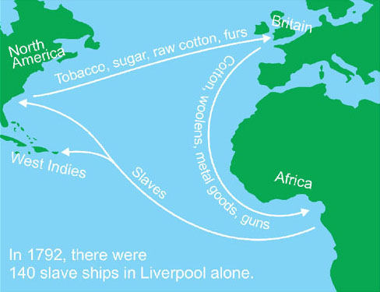

This is the triangular map that Thomas Clarkson developed. Abolitionists used this map to raise awareness of England’s role in the slave trade. From Wilberforce Central.

Appendix C

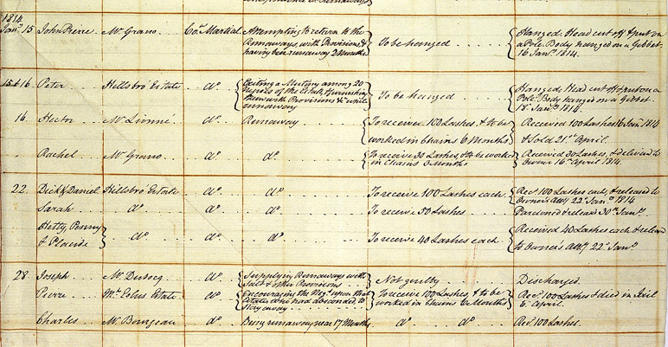

This court document lists the harsh punishments that slaves in Dominica received for attempting escape or assisting runaways. Some of the punishments included 100 lashes and even hanging. From The National Archives.

Appendix D
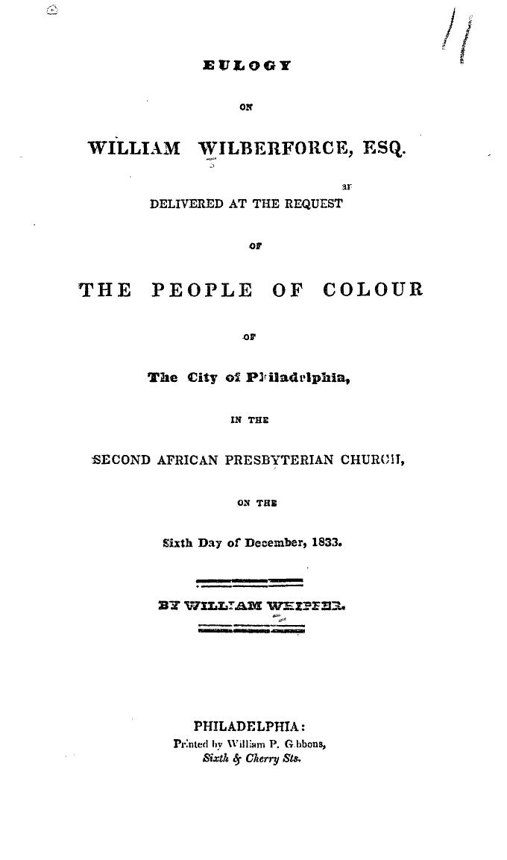

This is the title page of a eulogy dedicated to William Wilberforce by people in Philadelphia. It is an indication of the affection people in America felt for Wilberforce. From the online Cornell University Library.

Annotated Bibliography
Primary Sources
"About Wilberforce Central."Wilberforce Central. Web. 23 Oct. 2011. This page provides a
picture of the map developed by abolitionist Thomas Clarkson of the triangular Atlantic trade. It shows the flow of metal goods and guns from Europe to Africa, the flow of slaves from Africa to the West Indies and America, and the flow of cotton, sugar, and tobacco to Europe.
“American Anti-Slavery Society: Constitution.” TnCrimLaw. Web. 13 Feb. 2012. This primary
source is the document that gave direction to the American Anti-Slavery Society. From this source, I learned that the society’s goal was complete abolition of slavery. It was
written several months after England passed its Emancipation Act.
“Court records from Dominica, a British colony in the Leeward Islands, January 1814.” The
National Archives. Web. 03 Jan. 2012. This primary source lists crimes and punishments for slaves attempting to escape or assisting runaways. Seeing these brutal punishments helped me to realize the need for reform.
Cowper, William. "Sonnet to William Wilberforce." The Liberator [Boston] 28 June 1834. Print.
I learned that this sonnet was published in America a year after Wilberforce's death in The Liberator, but it was first published in 1792 in England. It shows the depth of appreciation that people felt for Wilberforce.
"Remarks on the American Colonization Society." The Christian Examiner and General Review
July (1833): 33-36. Microfiche. Microfilming Corporation of America. 1980; fiche 1.
I acquired a microfilm copy of this primary source at the Auburn Avenue Research Library in Atlanta. It contained the Protest that Wilberforce and others signed against the American Colonization Society. This source was important because it gave me greater knowledge of Wilberforce's work abroad until the end of his life.
Stuart, C. "Vindication of William Wilberforce." Editorial. The Liberator [Boston] 14 June 1834.
Print. In this letter to the editor, I learned of the controversy caused by the American Colonization Act. Some people were upset that Wilberforce had signed a protest against this act. Mr. Stuart wrote a piece for The Liberator to attest to Wilberforce's character.
Whipper, William. Eulogy on William Wilberforce, Esq. Delivered at the Request of the People
of Colour of the City of Philadelphia ... on the Sixth Day of December, 1833.
Philadelphia: Printed by W.P. Gibbons, 1833. Web. 30 Nov. 2011. This primary source provided a clear example of the close connection between Wilberforce's work and its effect on America. This eulogy helped me to understand the gratitude and admiration that African Americans felt for Wilberforce.
Wilberforce, Robert Isaac, and Samuel Wilberforce. The Life of William Wilberforce. London: J.
Murray, 1838. Microfiche. This first-hand account of Wilberforce's life was written by his sons. I accessed a copy of it on microfilm. It was in this source that I found a copy of a letter that Wilberforce wrote to Thomas Jefferson. In this letter, he encouraged Jefferson to agree to England's and America's seizing each other's ships in an effort to discover slave ships. This gave me an understanding of how the two nations needed to work together to end the slave trade.

Secondary Sources
Aitken, Jonathan. "The Force Behind William Wilberforce." American Spectator 40.2 (2007):
60-61. EBSCO. Web. 8 Dec. 2011. This secondary source sheds light on the relationship between Wilberforce and his former pastor John Newton. I thought that the advice that Newton gave Wilberforce to stay in politics was life-changing for Wilberforce.
The Better Hour--The Legacy of William Willberforce. Dir. Phil Cooke and Brian Mead. PBS,
2008. DVD. I viewed this film at the Auburn Avenue Research Library, and it helped me to see the scope of Wilberforce's work from a young member of Parliament to an older gentleman who died knowing he had completed his goal. A quote by Frederick Douglas showed how respected Wilberforce was by American abolitionists.
"Breaking the Chains." The Economist 382.8517 (2007): 71. MasterFILE Premier. Web. 8 Dec.
2011. This secondary source was helpful to me because it describes the system that shipped thousands of Africans over the Atlantic Ocean to cultivate sugar and tobacco that was sold to enrich Europeans. It made the cycle and connections among the countries clear.
Clark, Carolyn L. “Re: William Joseph Wilberforce (1759-1833) Follow-Up.” 30 Nov. 2011.
Email. In an email interview with Ms. Clark, a reference librarian at the Auburn Avenue Research Librarian, I first learned that Wilberforce signed the protest against the American Colonization Society. This information was important because I began to see that Wilberforce was active in abolition efforts outside of his own country.
Coles, Bill. “A Speech That Made Abolition History.” The Wall Street Journal 12 May 2007:
P14. Print. This source explained for me the motive behind the terrible practice of slavery and gave remarks made by Wilberforce when he learned that slavery was to be abolished.
Curry, Andrea. “The Abolition of the Slave Trade.” British Heritage 28.2 (2007): 50-53. Print.
This article was sent to me by the librarian at Wilberforce University. It added information about the plantation system and helped me to see why it was so difficult
to abolish the slave trade. This source also provided insight on how uneducated the public
was about the slave trade.
Curtin, Philip D. The Atlantic Slave Trade; a Census. Madison: University of Wisconsin, 1969.
Print. This source contained many charts and tables that helped me to realize the huge number of slaves that were transported from 1731 to 1807. The information was provided by shipping companies and was a little tedious, but it showed the large number of people touched by slavery.
Gibbins, Henry De Beltgens. English Social Reformers. London: Methuen & Co., 1892. Print.
Through this book, I learned some details about the difficulty of pushing the slave trade bill through the House of Commons. The stress took its toll on Wilberforce's health, but he continued to fight for years.
Haskins, James, Kathleen Benson, and Floyd Cooper. Bound for America: The Forced Migration
of Africans to the New World. New York: Lothrop, Lee & Shepard, 1999. Print. This book increased my knowledge of the horrible conditions on slave ships. After reading this book, I could see why Wilberforce was so compelled to fight against the injustice of slavery.
Mason, Matthew. "Keeping Up Appearances: The International Politics of Slave Trade Abolition
in the Nineteenth-Century Atlantic World." William and Mary Quarterly 66.4 (2009):
809+. JSTOR. Web. 27 Oct. 2011. This article helped me understand many of Britain's problems in trying to end Atlantic slave trade, such as countries agreeing publicly to support the ban but continuing privately to participate in the trade.
Meltzer, Milton. All Times, All Peoples: A World History of Slavery. New York: Harper &
Row, 1980. Print. This book was helpful to me because it stated that England accounted for over half the slave trade but was the first to abolish it. This shows how great of a task Wilberforce accomplished.
Pollock, John Charles. Wilberforce. London: St. Martin's, 1977. Print. This book was helpful in
describing the relationship between Wilberforce and American James Monroe. It quotes from two letters that Wilberforce wrote Monroe about America's abolition process.
Stableford, Brian. "William Wilberforce." Guide to Literary Masters and Their Works (2007): 1.
Web. 8 Dec. 2011. From this secondary source, I came to understand that Wilberforce's religious convictions drove him to keep trying even when his abolition bills failed time and time again. His speeches were listed among his most important literary works.
Teabeau, Hazel M. Wilberforce's Speeches on the Abolition of the Slave Trade. Diss. University
of Missouri, 1959. Columbia: University of Missouri, 1959. Print. I discovered this source at the Auburn Avenue Research Library in Atlanta. This provided an in-depth summary of Wilberforce's main speeches. Through reading the quotes, I soon understood that Wilberforce was a very moving speaker. Many of his speeches presented the same main arguments.
"Wilberforce's Influence on the Efforts of U.S. Abolition of Slavery." Wilberforce Central. Web.
23 Oct. 2011. I first read about Wilberforce's influence on the American abolition process in this article. It mentions his correspondence with James Madison and Thomas Jefferson.
"William Wilberforce." BBC. Web. 22 Oct. 2011. This website contained a photo of William
Wilberforce. It described his connections with other abolitionists and helped to introduce me to their methods of spreading their message.
Windschuttle, Keith. "William Wilberforce: The Great Emancipator." New Criterion 26.10
(2008): 17-24. Web. 8 Dec. 2011. This journal article gave specific information about the ways abolitionists spread their message. It was in this secondary source that I read the number of miles that Clarkson traveled giving speeches and the number of signatures that they presented to Parliament.

