History Undergraduate Course Descriptions
Spring 2021

HIS 101 (H080)
World Civilization I
Online
Dr. Courtney Luckhardt
In this course, we trace the story of civilization from prehistory through the fifteenth century. Through a kaleidoscope of kings and slaves, warriors and philosophers, farmers and merchants, we will focus on certain themes. Four themes intersect in all the societies we study this semester.
1) religious development and syncretism
2) elite power and political organization
3) technological innovations
4) trade and economic development

To focus on these themes and questions, we will be close reading primary sources (that is, texts produced by the societies we are studying, not by modern scholars) from many different civilizations. We will learn history by doing it – this means that students will learn to read and interpret primary evidence and come to their own conclusions about pre-modern societies.

HIS 102 (H083)
World Civ since 1500
ONLINE
Dr. Joshua Haynes
How did we get to where we are today? This course is designed to help us better understand the world in which we now live by examining some key global events and developments since 1500. Our goal will be not only to study important figures, societies, and events on their own terms, but to begin thinking about the world as a global network of social, cultural, economic, and political connections. In so doing, we will examine a wide array of materials and sources including historical documents, film, music, etc., all of which will help us to flush out the issues, people, and events which have shaped the modern world over the last five hundred years.

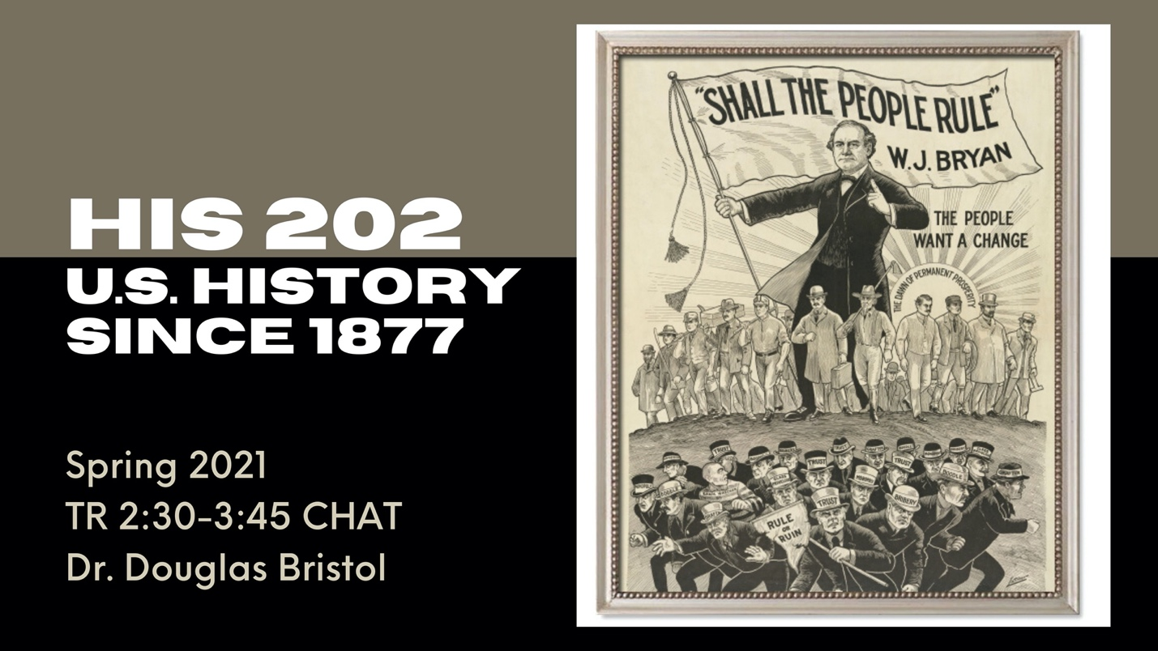HIS 202
U.S. History Since 1877
TR 2:30 - 3:45 CHAT
Dr. Douglas Bristol
The course describes and analyzes the economic, social, and political forces that affected the American nation after the Civil War, emphasizing the impact of repeated economic transformations and the emergence of the U.S. as a great power. In addition, by examining cycles of reform, you will learn the historical context for understanding current reform movements such as #blacklivesmatter and #MeToo. You will write a persuasive essay in response to a question about Dr. Martin Luther King’s book, Why We Can’t Wait.

HIS 300
Historical Research, Methods, and Writing
TR 11:00-12:15 (H001)
Dr. Kenneth Swope
This course is a semester-long apprenticeship in the craft of history. We will examine the nature of history, why it is important, and how it is practiced. When you successfully complete this course, you will have the basic skills necessary for beginning historians. The class will also prepare you, if you work hard and take its lessons to heart, for a more advanced study in upper division history courses. It will also introduce you to the mechanics of research and writing. Because I discovered that this course is often difficult for students to conceptualize and students have trouble finding viable research topics, this semester we will be focusing on “Manipulating the Past: Using History for Current Agendas” as the main topic/era of study. Students can, of course, select specific research topics within this area, but this will allow them to better interact with one another and make use of primary resources available at USM and nearby.
Course Texts
A Pocket Guide to Writing in History by Mary Lynn Rampolla 9th ed. (Bedford St. Martin’s, 2017) ISBN: 10:1319113028 [Required]
History in Three Keys: The Boxers as Event, Experience, & Myth by Paul A. Cohen (Columbia University Press, 1998) ISBN-13: 978-0231106511
Silencing the Past: Power & the Production of History by Michel Rolph-Trouillout (Beacon Press, 2015) ISBN: 13: 9780807080535 [Required]

HIS 300
Historical Research, Methodology, and Scholarship
MW 9:30-10:45 CHAT (H002)
Dr. Rebecca Tuuri
This core history course will introduce majors to the basics of historical research, methodology, and scholarship. Students will be required to complete a series of assignments including a website critique, book review, oral presentation, and a 12 page research paper. In order to complete these assignments, students will engage in classroom discussion about the process of conducting historical research and writing. They will also conduct research using archival repositories, including the McCain Archives, and the Cook Library to conduct their own primary and secondary source research for their research paper.

HIS 307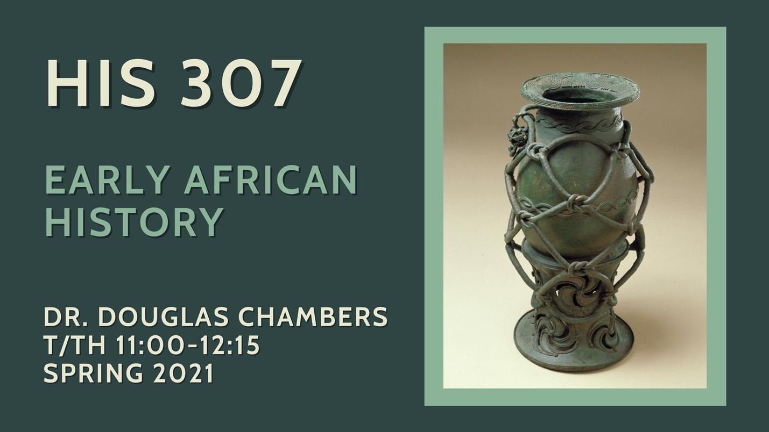
Early African History
TR 11:00-12:15
Dr. Douglas Chambers
This course is a general survey of Sub-Saharan African history, from ancient civilizations to the classical era and beyond, including the importance of Islam in African history, and of Africans in the Atlantic World Diaspora. We will explore key themes in the changing experience of the continent and its peoples through the early nineteenth century. You will gain a basic working knowledge of particular regions as well as of general themes and long-term changes over time.
Required Texts
Robert Harms, Africa in Global History (New York: W.W. Norton, 2018).
D. T. Niane, Sundiata: An Epic of Old Mali (Essex, England: Longman, 1994).

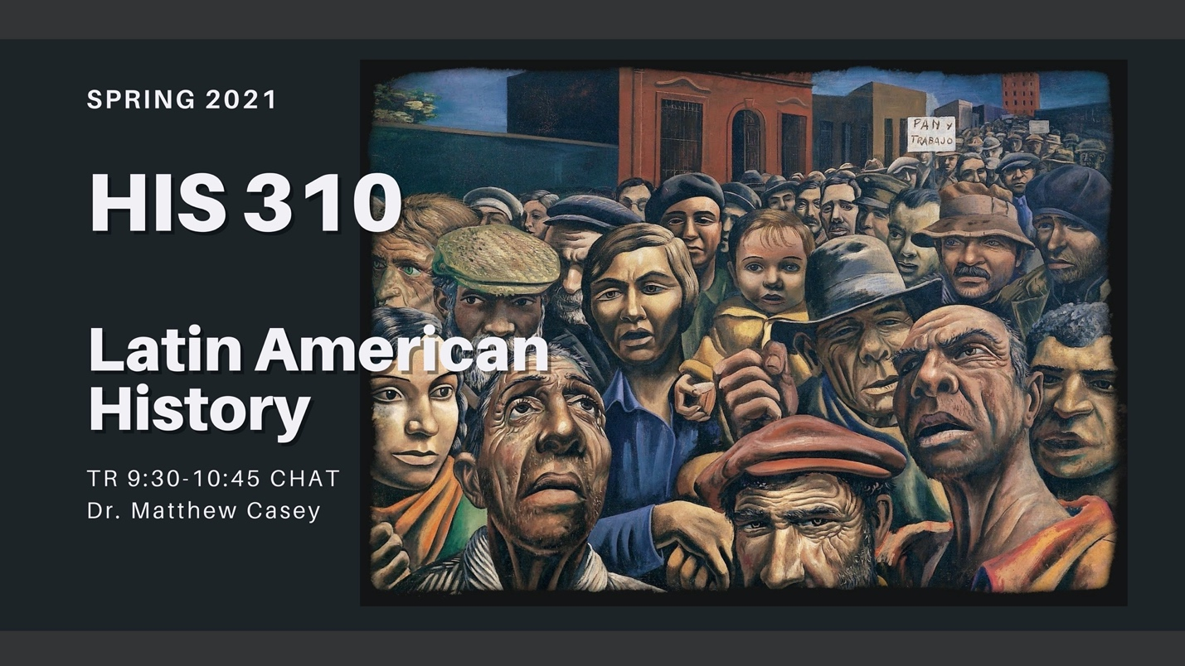HIS 310
Latin American History
TR 9:30-10:45 CHAT
Dr. Matthew Casey

Latin American History will explore the social, political, cultural and economic history of the region from pre-Columbian times to the present. The class will provide broad overviews of various time periods before zooming into case studies about specific countries and peoples' lived experiences. This online CHAT class will meet once per week for required discussions and students will complete other mandatory course modules and readings beforehand. There are no pre-requisites for the course and no prior knowledge of Latin American history is required. This course will use open access reading materials and no-cost books.

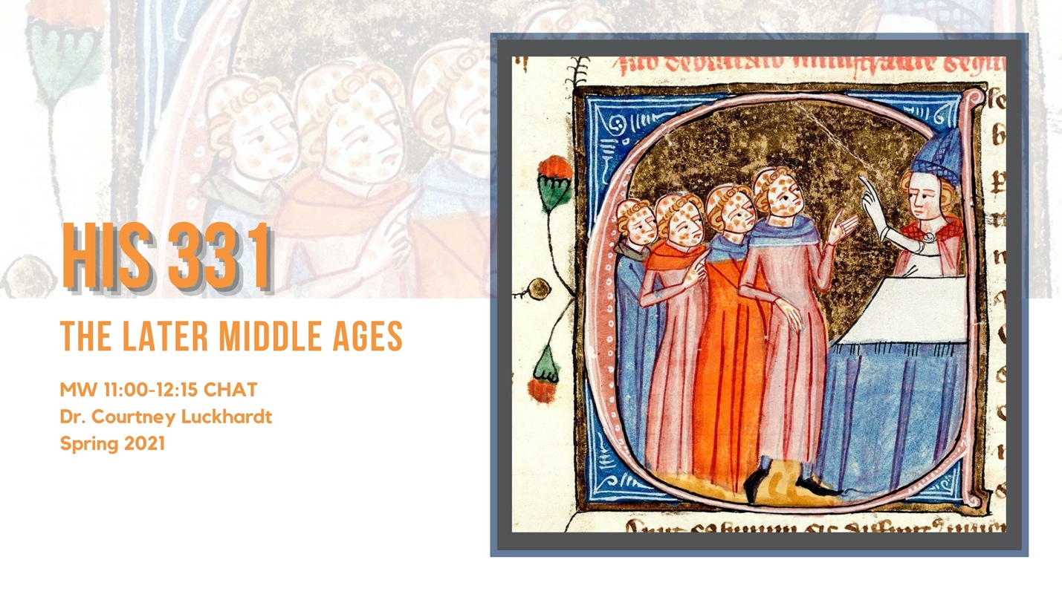HIS 331
The Later Middle Ages
MW 11:00-12:15 CHAT
Dr. Courtney Luckhardt
This course is designed as an in-depth examination of high and later medieval European history, roughly 1000 – 1450 AD. In this class, we shall see the development and flowering of new medieval cultures, from elite knights to lowly peasants, as well as the various crises that they encountered, including the Black Death. Our goal will be to trace the development of communities and cultures; social relations and economic conditions; political, religious and intellectual institutions and thought. You will acquire an informed understanding of topics and themes, from the role of the Christian church and secular authority in political systems, the cultural and ideological function of belief systems, to the nature of medieval source material, especially historical texts, religious texts, and material culture (archaeology).
HIS 334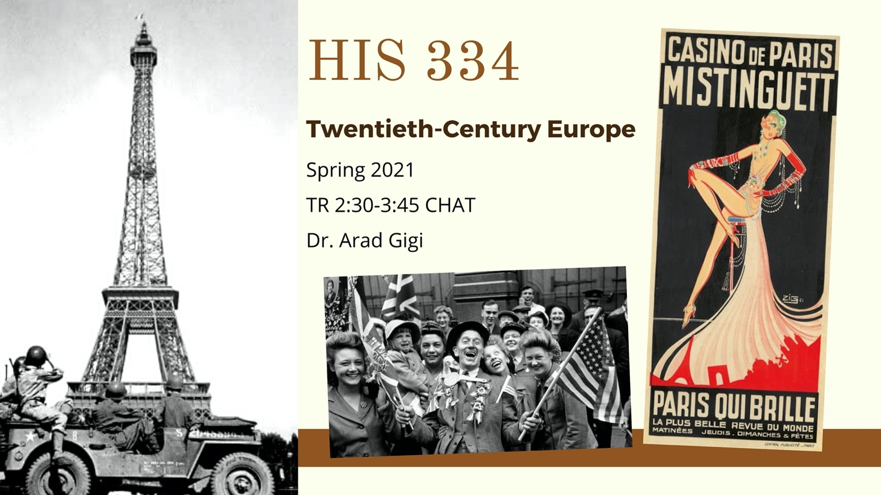
20th Century Europe
TR 2:30-3:45 CHAT
Dr. Arag Gigi
Twentieth-Century Europe, the century when the ‘Old Continent’ experienced not one but two world wars, only to then be plunged into a violent, draining, decades-long Cold War (which was anything but cold, actually). It is started with massive industrialization, radical nationalism, and the rise of extreme mass-political movements such as Fascism, Communism, and Nazism, all of which brought about death and despair on unprecedented scales, and turned to democracy, feminism, and human rights advocacies in the second half of the century. It is also a period of marvelous cultural developments in art, music, cinema, and the philosophy. In this course we will explore these various historical phenomena each on their own but also within the broader European and global contexts in an effort to gain a comprehensive understanding of this fascinating, unique period of modern history. Where else would you learn on Trench warfare, Blitzkrieg, and The Beatles and Pink Floyd in the same semester?

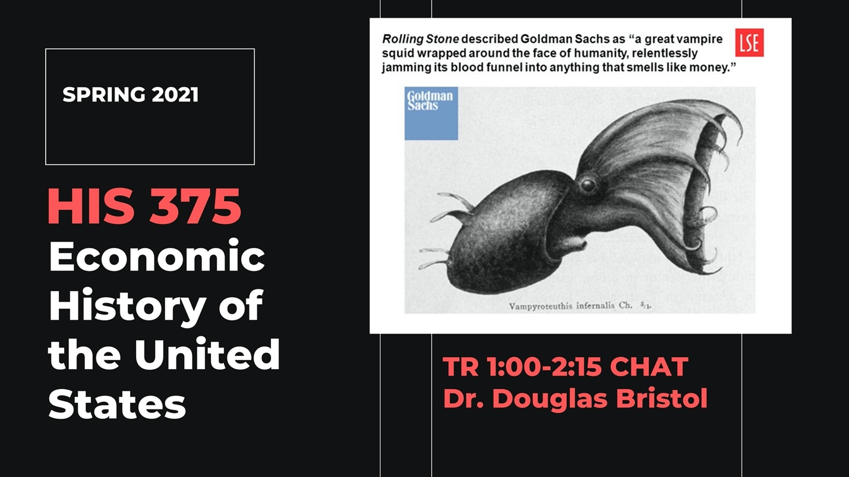HIS 375
Economic History of the United States
TR 1:00 - 2:15pm CHAT
Dr. Douglas Bristol
HIS 375 surveys the economic history of the United States from the 1820s to the present, which is presented in the context of the shift from an industrial to a service-based economy.
Major themes of the course are entrepreneurship, the evolution of the firm, globalization, regulating big business, and speculative manias. You will make comparisons between the past and the present for each of these themes. You will make two group presentations. In the first, you will describe Malcolm Gladwell’s 10,000 Hour Rule. In the second, you will evaluate Steve Jobs’ legacy based on your reading of Walter Isaacson's biography of Jobs.
NOTE: This course fulfills a degree requirement for Licensure in Social Studies. Licensure majors also have the option to prepare a lesson plan instead of taking the first examination.

HIS 375
Economic History of the United States
ONLINE (H080)
Dr. Max Grivno
The economic history of the United States traces the nation’s development from the colonial period through the late twentieth century. Although I have geared this course toward social studies licensure students, the content will be valuable to anyone interested in the broad contours of American history. The course views the dynamic and sometimes wrenching development of the nation’s economy from a variety of perspectives, tracing the lives of workers—both free and enslaved—along with those of inventors, managers, and policymakers. It considers how and why the nation’s economy changed, what those changes meant for consumers and workers, and how political leaders sought to regulate economic change.
For the spring semester of the 2020-21 academic year, I will be teaching History 375 as an asynchronous online course. Students will watch recorded lectures and documentaries, complete online quizzes, write weekly response papers, and take three examinations. There are no required readings for the course; all of the material necessary for this class will be available on Canvas.

HIS 400
Senior Capstone
Doing Cultural History
TR 1:00-2:15 CHAT (H001)
Dr. Douglas Chambers
This course is a senior capstone research seminar for upper division history majors. Our thematic focus will be on Cultural History, which is an approach that uses various humanities methods, especially from anthropology and literary studies to understand cultural traditions and interpretations of historical experience. We will begin with a set of core readings (three books in American history), and then proceed to a major term-paper based on original research.
Required Texts
Ramón A. Gutiérrez, When Jesus Came, the Corn Mothers Went Away: Marriage, Sexuality, and Power in New Mexico, 1500-1846 (Stanford University Press, 1991)
Nell Irvin Painter, Sojourner Truth: A Life, A Symbol (W. W. Norton and Co., 1997)
Mark Kurlansky, 1968: The Year That Rocked The World (Random House, Inc., 2004)

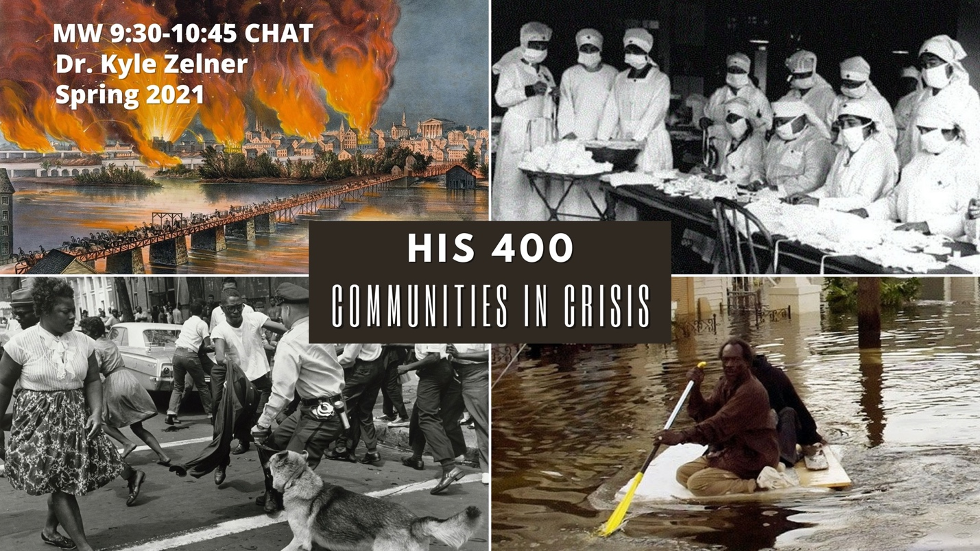HIS 400
Senior Capstone
Topic: Communities in Crisis
Dr. Kyle. Zelner
MW 9:30-10:45 CHAT (H002)
Reg. Code: 9044
Communities throughout history have had to deal with different crises, be they wars, natural disasters, pandemics, crime waves, civil unrest, or countless other catastrophes.
HIS 400 is the required senior capstone class for all history majors and as such, the class will include a mixture of discussion seminars and considerable independent research/writing time. After an overview of how to do primary research and historical writing, in the first several weeks, students will read a number of articles and/or books about communities in crisis and discuss them in a virtual seminar setting. For the remainder of the semester, students will research and write an original history of a community in crisis. The paper must make extensive use of primary documents (such as newspapers, oral histories, diaries, letters, and other accounts) as well as the secondary sources written on their topic. In addition to their major research paper (15-20 pages), students will be required to give two oral presentations on their work (which will be done virtually).
Some possible research paper topics might include:
•What happened to New York City during the American Revolutionary War?
•How did the community in Birmingham, Alabama experience the Civil Rights movement?
•What happened to the community in New Orleans during Hurricane Katrina?
•How did the Spanish Flu pandemic in 1918 change life in Chicago?
•What happened to Honolulu during World War II?
•How did the Civil War affect the town of Vicksburg?
The possibilities are almost endless . . .

HIS 415
World War I
TR 2:30-3:45
Dr. Andrew Wiest
This course will investigate the most important military/social event of the twentieth century, the Great War. With roots that date back to the age of great empires and repercussions that the world still deals with today, World War I ripped the old world asunder and laid the foundations for something new – at once a brave new world and one darkly sinister. On the battlefront the Great War transformed the way wars were fought – from battles that Napoleon or Robert E. Lee would recognize to battles that spanned a globe and destroyed a generation. As the world burned, societies were forged into something new, from women receiving the vote, to the rise of Fascism, to the coming of modernism. This course will balance the battlefield, the home front, and the humanity of war. Poetry, fiction, and music will also help us envision this important past.
Students will read: Alistair Horne; The Price of Glory: Verdun 1916; G.J. Meyer; The World Remade: America in World War I; Ernst Junger; The Storm of Steel; and Paul Fussell; The Great War and Modern Memory.
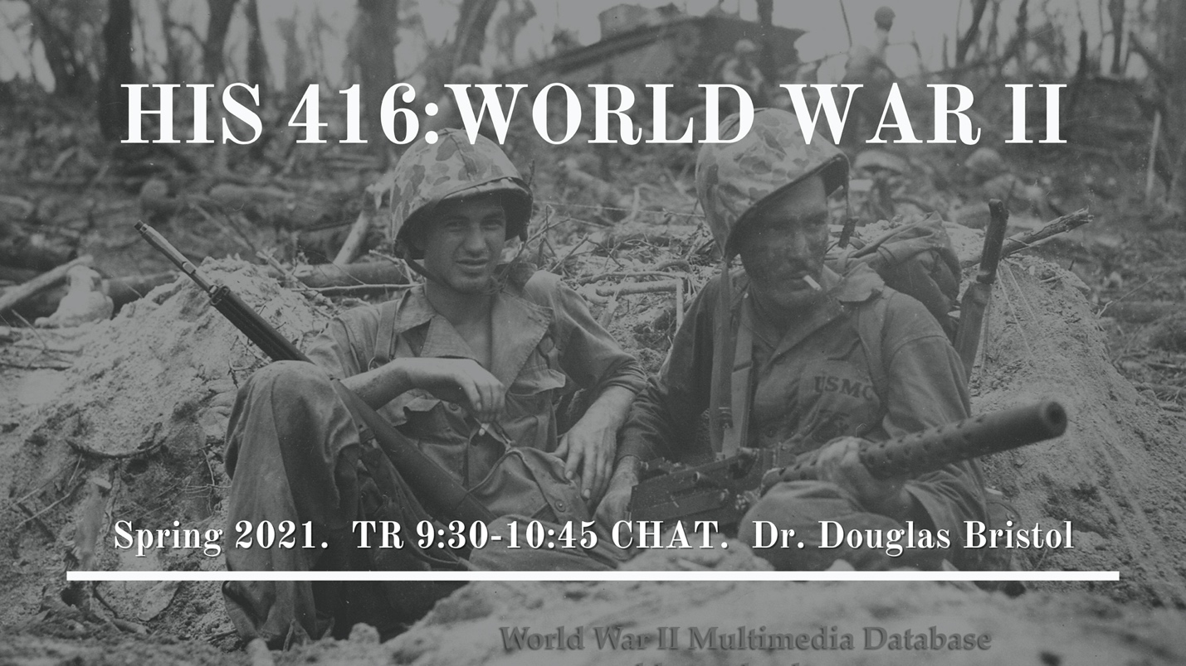HIS 416
World War II
TR 9:30 - 10:45 CHAT
Dr. Douglas Bristol
HIS 416/516 is an in-depth study of the causes, conduct, and aftermath of World War II. In this class, you will see the development of authoritarian governments and mobile warfare (Blitzkrieg) threaten liberal democracies, which were slow to respond and almost lost the war. You will understand how the Allies won, what the experience of ordinary soldiers was like, and what impact the war had on American society. You will make a group presentation on a controversial command decision. You will write an essay assessing German participation in the Holocaust based on reading Ordinary Men: Reserve Police Battalion 101 and the Final Solution in Poland. You will also write a research paper on a topic of your choice.
NOTE for Graduate Students: You will have your own syllabus and a number of separate meetings to discuss your readings. In addition, you will make a short presentation to undergraduates in the class

HIS 461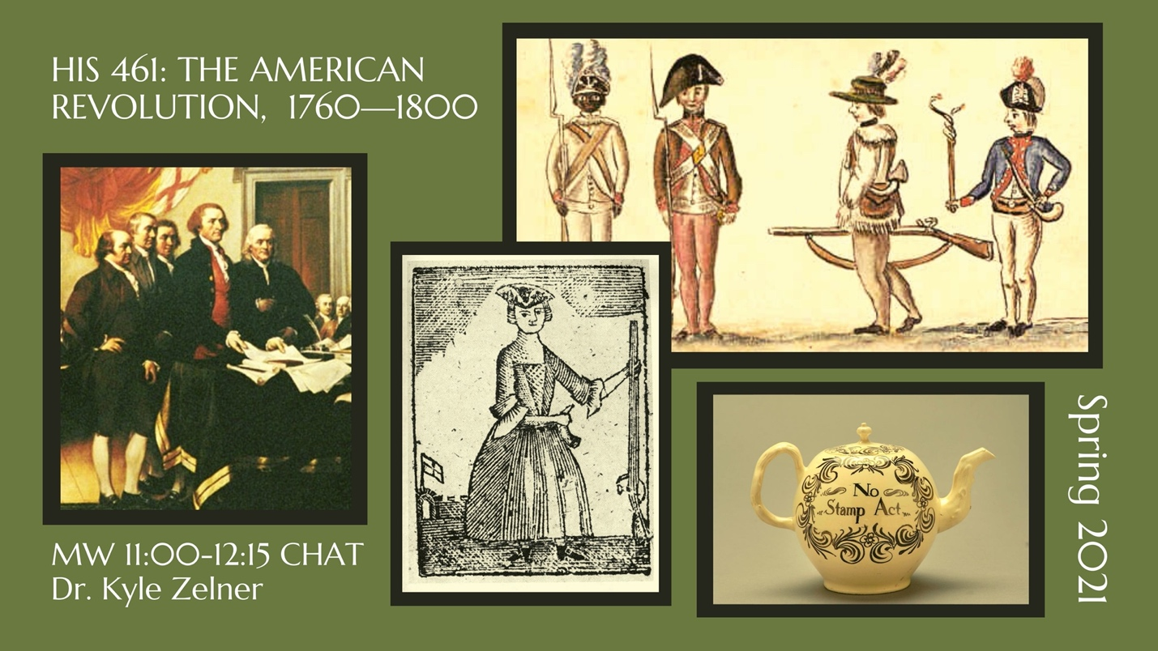
THE AMERICAN REVOLUTION, 1760—1800
MW 11:00-12:15 CHAT
Dr. Kyle Zelner
This course will examine the political, military, and social aspects of the Revolutionary period, roughly from 1760 to 1800. We will focus on the imperial crisis that leads to war; the politics of protest and nation-building; the military conflict from 1775-1783; Loyalists, African-Americans, and women during the war; the post-war crisis in national and state governments; the writing of and ratification fight over the new Constitution; and the Federalist era. Ultimately, we will have to attempt to answer the question, “Just how revolutionary was the American Revolution?”
HIS 461 is a great class for licensure majors as it covers many highlights of American Government classes, as well as Early American History.
Books for the class include:
Anderson, Virginia DeJohn. The Martyr and the Traitor: Nathan Hale, Moses Dunbar, and the American Revolution. New York: Oxford University Press, 2017.

Richard D. Brown, Major Problems in the Era of the American Revolution, 1760-1791. 3rd ed. New York: Cengage Learning, 2013.

Woody Holton, Forced Founders: Indians, Debtors, Slaves, and the Making of the Revolution in Virginia. Chapel Hill: University of North Carolina Press, 1999.

Bouton, Terry. Taming Democracy: “The People,” the Founders, and the Troubled Ending of the American Revolution. New York: Oxford University Press, 2007.

Assignments: Tentatively, class requirements will include three papers, a midterm and final exam, and active participation in weekly class discussions.

HIS 473
U.S. Foreign Relations
TR 1:00-2:15 CHAT
Dr. Heather Stur
In his farewell address in 1796, President George Washington warned Americans to “steer clear of permanent alliances.” President Donald Trump thinks NATO is exactly that. Between America’s beginning and the U.S. of today, presidents, citizens, diplomats, and military leaders have thought of U.S. foreign relations in a variety of ways. Some have considered it to be America’s duty to the world. Others have argued that the U.S. should focus internally. Some have emphasized that with U.S. expansion comes liberty, while others have accused the U.S. of imperialism. In this course, we will investigate these debates and more as we explore the history of U.S. foreign relations from the founding of the U.S. to the present, including presidential philosophies, military interventions, the role of ordinary citizens in diplomacy, and the impact of American culture on international affairs. Grades will be based on exams, written assignments, and online discussion/presentations. There are no textbooks to be purchased for this class – all readings will be available for free on our class Canvas page.

HIS 475
American Indians of the Southeast
MW 1:00-2:15 CHAT
Dr. Joshua Haynes
Native American history is southern history. When Americans imagine southern history, they often think of the Civil War and Civil Rights. But for centuries before those events, Native Americans ruled the South. This course focuses on the Native South from the early Mississippian Period (800 CE) to the Civil War (1861-1865). We will examine the distinctive pre-contact cultures of the Native South characterized by agriculture, chiefdoms, matrilineal kinship, and temple mounds. We also will explore the ways colonialism changed Native Southerners. Environmental change, disease, trade, and warfare all led Native Americans in the South to transform their societies. Finally, we will scrutinize U.S. Indian policy culminating in the forced removal of many Native Americans from their homelands and Native Southerners’ responses to the Civil War.

HIS 477/WGS 410
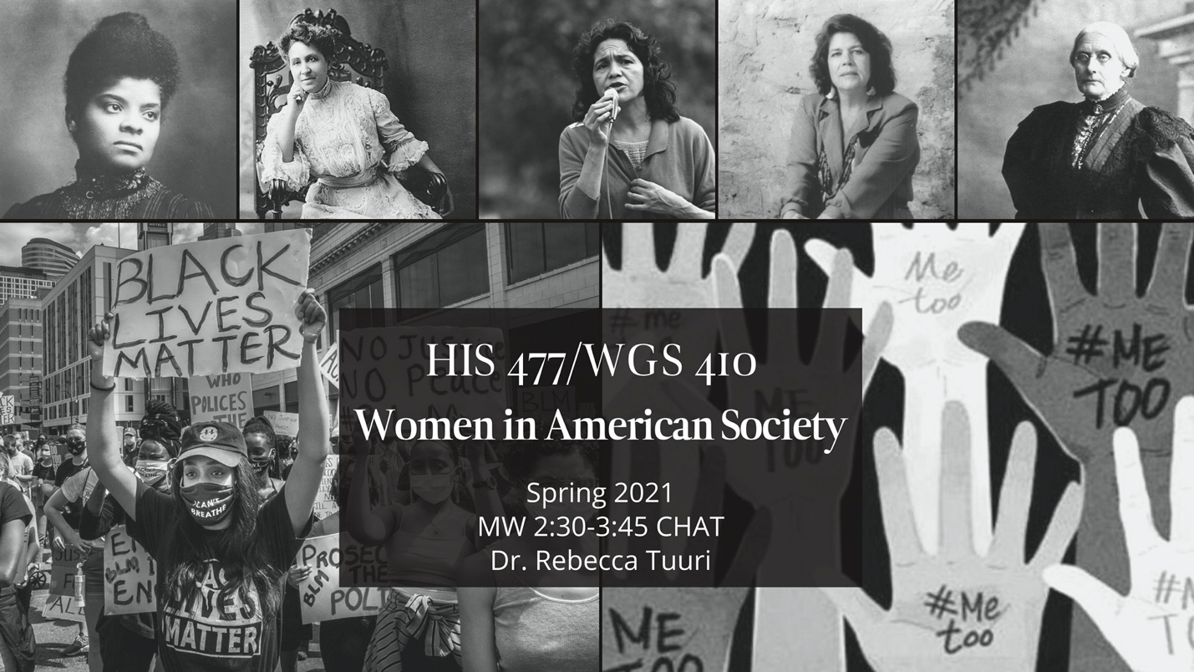
Women in American Society
MW 2:30-3:45 CHAT
Dr. Rebecca Tuuri
This course will focus specifically on women who have lived in the region that is now the modern United States, from pre-European contact to the present #Me Too and #BLM movements. Topics will include work, family, religion, war, sexuality, organizations, and feminism. We will study women’s activism, their everyday lives, the changing concepts of women’s proper “place” in society, and the relationship of women to gender and sex. We will consider how differences across race, class, ethnicity, and region have affected women’s status and women’s interactions with one another. Finally, we will explore the development and evolution of the historical subfield of women’s history and its impact on the historical profession.

HIS 482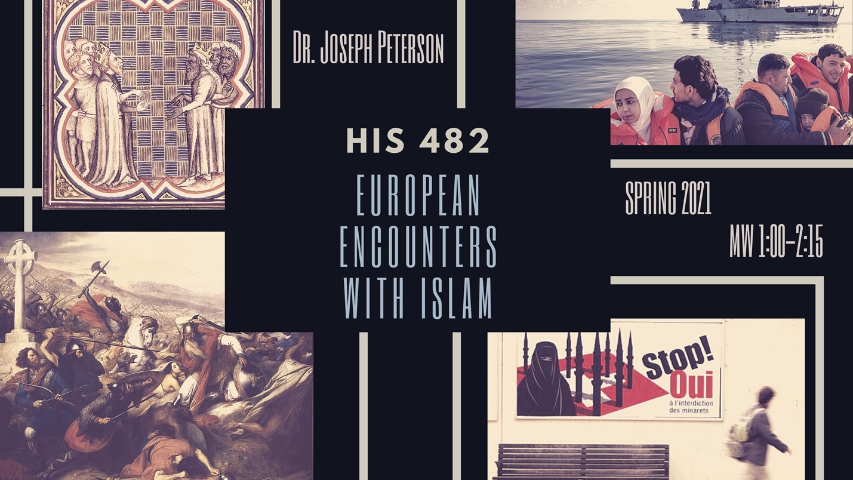
European Encounters with Islam
MW 1:00-2:15
Dr. Joseph Peterson
Why do some people in Europe and in the West see Islam as a threat to European values? Why do so many fear that Muslim immigration will fundamentally transform or destroy "Western Civilization"? Why do Westerners assume that "Islam" is not a complex religion, but a single, unified civilization? Why do Westerners often associate Islam with a race—Arab-ness—even though the majority of Muslims worldwide are not Arabs? Have Europeans always thought of Islam this way: as an enemy of liberal values, of secularism, and of gender equality, even a racial enemy?
Despite current ideas of a "clash of civilizations" between the West and the Islamic World, there is in fact a long and not-always-violent history of Muslim presence within Europe and of European thinking about Islam. In this course, we will explore the history of European and Western approaches to Islam: from medieval religious debates and Enlightenment travel writing, up through the colonial conflicts of the nineteenth and twentieth centuries, and all the way to present-day anxieties over Muslim immigration, “political” Islam, and terrorism. We will focus especially on how European attitudes towards Islam have become increasingly racialized, viewing Islam not only as the traditional religious enemy, but now also as a racial (usually Arab) Other. We will also look at the gendered dimensions of these discourses, with Muslim men often portrayed as sexual threats, and Muslim women portrayed as in need of saving.

HUM 402/502
Digital Humanities Practicum
TR 2:30-3:45
Dr. Stephanie Seal Walters
This course is designed to engage both undergraduate and graduate students in a specialty field within the digital humanities. Students will learn how to research, build, and curate online exhibits using Omeka Classic and Omeka S software, the current field standard for museums, archives, and public history sites. Students will build interactive online maps, think about ways to engage the public, and conduct user tests on a large-scale digital humanities projects. This specific HUM 402/502 class will use Dr. Susannah Ural’s “Civil War and Reconstruction Governors of Mississippi” digital project as the basis for learning and creating online content.
There are no prerequisites for this class and no background in digital humanities or programming is required. Students will learn all skills necessary to create these exhibits in class.

IS 491
Senior Capstone in International Studies
Everything You Always Wanted to Know about Vladimir Putin But Were Afraid to Ask
MW: 11-12:15 CHAT
Dr. Brian LaPierre
International Studies 491 is the senior capstone seminar required of all International Studies majors and minors. However, the course is not limited to IS majors/minors and all interested students are welcome. This semester, we will be studying Vladimir Putin and the Russia that he has created. It is not an exaggeration to say that Putin is one of the most well-known and controversial politicians on the planet. To his admirers, Putin is a model of assertive and effective leadership; he is the statesman who made Russia great again. For his critics, however, Putin is a corrupt dictator who has trampled on human rights, destroyed Russia’s post-communist democracy, and led a global campaign against Western institutions and liberal ideals. In this semester, we will study Putin in all his complexities. By researching Putin and his policies, students will better understand this pivotal global figure and his role in Russia and the wider world.

