Spring 2021
PHI 151
Introduction to Philosophy
ONLINE (H080 and H081)
Dr. Michael DeArmey
An online course. An introduction to the most basic questions human beings ask about themselves and the world, and the answers philosophers have developed in response to these questions. What does it mean to know something? What is real? What is the mind? Self? Is there a God? What makes an object an art object? How can I tell what is right and what is wrong? What is evil?

PHI 151
Introduction to Philosophy
ONLINE (H082)
Dr. Paula Smithka
Aristotle says, “For it is owing to their wonder that people both now begin and at first began to philosophize”.
Philosophy begins in wonder. It’s about asking fundamental questions—questions like, “Does God exist?”; “What is the nature of reality?”; “Is what I perceive really the way things are?”; “What is a Self?”; “Am I the same person over time?”; “What makes an action morally right?”
Study philosophy and unlock your mind!

PHI 151
Introduction to Philosophy
ONLINE (H083 & H084)
Dr. Katarzyna Paprzycka-Hausman (Dr. P.)
This course is an introduction to three major areas of philosophy: metaphysics (study of being), epistemology (study of knowledge) and ethics (study of morality). It will take into account both traditional and contemporary approaches. We will begin with some issues in the philosophy of religion: Can one prove that God exists? Is the existence of evil compatible with the existence of an all-good all-powerful being? We will then consider some issues in epistemology: Do we know (as opposed to merely believe) anything? Can we know anything about the future (scientists frequently make claims to knowledge)? We will end with the consideration of some issues in ethics: Is morality relative? What does it mean to be moral? We will read excerpts from St. Anselm, Descartes, Locke, Hume, J.St. Mill, Kant as well as some contemporary authors. The course is largely self-paced but you are required to meet five deadlines.

PHI 171
Ethics and Good Living
ONLINE
Dr. Sam Bruton
One of the earliest and most enduring of all philosophical questions is both unavoidable and profoundly important for all of us: How Should I Live? This course examines classic and contemporary answers to this question. The goal is not to arrive dogmatically at one favored view or to criticize those who lead lives very different from our own. Different people find meaning in different ways. Rather, the goal of the class is to help each student refine his or her own answer to the question by studying the most respected and time-tested views available to us.

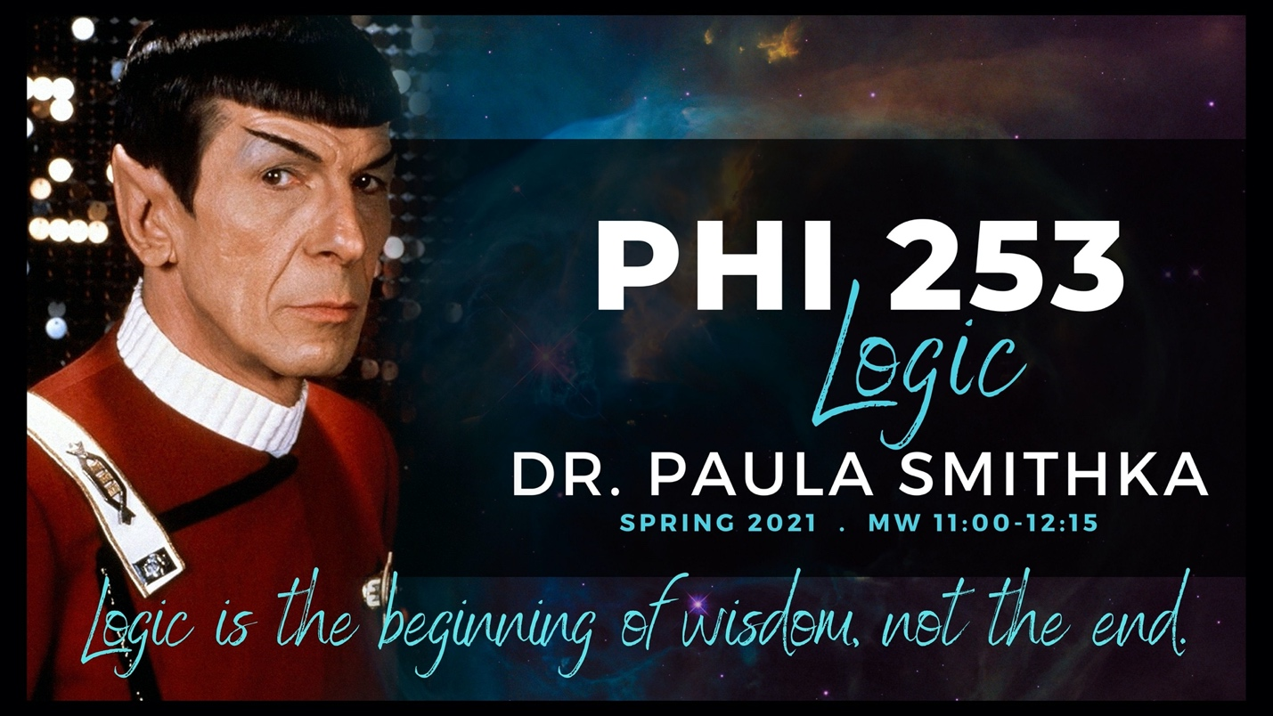PHI 253
Logic
MW 11:00-12:15
Dr. Paula Smithka
Developing good critical thinking skills is useful for clarity of reasoning and evaluating the views of others both in philosophical studies and everyday life. In Logic, you will learn the importance of having evidence or reasons to support one’s views, how to evaluate arguments for their strength and cogency, and how to construct good arguments. In addition, you will not only learn what constitutes a good/strong argument but we will examine common mistakes in reasoning. The reasoning skills that you begin to develop by taking a logic course will aid you in whatever academic or professional directions you choose to take. This course will make you a detail person!

PHI 351
Critical Thinking
MW 1:00 – 2:15 (H001)
ONLINE (H080)
Dr. Sam Bruton
This class introduces students to skills for becoming a more effective thinker and a better reasoner, including various techniques for avoiding common reasoning pitfalls and for critiquing the flawed reasoning of others. From interpreting political debates to careful evaluation of scientific evidence, good critical reasoning skills are invaluable in most aspects of life. Some class time is set aside to practice the kinds of questions commonly found on the LSAT, GRE, and other standardized tests. This course is required for the Philosophy Pre-Law emphasis track.
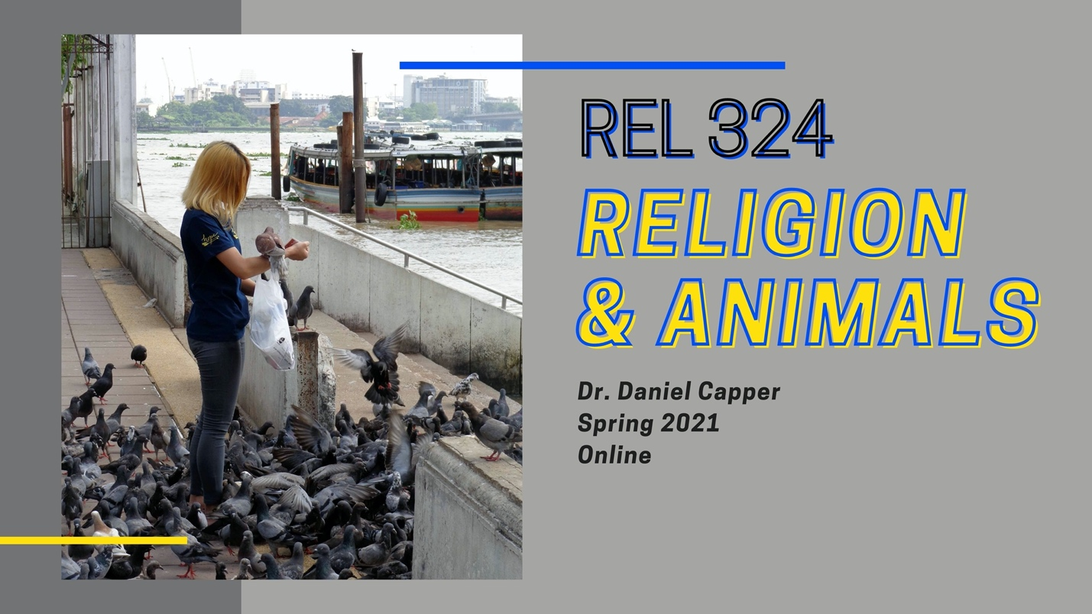REL 324
Religion & Animals
ONLINE
Dr. Daniel Capper
Across times and cultures animals have played myriad roles in human religiosity. This course examines some of these interactions between human religions and the nonhuman natural world. Topics include fundamental theories of human-animal interactions, the psychology of human experience of nature, environmental ethics and metaphysics, pet keeping, religious perspectives on the uses of animals in science, and the appearances of animals in a variety of religious settings.

PHI 440
American Philosophy
ONLINE
Dr. Michael DeArmey
An examination of significant philosophical movements and thinkers in the history of American Philosophy, with a special focus on John Dewey's lifelong analysis of democracy, as well as other contemporary analyses of the problems of democracy.

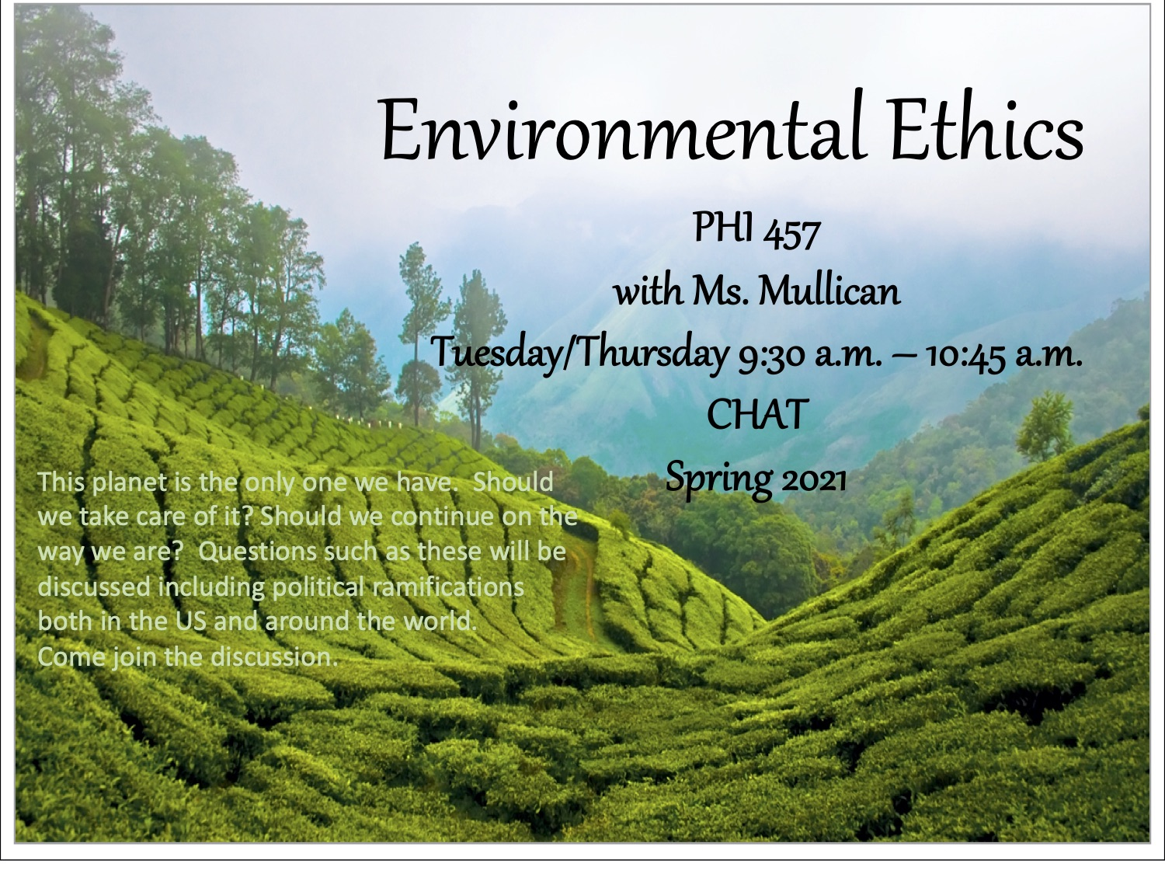PHI 457
Environmental Ethics
TR 9:30-10:45 CHAT
Ms. Susan Mullican

REL 490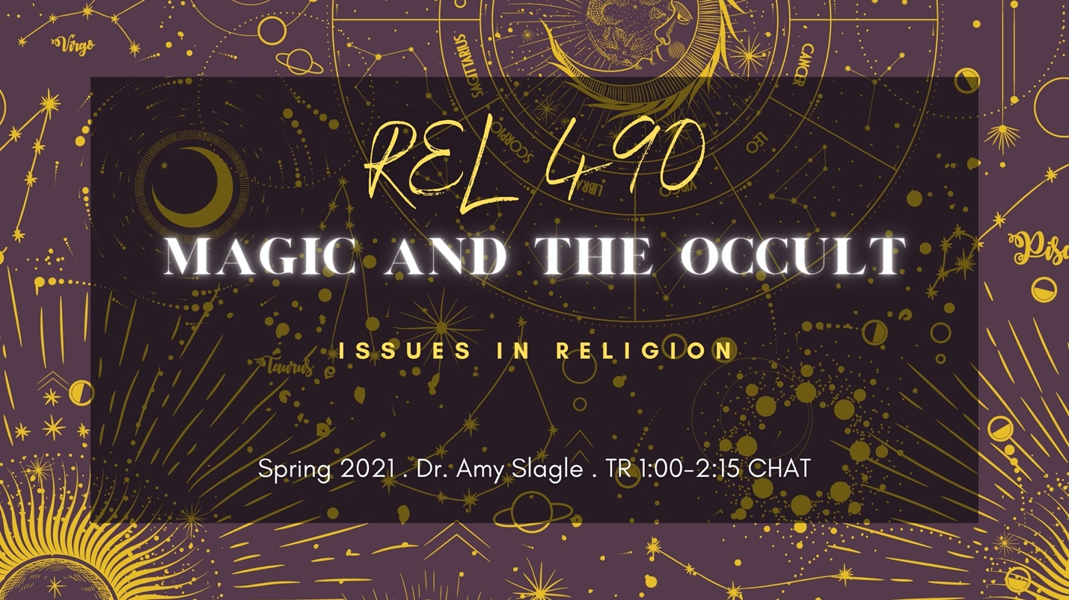
Issues in Religion
Magic and the Occult
TR 1:00-2:15 CHAT
Dr. Amy Slagle
Why have witches and magicians been so maligned and feared over the centuries? What is magical practice? Why do people believe in ghosts, vampires, and the possibility of communicating with the dead? These are just a few of the questions to be discussed in “Magic and the Occult” (Religion 490). This course explores the theory and practice of magic and the occult (including spiritualism, forms of divination, and paranormal research) as they have developed within the Western esoteric tradition. Particular attention will focus on how these phenomena continue to shape religious life today.

