English Graduate Course Descriptions

Summer & Fall 2022 Course Descriptions

Summer 2022
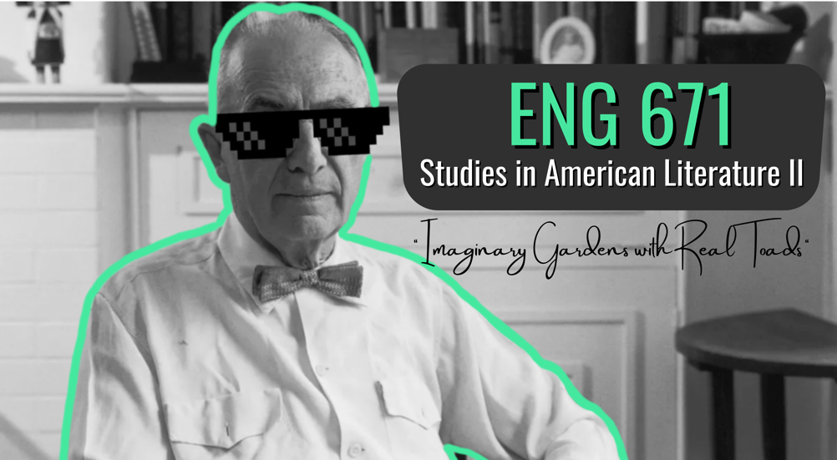

ENG 671
Studies in American Literature II
“Imaginary Gardens with Real Toads"
Dr. Adam Clay
MWF 8:00-11:15AM

** fulfills American post-1865

This course will consider American poets from the period of modernism, including William Carlos Williams, Wallace Stevens, Marianne Moore, Langston Hughes, H.D., Hart Crane, and others. We’ll be particularly interested in the interplay between ideas and things, to borrow a phrase from Williams, and initially discuss poems from Dickinson and Whitman to develop a framework for the poets that follow them. This course will especially benefit students preparing for comprehensive exams, though all are welcome. Students will submit shorter response papers each week and a longer seminar paper at the end of the term.

Fall 2022
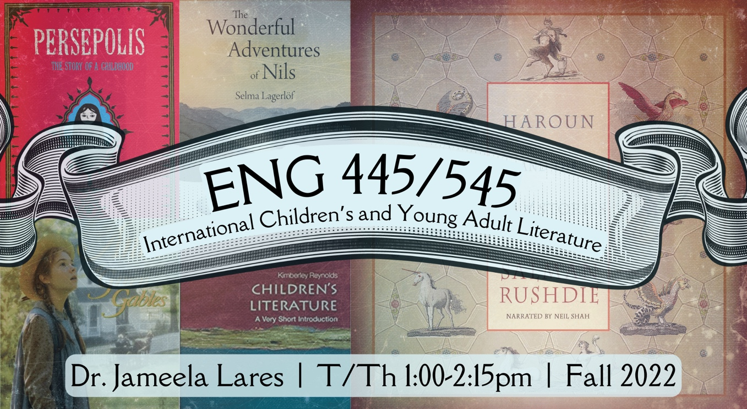ENG 445/545
International Children’s and Young Adult Literature
Dr. Jameela Lares
T/Th 1:00-2:15PM

** fulfills non-traditional requirement

This seminar will explore the world of children’s and young adult literature from countries outside the Anglo-American tradition to see how other cultures understand childhood and adolescence. Readings will focus on three areas—schools, conflicts/adventures, and fantasy—but undergraduate seminar members will be able to add to the conversation by reporting on an additional text, while graduate members will be able to add their further insights by teaching one of the assigned texts. Undergraduates will also facilitate class discussion on an assigned text, while graduate members will report on a critical article, chapter, or even book. Our assigned readings will be primarily novels, but class members may also explore other genres or media (pictures books, movie tie-ins, games, etc.) for their presentations and their seminar paper.

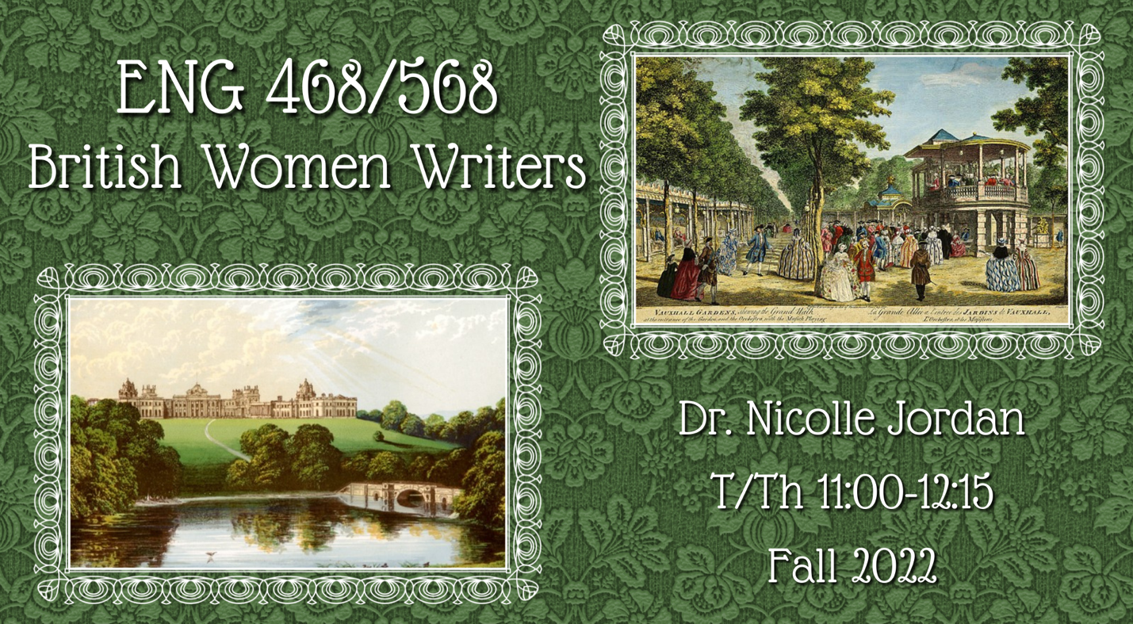ENG 468/568
British Women Writers
Dr. Nicolle Jordan
T/Th 11:00AM-12:15PM

** fulfills British pre-1800

How does female identity vary depending on whether it is depicted in a rural or urban setting? Is one setting more congenial to the heroine—or the woman writer—than another? How does a woman’s experience of the country and/or the city vary depending upon her social status? In this course we will read British poetry and novels that imagine female characters in an array of settings, from the bucolic English countryside to the bustling social season of London. We will explore whether a woman’s value, and her values, change depending on the familiarity or strangeness of her surroundings.

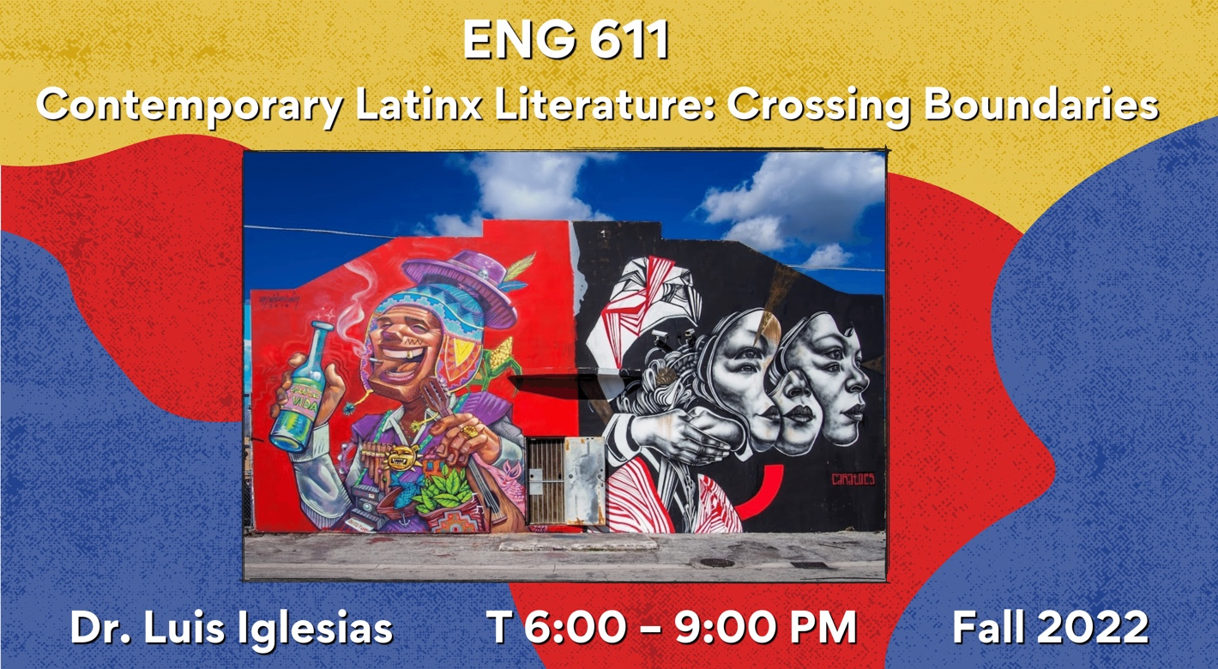ENG 611
Contemporary Literature
“Contemporary Latinx Literature: Crossing Boundaries”
Dr. Luis Iglesias
T 6:00 – 9:00PM

** fulfills non-traditional requirement

“Contemporary Latinx Literature: Crossing Boundaries” will explore the multiethnic, multiracial, and socially diverse dimensions of contemporary Latina/o/x literature. A problematic category of internal differences, Latinx writing and culture are most frequently understood in relation to “the border,” itself manifested in a variety of both spatial and psychic ways. This class will read a range of works across different genres as we unpack the monolithic term “Latinx,” which has come to represent a diverse set of communities from across the full spectrum of American life, experiences, and geography. At the same time, we will seek to locate those moments – literary, aesthetic, and/or experiential – that problematize (and often reject) the boundaries of “borders” that define “Latino” identity in the U. S. across a prolific body of writings.

Among the texts:

Unaccompanied (2017): Javier Zamora
House of Broken Angels (2018): Luis Alberto Urrea
Poet X (2018): Elizabeth Acevedo
Lot: Stories (2019): Bryan Washington
Postcolonial Love Poems (2020): Natalie Diaz
Fiebre Tropical (2020): Juliana Delgado Lopera
An Incomplete List of Names (2020): Michael Torres
Of Woman and Salt (2021): Gabriela Garcia
Stepmotherland (2022): Darrel Alejandro Holnes
High-Risk Homosexual: A Memoir (2022): Edgar Gomez
Please contact Prof. Iglesias with questions: Luis.Iglesias@usm.edu

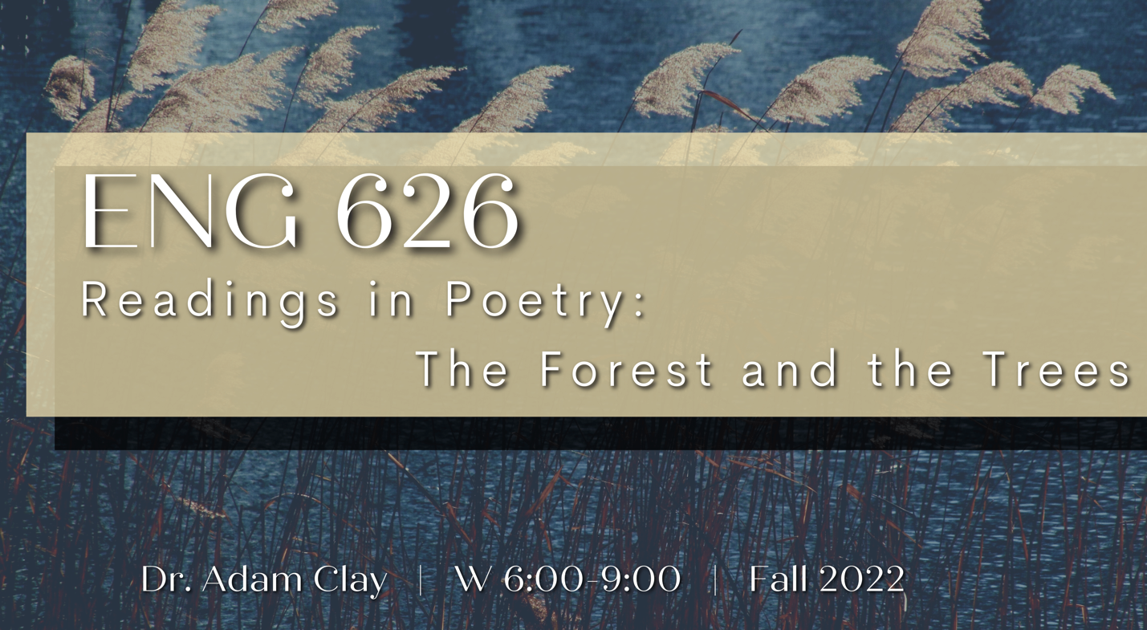ENG 626
Readings in Poetry: The Forest and the Trees
Dr. Adam Clay
W 6:00-9:00PM

** fulfills creative writing elective, only open to CW students

In ENG 626 we’ll consider contemporary first books of poetry (published within roughly the last ten years) and discuss how structure and order can influence the way a book functions. To section or to not section? Should you have a title poem? Frontloading? Thematic structure? Chronological ordering? Epigraphs? Where does that long poem/sequence go? We’ll invite poets (virtually and otherwise) to discuss their techniques and approaches. Students will also interview a writer of their choosing and report back to the class on their findings. This class will be insightful for poets working to draft a thesis or dissertation, but fiction writers will also find the course helpful in terms of how to thematically order a collection of stories.

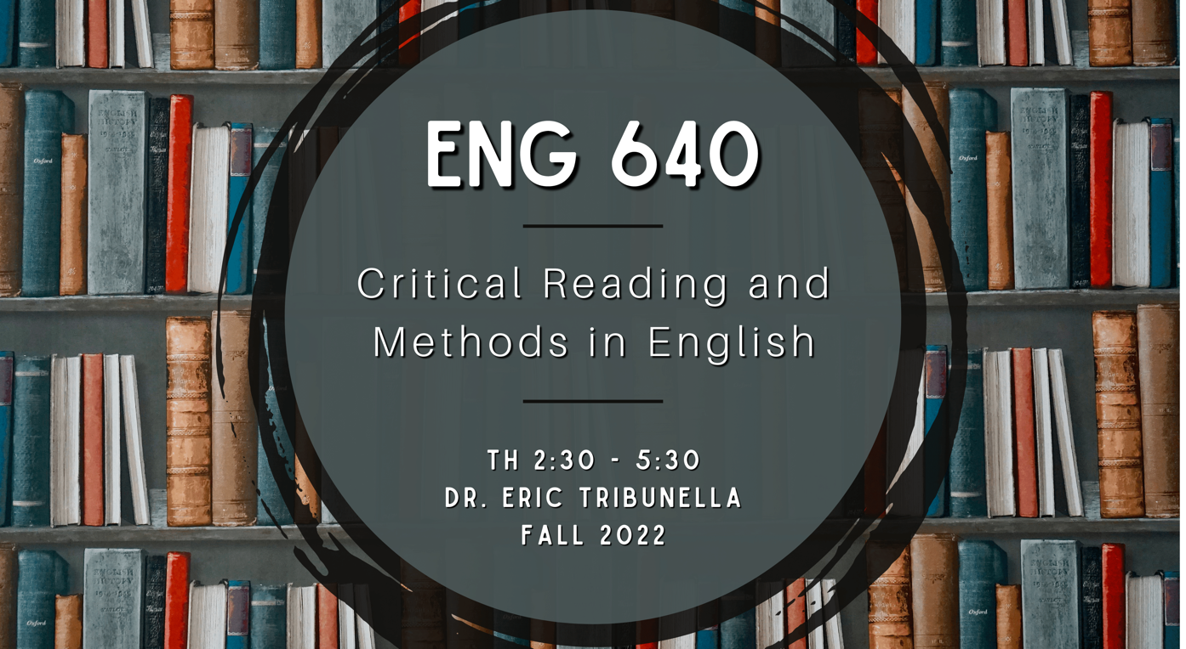ENG 640
Critical Reading and Methods in English
Dr. Eric Tribunella
Th 2:30-5:30PM
ENG 640 is designed to introduce or review the methods of research in literary studies, the conventions of scholarly conversations about literary works, common critical approaches to literary analysis, and the components and mechanics of literary-critical essays. We will read a selection of literary and theoretical works to consider how critics engage in scholarly conversations and shape analytical projects.

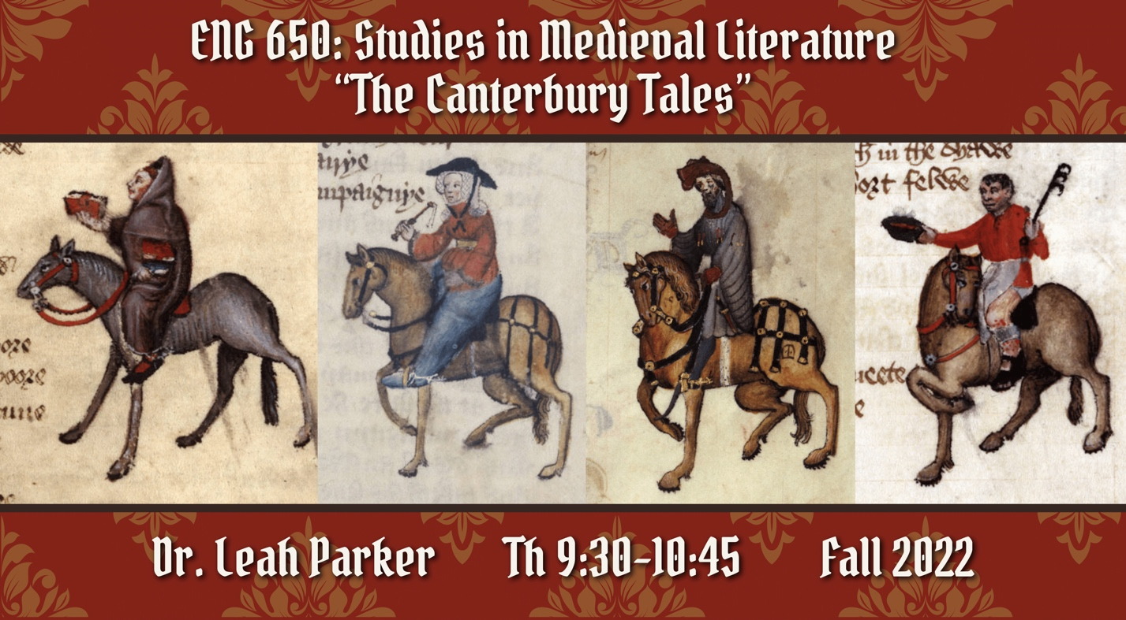ENG 650
Studies in Medieval Literature
“The Canterbury Tales”
Dr. Leah Parker
T/Th 9:30–10:45AM

** fulfills British pre-1800
In this seminar, we will read—in full!—one of the most influential works in the history of English literature: Chaucer’s Canterbury Tales. We will trace through the Tales questions of genre and poetic form, truth and fiction, disability and embodied difference, sex and marriage, sin and salvation. Seminar participants will receive extensive training in reading Middle English, learn about the late medieval context in which Chaucer wrote, and develop a deep understanding of one of the most widely read works in the British literary canon. Required text: Geoffrey Chaucer, The Riverside Chaucer, 3rd edition (Oxford University Press, 2008 reissued paperback), ISBN: 978-0-19-955209-2

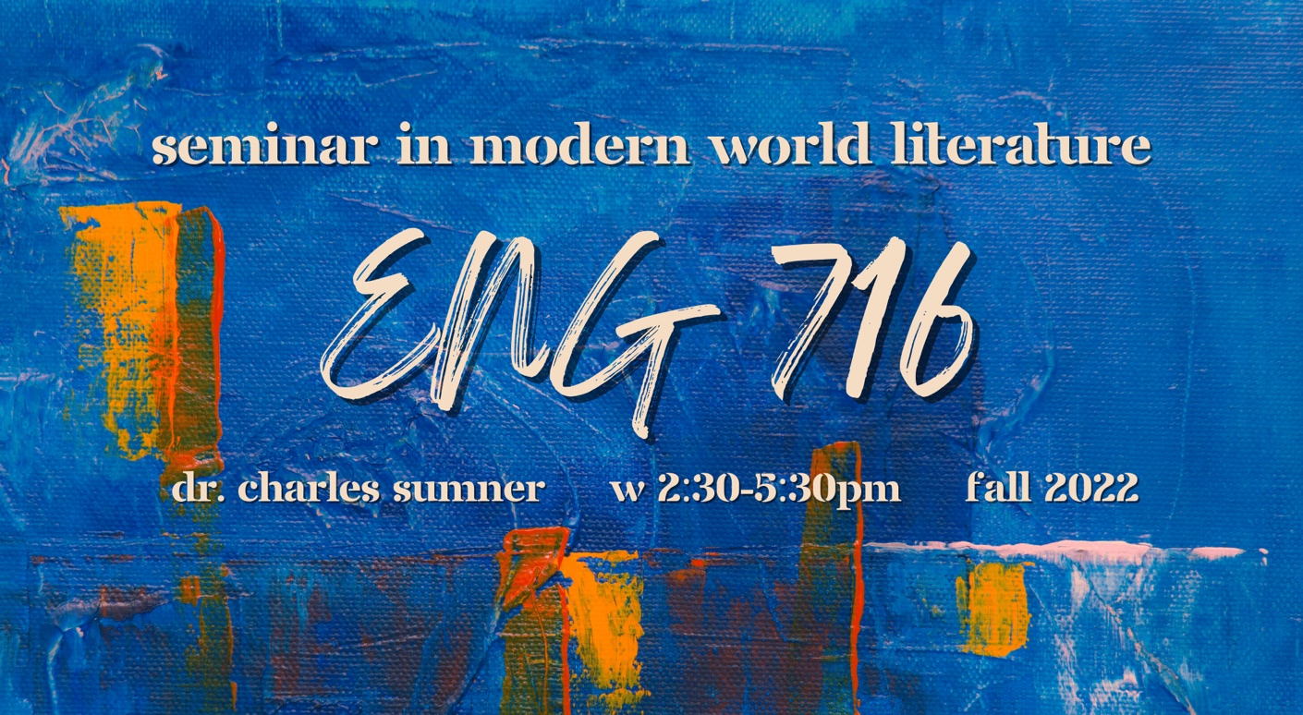ENG 716
Seminar in Modern World Literature
Dr. Charles Sumner
W 2:30-5:30PM

**fulfills American post-1865, British post-1800

This class will set modernist literature in its internal context in order to demonstrate the formal and ideological influences and pressures that major writers from America, Great Britain, and the continent exerted on each other during this period. Major writers include Marcel Proust, Franz Kafka, Filippo Marinetti, André Breton, T. S. Eliot, Wyndham Lewis, and Ernest Hemingway, among others.

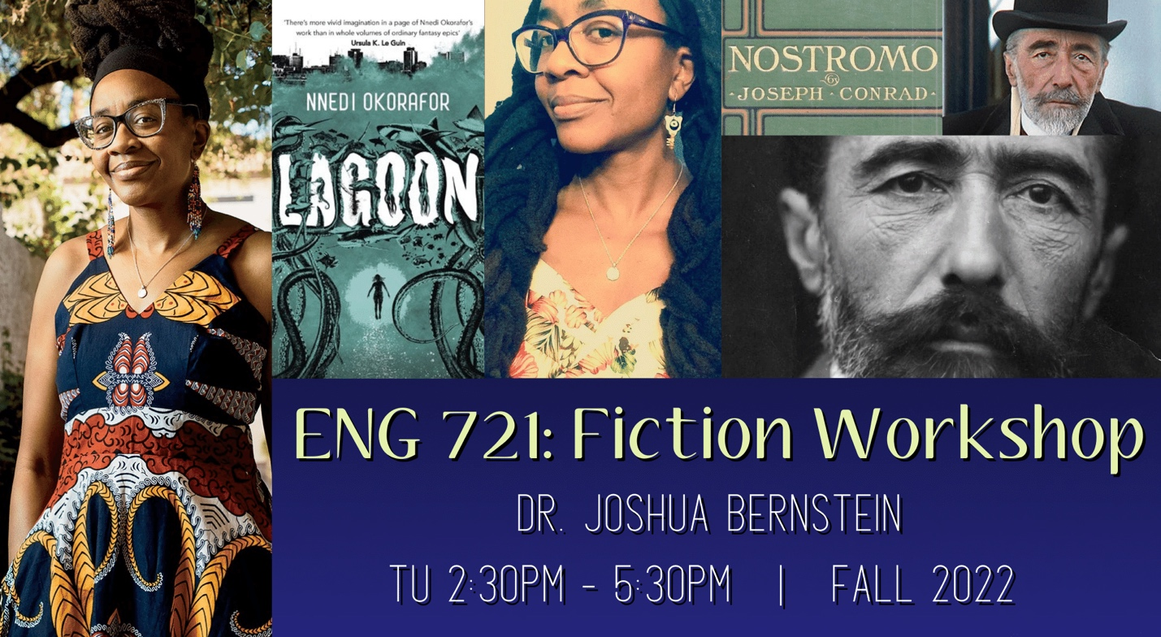ENG 721
Fiction Workshop
Dr. Joshua Bernstein
Tu 2:30PM - 5:30PM

** fulfills fiction workshop
What does it mean to depict a foreign setting in literature, and what’s at stake in doing so? We’ll read two novels about fictionalized locales, one in colonial South America, the other a future but no-so-distant Africa. We’ll also draw on our own experiences as writers to try our hands at recreating places, both imagined and remembered. We’ll pay attention to the normal aspects of craft—scene-creation, plot development, perspective, tense, pacing, conflict, and dialogue. We’ll also talk about world-building: how much to show, how much to tell, and when, if ever, to explain things to a reader, including foreign phrases or customs. Naturally, those who have never been outside the United States are equally welcome in this class. For workshop, you may submit either stories or excerpts from a larger project, such as a novel.

Readings:
• Nostromo, Joseph Conrad
• Lagoon, Nnedi Okorafor

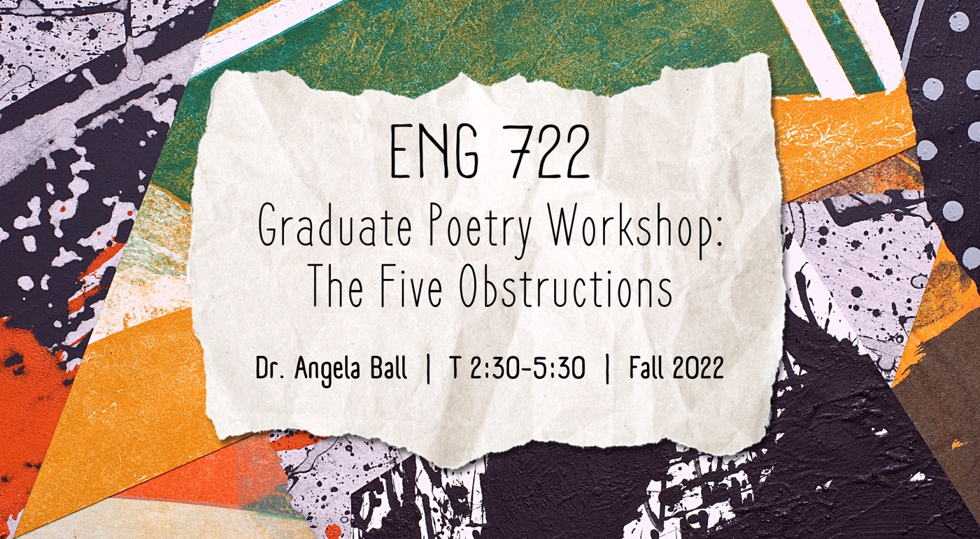ENG 722
Graduate Poetry Workshop: The Five Obstructions
Dr. Angela Ball
T 2:30-5:30PM

** fulfills poetry workshop

This workshop has its source in Lars von Trier’s 2003 film, The Five Obstructions, in which von Trier asks his mentor, director Jorgen Leth, to remake his 1967 short film, The Perfect Human in accordance with various crippling stipulations, or “obstructions,” such as “no frame longer than twelve seconds,” “set it in the worst place in the world,” etc. In the workshop version, the student submits his or her poem, which is commented on by the first respondent, also known as the “vile obstructionist,” then by the group as a whole. At the end of the discussion, the obstructionist provides the poet one or more obstructions which he or she must use in the revision.
I consulted a few of our former graduate student poets for their response to the Obstructions workshop. Here is what two of them had to say:
Gary Wilkens:
One way that will beat the fluff out of your lines is to move the poem to the other side of the formal/free distinction. If it's verse, remove the meter. If it's free, put it into iambic pentameter. Going from verse to free allows the voice to speak, well, freely, and leads to discovery, and moving from free to verse eliminates excess and creates rhythm.
Greg Weiss:
I found that the obstructions that helped me the most were those that were fairly general, but still changed the poem in a fundamental way--two examples would be obstructions related to the length of the poem--"Make it twice/half as long"--or the point of view of the poem--"Write it from this character's perspective."
The notion behind the workshop resides in a paradox: sometimes the imposition of requirements is freeing to the poet and to the poem.

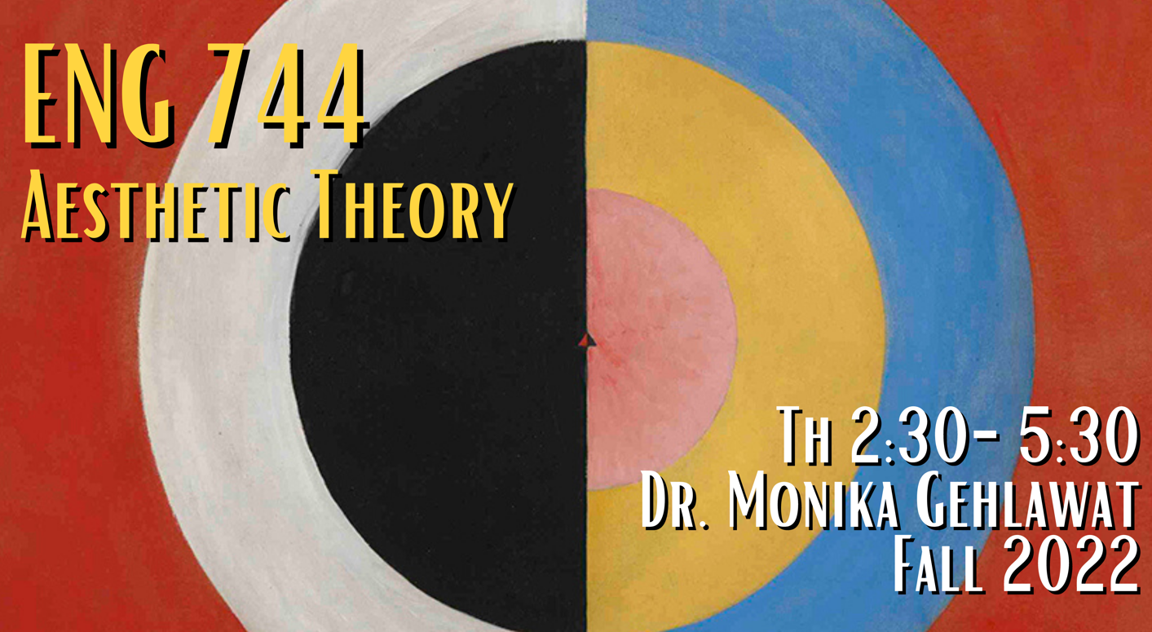
ENG 744
Aesthetic Theory
Dr. Monika Gehlawat
Th 2:30-5:30PM

** fulfills theory requirement

Casting a wide net, this seminar will engage with different schools and critics who contribute to discussions of aesthetic theory. The Frankfurt School and continental theory, Maurice Merleau-Ponty’s theory of phenomenology and perception, bell hooks’ writing on visual politics, theories of ekphrasis, and contemporary affect theory will be among the work we read this semester. In addition to theory, we’ll read art historians and cultural critics who have contributed to a discourse around and about aesthetic experience. Throughout the semester, we will consider a variety of art forms including, but not limited to painting, photography, music, film, installation art and sculpture, and of course, literature.

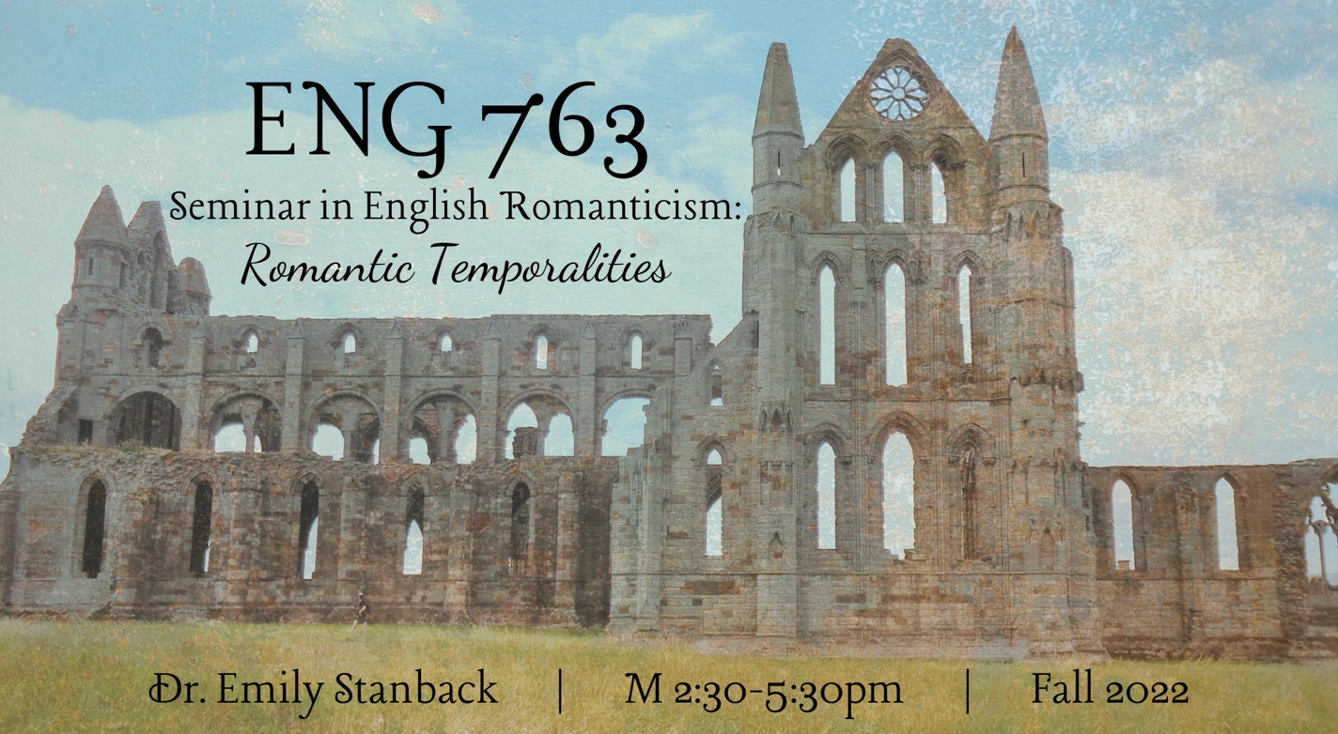ENG 763
Seminar in English Romanticism: Romantic Temporalities
Dr. Emily Stanback
M 2:30-5:30PM

** fulfills British post-1800

This course focuses on Romantic-era texts that will allow us to reflect on the theme of time–how we mark days and years and eras, tensions between experiential time and measured time, cycles and repetitions, memory and remembrance, imaginative time travel, crip time, traumatic remembrance, and even geological time. Major course readings will include William Wordsworth’s autobiographical The Prelude, in which the author explores the relationship between past and present selves, as well as what he calls “spots of time,” those memories that “From our first childhood” “Are scattered everywhere” through our lives–and continue to act upon us. We will look at the ways that Charlotte Smith engages deep time, human history, and personal history in focusing on the landscape of “Beachy Head.” We will look at how time and language loop and cycle in Samuel Taylor Coleridge’s “The Rime of the Ancient Mariner,” and the time travel of “Kubla Khan.” We’ll consider the ways that traumatic recollection shapes Mary Prince’s History, the immediacy and deferral of John Keats’s letters, Thomas DeQuincey’s imagining of the human mind as a palimpsest, the no-time and apocalypse of John Clare’s asylum-era poetry, and how Dorothy Wordsworth’s journals mark the passing of time by day and weather and season. We’ll think about commemorative poetic forms, such as elegies and epitaphs; commemorative texts that mark events, dates, and holidays; and commemorative objects, such as gravestones and mourning jewelry. We’ll consider ruins and relics, as well as the ways that art might transcend human mortality: “When old age shall this generation waste,” Keats writes of the Grecian urn, “Thou shalt remain.” We’ll also consider questions of temporality and form, such as how texts, particularly poetry, embody, enact, speed up, and warp the passing of time–through meter, for example, or repetition, chiasmus, alliteration, or rhyme.

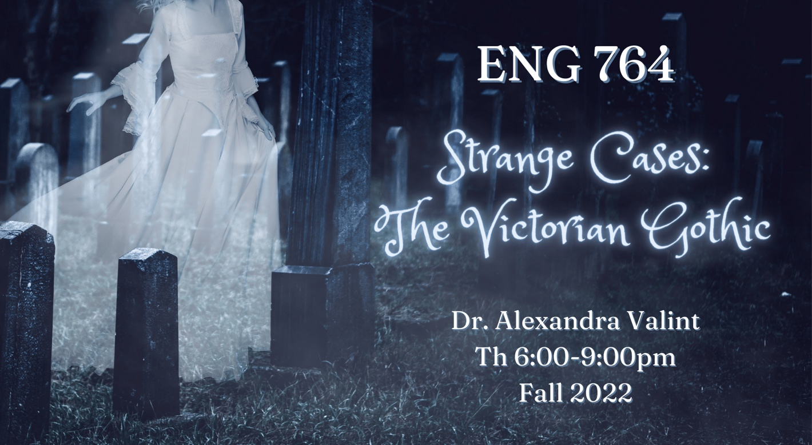ENG 764
Strange Cases: The Victorian Gothic
Dr. Alexandra Valint
Th 6:00-9:00PM
** fulfills British post-1800

Vampires, ghosts, haunted mansions, secret passageways, prophetic dreams, dark and stormy nights. Finding yourself suddenly alone…or, suddenly not alone. The gothic trades in fears, anxieties, surprises, and thrills; it attempts to speak the unspeakable, know the unknowable, and disrupt the normative. To explore the possibilities of this expansive genre, we will read a riveting assortment of “strange cases” (to borrow from the full title of Stevenson’s Strange Case of Dr. Jekyll and Mr. Hyde); authors will likely include Charlotte Brontë, Wilkie Collins, Charles Dickens, George Eliot, Elizabeth Gaskell, Rabindranath Tagore, Robert Louis Stevenson, Bram Stoker, and Oscar Wilde. We will seek not only to define the gothic, to itemize its trappings and set pieces, but also to interrogate the gothic’s functions and uses: what does using the gothic make possible? We will consider the gothic’s potential (and limits) for cultural transgression and critique, tracking how the gothic utilizes and transforms bodies, selves, environments, and relationships between the metropole and colony. To this end, we will read a variety of gothic theory and scholarship representing subfields such as ecogothic, female gothic, queer gothic, and imperial gothic. The gothic genre, much like a vampire, won’t stay dead—let’s learn why the Victorians, as well as authors since then, have continued to turn to its creepy possibilities.

HUM 501
Introduction to Digital Humanities
Online

** fulfills research tool

This class is designed as a broad introduction to the digital humanities for graduate students who are DH curious but possibly ambivalent or unsure about the field’s purposes, or even a bit intimidated by the digital-isms within their own field of study. I designed this class so that you can familiarize yourself with scholarly debates in DH, but also so that you can feel more comfortable exploring digital humanities methods in your own career paths, whether that be in research, pedagogy, or information specialization and organization. Students will leave this class with a stronger sense of the necessity of digital humanities in our current moment, so that even if you do not become a DH specialist, you will be able to approach any DH project with confidence. Our readings will include histories of computing, as well as a selection of articles from Debates in the Digital Humanities and the Digital Humanities Quarterly; we will also spend time conducting user-friendly lab exercises. No experience with digital humanities is required to succeed in this class.

