English Graduate Course Descriptions

Spring 2022 Course Descriptions

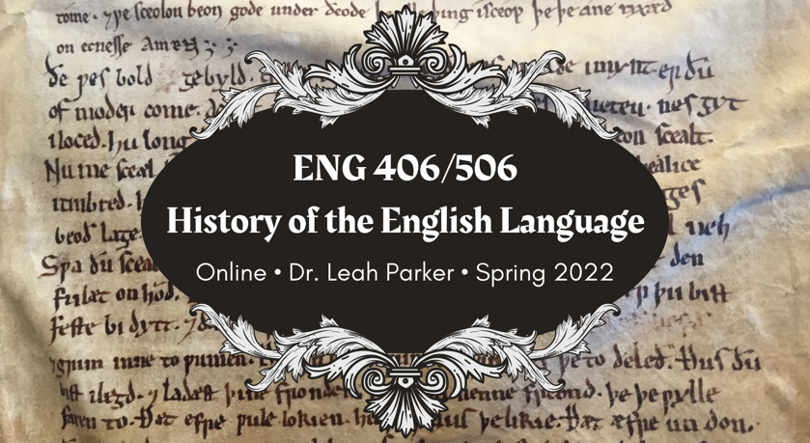
ENG 506

History of the English Language
Dr. Leah Parker
ONLINE
** fulfills British Literature to 1800
Have you ever wondered why each letter C in “Pacific Ocean” is pronounced differently? Why sometimes you call yourself “I” and other times call yourself “me”? Why you can play a “bass,” but catch a “bass”? Why you can feel the “wind” on your face, but you “wind” down at the end of the day? Why, when the truth comes out, we say: “the cat’s out of the bag”? What cat? What bag?! The answers to these questions and more lie in the wild and weird history of the English language!
ENG 506, History of the English Language, will be fully online and asynchronous—there will be no required full-class synchronous meetings, though office hours and individual or small-group meetings will be available to help students succeed in the course.
In ENG 506, we will trace the history of the English language from its prehistoric Indo-European roots, through sound changes of the Middle Ages, standardization in the era of print, and diversification as a global language in the modern world. You will learn the basics of linguistics; the pronunciation and basic grammar of Old English (spoken ca. 450–1150 CE) and Middle English (spoken ca. 1150–1500); how to fully utilize dictionaries and editions of English texts; and how dialects develop through isolation, imperialism, and human interactions.
Graduate students will choose between two “tracks” for their projects: the linguistics/TESOL track and the literary history track. In the linguistics/TESOL track, students will complete a 15–20-page lit review on a relevant topic in “socio-linguistics and contemporary language instruction” of their choice as well as an accompanying TESOL/HEL topical lesson informed by current scholarship and debates within the field. Students choosing the literary history track will produce a “mini-edition” of a pre-1700 English text of their choice as well as a 15–20-page seminar paper analyzing the text of their mini-edition utilizing both literary and linguistic methodologies.
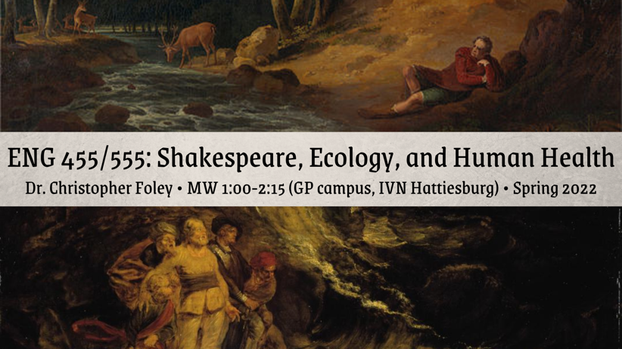

ENG 555
Shakespeare, Ecology, and Human Health
Dr. Christopher D. Foley
M/W 1:00-2:15
** fulfills British Literature to 1800
From a historical vantage point informed by an unstable climate, extended disease outbreaks, and unsustainable development practices, Shakespeare wrote a number of plays exploring the interconnectedness of human health and well-being, social stability, and the ecologically vibrant non-human world. In this seminar, we will examine a number of these plays from across the customary spectrum of Shakespearean genres: comedies, problem plays, tragedies, and romances. Throughout the semester, we will attend to the historical and generic dimensions of Shakespeare’s dramatic engagements with the non-human world, while also exploring how his plays inform our present condition in an era of increasingly extreme weather patterns, global environmental degradation, and mass extinction.
Please note that this course will be offered face-to-face on the Gulf Park campus and via IVN on the Hattiesburg campus.
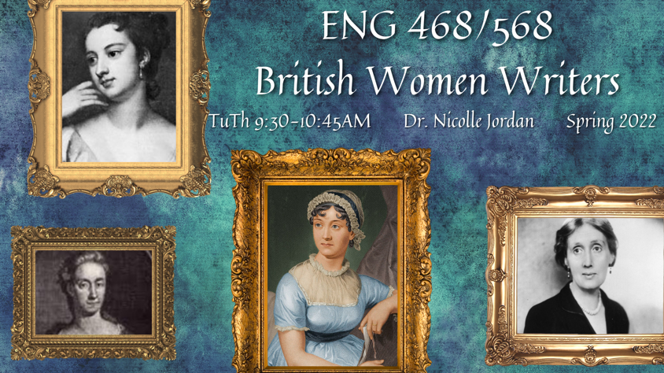

ENG 568
British Women Writers
TR 9:30-10:45am
Dr. Nicolle Jordan
** fulfills British Literature post 1800
How does female identity vary depending on whether it is depicted in a rural or urban setting? Is one setting more congenial to the heroine—or the woman writer—than another? How does a woman’s experience of the country and/or the city vary depending upon her social status? In this course we will read British poetry, closet drama, novels, and letters that imagine female characters in an array of settings, from the bucolic English countryside, to the bustling social season of London, to the foreign cityscapes of Constantinople. We will explore whether a woman’s value, and her values, change depending on the familiarity or strangeness of her surroundings. Featured writers include Jane Barker, Anne Finch, Sarah Scott, Jane Austen, and Virginia Woolf.
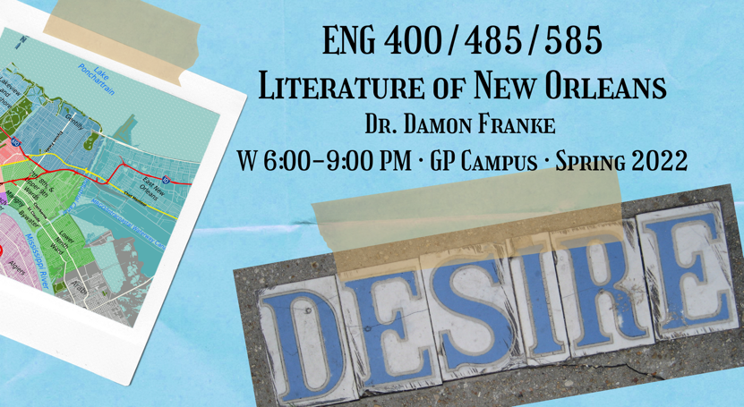

ENG 585
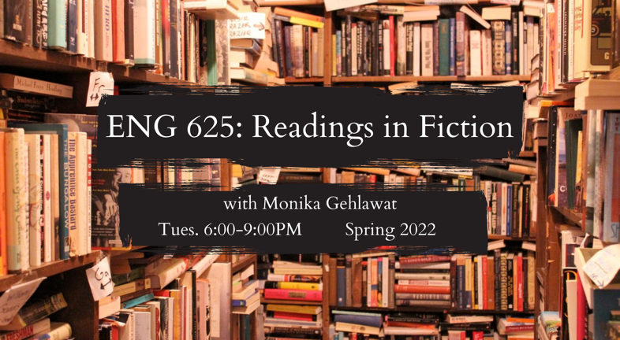
Literature of New Orleans
W 6:00-9:00PM
Professor Damon Franke
*Gulf Park Campus face to face
** fulfills American Literature to 1865
Course Objectives: This course will primarily delve into literary portrayals of New Orleans over the course of the 20th Century. We will read Kate Chopin’s The Awakening, William Faulkner’s Pylon, Tennessee Williams’ A Streetcar Named Desire, Natasha Trethewey’s Bellocq’s Ophelia, Nelson Algren’s Walk on the Wild Side, and John Kennedy Toole’s A Confederacy of Dunces. Over the course of the semester, students may “tour” the New Orleans neighborhoods of the Garden District, Bywater, Uptown, and Storyville. Major issues of concern will be the history and culture of these areas as we discuss the communities’ relationship to the Mississippi River and the Gulf of Mexico, the origins and development of jazz, the unique history and legacy of race relations, and the Big Easy’s associations with corruption, depravity, and the occult in the face of, and perhaps as a result of, the ethos of laissez le bon temps roule. This seminar involves intensive reading as preparation for an article-length research paper, and then participation in activities, including a field trip to New Orleans culminating the semester. This is a course about the literature of your metropolis; embrace how others have thought about it and portrayed it. Students in history, film, psychology, education, political science, and interdisciplinary studies can design their own projects according to their interests. The elective version of the course (ENG 485) requires less research and writing.

ENG 625
Readings in Fiction
T 6:00-9:00PM
Dr. Monika Gehlawat
**fulfills a creative writing elective, creative writers only
Readings in Fiction offers a craft-based approach to studying literary classics, modern and contemporary literature, as well as selected essays on narrative. Drawing from fiction on the creative writing exam lists as
well as new and emerging writers, this class requires students to read and discuss a broad range of literature with an eye towards formal innovation and the choices writers make to get there. We will read Thomas Mann, Patricia Highsmith, Hisham Matar, Vladimir Nabokov, Aravind Adiga, Marilynne Robinson, and Zadie Smith, among others.
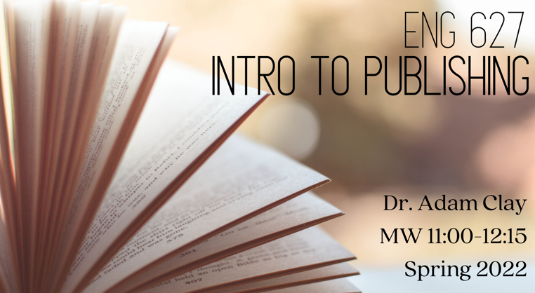

ENG 627
Introduction to Publishing
Dr. Adam Clay
MW 11:00-12:15
**fulfills CW Elective, creative writers only
ENG 627 is a course primarily focused on literary citizenship and engagement in the publishing world. The course will allow students to gain hands-on experience through reading submissions and selecting finalists for the Mississippi Review Prize. We’ll also publish an issue of Product Magazine and organize an event to coincide with its release. During the term we’ll host a range of guest speakers via Zoom to learn about their roles in an ever-changing literary world. In addition to considering the publishing world from the perspective of an editor, we’ll also discuss techniques and approaches from the perspective of a writer, which will include selecting magazines and journals to submit work to, drafting cover and query letters, and other elements writers need to be aware of when publishing creative work.
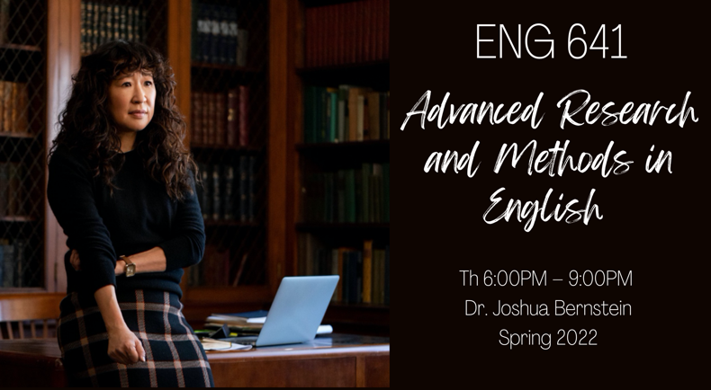

ENG 641
Advanced Research and Methods in English
Th 6:00PM – 9:00PM
Dr. Joshua Bernstein
** fulfills literature requirement and creative writing elective
This course will help you enhance your research methods and editing skills so that you can turn a seminar paper into a thesis defense and/or published article. We will submit and workshop assignments with a view towards improving their claims, expanding their arguments, and revising them for clarity and concision. During the course, you’ll likely consult with specialists in your paper’s field, including your seminar professor and/or project chair. We’ll ask what editors and reviewers look for in evaluating academic work, and we’ll talk about the process and expectations of publishing, as well as strategies going forward. We will also explore some of the changes in academic publishing and norms, the use of specialized or non-specialized language in writing, the growing trend of memoir in criticism, as well as its risks, and the evolving landscape for literary critics. While we won’t favor any particular kind of criticism, we will encourage you to dig deeply in your writing and produce your best work. This class is designed for both literature and creative writing students.

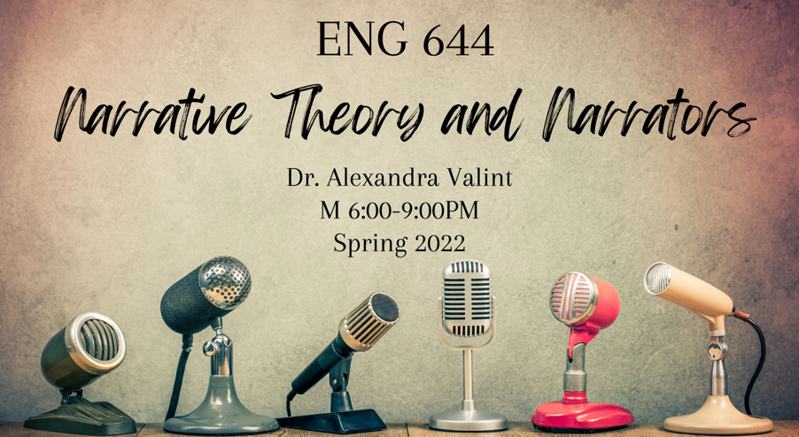

ENG 644
Narrative Theory & Narrators
Dr. Alexandra Valint
M 6:00-9:00PM
** fulfills theory requirement
Who speaks a narrative? And to whom? And why? And can we trust them? These are some of the driving questions of narrative theory (also known as narratology). In this course, we will focus on the expansive topic of narrators, embroiling ourselves within issues of omniscience and limitation; first-, second-, and third-person narrators; multinarration; “we” narrators; narratees and readers; reliability and unreliability; voice and style; unnatural, strange, and/or nonhuman narrators. Through our examination of narrators in literature, scholarship, and theory, we will engage with various branches of narratology: rhetorical narratology, unnatural narratology, feminist narratology, and econarratology, among others. Every narrative has a narrator (or does it?), so this course will provide you with a new lens to apply to your fields of literary interest; if you have a creative practice, I hope this course will help you reflect on your creative choices and options. As Robert Scholes and Robert Kellogg assert, “In the relationship between the teller and the tale, and that other relationship between the teller and the audience, lies the essence of narrative art.” Let’s get to the essence.

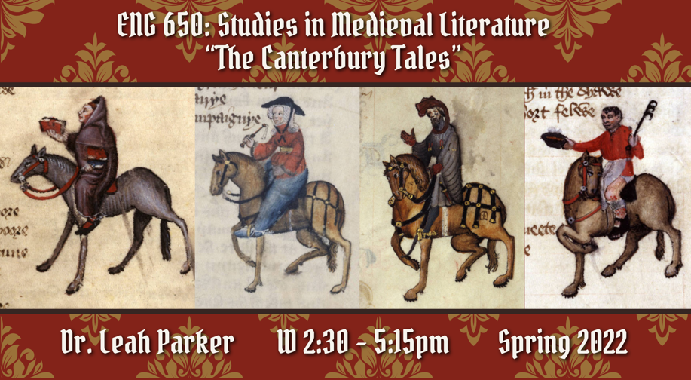
ENG 650
Studies in Medieval Literature
“The Canterbury Tales”
Dr. Leah Parker
Wednesdays, 2:30-5:15 pm
** fulfills British Literature to 1800
In this seminar, we will read—in full—one of the most influential works in the history of English literature: Chaucer’s Canterbury Tales. We will trace through the Tales questions of genre and poetic form, truth and fiction, disability and embodied difference, sex and marriage, sin and salvation. Following a boot camp in reading Middle English, seminar participants will complete two short essays for early feedback and a longer seminar paper.

ENG 716
LGBT Literature and Film
Th 2:30-5:15pm
Dr. Ery Shin
** fulfills non-traditional and theory-rich requirements
Across millennia and world civilizations, this course surveys works that broach the matter of queer love and being. The deviant elements underlying all desire, those framing each act of intimacy and togetherness, will earn an ongoing emphasis.

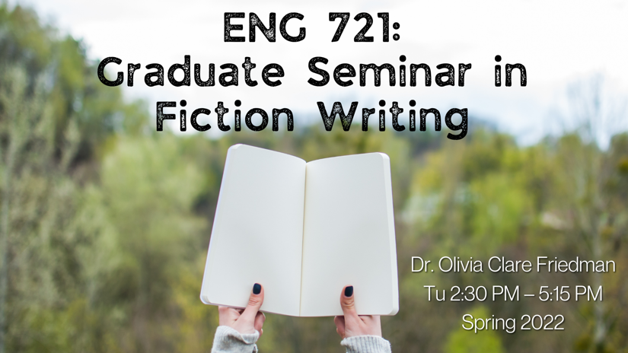

ENG 721
Graduate Seminar in Fiction Writing
Dr. Olivia Clare Friedman
Tu, 2:30 PM – 5:15 PM
** fulfills fiction workshop
We’ll examine the form of workshop, and we’ll experiment. You’ll always have an option to have a traditional workshop, but you’ll have other options too. These will include: an open conversation between writer and readers, a workshop that begins with a series of questions, a workshop with alternate beginnings, middles, and ends, or a discussion of a poem or piece of nonfiction, yours or not yours, alongside your fiction.
You may submit either short stories or novel excerpts for workshop. We’ll also devote some time to in-class writing exercises, both solo and collaborative. You’ll write two imitations as informal exercises, and at the end of the term you’ll complete a revision of one of your workshop pieces.
Outside readings will be distributed in class and will include work by:
Rumena Bužarovska, Yiyun Li, Carl Phillips, Grace Paley
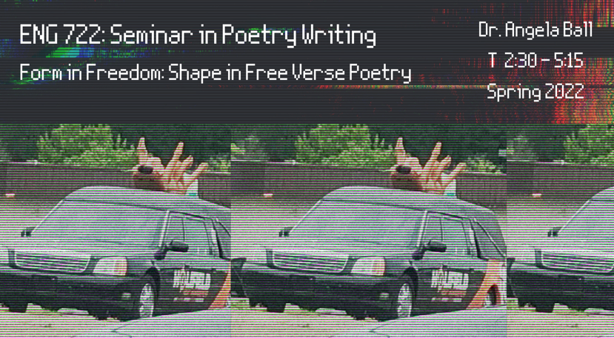

ENG 722
Seminar in Poetry Writing
FORM IN FREEDOM: SHAPE IN FREE VERSE POETRY
Dr. Angela Ball
T 2:30-5:15PM
** fulfills poetry workshop
This course will focus on technique, incorporating a variety of constraints devised by class members and focusing on elements found in traditional poetic forms that can strengthen the patterns of free verse. In addition, structures from other art forms, including jazz, dance, painting, and cinema may find themselves enlisted as prototypes for poetry. The goal will be a free verse both informed by tradition and productive of new and surprising poetic effects—experimentation grounded in the knowledge of what works.

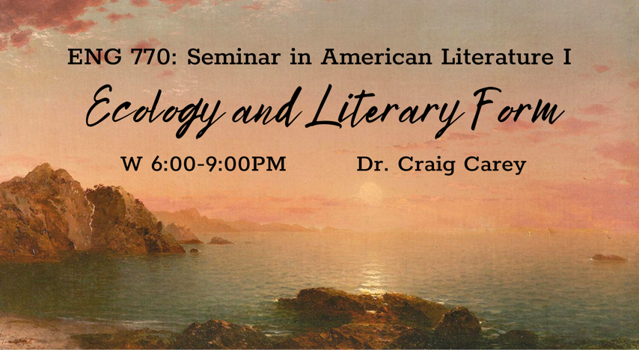
ENG 770
Seminar in American Literature I
Ecology and Literary Form
Dr. Craig Carey
W 6:00-9:00PM
** fulfills American literature before 1865 and counts as theory rich
This course examines the vital relationship between literature, the environment, and varieties of ecological perception in early American and nineteenth-century American literature. Drawing on ecocritical theory, the course will investigate different ways of seeing, sensing, writing, and expressing environmental relations in literature, with specific focus on the interface of ecology and literary form within different periods, genres, contexts, and styles. The class will begin with the ecological affordances of Native American oral literature and indigenous poetry, which we’ll read alongside ecocritical work by David Abram (The Spell of the Sensuous) and Robin Wall Kimmerer (Braiding Sweetgrass). From there, we’ll examine ecological descriptions of the New World, New England, and the Black Atlantic; varieties of transcendentalist forms in Emerson, Fuller, and Thoreau; traces of dark ecology and the ecogothic in Poe and Melville; the sublime and the picturesque in American landscape painting; and the ecological poetics of Whitman and Dickinson. We will also consider how these interfaces of ecology and literature relate to other media such as painting, music, film, and videogames. Throughout the course, we will work to unsettle our perceptions through comparative media analysis, drawing on ecocritical perspectives to analyze the diverse ecology of forms within, around, and through American literary history.
Course readings will likely include:
· Selections of Native American oral literature and indigenous poetry
· Thomas Harriet, A Briefe and True Report of the New Found Land of Virginia
· Selections from The Interesting Narrative of the Life of Olaudah Equiano
· William Cronon, Changes in the Land: Indians, Colonists, and the Ecology of New England
· Essays, poems, and nature writing by Ralph Waldo Emerson, Henry David Thoreau, Margaret Fuller, James Fenimore Cooper, and Susan Fenimore Cooper
· Henry David Thoreau, Walden and Tracy Fullerton’s Walden, a Game
· Herman Melville, “The Encantadas” and selected stories by Edgar Allan Poe
· Selected poetry by Walt Whitman and Emily Dickinson
· Visual art by the Hudson River School and Luminist landscape painters
· Screenings of The New World, First Cow, and Dead Man
· Ecocritical scholarship by William Cronon, David Abram, Laura Dassow Walls, Kate Riby, Dana Phillips, Robin Wall Kimmerer, and others.

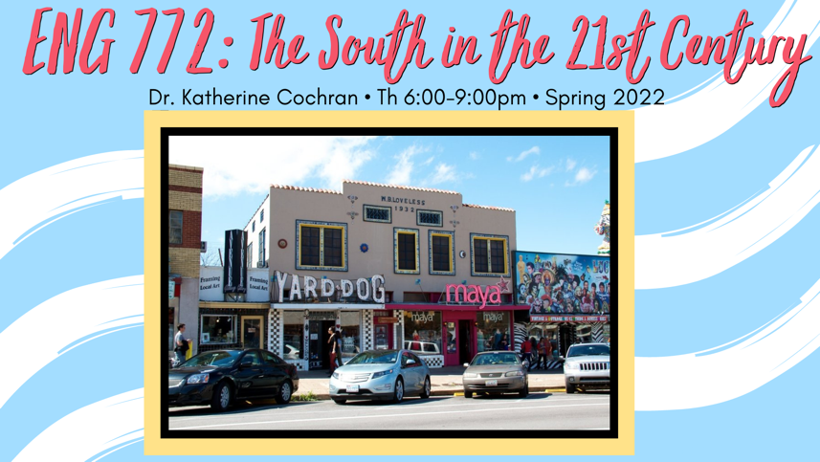

ENG 772
Readings in American Literature: The South in the 21st Century
Th 6:00-9:00pm
Dr. Katherine Cochran
** fulfills American literature post-1865
21st-century southern fiction reflects a multiethnic, global South that moves beyond the sentimentalist’s nostalgic vision of a past-haunted pastoral; in this class, we will read several novels which complicate our understanding of an already complex region. The novels under consideration will be supplemented with critical readings demonstrating the development of southern literary study over the past 20 years. Assignments will include a conference-length paper, an oral presentation, and a book review of a recent critical text, which will be considered for publication in The Southern Quarterly.
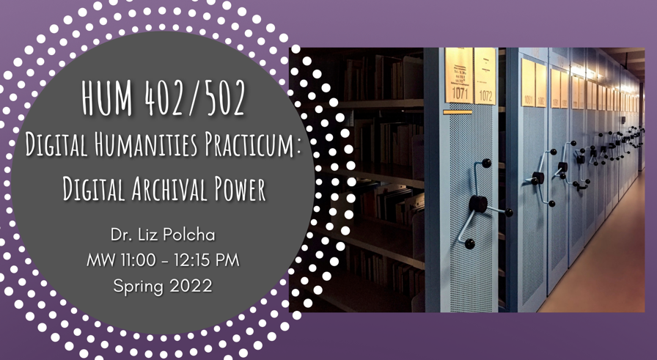

HUM 502
Digital Humanities Practicum: Digital Archival Power
Dr. Liz Polcha
M/W 11:00 - 12:15 PM
** fulfills research tool
This course offers a deep-dive into digital archives as a cornerstone of the digital public humanities. As a practicum, the class is focused on developing advanced skills in digital humanities methods and theory.
Together we will examine theories of the archive, and explore how librarians, scholars, community organizers, artists, and educators have developed digital archives to bring together various audiences. This class begins with Michel-Rolph Trouillot's claim that archives are shaped by silences and erasure. To that end, we will ask questions such as: how can digital archives address histories of violence and archival absence? What is the history of collecting and documentation as humanistic practices, and how might we understand the legacy of this history in digital scholarship today? What are the social justice approaches to digital archiving? Is it possible to "decolonize" the archive through computational methods? And, relatedly, how has the climate crisis changed the way we understand archives, storage, and sustainability?
Our class activities will involve both discussion of archival theory, as well as experimentation with various methods of digital archiving—such as: writing metadata for archival objects, designing exhibits using web-based platforms, learning the basics of digital project management, and developing good data management practices including writing documentation. We will also review an extensive list of digital archives, meet archivists, and learn from digital scholars who are pushing the boundaries of what a digital archive is.
This course is a combined undergraduate and graduate practicum; Introduction to Digital Humanities is recommended as a prerequisite but not required.

