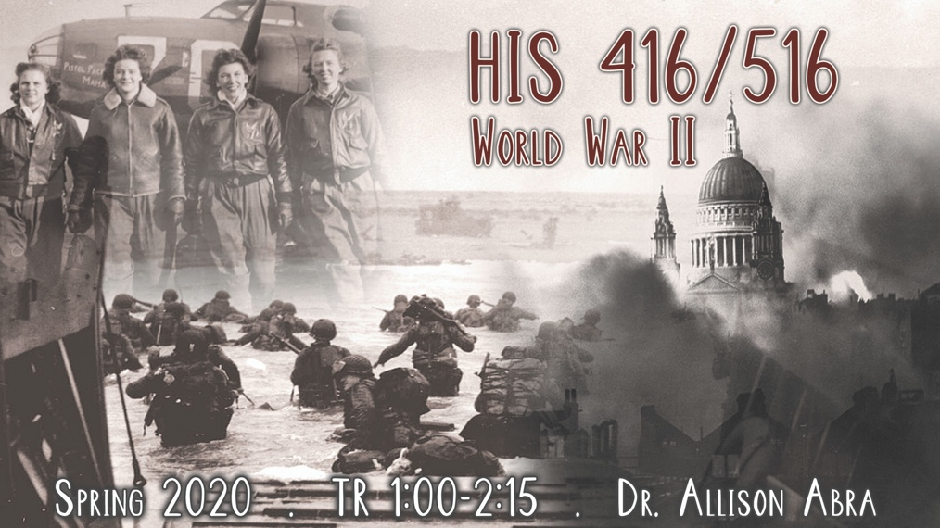
HIS 416/516
World War II
TR 1:00-2:15
Dr. Allison Abra

The Second World War was the most devastating war the world has ever witnessed. People of all sexes, ages, backgrounds, and regions of the world were gripped by the dangers, deprivations, and duties that accompanied a “total war.” Millions took on new roles and responsibilities on the home and battle fronts, and endured the horrors of aerial bombardment, occupation, and genocide. At the same time, the war inspired remarkable acts of compassion and feats of heroism. In this course we will survey the history of the war, with attention being paid to social, cultural, political, and military perspectives. We will explore the profound and enduring effects of this global conflict, and why more than seventy years later it continues to fascinate historians and the general public alike, and to resonate across 21st century society.

Required Books
- Diana Lary, The Chinese People at War: Human Suffering and Social Transformation, 1937-1945, (Cambridge, 2010). ISBN: 978-0521144100
- Primo Levi, Survival in Auschwitz, (Touchstone, 1996). ISBN: 978-0684826806
- J. Samuel Walker, Prompt and Utter Destruction: Truman and the Use of Atomic Bombs Against Japan, (Dev Books, 2017). ISBN: 978-9381406717

HIS 417/517
THE VIETNAM WAR
TR 11:00 – 12:15
Dr. Andy Wiest

This course uses a multi-disciplinary approach to investigate the Vietnam War, arguably the most important event, or series of events, in the history of 20th century America. The United States entered the conflict unified behind the doctrine of the Cold War. Idealistic American youth answered the call defend their nation against Communist aggression. But by the end of the war America had suffered its first ever defeat, and its society was in turmoil. America would never be the same, or as innocent, ever again. Over 3 million Americans served in Vietnam, and over 58,000 lost their lives there in a unique national tragedy. In Vietnam itself over 2.4 million people perished in a brutal civil war that impacted society there in a way few outsiders can understand.

The course will investigate Vietnamese culture, the antecedents to the war, the Fist Indochina War, the military prosecution of the American war in Vietnam, the political battles on the American homefront and the ramifications of the US defeat in Vietnam. The course will also focus on less-known topics such as Post-Traumatic Stress Disorder, the music of the era, theories of counterinsurgency, and wartime literature. The course is enriched by the participation of several Vietnam veterans. Simply put there is no better way to learn of Vietnam than through the eyes of those who participated in the conflict. Past class participants have included: Marines, helicopter pilots, nurses, CIA operatives, a contentious objector, medics, a Phoenix Program operative, South and North Vietnamese veterans, a member of the Weather Underground, pilots, POWs, a SOG operative and countless “grunts.”

Course readings will include: Wiest – The Boys of ’67: Charlie Company’s War in Vietnam; Jonathan Shay, Achilles in Vietnam; Stur -- Beyond Combat: Women and Gender in the Vietnam War Era; and McMaster – Dereliction of Duty: McNamara, the Joint Chiefs of Staff, and the Lies That Led to Vietnam.

Course participants will produce book reviews of each book. The average of the book reviews will form 33% of the final grade. Students will also take one midterm and one final – each comprising 33% of the final grade.

Graduate Students enrolled in HIS 517 will read and report on two additional books Nguyen – Hanoi’s War: An International History of the War for Peace in Vietnam, and Appy – Working Class War: American Combat Soldiers in Vietnam.

Graduate students will also produce a research paper (15-20 pages), based at least in part on primary source material and will take part in additional seminars with the instructor or will write a historiographical paper that will relate to their main field of study.

Graduate students will also engage in scheduled seminars with the instructor.

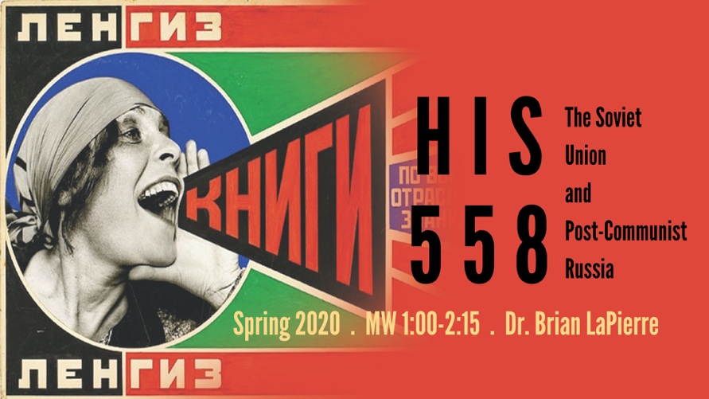
HIS 458/558
The Soviet Union and Post-Communist Russia
MW 1:00-2:15
Dr. Brian LaPierre

For anti-capitalist intellectuals, the Soviet Union was a savior society that promised non-exploitative economic development and classless international cooperation. For its many conservative and liberal opponents, the Soviet Union was a militaristic monster that exemplified godless atheism, aggressive expansionism, social repression, and brutal state terror. In this class, we will look at the Soviet Union from all its angles – both good and bad. We will look at a state that dragged Russia from rural idiocy to industrial modernity, eliminated illiteracy, equalized gender opportunities, achieved enviable scientific accomplishments and instituted a generous cradle-to-grave system of state-supported social welfare. On the other hand, we will also look at a state that slaughtered and starved to death millions of its citizens and imprisoned millions more in the service of its utopian ideological ideals. Topics to be explored include the causes and consequences of the 1917 Revolution, Stalinism, the war of annihilation against the Nazis, the Cold War-era clash of civilizations, the Gorbachev reforms, the collapse of communism, and the Putin dictatorship.

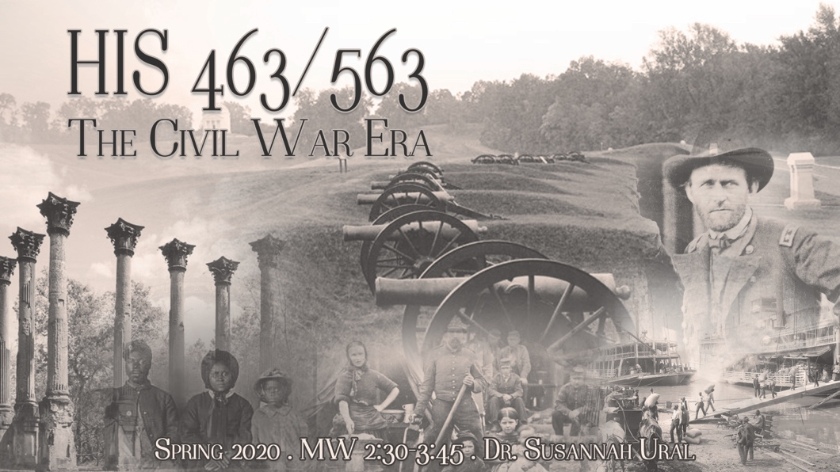
HIS 463/563
The U.S. Civil War Era
MW 2:30PM - 3:45PM
Dr. Susannah Ural

The U.S. Civil War Era is one of the most popular periods of study in American history among the public and scholars alike. Despite this interest, stubborn disagreements remain regarding its causes and consequences. This course looks at the divisions that led to the conflict, the war itself, and the possibilities and failures of Reconstruction. Lectures and readings will focus on the defining themes of the era, while examining the impact of the war on representative individuals or communities in the Union and the Confederacy and how they, in turn, influenced the conflict around them. In addition, the class will discuss how scholars have interpreted the war in the past and today. Successful students will emerge with a better understanding of the broad issues that shaped the period and they will be conversant — in speech and in writing — on this definitive American era. Class includes a trip/tour of the Vicksburg National Military Park.

HIS 722
War Historiography
T 2:30-5:30
Dr. Heather Stur

This graduate course is a survey of military and war historiography across time and place. It will introduce students to some of the Dale Center for the Study of War & Society's "Top 40" and will examine the continuities and changes in how historians have understood and written military history. Students will read at least one book a week, and grades will be based on class participation, papers, and other written assignments.

HIS 726
American Historiography II
W 6:00-9:00
Dr. Rebecca Tuuri

This course will examine classic works in American historiography covering the period from 1865 to the present. I will assign a set of fourteen readings from our U.S. II Comprehensive Exam list while also assigning occasional additional readings. We will be discussing the historiography of the Modern United States, including late 19th century urbanization and immigration; transitions in production, consumerism, and mass marketing; the development of federal welfare programs; the Cold War; the rise and fall of organized labor; social movements for equality along lines of race, gender, and sexuality; and the rise of the New Right.

