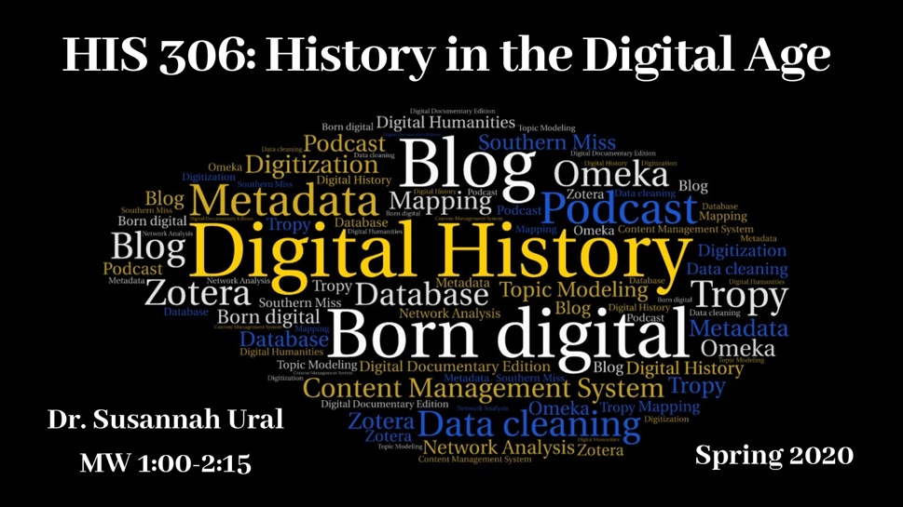
HIS 306
History in the Digital Age
MW 1:00PM - 2:15PM
Dr. Susannah Ural

The digital humanities, and digital history in particular, has revolutionized the way we study and learn about history. Data mining, digitization, and geographic information systems have changed how we gather and analyze data, Wikipedia, blogs, open-access journals, and social media are transforming traditional publishing. This course engages with these cutting-edge developments by introducing students to digital history to help them understand how technology has transformed the process of human knowledge. Topics include databases and searching, crowdsourcing and Wikipedia, blogging and podcasting, data mining and textual analysis, and presenting audio and visual forms of history.

HIS 328
Ancient and Medieval Women
MW 9:30-10:45
Dr. Courtney Luckhardt

In this course, we will explore the ancient and medieval roots of our modern ideas about women, marriage, and gender roles. From the Roman period through the Middle Ages, and ending in the Renaissance, we examine the ancient and medieval practices of marriage and divorce, as well as the important role that childbearing, motherhood, and sexuality played in women’s lives. We will see relationships between women and men, including the personal, the professional, the political, and the spiritual. The dangers and challenges women of the past faced were the same as modern women in terms of domestic violence, sexual assault and rape, prostitution, abortion, and access to contraception, and we will explore as a class how they dealt with those issues. At the same time, the joys, friendships, and adventures of medieval women will also be key. From queens to peasants, from abbesses to brewsters, ancient and medieval women’s experiences and work were as diverse as our own, with cultural changes affecting women's daily lives and reality.

HIS 374
African American History, 1890–present
MW 11:00-12:15
Dr. Rebecca Tuuri

African American History II seeks to do the following: 1.) provide an overview of significant events, movements, and people from the beginning of Reconstruction to the present 2.) examine the history of cultural formation within the African American community. 3.) Examine the struggle towards freedom of African Americans themselves 4.) Consider how larger American society, especially that of white America, has manipulated images and ideas in an oppositional way to African Americans 5.) Consider how “memory,” literacy, and access to archival sources affect African American historiography.

HIS 375
Economic History of the United States
TR 9:30 – 10:45am
Dr. Max Grivno
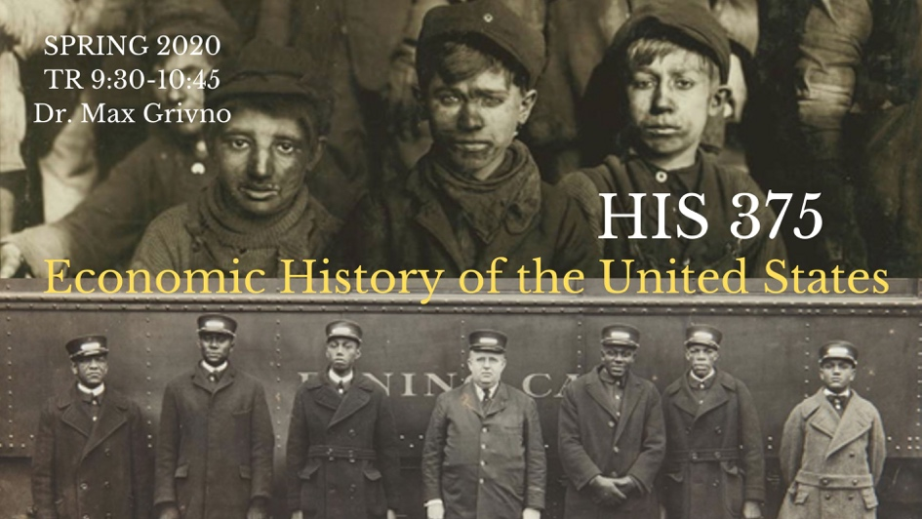
Today, Americans live in a world characterized by profound and often wrenching economic change. The lingering effects of the financial crisis of 2008, growing income and wealth inequality, and the combined challenges of automation, climate change, and globalization have touched almost every aspect of our lives. While we might imagine these challenges are unprecedented, Americans have always grappled with economic change and uncertainty. This course traces the evolution of the American economy from the colonial period to the present. Designed to meet the needs of students from many disciplines and to serve a broad constituency, it caters to students in the Social Studies Licensure Program, as well as to those pursuing degrees in Business, Economics, and Social Work. We will examine a range of topics, including the legal and social construction of capitalism, the booms and busts that shook the economy, and the lives of workers—free and enslaved, men and women—who created our nation’s wealth. Along the way, we will learn how Americans responded to earlier economic upheavals and how those changes created the world we face today.

HIS 400
Senior Capstone
Communities in Conflict
MW 9:30AM - 10:45AM
Dr. Susannah Ural

History 400 is the capstone of the history major at the University of Southern Mississippi; it requires that students demonstrate their facility with historical thinking by crafting an original research paper. The focus of this class is “Communities in Conflict.” This theme will shape each student’s research paper and allow it to be grounded in the collections of Southern Miss’s McCain Archives as well as our Center for Oral History and Cultural Heritage and the Civil War & Reconstruction Governors of Mississippi Project or some other major, easily accessed collection. Conflict can be defined as everything from war to social reform efforts to social responses to revolutionary change like industrialization.

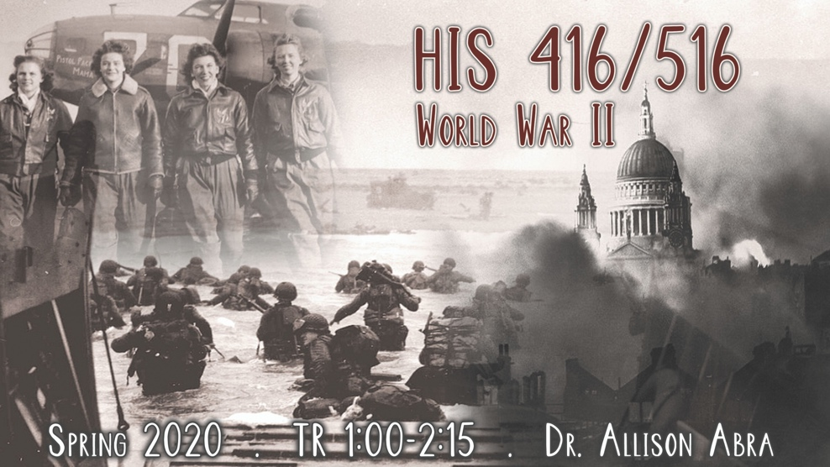
HIS 416/516
World War II
TR 1:00-2:15
Dr. Allison Abra
The Second World War was the most devastating war the world has ever witnessed. People of all sexes, ages, backgrounds, and regions of the world were gripped by the dangers, deprivations, and duties that accompanied a “total war.” Millions took on new roles and responsibilities on the home and battle fronts, and endured the horrors of aerial bombardment, occupation, and genocide. At the same time, the war inspired remarkable acts of compassion and feats of heroism. In this course we will survey the history of the war, with attention being paid to social, cultural, political, and military perspectives. We will explore the profound and enduring effects of this global conflict, and why more than seventy years later it continues to fascinate historians and the general public alike, and to resonate across 21st century society.

Required Books
- Diana Lary, The Chinese People at War: Human Suffering and Social Transformation, 1937-1945, (Cambridge, 2010). ISBN: 978-0521144100
- Primo Levi, Survival in Auschwitz, (Touchstone, 1996). ISBN: 978-0684826806
- J. Samuel Walker, Prompt and Utter Destruction: Truman and the Use of Atomic Bombs Against Japan, (Dev Books, 2017). ISBN: 978-9381406717

HIS 417/517
THE VIETNAM WAR
TR 11:00 – 12:15
Dr. Andy Wiest

This course uses a multi-disciplinary approach to investigate the Vietnam War, arguably the most important event, or series of events, in the history of 20th century America. The United States entered the conflict unified behind the doctrine of the Cold War. Idealistic American youth answered the call defend their nation against Communist aggression. But by the end of the war America had suffered its first ever defeat, and its society was in turmoil. America would never be the same, or as innocent, ever again. Over 3 million Americans served in Vietnam, and over 58,000 lost their lives there in a unique national tragedy. In Vietnam itself over 2.4 million people perished in a brutal civil war that impacted society there in a way few outsiders can understand.

The course will investigate Vietnamese culture, the antecedents to the war, the Fist Indochina War, the military prosecution of the American war in Vietnam, the political battles on the American homefront and the ramifications of the US defeat in Vietnam. The course will also focus on less-known topics such as Post-Traumatic Stress Disorder, the music of the era, theories of counterinsurgency, and wartime literature. The course is enriched by the participation of several Vietnam veterans. Simply put there is no better way to learn of Vietnam than through the eyes of those who participated in the conflict. Past class participants have included: Marines, helicopter pilots, nurses, CIA operatives, a contentious objector, medics, a Phoenix Program operative, South and North Vietnamese veterans, a member of the Weather Underground, pilots, POWs, a SOG operative and countless “grunts.”

Course readings will include: Wiest – The Boys of ’67: Charlie Company’s War in Vietnam; Jonathan Shay, Achilles in Vietnam; Stur -- Beyond Combat: Women and Gender in the Vietnam War Era; and McMaster – Dereliction of Duty: McNamara, the Joint Chiefs of Staff, and the Lies That Led to Vietnam.

Course participants will produce book reviews of each book. The average of the book reviews will form 33% of the final grade. Students will also take one midterm and one final – each comprising 33% of the final grade.

Graduate Students enrolled in HIS 517 will read and report on two additional books Nguyen – Hanoi’s War: An International History of the War for Peace in Vietnam, and Appy – Working Class War: American Combat Soldiers in Vietnam.

Graduate students will also produce a research paper (15-20 pages), based at least in part on primary source material and will take part in additional seminars with the instructor or will write a historiographical paper that will relate to their main field of study.

Graduate students will also engage in scheduled seminars with the instructor.

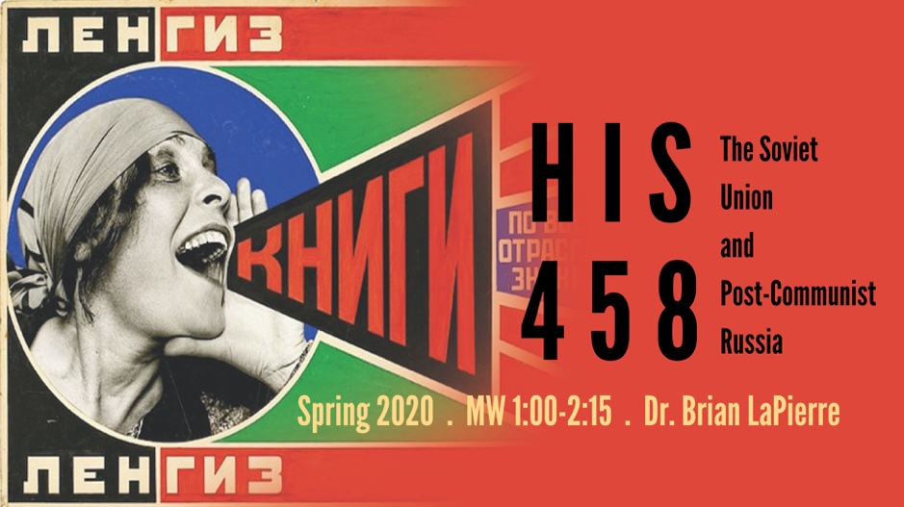
HIS 458/558
The Soviet Union and Post-Communist Russia
MW 1:00-2:15
Dr. Brian LaPierre

For anti-capitalist intellectuals, the Soviet Union was a savior society that promised non-exploitative economic development and classless international cooperation. For its many conservative and liberal opponents, the Soviet Union was a militaristic monster that exemplified godless atheism, aggressive expansionism, social repression, and brutal state terror. In this class, we will look at the Soviet Union from all its angles – both good and bad. We will look at a state that dragged Russia from rural idiocy to industrial modernity, eliminated illiteracy, equalized gender opportunities, achieved enviable scientific accomplishments and instituted a generous cradle-to-grave system of state-supported social welfare. On the other hand, we will also look at a state that slaughtered and starved to death millions of its citizens and imprisoned millions more in the service of its utopian ideological ideals. Topics to be explored include the causes and consequences of the 1917 Revolution, Stalinism, the war of annihilation against the Nazis, the Cold War-era clash of civilizations, the Gorbachev reforms, the collapse of communism, and the Putin dictatorship.

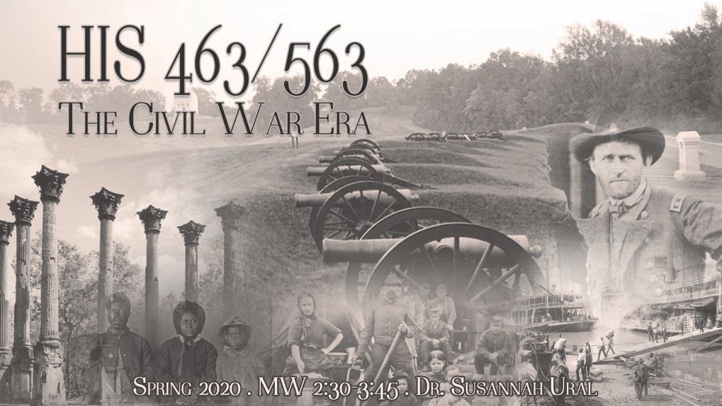
HIS 463/563
The U.S. Civil War Era
MW 2:30PM - 3:45PM
Dr. Susannah Ural

The U.S. Civil War Era is one of the most popular periods of study in American history among the public and scholars alike. Despite this interest, stubborn disagreements remain regarding its causes and consequences. This course looks at the divisions that led to the conflict, the war itself, and the possibilities and failures of Reconstruction. Lectures and readings will focus on the defining themes of the era, while examining the impact of the war on representative individuals or communities in the Union and the Confederacy and how they, in turn, influenced the conflict around them. In addition, the class will discuss how scholars have interpreted the war in the past and today. Successful students will emerge with a better understanding of the broad issues that shaped the period and they will be conversant — in speech and in writing — on this definitive American era. Class includes a trip/tour of the Vicksburg National Military Park.

