History Graduate Course Descriptions

Fall 2022
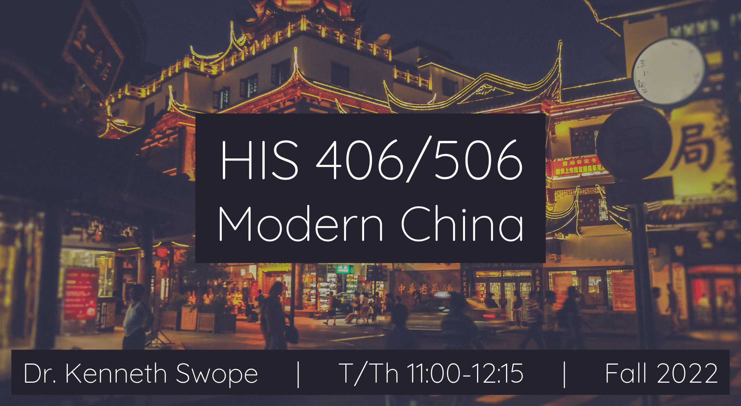HIS 406/506
Modern China
Dr. Kenneth Swope
T/Th 11:00-12:15

This course provides a general, but sophisticated, overview of the history of China from the decline and fall of the Ming Dynasty (1368-1644) to the present day. Topics covered include the rise and expansion of the Qing (1644-1911) empire, its eventual decline and defeat at the hands of Western imperialists and internal enemies, the rise of the Chinese Republic, the Communist Revolution, and China’s reemergence as an economic and military power at the dawn of the twenty-first century. While the overall approach is chronological, special attention will be devoted to continuities throughout China’s modern period. We will learn about dashing peasant rebels, warrior emperors, fanatical martial artists, eunuch dictators, communist revolutionaries, dazzling courtesans and student protestors and see how and why these people became the movers and shakers of modern Chinese history. More importantly you will be encouraged to approach the major events and issues from a critical perspective to better understand how and why they happened. Rather than emphasizing rote memorization of names and dates, this course will focus on critical reading, discussion and analysis of both primary and secondary sources. These skills will be evaluated through written assignments, quizzes, tests and class discussions and exercises.

The graduate version of the course will involve more intensive reading assignments, weekly meetings with the instructor and fellow graduate students, and completion of a series of historiographical essays, capped by a research paper on a topic of the student’s choice.

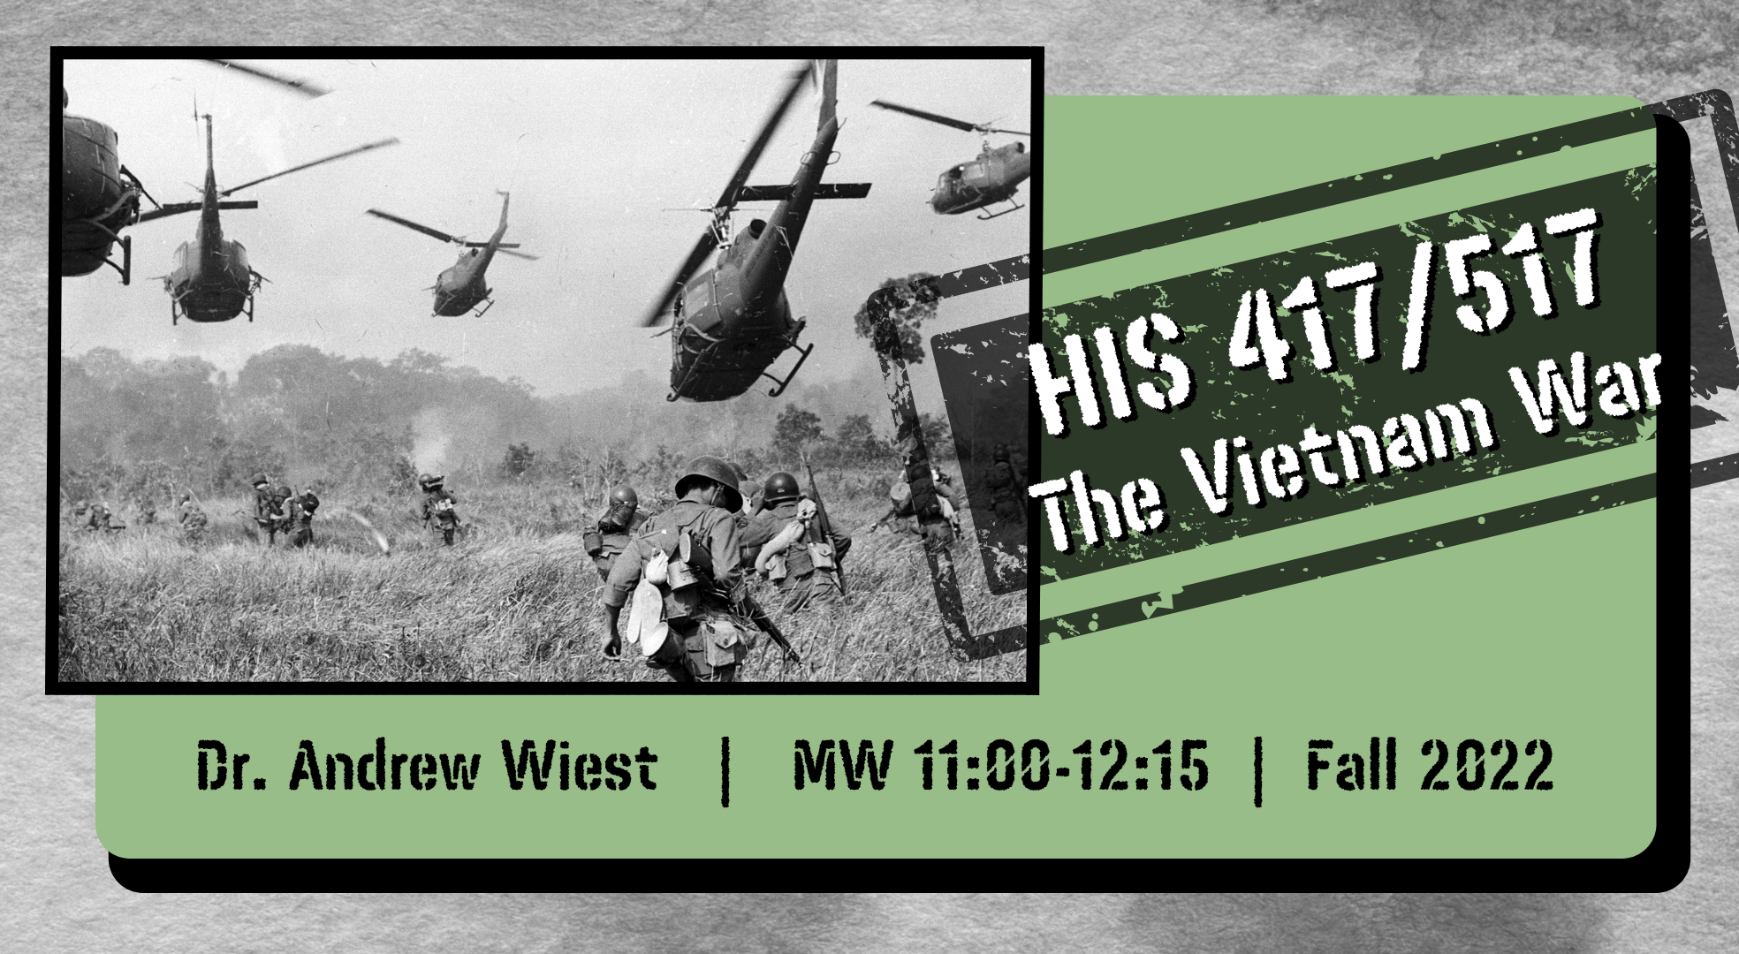HIS 417/517
The Vietnam War
Dr. Andrew Wiest
MW 11:00-12:15

This course uses a multi-disciplinary approach to investigate the Vietnam War, arguably the most important event, or series of events, in the history of 20th century America. The United States entered the conflict unified behind the doctrine of the Cold War. Idealistic American youth answered the call defend their nation against Communist aggression. But by the end of the war America had suffered its first ever defeat, and its society was in turmoil. America would never be the same, or as innocent, ever again. Over 3 million Americans served in Vietnam, and over 58,000 lost their lives there in a unique national tragedy. In Vietnam itself over 2.4 million people perished in a brutal civil war that impacted society there in a way few outsiders can understand.
The course will investigate Vietnamese culture, the antecedents to the war, the Fist Indochina War, the military prosecution of the American war in Vietnam, the political battles on the American home front and the ramifications of the US defeat in Vietnam. The course will also focus on less-known topics such as Post-Traumatic Stress Disorder, the music of the era, theories of counterinsurgency and wartime literature. The course is enriched by the participation of several Vietnam veterans. Simply put there is no better way to learn of Vietnam than through the eyes of those who participated in the conflict. Past class participants have included: Marines, helicopter pilots, nurses, CIA operatives, a contentious objector, medics, a Phoenix Program operative, South and North Vietnamese veterans, a member of the Weather Underground, pilots, POWs, a SOG operative and countless “grunts.”
Course readings will include: Wiest – The Boys of ’67: Charlie Company’s War in Vietnam; Jonathan Shay, Achilles in Vietnam; Stur -- Beyond Combat: Women and Gender in the Vietnam War Era; and Appy – Working Class War: American Combat Soldiers in Vietnam. Students will also read two books of their choice (in consultation with the instructor) that best fits their historical interest areas.
Students will develop a course syllabus for their own Vietnam War course and produce a research paper (15-20 pages), based at least in part on primary source material (hopefully one that relates to their own MA or PHD research) and will take part in additional seminars with the instructor or will write a historiographical paper that will relate to their main field of study.

HIS 711/712
Dr. Susannah Ural
M 2:30-5:15

Course Description: This course focuses on the craft of historical research and writing at the graduate level. It is specifically designed to help you complete two thesis chapters or your dissertation prospectus. All 711/712 students have at least one year of MA studies behind them, so I assume you already understand the basics of good grammar, clear writing, proper citations, and the importance of making a clear argument that weaves throughout a written work. There is a difference, though, between knowing what is needed and creating that yourself. It’s a skill we all develop over time, and this course is designed to help you with that process. Students will spend the majority of class time presenting and respectfully critiquing each other's small writing assignments; I'll be helping with those critiques, too. You will revise according to feedback received in class & then upload your assignment into Canvas about two days later almost every week. I’ll return these to you graded before or during our next class period, with more feedback. All assignments are designed as parts of your thesis or your dissertation prospectus. By focusing on manageable pieces of your work, we will have your thesis abstract, title page, bibliography, and one chapter done by the end of October and a second chapter done by early December, along with a clear plan to move forward in the spring. If you come to class with your thesis introduction completed (according to your advisor), you’ll write two additional chapters. For Ph.D. students, this class is often used to draft their dissertation prospectus and you’ll receive a separate version of the syllabus to ensure that you’ll have a prospectus ready to send to your committee by the end of the semester.

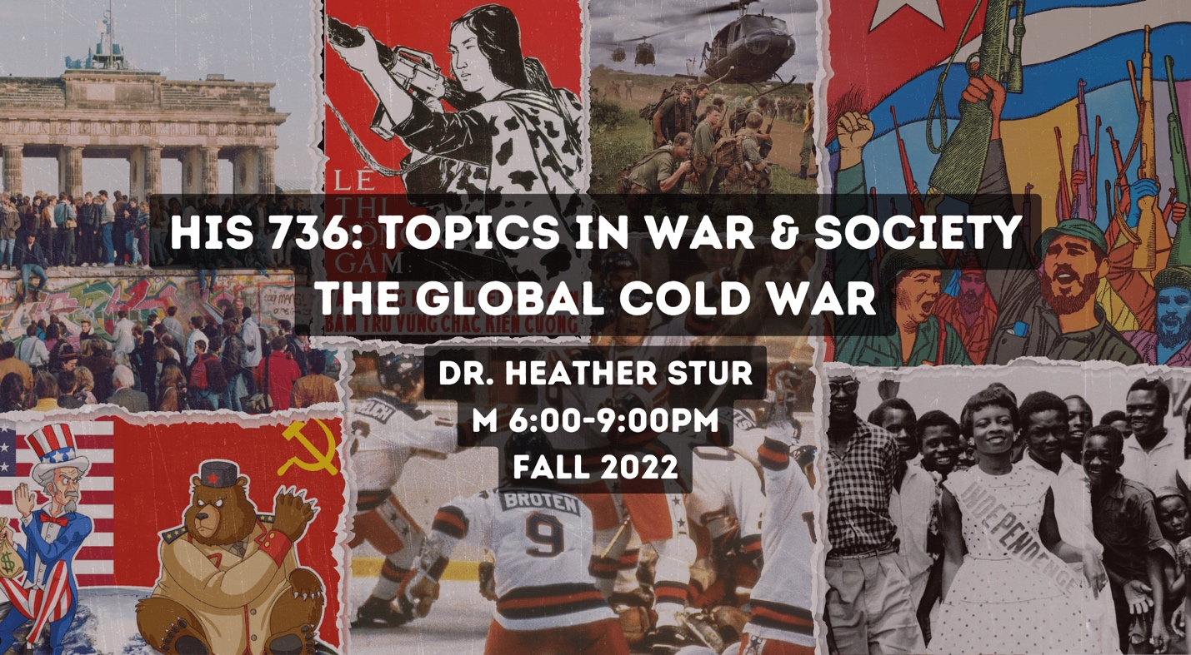HIS 736
Topics in War & Society, The Global Cold War
Dr. Heather Stur
M 6:00-9:00
This graduate seminar will explore the events and historiography of the Cold War in a global context. In addition to the East-West conflict between the U.S. and the Soviet Union, we will also examine the roles of the “Third World,” cultural influences, and non-state actors in shaping global affairs from the end of the World War II to the collapse of the Soviet Union. We will also use the events and ideas of the Cold War to understand subsequent global conflicts. It's a great class!

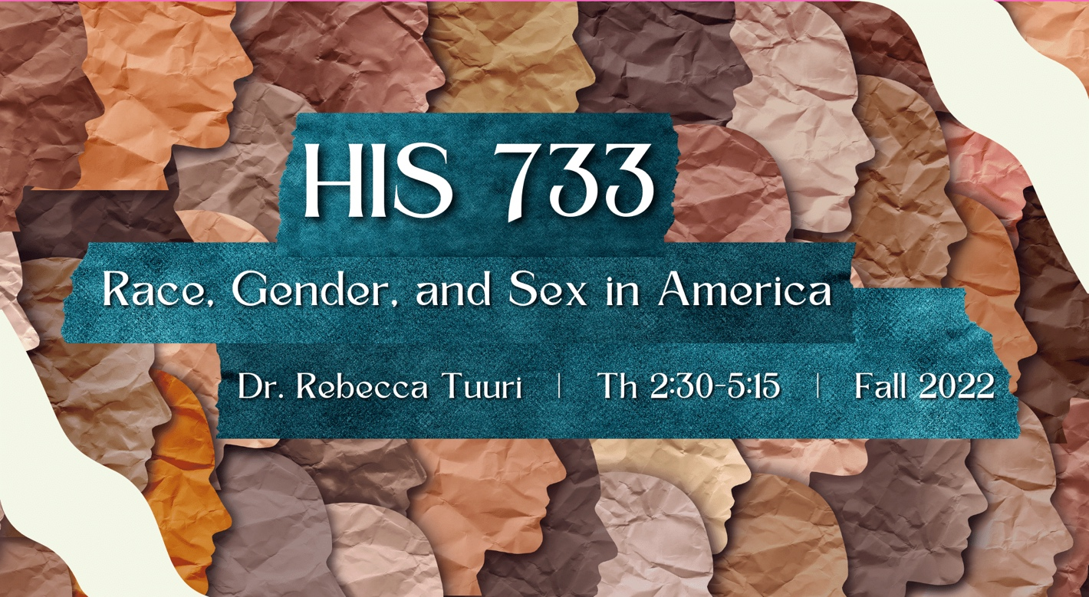HIS 773
Race, Gender, and Sex in America
Dr. Rebecca Tuuri
Th 2:30-5:15
This seminar will introduce students to the concept of Intersectionality and will explore the roles of race and gender, along with class and sexuality, in configuring American identities and experiences. We will read and discuss a range of chronologically organized books that explore a variety of methodologies and historiographies associated with Women's and Gender and African American history. This course will be useful to history graduate students interested in thinking critically about race and/or gender in their own projects, regardless of topic. This course should enable students to see ways in which they too can incorporate a racial and gendered analysis in their own projects, or at least explore methodologies introduced in this course.

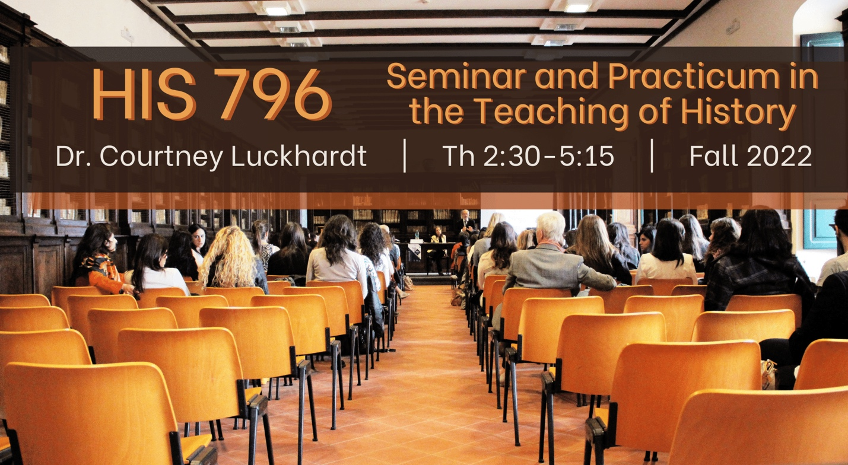History 796
Seminar & Practicum in the Teaching of History
Dr. Courtney Luckhardt
Th 2:30-5:15

This class will introduce graduate students to the theory and practice of teaching of teaching history. The course has two goals. First, it will train graduate students to become GAs here at USM, focusing on topics such as how to help lead discussion, facilitate active learning, and grade assessments of their students. Second, it will provide graduate students with an introduction to the process of designing and running a course independently, including designing a syllabus and assessing and improving their own teaching practice. Students will also focus on their own professional development as teachers, as they begin to formulate a teaching statement and construct a preliminary teaching portfolio. Through assigned readings, assignments, and in-class conversations with the instructor and their peers, students will become familiar with basic pedagogical methods and practices that will help them in careers at different institutions.

