Spring 2022 Course Descriptions
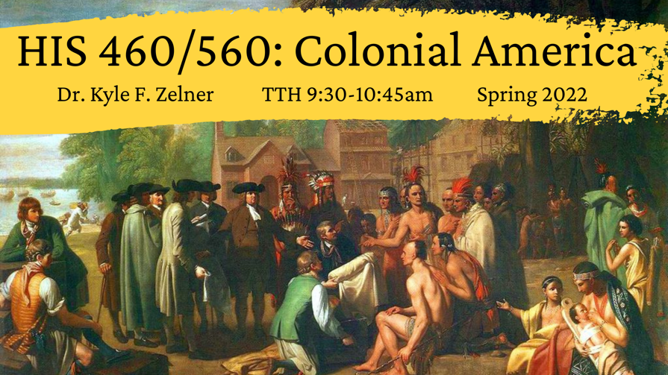

HIS 560
Colonial America
Dr. Kyle F. Zelner
Reg. Code: 9176/9334
TTH 9:30-10:45am
Once thought to be a mere backdrop for the American Revolution, the colonial period of American history, lasting over 250 years (1492-1765) is today recognized as an incredibly important and complex world all on its own—one that deserves and receives an enormous amount of attention from historians, archivists, archaeologists, anthropologists, and museum scholars. It is in the colonial period that the true nature of America was born—a culture of diverse immigrants (some voluntary, others forced, others invaded) who struggled to live and work together in an alien environment in order to better their lives and the lives of their families. The course will explore the settlement, peopling, and development of British North America from around 1600 to 1750.
Assignments: Tentatively, class requirements will include several short papers, a midterm and final exam, and participation in class discussions. Graduate students will have additional assignments, as negotiated with the instructor.

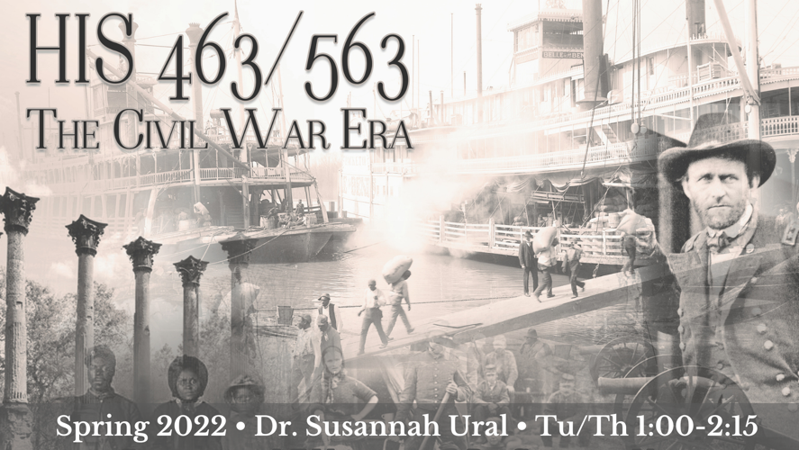
HIS 563
Tu/Th 1:00-2:15
Dr. Susannah Ural
Graduate Students in HIS563 will attend and participate in all HIS463 classes and readings (see HIS463 description). Grad students’ additional assignments, however, will relate to weekly HIS563 readings and meetings with Ural, and to mentoring the undergrads in HIS463 on their Vicksburg NMP presentations.

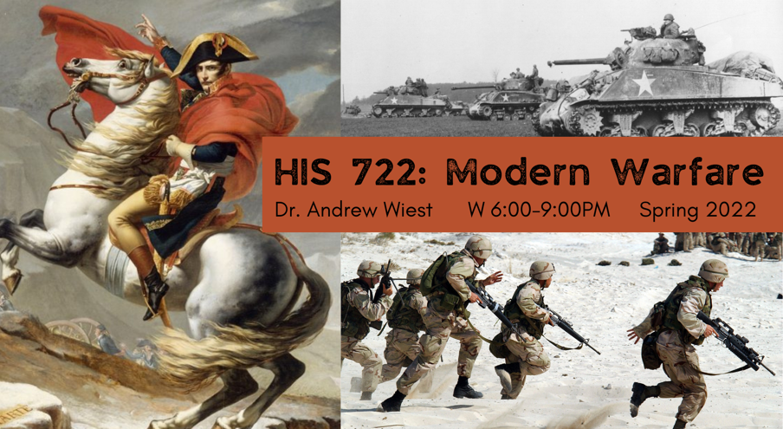
HIS 722
Modern Warfare (seminar)
Dr. Andrew Wiest
W 6:00-9:00PM
This course investigates the ebb and flow of modern warfare through discussions framed around the most important books in the field. The course will begin with the rise of nationalism in warfare in the time of Napoleon, through the move to modernity in the US Civil War and the Great War, through the cataclysm of World War II, through the clash of superpowers in the Cold War, to a new world order and a dramatic shift in warfare in the 21st century.

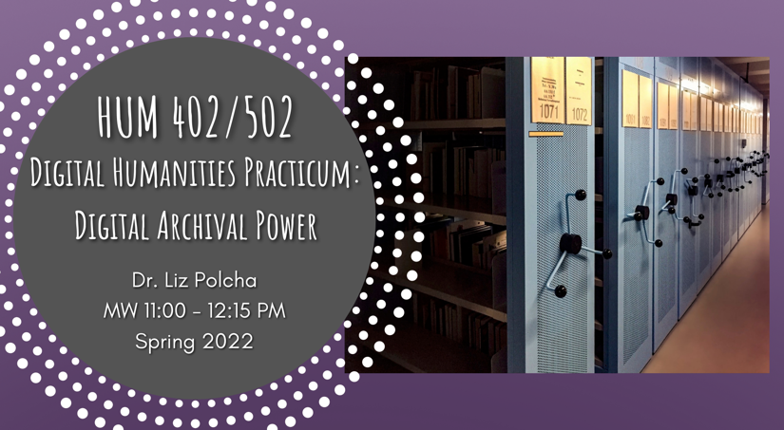
HUM 502
Digital Humanities Practicum: Digital Archival Power
M/W 11:00 - 12:15 PM
Dr. Liz Polcha
This course offers a deep-dive into digital archives as a cornerstone of the digital public humanities. As a practicum, the class is focused on developing advanced skills in digital humanities methods and theory.
Together we will examine theories of the archive, and explore how librarians, scholars, community organizers, artists, and educators have developed digital archives to bring together various audiences. This class begins with Michel-Rolph Trouillot's claim that archives are shaped by silences and erasure. To that end, we will ask questions such as: how can digital archives address histories of violence and archival absence? What is the history of collecting and documentation as humanistic practices, and how might we understand the legacy of this history in digital scholarship today? What are the social justice approaches to digital archiving? Is it possible to "decolonize" the archive through computational methods? And, relatedly, how has the climate crisis changed the way we understand archives, storage, and sustainability?
Our class activities will involve both discussion of archival theory, as well as experimentation with various methods of digital archiving—such as: writing metadata for archival objects, designing exhibits using web-based platforms, learning the basics of digital project management, and developing good data management practices including writing documentation. We will also review an extensive list of digital archives, meet archivists, and learn from digital scholars who are pushing the boundaries of what a digital archive is.
This course is a combined undergraduate and graduate practicum; Introduction to Digital Humanities is recommended as a prerequisite but not required.

