PHI 171
Ethics and Good Living
TR 9:30 – 10:45
Dr. Sam Bruton

One of the earliest and most enduring of all philosophical questions is both unavoidable and profoundly important for all of us: How Should I Live? This course examines classic and contemporary answers to this question. The goal is not to arrive dogmatically at one favored view or to criticize those who lead lives very different from our own. Different people find meaning in different ways. Rather, the goal of the class is to help each student refine his or her own answer to the question by studying the most respected and time-tested views available to us.

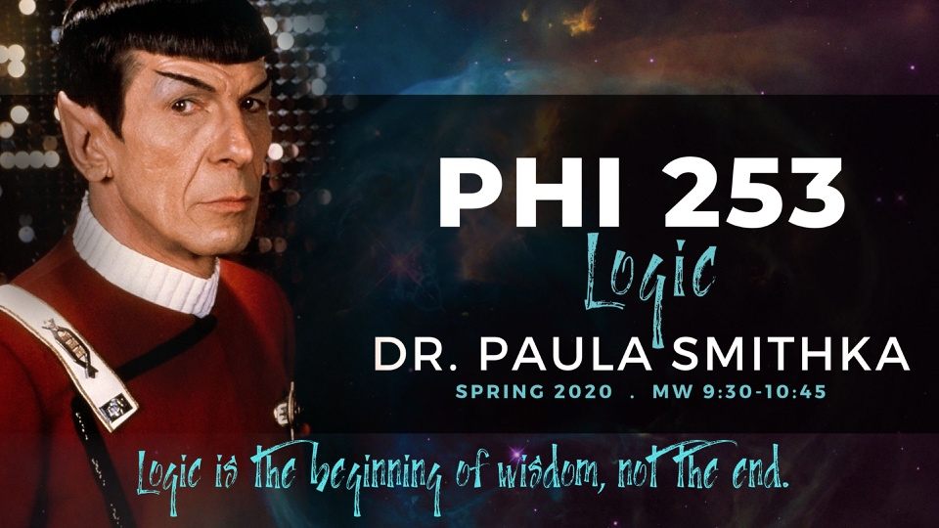
PHI 253
Logic
MW 9:30 – 10:45
Dr. Paula Smithka

Developing good critical thinking skills is useful for clarity of reasoning and evaluating the views of others both in philosophical studies and everyday life. In Logic, you will learn the importance of having evidence or reasons to support one’s views, how to evaluate arguments for their strength and cogency, and how to construct good arguments. In addition, you will not only learn what constitutes a good/strong argument, but we will examine common mistakes in reasoning. The reasoning skills that you begin to develop by taking a logic course will aid you in whatever academic or professional directions you choose to take. This course will make you a detail person!

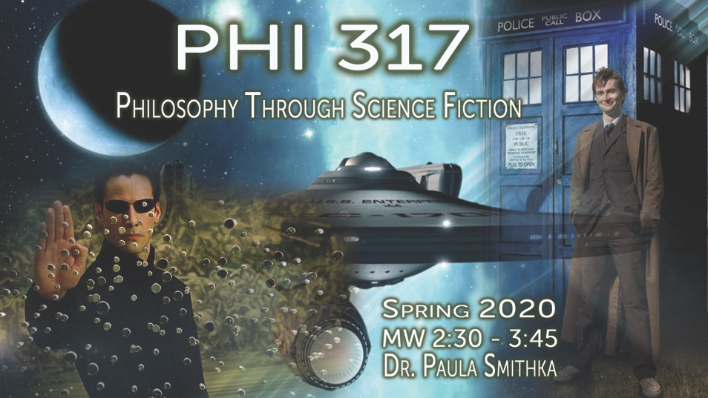
PHI 317
Philosophy Through Science Fiction
MW 2:30 – 3:45
Dr. Paula Smithka

This course is an exploration of philosophical issues presented in various works of science fiction. Science fiction is not only a popular genre in both literature and film, it is a fecund medium for philosophical issues, incorporating issues from metaphysics: appearance vs. reality, personal identity; the nature of mind and the possibility of artificial intelligence; ethics: what does it mean to be a moral person? How should we treat others who may be quite unlike ourselves?; and philosophy of science: the nature of time; and is time travel possible?
So, step into the TARDIS and let’s “boldly go” explore the intersections of philosophy and science fiction!
And, for Online students, there is an online section available.

PHI 351
Critical Thinking
TR 11:00 – 12:15
Dr. Sam Bruton

This class introduces students to skills for becoming a more effective thinker and a better reasoner, including various techniques for avoiding common reasoning pitfalls and for critiquing the flawed reasoning of others. From interpreting political debates to careful evaluation of scientific evidence, good critical reasoning skills are invaluable in most aspects of life. Some class time is set aside to practice the kinds of questions commonly found on the LSAT, GRE, and other standardized tests. This course is required for the Philosophy Pre-Law emphasis track.

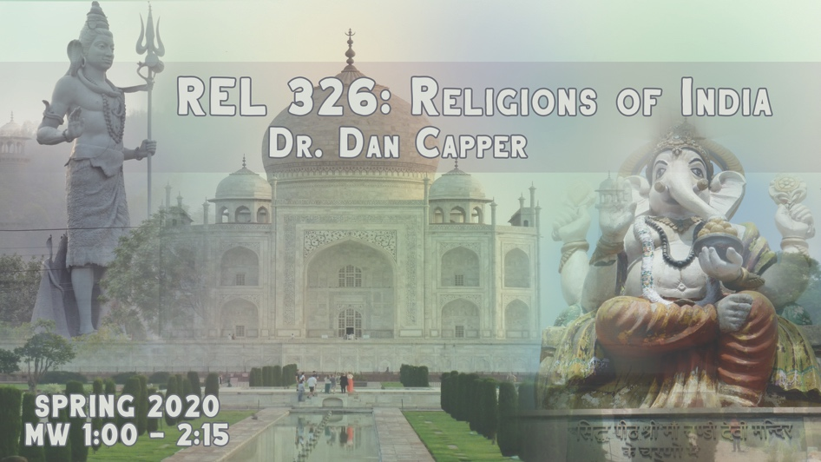
REL 326
Religions of India
MW 1:00-2:15 PM
Dr. Dan Capper
India, one of the great cradles of religion in the world, offers an unrivaled environment of religious diversity and intensity. This course studies the varieties of religious contributions which India has made to world cultures.

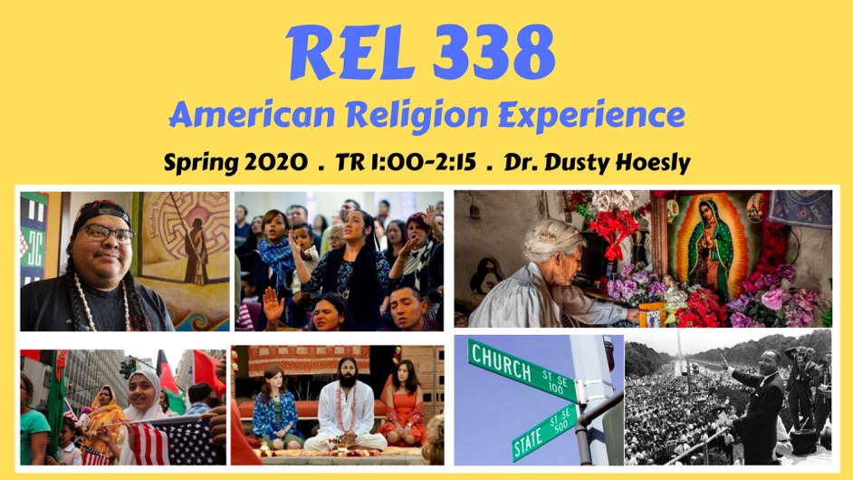

REL 338
The American Religious Experience
TR 1:00-2:15
Dr. Dusty Hoesly

This course will introduce students to religious diversity in America. Using primary and secondary sources, we will explore the relationship between religion and culture from pre-contact and colonial periods to the present. How have different religions reacted to each other and to changes in American society? What is the role of religion in American public life? Topics include various religions, law, politics, empire, education, migration, race, ethnicity, gender, sexuality, globalization, secularism, nature, and media.

