English Graduate Course Descriptions

Spring 2021
ENG 506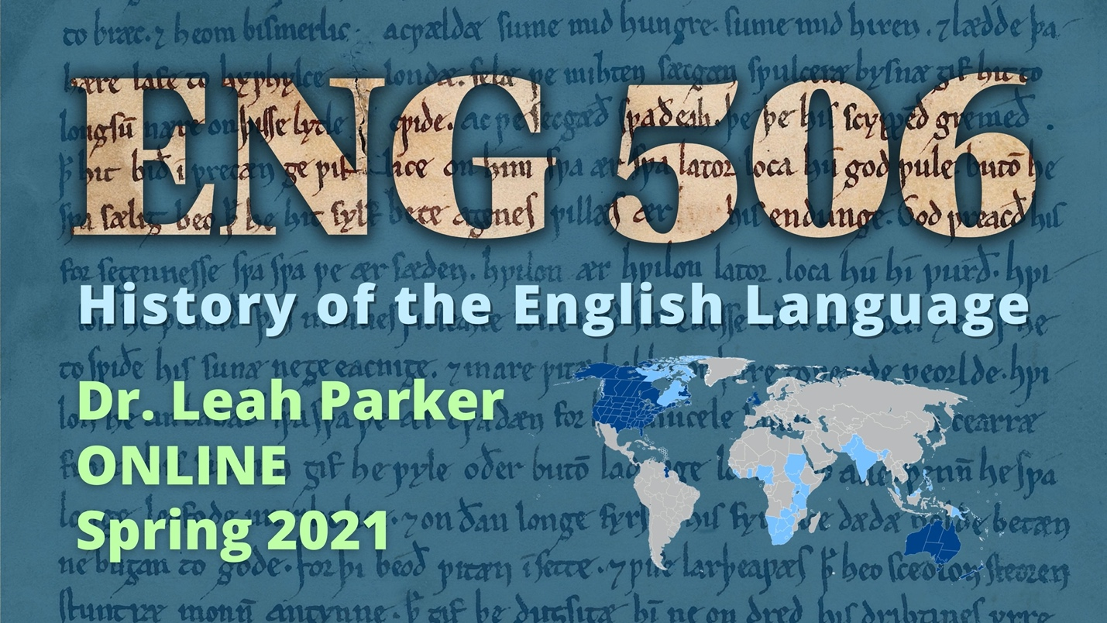
History of the English Language
ONLINE
Dr. Leah Parker
*fulfills British Literature to 1800
Have you ever wondered why each letter C in “Pacific Ocean” is pronounced differently? Why sweetbreads are meats and sweetmeats are candy? Why sometimes you call yourself “I” and other times call yourself “me”? Why you can play a “bass,” but catch a “bass”? Why you can feel the “wind” on your face, but you “wind” down at the end of the day? Why, when the truth comes out, we say: “the cat’s out of the bag”? What cat? What bag?! The answers to these questions and more lie in the wild and weird history of the English language!
ENG 506, History of the English Language, will be fully online and asynchronous—there will be no required full-class synchronous meetings, though office hours and individual or small-group meetings will be available to help students succeed in the course.
In ENG 506, we will trace the history of the English language from its prehistoric Indo-European roots, through sound changes of the Middle Ages, standardization in the era of print, and diversification as a global language in the modern world. You will learn the basics of linguistics; the pronunciation and basic grammar of Old English (spoken ca. 450–1150 CE) and Middle English (spoken ca. 1150–1500); how to fully utilize dictionaries and editions of English texts; and how dialects develop through isolation, imperialism, and human interactions.
In addition to learning about the deep history and vast geographical range of English, students will have the opportunity to create an entry in an ongoing online glossary project (which, if accepted, is a publication credit). Graduate students will choose between two “tracks” for their projects: the linguistics/TESOL track and the literary history track. In the linguistics/TESOL track, students will complete a 15–20-page lit review on a relevant topic in “socio-linguistics and contemporary language instruction” of their choice as well as an accompanying TESOL/HEL topical lesson informed by current scholarship and debates within the field. Students choosing the literary history track will produce a “mini-edition” of a pre-1700 English text of their choice as well as a 15–20-page seminar paper analyzing the text of their mini-edition utilizing both literary and linguistic methodologies.

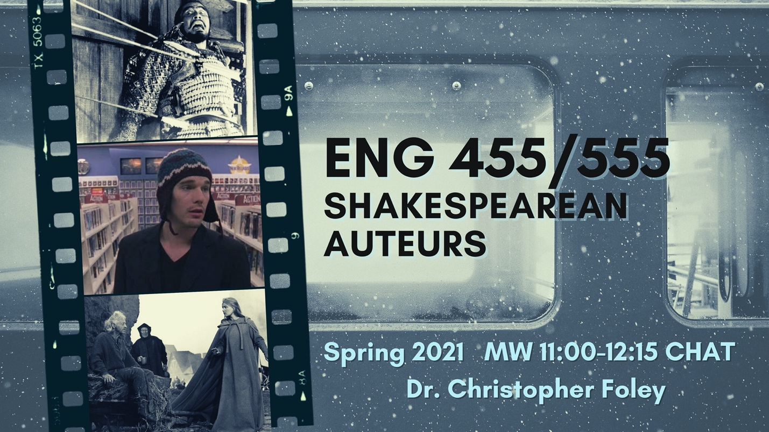ENG 555
Shakespearean Auteurs
MW 11:00-12:15 CHAT
Dr. Christopher Foley
*fulfills British Literature to 1800
Olivier. Welles. Kurosawa. Kosintsev. Zeffirelli. Branagh. Abela. Almereyda. The list of distinguished film directors who have adapted Shakespeare’s plays more than once for film audiences continues to grow. In this course, we will read a number of Shakespeare’s most frequently filmed tragedies, discussing their thematic concerns and theatrical staging possibilities, before turning our critical attention to several film adaptations of each play by those auteurs listed above. Attending to the diverse appropriations and adaptations of Shakespeare worldwide, we will strike a balance on our syllabus between Anglophone/American directors and those from World Cinema. Intended to attract both English and Film majors/minors, as well as general Shakespeare enthusiasts, we will cultivate the ability to analyze and interpret film as literature while giving reciprocal consideration to the latent filmic potential of dramatic texts.

ENG 589
Studies in American Literature
T 1:00-3:45 CHAT
Dr. Jonathan Barron
ROBERT FROST AND EDNA ST. VINCENT MILLAY
*fulfills American Literature Post 1865
In this class, we’ll be reading two of the most popular poets from the first half of the 20th century. We’ll be asking why they were so popular, and we’ll be discovering that they may not have been all that different. It may seem like Millay, one of the first poets to advocate for women’s rights, a radical devoted to left and liberal social causes, would have little to do with Frost, a well-established poet old enough to be her father; yet this class will bring these two poets together as equally rebellious with regard to their approach to poetry. By reading them together, this class will investigate how beginning in the 1910s their break with literary conventions helped recreate and reimagine what American literature and poetry would become today.

ENG 627
Introduction to Publishing
MW 11:00-12:15 CHAT
Dr. Adam Clay
*fulfills CW Elective, Creative Writers only
ENG 627 is a course primarily focused on literary citizenship and engagement in the publishing world. The course will allow students to gain hands-on experience through reading submissions and selecting finalists for the Mississippi Review Prize. We’ll also publish an issue of Product Magazine and organize an event to correspond with its release. During the term we’ll host a range of guest speakers via Skype to learn about their roles in an ever-changing literary world. In addition to considering the publishing world from the perspective of an editor, we’ll also discuss techniques and approaches from the perspective of a writer, which will include selecting magazines and journals to submit work to, drafting cover and query letters, and other elements writers need to be aware of when publishing creative work.

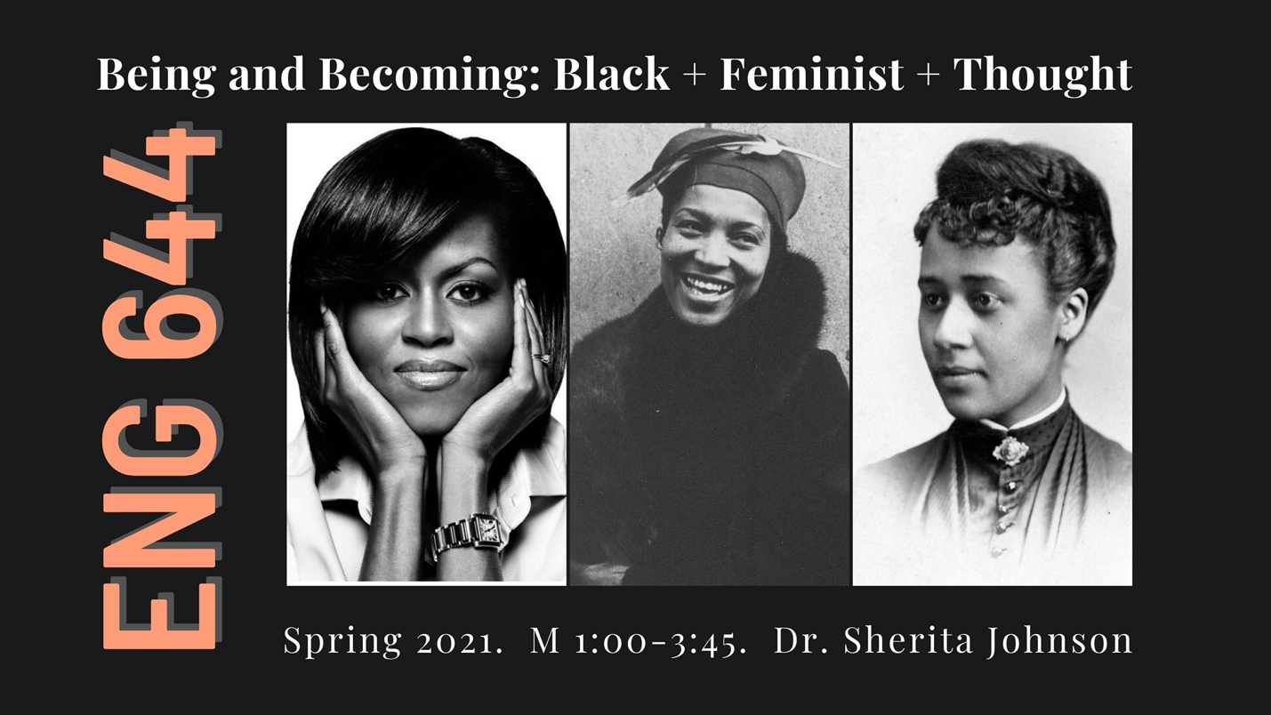ENG 644
Topics in Literary Theory
M 1:00-3:45 CHAT
Dr. Sherita Johnson
“Being and Becoming: Black + Feminist + Thought”
_{*fulfills Theory}
From Maria Stewart’s public addresses in the 1830s to Michelle Obama’s democratic ethos of today, we will examine in this course the multidimensional praxis—critical thinking, sociopolitical action, and creative expression—of black feminism. Readings will focus on the experiences of African American women in slavery and in freedom, as public intellectuals and grassroots activists in equal rights movements as well as within the “ivory tower of academia.” Course assignments may include two critical essays, a book review, and interactive presentations.
Required Texts
Beverly Guy-Sheftall, ed. Words of Fire: An Anthology of African-American Feminist Thought (1995)
Elizabeth Keckley, Behind the Scenes: Or, Thirty Years a Slave, and Four Years in the White House (1868)
Zora Neale Hurston, Their Eyes Were Watching God (1937)
Toni Morrison, Sula (1973)
Michelle Obama, Becoming (2018)
RECOMMENDED:
Brittney Cooper, Eloquent Rage: A Black Feminist Discovers Her Superpower (2019)
Koritha Mitchell, From Slave Cabins to the White House: Homemade Citizenship in African American Culture (2020)

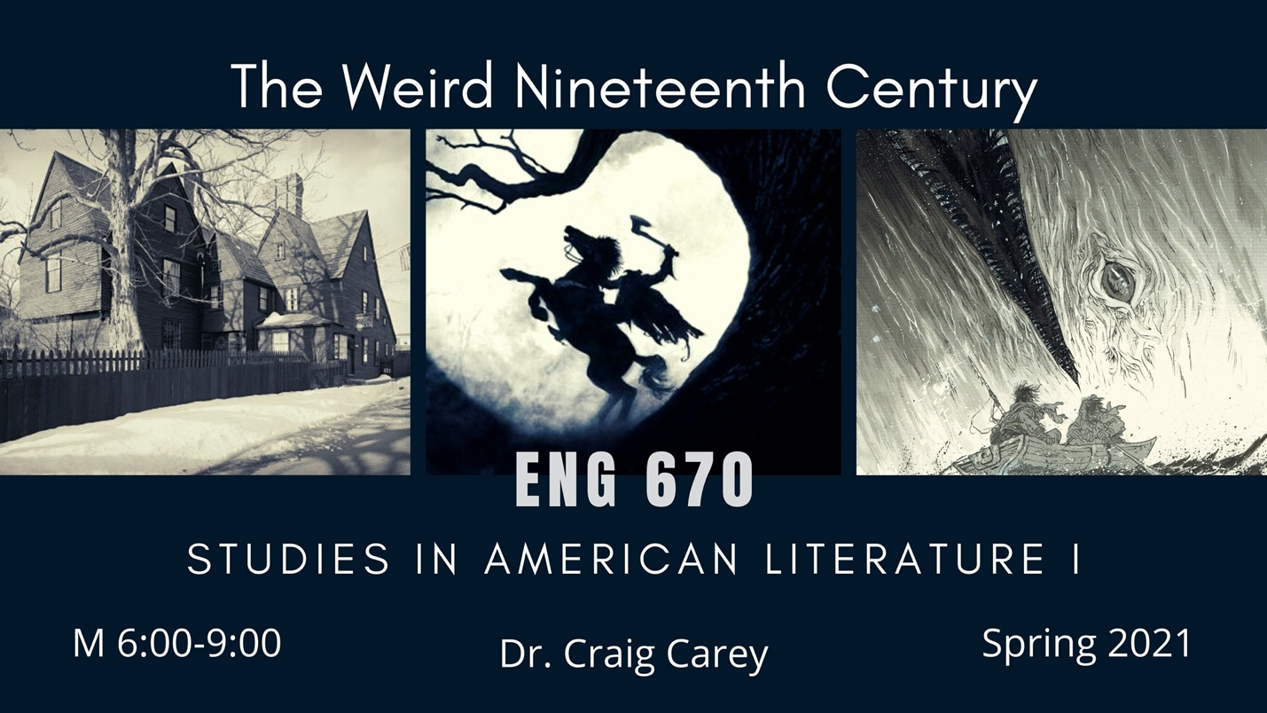ENG 670
Studies in American Literature I
M 6:00 - 9:00 PM CHAT
Dr. Craig Carey
The Weird Nineteenth Century
*fulfills American Literature to 1865
Strange things are happening in literature and literary history. The rise of weird and speculative fiction has started to twist, turn, tangle, and invert our normal perspectives on literature, history, knowledge, and even the human itself. With its mixing of genres and overturning of conventions, weird fiction has struck a nerve that reverberates into the darker recesses of literary history. In this course, we’ll track the weird back to the nineteenth century and explore early precursors to weird fiction in ghost stories, Gothic tales, supernatural fiction, satires, metaphysical sketches, tales of mesmerism and spiritualism, and other romantic works that subvert reason, rationality, and other Enlightenment principles. We’ll survey the historical roots of weird fiction by attuning ourselves to affects and atmospheres of anxiety, dread, terror, and the uncanny, pushing through the mundane into “the colossal orbs” of the alien, strange, sublime, and metaphysical.
Designed as a survey, the course will examine the peculiar styles and sensibilities of American authors as they invoke the weird, strange, supernatural, and speculative as a means to probe the limits of human knowledge and understanding. In the process, we will explore “the weird” as a sensation, a mood, an aesthetic, a mode of writing, an epistemology, and a gesture toward dark ontology. How is the weird figured and disfigured in the nineteenth century? How and why does it transfigure reality, transcend human understanding, and breathe life into supernatural, cosmic, and nonhuman agencies? In addition to primary texts, we’ll also read a handful of short essays on weird fiction, the Gothic, dark ecology, animal studies, and speculative realism.
Possible texts will include:
Charles Brockden Brown, Weiland; or, The Transformation: An American Tale
Washington Irving, “Rip Van Winkle” and “The Legend of Sleepy Hollow”
Edgar Allan Poe, The Narrative of Arthur Gordon Pym of Nantucket
Essays by Emerson, combined with satirical works by Hawthorne and Alcott
Speculative and metaphysical sketches by Poe, Hawthorne, and Margaret Fuller
Nathaniel Hawthorne, The House of Seven Gables
Herman Melville, Moby-Dick; or, The Whale
Henry David Thoreau, Walden
Supernatural stories by Fitz James O’Brien, Ambrose Bierce, and Henry James
Supernatural fiction by women writers such as Louisa May Alcott, Elizabeth Stuart Phelps, Charlotte Perkins Gilman, Mary Wilkins Freeman, and Sarah Orne Jewett
Charles Chesnutt, selections from “The Conjure Tales”
Pauline Hopkins, Of One Blood: Or, The Hidden Self

ENG 721
Seminar in Fiction Writing
Dr. Olivia Clare
T 1:00-3:45 CHAT
_{*fulfills Fiction Workshop}
In this course, you will share your own short stories and novel excerpts in a workshop setting. You will also analyze and discuss various techniques employed in assigned readings. In addition, we’ll make a bit of time for in-class writing exercises.
We will discuss: craft topics (beginnings, characterization, dialogue, setting, pacing, momentum, compression, expansion, volume, subtlety, syntax, syncopation, tension, anticipation, endings, and style), your creative life, your reading habits, your writing habits, revision, publishing, and literary citizenship. Additionally, you’ll think about some of the harder questions you have for your writing. No doubt you know what some of those questions are already, and you’ll discover more in this class.
Short stories and novel excerpts to be distributed in class

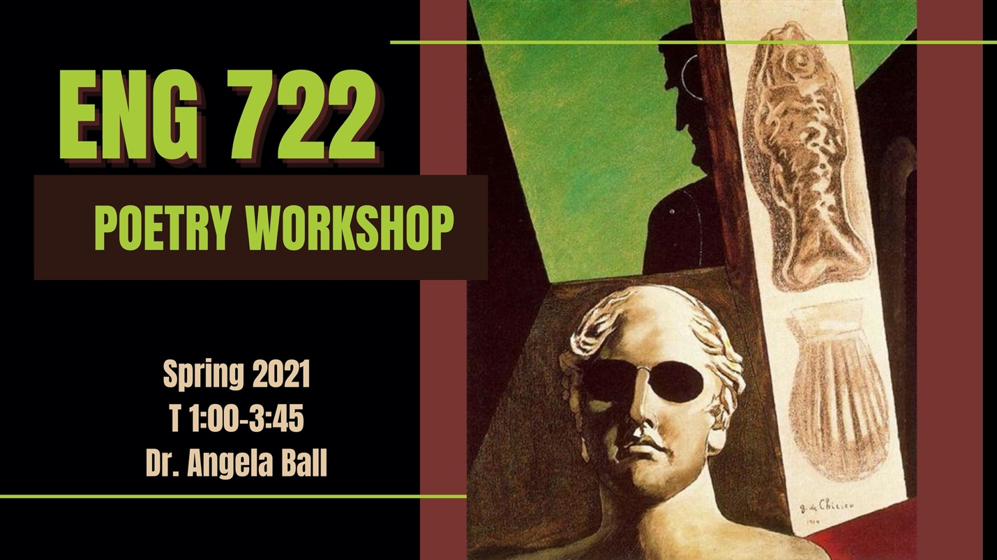ENG 722
Seminar in Poetry Writing
T 1:00-3:45
Dr. Angela Ball

My Life by Somebody Else
_{*fulfills Poetry Workshop}
This workshop will center on persona poems and poems in translation. The term “translation” will be used liberally, to include poems “in the manner of,” “adapted from,” “after,” etc. Versions of poems available in literal translations will also qualify, along with student-devised variations on writing their lives “by somebody else.”
Textbooks will include John Ashbery’s Collected French Translations in two volumes: Poetry and Prose

ENG 723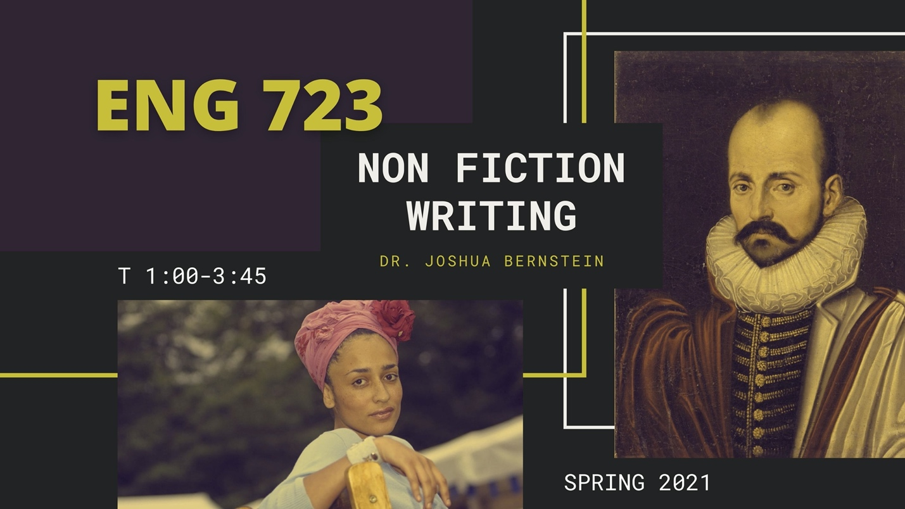
Nonfiction Writing
T 1:00-3:45 CHAT
Dr. Joshua Bernstein

*fulfills creative writing elective, Creative Writers only
The Essay
The word essay, deriving from the French essayer, meaning “to attempt” or “to try,” was originally conceived as a kind of experiment, or planned inquiry on a topic. Montaigne famously applied the term around 1580 to his writings. Four-and-a-half centuries later, we’ll ask to what extent the essay can still be conceived as an experiment, or an attempt at understanding, as opposed to a preconceived answer, and try our hands at writing them. We’ll also look at the variety of forms the essay can take, from the narrative and reflective to the lyric and experimental. Finally, and per Montaigne’s intent, we’ll treat the writing as a kind of process, one in which the writer is led through writing to discovery and, hopefully, surprise.
Although ours is primarily a workshop, we’ll also trace the history of the essay, its evolution as a form, and its current status and outlook as a genre. Outside works will likely include Lily Hoang’s A Bestiary and shorter works by Woolf, Orwell, Borges, Didion, Maggie Nelson, Roxane Gay, Ander Monson (who may visit our class), David Foster Wallace (who won’t), Zadie Smith, Christopher Hitchens, Wendell Berry, Randall Kenan, Lia Purpura, and, of course, Montaigne himself. Please keep in mind that all work submitted for the class must be factual and, if applicable, documented, though we will also work on traditional techniques, including (faithfully) reinvented dialogue, narrative arc, and the building of dramatic tension and conflict. Oh, and because nature is often our best guide, we will, health and weather-permitting, get outside to write a bit, possibly with pens and canoes.

ENG 763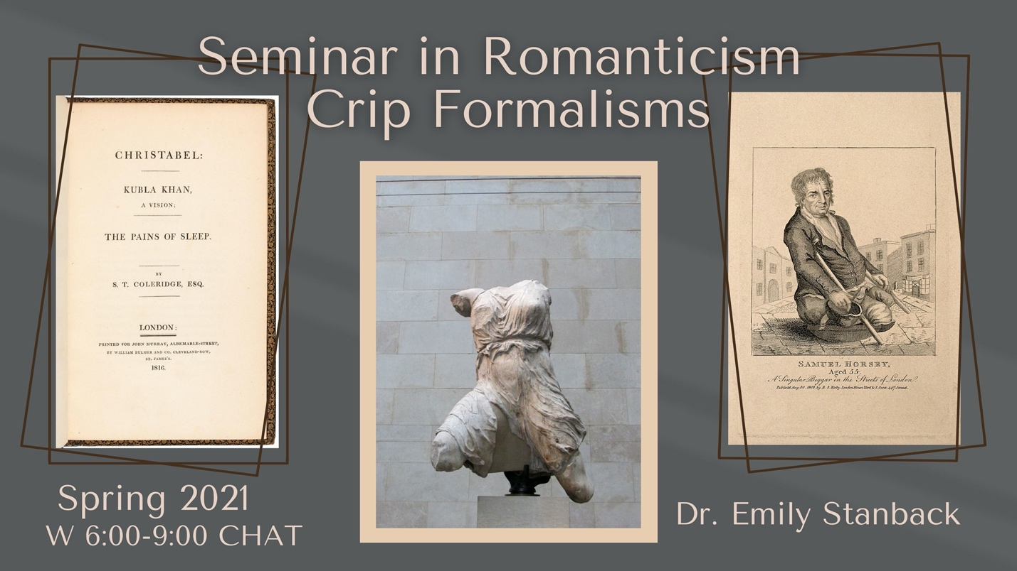
Seminar in Romanticism
W 6:00-9:00
Dr. Emily Stanback
Crip Formalisms
*fulfills British Literature post 1800
Many of the most enduring characters from Romantic-era literature, from the Ancient Mariner to Frankenstein’s Creature, embody pathologized states. Most Romantic-era authors also lived with conditions that, then and now, were pathologized by medicine—and most explicitly claimed the importance of these embodied states to their lives and writing. For example, Samuel Taylor Coleridge wrote letters and poetry about a wide range of chronic bodily and mental symptoms, Mary Prince spoke movingly about her rheumatism, Thomas De Quincey minutely tracked his “crazy body,” and Charles Lamb wrote about his stuttering, limping, and experience of madness.
This course seeks to put all of these variously disabled bodyminds into conversation with literary form in order to explore the ways in which disability has left its palpable trace on Romanticism. The fact of disabled embodiment can be felt in the Romantic fragment and in the epistolary novel, in private notebooks and in missives from abroad—and also in epitaphs and on gravestones that detail a person’s cause of death, as they often did during the era. Mindful of intersectionality, we will consider how experiences of, and formal expressions of, disability can be shaped by race, gender, and class.
In addition to primary texts by authors including Coleridge, Prince, De Quincey, Lamb, Mary Shelley, Lord Byron, Mary Wollstonecraft, John Keats, Dorothy Wordsworth, and John Clare, we also will consider foundational texts in disability studies and disability theory by authors including Tobin Siebers and Ato Quayson.

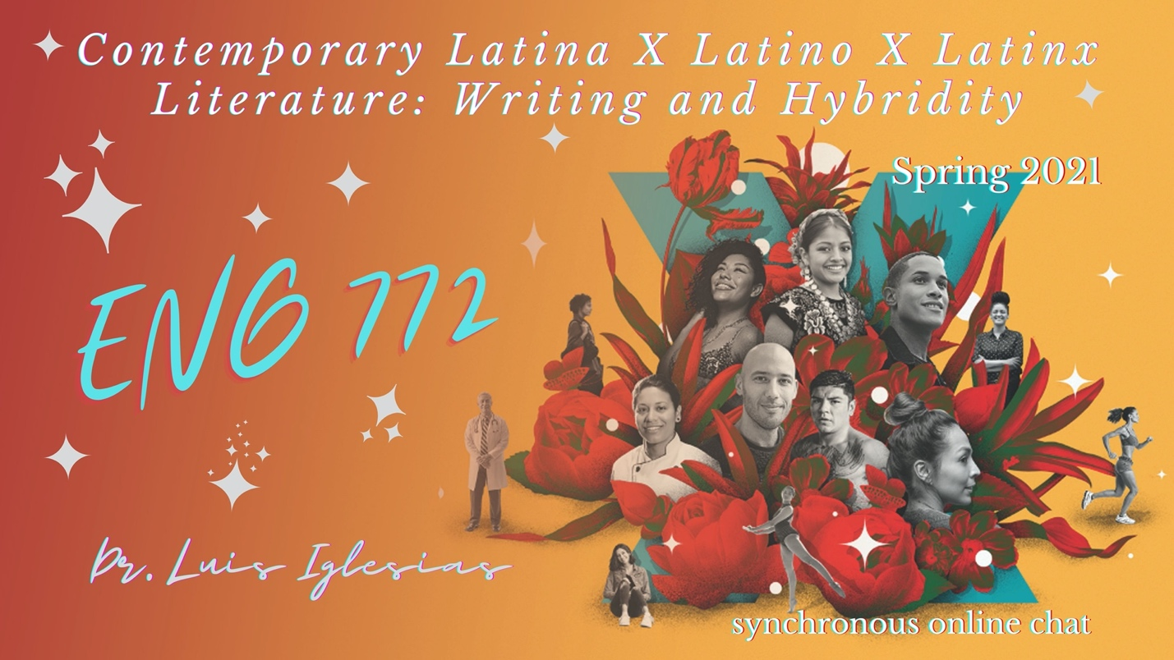ENG 772
Readings in American Literature
T 6:00-9:00 CHAT
Dr. Luis Iglesias

*fulfills Non-traditional or Contemporary
Contemporary Latina X Latino X Latinx Literature: Writing and Hybridity
Contemporary Latina/o/x Literature: Writing and Hybridity will seek to unpack the multiethnic, multiracial, and socially diverse dimensions of contemporary Latino-American writings from the past 20 years, looking at a range of Hispanic-American writers who represent a diverse set of communities across the full spectrum of American life. At the same time, we will seek to locate those aesthetic and/or experiential moments that reveal the complex hybrid nature and yearnings of Latinx identity and literary production. Potential reading list: Javier Zamora’s Unaccompanied (2017); Gambino Iglesias’ Coyote Songs (2018); Luis Alberto Urea’s The House of Broken Angels (2018); Bryan Washington’s Lot (2019); Eduardo Corral’s Guillotine (2020); among others

