English Undergraduate Course Descriptions

Spring 2021
ENG 200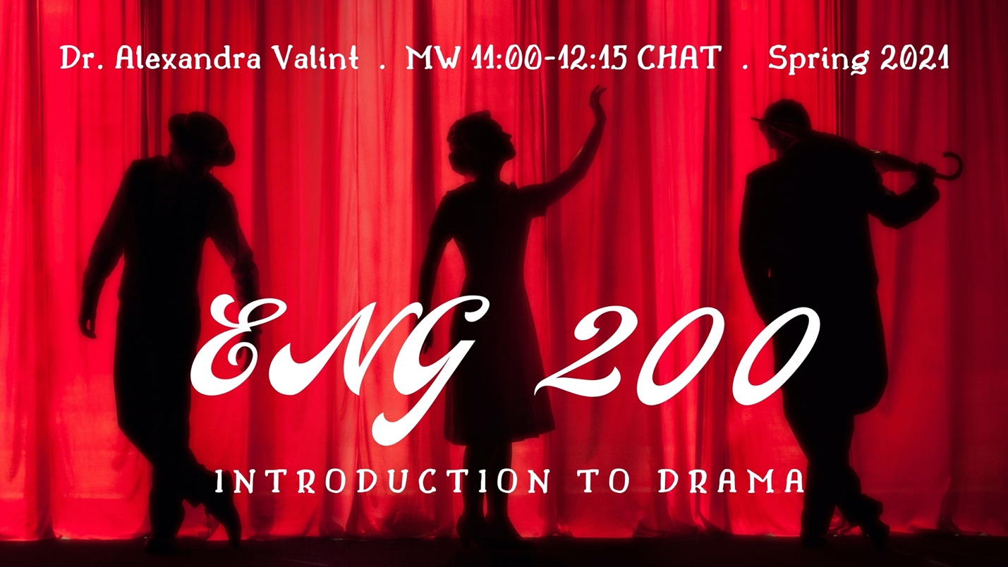
Intro to Drama
MW 11:00-12:15 CHAT
Dr. Alexandra Valint
The primary goal of this course is to make you more confident, enthusiastic, and sophisticated readers and interpreters of drama. We will explore a diverse selection of plays, from Ancient Greek tragedy to contemporary Pulitzer-Prize winners. We will pay particular attention to how these plays engage with issues of gender, race, love, and war, as well as to how they represent the struggles of individuals, relationships, and societies. We also will virtually watch at least one theatrical performance. Whether you are a seasoned theatre practitioner or a new visitor to the world of drama, you are welcome in this class. Together we will experience the wisdom and wonder of theatre. We will likely read plays by Edward Albee, Euripides, Lin-Manuel Miranda, Lynn Nottage, Suzan-Lori Parks, William Shakespeare, Oscar Wilde, and Tennessee Williams.
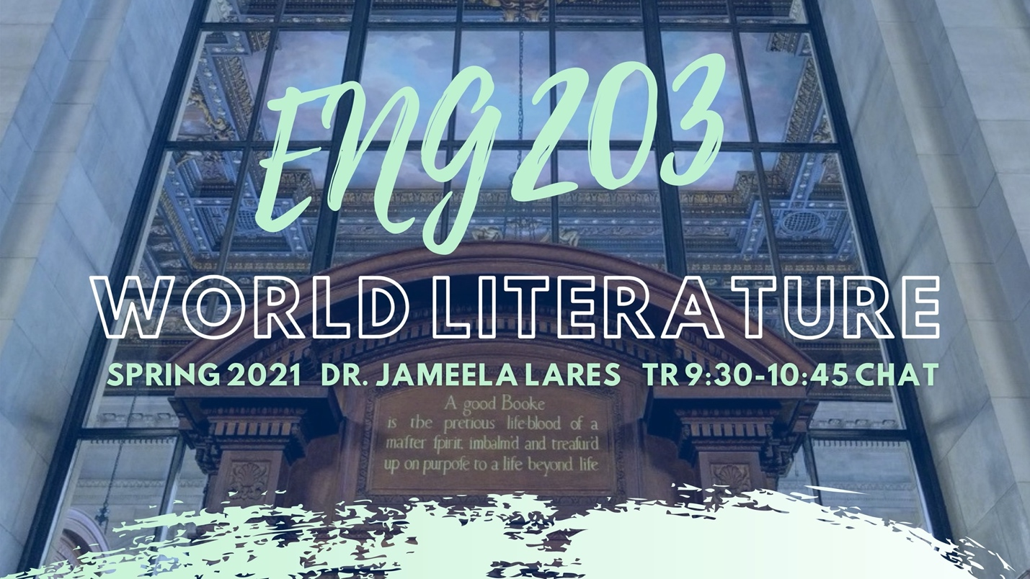ENG 203
World Literature
TR 9:30-10:45 CHAT (H004)
Dr. Jameela Lares
This course is intended to acquaint you with significant figures and works of world literature, beginning with early lyric poetry in China and The Epic of Gilgamesh in Mesopotamia and moving through time and space to the modern age. We will focus how literature is constructed, how it describes the human experience, and how we can talk about its interrelationships with time, place, culture, and other contexts. Texts: The Norton Anthology of World Literature, Shorter Fourth Edition, 2 vols., and the handy Oxford Dictionary of Literary Terms, 4th edition, ed. Chris Baldick.

ENG 221
Fiction Writing I
TR 9:30-10:45 CHAT
Apoorva Mittal
Virginia Woolf called fiction an “unsolved problem.” In this introductory class, we will try to understand what that unsolved problem is. The course is open to students who have never taken a creative writing class. You will write your own fiction as well as workshop a short story (or two) or a novel chapter. Based on the feedback you receive from me and your peers, you will revise your fiction. In addition, each session will involve in-class writing based on prompts. We will discuss craft elements like dialogue, character, setting, style, points-of-view, and perspectives. We will read short stories and novel excerpts by a mix of authors from around the world such as Akwaeke Emezi, Chimamanda Ngozi Adichie, Zadie Smith, Carmen Maria Machado, Sally Rooney, Jhumpa Lahiri, and Angela Carter. Readings will be distributed in class.

ENG 222
Poetry Writing 1
MW 11:00-12:15
Kevin Thomason
This course is open to anyone interested in writing and reading poetry. Students will submit original work to share with the class. We’ll also look at a wide range of poems from the past and present, with a focus on articulating what we like about them. In our own writing, we’ll practice how to craft images, sounds, and metaphors. Readings will include work from Elizabeth Bishop, Gwendolyn Brooks, Philip Larkin, and others. These will be distributed in class.

ENG 314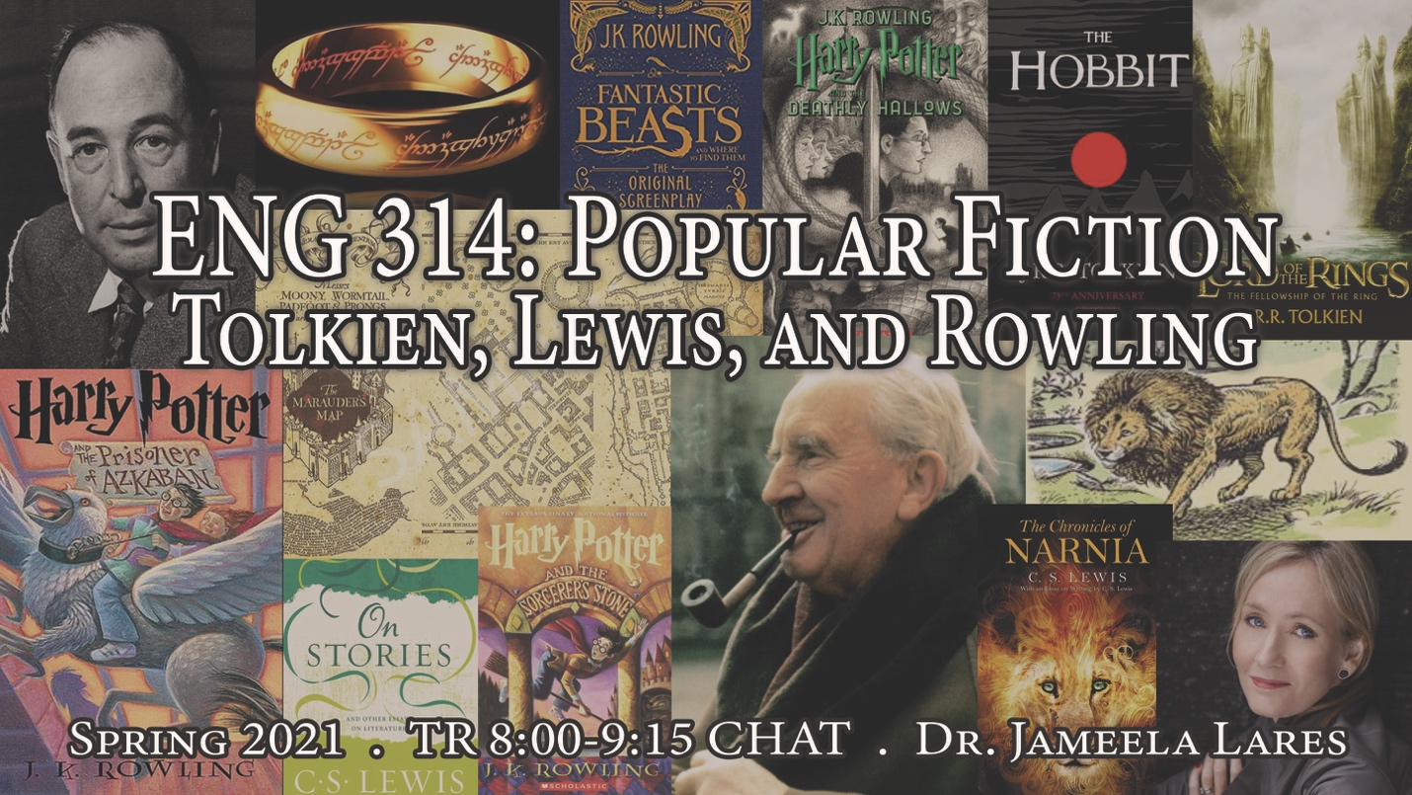
Popular Fiction
TR 8:00-9:15 CHAT
Dr. Jameela Lares
Tolkien, Lewis, and Rowling
In this course, we will be exploring how three blockbuster authors—J. R. R. Tolkien, C. S. Lewis, and J. K. Rowling—have both understood the nature of imaginative literature and successfully written it. As a class, we will read not only several works by each author but also look at their own theories of composition, including Tolkien’s On Fairy Stories and Lewis’s On Stories. Course requirements: thoughtful reading of texts, regular class attendance and participation, blog posts and/or responses on Canvas, an oral presentation on an additional text, a short paper, a midterm, and a final.
Probable texts:
J. R. R. Tolkien, The Tolkien Reader (includes Tree and Leaf, Farmer Giles of Ham)
The Hobbit
The Fellowship of the Ring
C. S. Lewis, The Chronicles of Narnia
Out of the Silent Planet
Perelandra (beginning chapters as ghost story—will have .pdf)
On Stories and Other Essays on Literature
Till We Have Faces: A Myth Retold
J. K. Rowling, Harry Potter and the Sorcerer’s Stone
Harry Potter and the Prisoner of Azkaban
Harry Potter and the Deathly Hallows
Fantastic Beast and Where to Find Them: The Original Screenplay

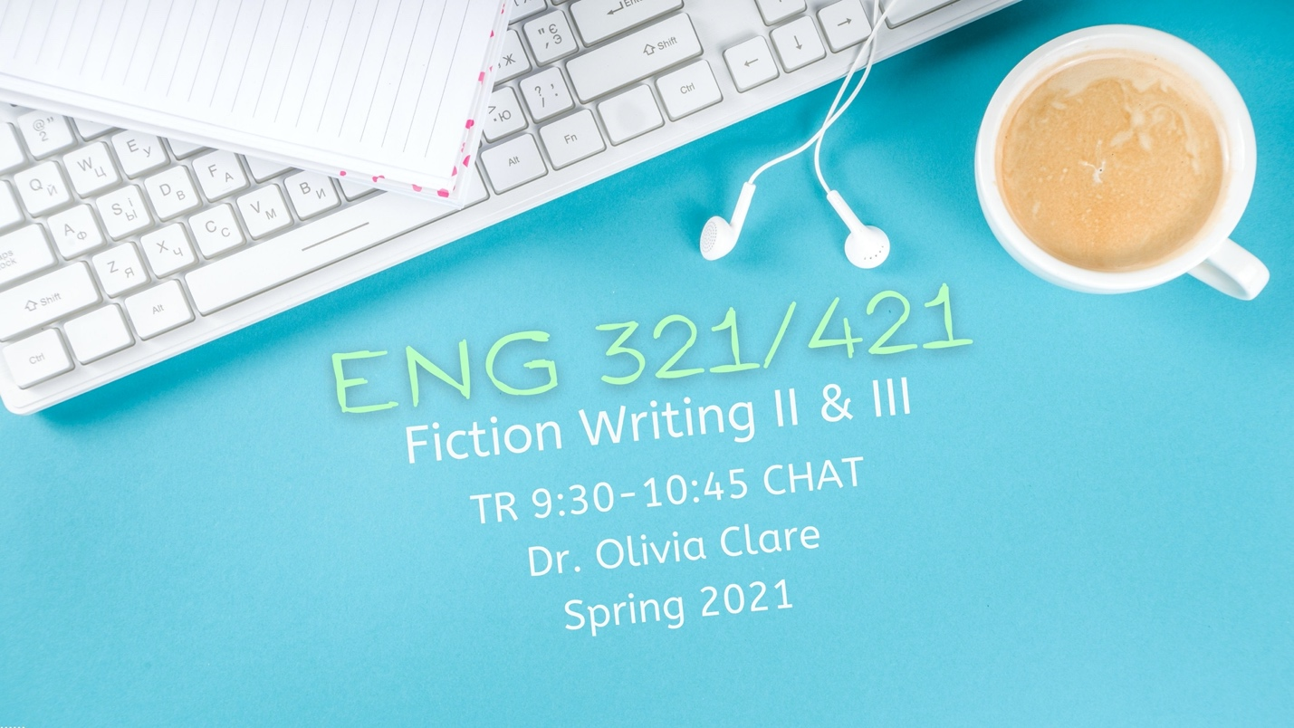ENG 321/421
Fiction Writing II and III
TR 9:30-10:45 CHAT
Dr. Olivia Clare
In this class, you will write your own original fiction and workshop one another’s fiction. In addition to honing your craft, you will be working on your workshop skills. Craft topics will include: character, dialogue, setting, structure, style, revision, and more. You may turn in either short stories or novel chapters.
Recommended Text:
- Writing Fiction, 10th Edition, Janet Burroway, Elizabeth Stuckey-French, Ned Stuckey-French
- Short stories and novel excerpts to be distributed in class

ENG 332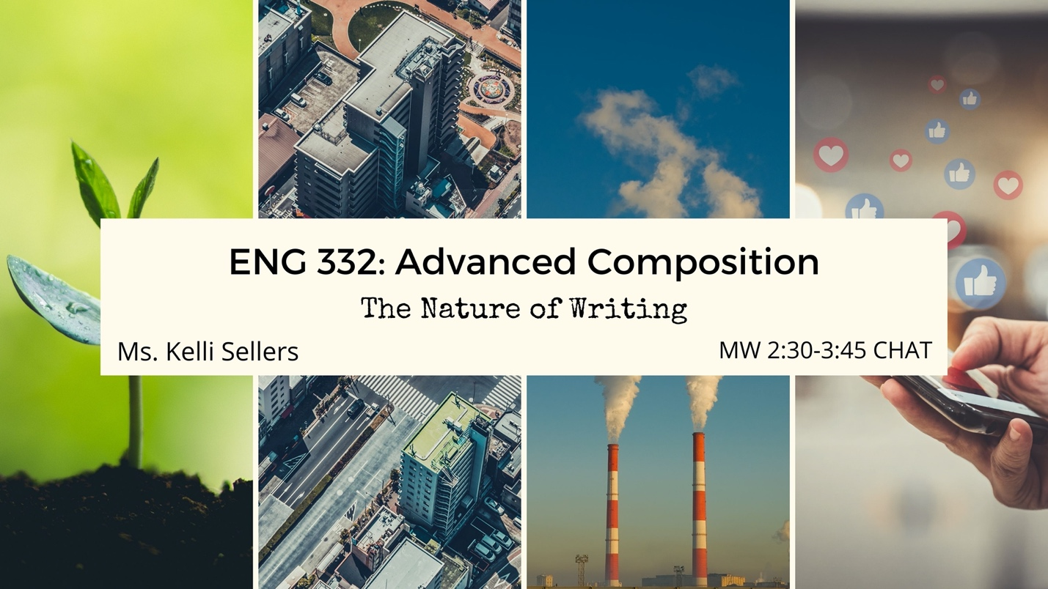
Advanced Composition
MW 2:30-3:45 CHAT
Ms. Kelli Sellers
The Nature of Writing
In a recent defense of nature writing today, Robert MacFarlane says, “A 21st-century culture of nature has sprung up, born of anxiety and anger but passionate and progressive in its temperament, involving millions of people and spilling across forms, media and behaviours.”
In this course, we will explore the relationships between storytelling and world-making and between writing and activism. By reading and writing about nature across forms and media, we will learn to engage in the conversations that seek to understand the landscapes of our lives and to create change in the world around us.
Likely topics of research and discussion will include conservation, nature and health, environmental (in)justice, social media and activism, climate change, technology and urban development, and constructions of place.

ENG 335
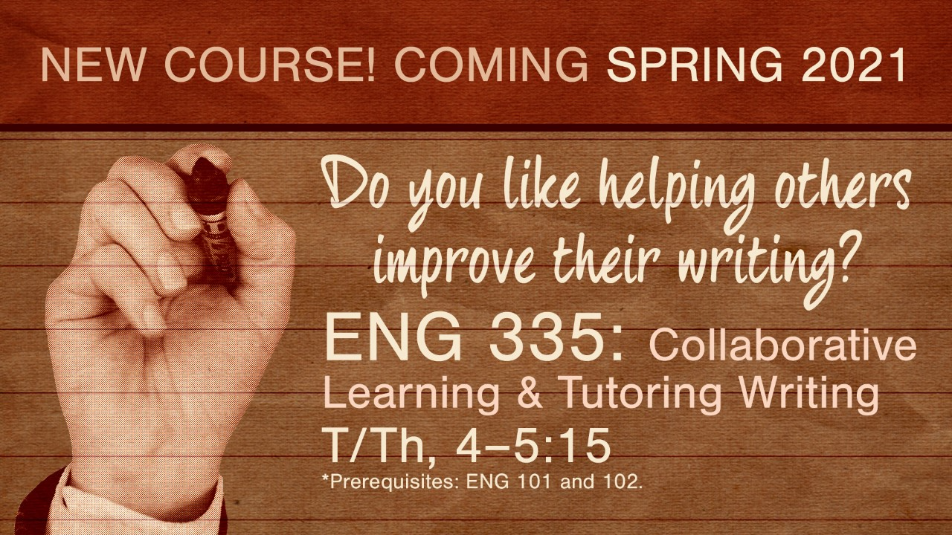
Collaborative Learning and Tutoring Writing
TR 4:00-5:15 CHAT
Dr. Maria Conti Maravillas (Dr. M)
Do you like helping others improve their writing?
Do people come to you for writing advice?
In this interactive course, we will learn practical skills for providing writing feedback, from helping others brainstorm and draft ideas to assisting them with revising and editing. These skills can open doors to opportunities in tutoring, teaching, and peer mentoring in a variety of fields. We’ll apply writing center research to real-life situations to explore several key questions: What are best practices for tutoring writing? How can we help diverse learners succeed? How can we tutor in online environments? You can tailor your final project (a research paper, grant or business proposal, or a digital writing center resource) to your future professional goals.
Even if you do not plan to become a tutor or teacher, this class provides a learning community centered on shared resources, activities, strategies, and knowledge. As such, ENG 335 will prepare you to adapt to new writing situations, which is a crucial skill for almost every professional job.
Questions are welcome! Email Dr. M at m.contimaravillas@usm.edu.

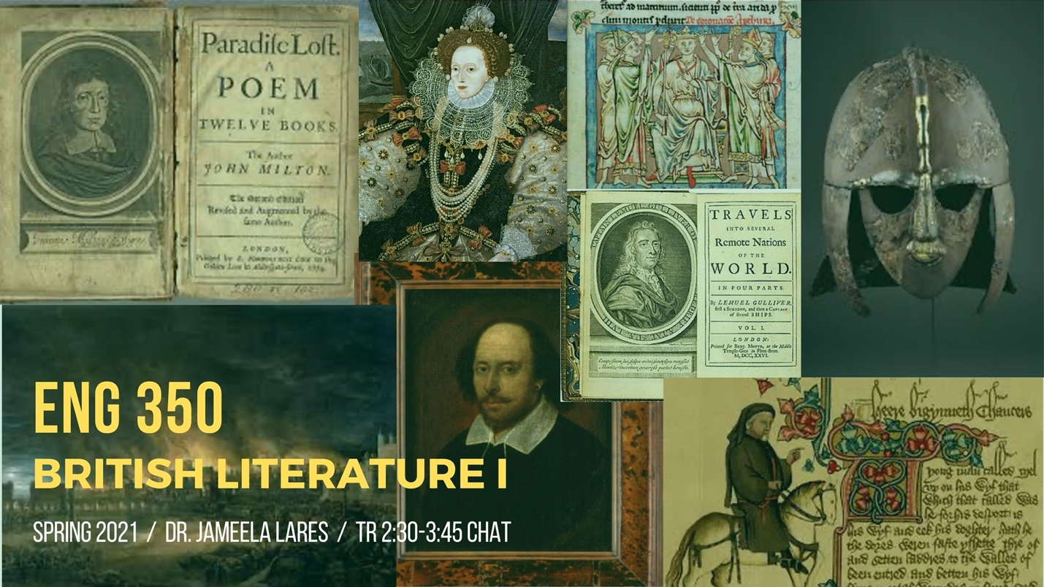ENG 350
British Literature I
TR 2:30-3:45 CHAT
Dr. Jameela Lares
A survey of major works of British literature from the beginnings in Old English poetry and prose through the Anglo-Norman, Middle English, and Renaissance periods and into the middle of the eighteenth century. We will focus not only on significant authors, texts, and genres but also on helpful strategies for reading and discussing them.
Texts: Norton Anthology of English Literature, 10th edition, vol. 1; Shakespeare, A Midsummer Night’s Dream; and Oxford Dictionary of Literary Terms, 4th edition, ed. Chris Baldick.

ENG 351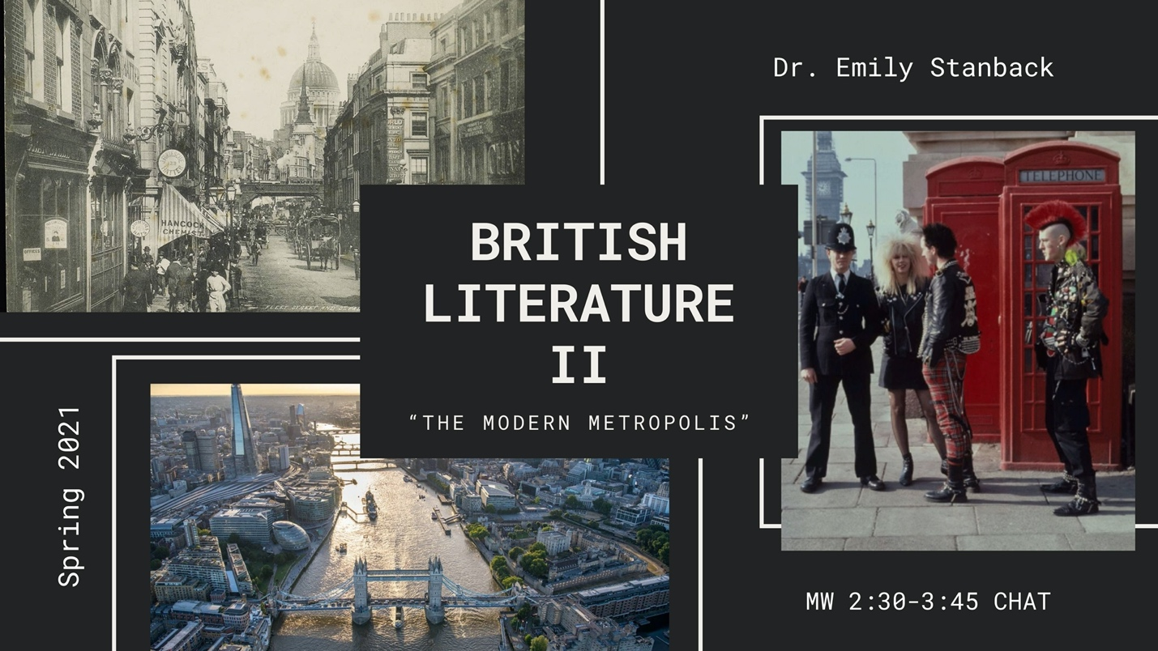
British Literature II
MW 2:30-3:45 CHAT
Dr. Emily Stanback
This section of English 351 focuses on London as it appears in British literature from the 1790s to present. In London, people from all corners of the British Empire mixed on the city streets. The city was home to the wealthy and home to the poor. Over the past two centuries it has been the site of major historical, political, and cultural events, and a center of imperial, economic, and cultural power.
This class will explore topics including slavery, empire, gender, disability, poverty, and industrialization; figures including the chimney sweep, the flâneur, and the urban criminal; and historical moments including the 1790s, the Blitz, and the 1970s. Course texts include novels, poetry, short stories, essays, and journalistic writing by authors including William Blake, William Wordsworth, Mary Prince, Charles Dickens, Amy Levy, and Elizabeth Bowen. We will also discuss Michaelangelo Antonioni’s film Blow-Up and lyrics and music videos from the London punk scene of the ’70s and ’80s.

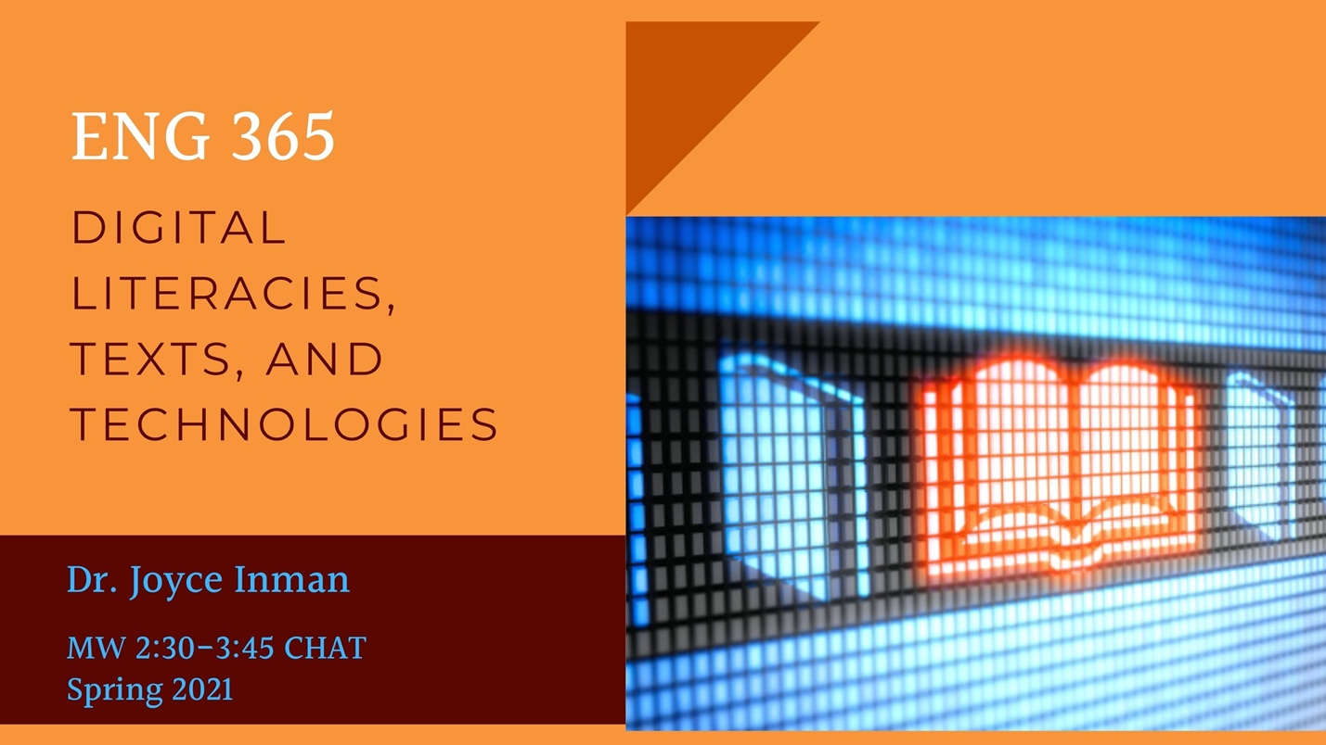ENG 365
Digital Literacies, Texts, and Technologies
MW 2:30-3:45 CHAT
Dr. Joyce Inman
Is texting changing the way we write, talk, or think? How can social media platforms influence the identities both of the poster and the follower? What does your digital footprint say about you? What roles can big data play in our lives? How have digital archives changed the way we write and conduct research? How does digital media allow us to reach new audiences with new ideas? Should we differentiate between traditional print literatures and digital literatures? How do interactive literatures and video games encourage us to rethink our understandings of narrative and choice? Is the traditional essay dead?
In ENG 365, we will ask these questions and investigate the relationships between writing, technology, and identity. Coming from the premise that “mediality, in all its forms, is a central concern of the twenty-first century,” we will consider scholarship about the ways digital literacy has changed how we approach reading, writing, creating, and thinking. Projects will include analyzing our own data-driven experiences, creating and analyzing digital literature, and researching topics stemming from our studies of digital literacies, texts, and technologies.
Potential texts include M.T. Anderson’s Feed, Richard E. Miller’s On the End of Privacy: Dissolving Boundaries in a Screen-Centric World, and Kristen L. Arola, Jennifer Sheppard, and Cheryl E. Ball’s Writer/Designer: A Guide to Making Multimodal Projects.

ENG 371
American Literature II
MW 4:00-5:15 CHAT (H001)
Dr. Ery Shin
Picking up in the aftermath of the Civil War, this course traces how suffragism, Jim Crow laws, both World Wars, Flower Power, the legacy of the American Indian Wars, and accelerating globalization, among other things, have molded the nation's imagination. It asks all throughout: what makes certain styles, genres, and sensibilities distinctly “American”?
Sample reading list: editor Robert S. Levine’s The Norton Anthology of American Literature, Shorter 9th edition, Volume Two: 1865-Present; Jesmyn Ward's Salvage the Bones

ENG 400
Introduction to Modernism (Senior Capstone)
MW 1:00-2:15 CHAT (H001)
Dr. Ery Shin
What was modernism? Through Stein, Proust, Beckett, Lispector, and Dada as well as surrealist films, this course explores the term as a formal concept, historical period, lifestyle, political sensibility, cultural buzzword, global phenomenon, and so on. The word’s amorphousness—the questions it continually generates for new and old readers alike—suggests an art of deflection, a certain fondness for evasions is at play, one that provokes us to look longer and more intently at the spaces we claim as our own.

ENG 400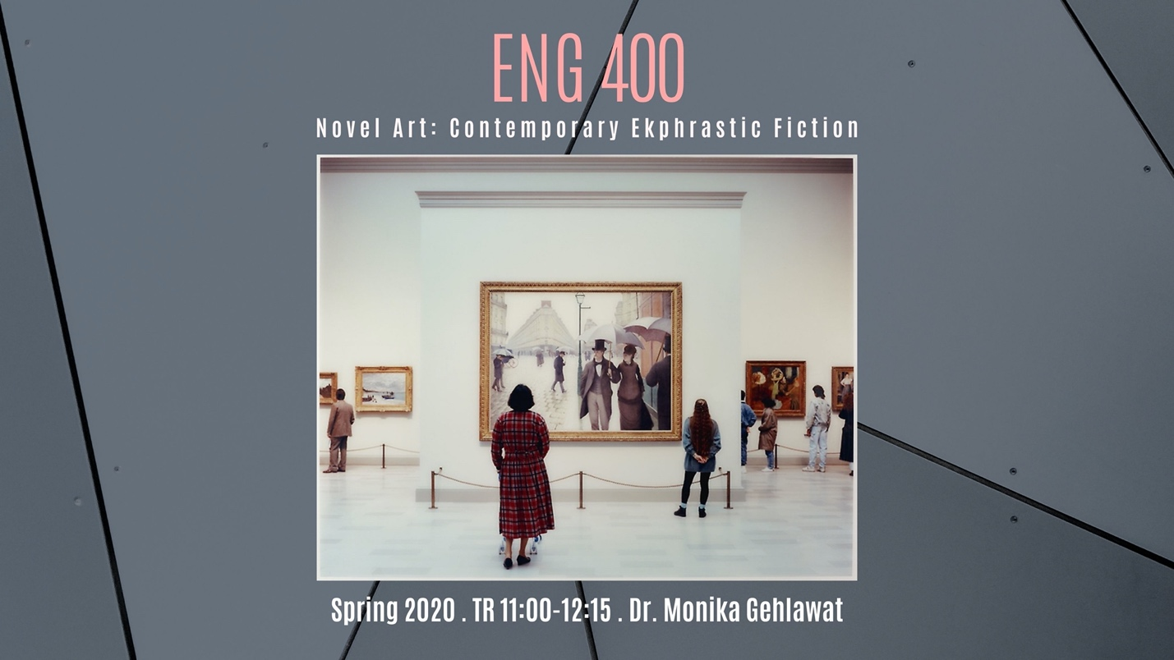
Senior Capstone
TR 11:00-12:15 CHAT (H002)
Dr. Monika Gehlawat

Novel Art: Ekphrastic Contemporary Literature
Ekphrastic literature is interested in writing about art forms like painting, film, music, and sculpture. Authors who write ekphrastic novels show their characters and narrators engaging with art in order to develop their psychology and relationships, as well as to deepen the conflicts and themes of their narratives. This senior capstone will consider why certain contemporary novelists spend so much time dramatizing aesthetic experience, how they use it to examine political and social concerns, and finally, how in doing so, they emphasize the growing need for social bonds in the 21st century. Among others, we will read Teju Cole, Lauren Groff, Rachel Kushner, Siri Hustvedt, Ben Lerner, and Michael Frayn. Alongside literature, there will be significant engagement with aesthetic theory, painting, film, and music, as it pertains to the fiction we read. Art lovers and those curious to learn more contemporary culture should find this class a stimulating experience!

ENG 400/489
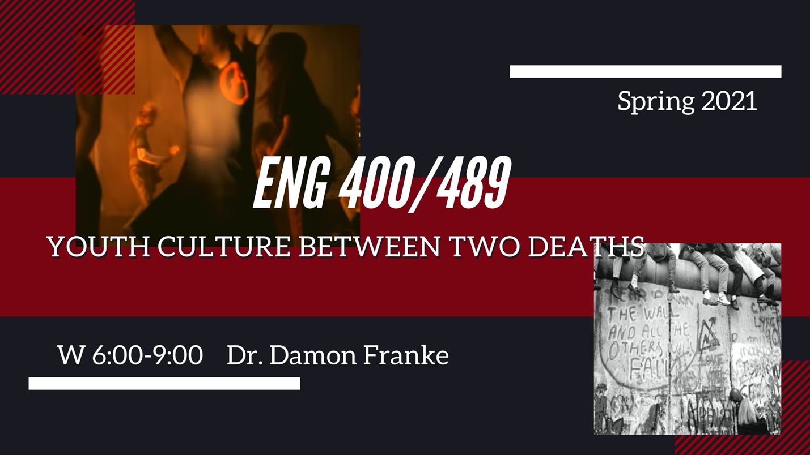

Senior Capstone
Studies in American Literature
W 6:00-9:00
Dr. Damon Franke
YOUTH CULTURE BETWEEN TWO DEATHS
This course examines American literature and culture of the early 1990s with particular focus on youth culture during that time. In his critical study Life Between Two Deaths, 1989-2001, Philip Wegner argues that the fall of the Berlin Wall and the 9/11 attacks function as two “deaths” surrounding the 1990s with the latter solidifying the former’s symbolic end of the Cold War. Wegner’s book shows how this period “fostered a unique consciousness and represented a moment of immense possibility now at risk of being forgotten.” Indeed, young people coming of age during the early 1990s faced a vastly different political and economic future than their predecessors had. In what is called the “age of diminished expectations,” economic growth of the 1980s had born a recession. The Cold War was over, the Iron Curtain had fallen, and Eastern Europe was open for discovery. Youth culture of the day reflects an antimaterialism, a distrust of government, and a desire to reside out of the mainstream. Such counterculturalism is familiar, and in the five-year span from 1990-94 we will look at how culture fashioned itself out of the old and the alternative. Environmental awareness was common and passionate, Top 40 radio was abhorred, people developed a do-it-yourself ethos, and consumerism was scoffed at. Yet the youth of the time slowly fashioned a striking and unique character of its own, while incorporating elements of the Lost Generation, the Beats, the Hippies, and the Punks. How did this alternative culture become mainstream and then commodified? The course will examine literature, music, and film of the time; the lives of people during this time; and youth cultural phenomena of the era. We will discuss independent film and indymedia of all sorts including fanzines. We will listen to and discuss grunge, gangsta rap, riot grrrl, and post-punk music and its various scenes. Students can pursue research topics on films such as Pulp Fiction, Clerks, CB4, and My Own Private Idaho, musicians such as Tupac, Nirvana, and Bikini Kill, and television shows such as The Simpsons, Twin Peaks, Blossom, and In Living Color. Students also can pursue research topics on the books we will read: Danzy Senna’s Caucasia, Jim Dodge’s Stone Junction, Cheryl Strayed’s Wild, Jon Krakauer’s Into the Wild, John Beckman’s The Winter Zoo, short stories by Don Delillo and ZZ Packer, and some fanzines. Students will choose a film and music album of the time to present upon. In the spirit of the bricolage of the time, students can eclectically design their own research projects drawn from the various course materials.

ENG 406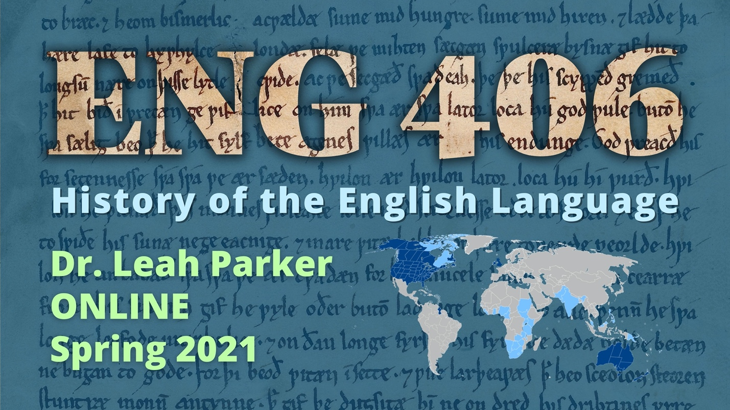
History of the English Language
Dr. Leah Parker
ONLINE
Have you ever wondered why each letter C in “Pacific Ocean” is pronounced differently? Why sweetbreads are meats and sweetmeats are candy? Why sometimes you call yourself “I” and other times call yourself “me”? Why you can play a “bass,” but catch a “bass”? Why you can feel the “wind” on your face, but you “wind” down at the end of the day? Why, when the truth comes out, we say: “the cat’s out of the bag”? What cat? What bag?! The answers to these questions and more lie in the wild and weird history of the English language!
ENG 406, History of the English Language, will be fully online and asynchronous—there will be no required full-class synchronous meetings, though office hours and individual or small-group meetings will be available to help students succeed in the course.
In ENG 406, we will trace the history of the English language from its prehistoric Indo-European roots, through sound changes of the Middle Ages, standardization in the era of print, and diversification as a global language in the modern world. You will learn the basics of linguistics; the pronunciation and basic grammar of Old English (spoken ca. 450–1150 CE) and Middle English (spoken ca. 1150–1500); how to fully utilize dictionaries and editions of English texts; and how dialects develop through isolation, imperialism, and human interactions. In addition to learning about the deep history and vast geographical range of English, students will have the opportunity to create an entry in an ongoing online glossary project (which, if accepted, is a publication credit) and will finish the semester analyzing contemporary language debates.

ENG 410
Cross-Cultural Encounters
MW 9:30-10:45 CHAT
Dr. Ery Shin
This course examines the idea of ethnicity on a world stage, thinking through race and its relations with gender, sexuality, class, religion, citizenship, and all the other ways by which an individual comes into focus before the public. It not only crosses national boundaries, but also genres in this pursuit. From South Africa’s psychiatric wards to Oakland’s freeways—from spiritual memoirs to bilingual poetry—this lecture-seminar series delves into those liminal social spaces dividing the powerful from the abject.
Sample reading/viewing list: Tommy Orange’s There There, K. Sello Duiker’s The Quiet Violence of Dreams, Raoul Peck’s I Am Not Your Negro, Sonsyrea Tate's Little X: Growing Up in the Nation of Islam, Gloria E. Anzaldúa’s Borderlands/La Frontera: The New Mestiza

ENG 455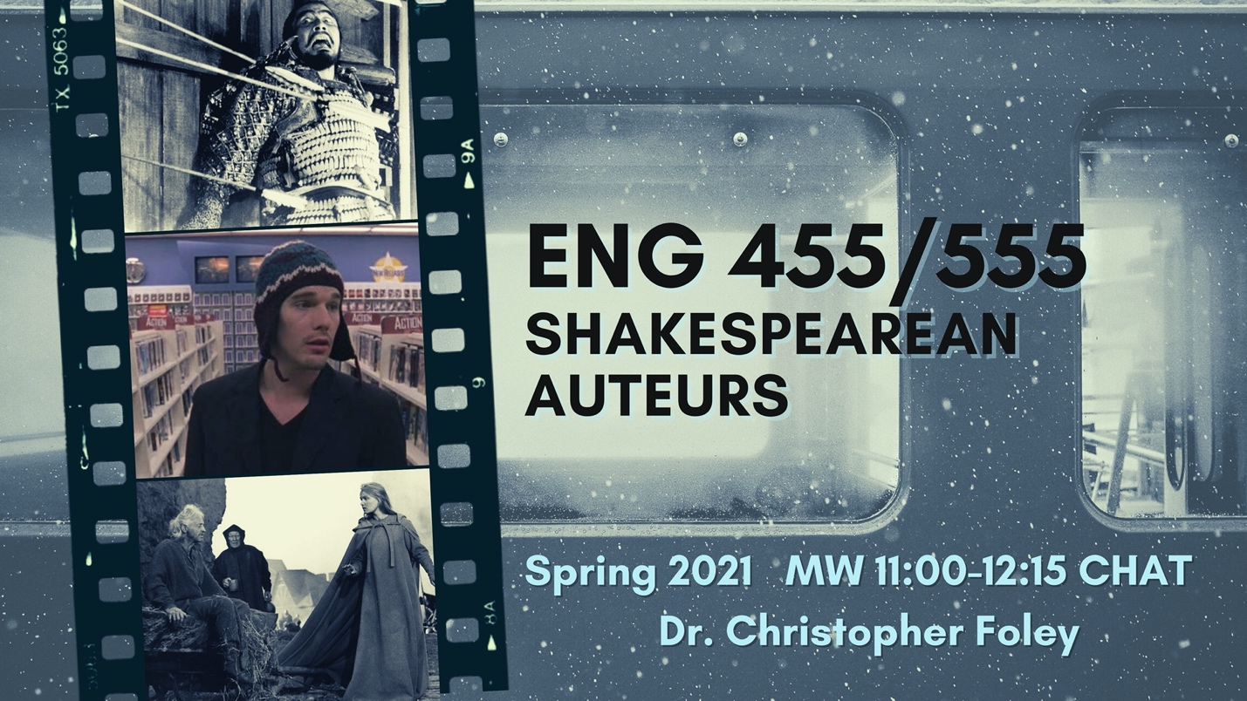
Shakespearean Auteurs
MW 11 AM-12:15 (CHAT)
Dr. Christopher Foley
Olivier. Welles. Kurosawa. Kosintsev. Zeffirelli. Branagh. Abela. Almereyda. The list of distinguished film directors who have adapted Shakespeare’s plays more than once for film audiences continues to grow. In this course, we will read a number of Shakespeare’s most frequently filmed tragedies, discussing their thematic concerns and theatrical staging possibilities, before turning our critical attention to several film adaptations of each play by those auteurs listed above. Attending to the diverse appropriations and adaptations of Shakespeare worldwide, we will strike a balance on our syllabus between Anglophone/American directors and those from World Cinema. Intended to attract both English and Film majors/minors, as well as general Shakespeare enthusiasts, we will cultivate the ability to analyze and interpret film as literature while giving reciprocal consideration to the latent filmic potential of dramatic texts.

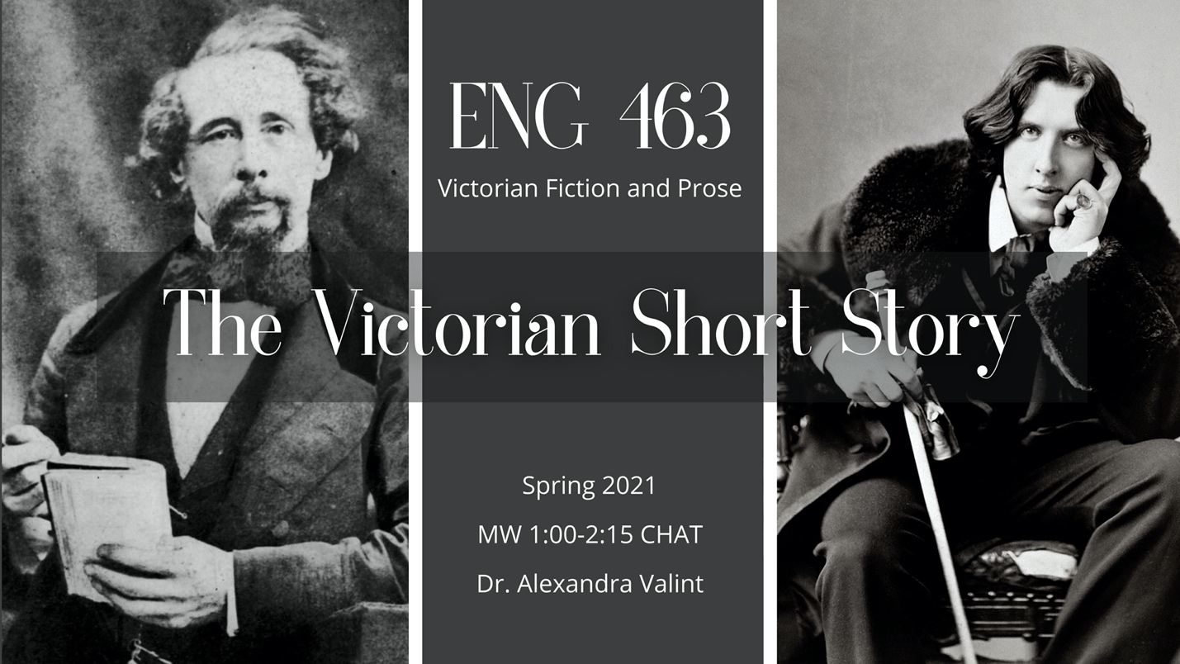ENG 463
Victorian Fiction and Prose
MW 1:00-2:15 CHAT
Dr. Alexandra Valint
The Victorian Short Story
Although we think of the massive novel—the so-called “three-decker novel”—as the literary hallmark of the Victorian period, short fiction also flourished amidst an expanding and lively periodical culture. Most critics agree that by the end of the nineteenth century, the modern short story was born. In this course, we will read short stories from a variety of genres including the ghost story, fairytale, gothic, horror, science fiction, and detective fiction. Given the expanse of the British Empire in this time period, we will read authors from England, India, Ireland, Scotland, and South Africa. Authors will likely include Charles Dickens, Arthur Conan Doyle, Elizabeth Gaskell, Rokeya Sakhawat Hossain, Olive Schreiner, Robert Louis Stevenson, Rabindranath Tagore, H. G. Wells, and Oscar Wilde. Not only will we seek to understand how individual stories use and challenge the conventions of their genre, but we will also use short fiction to explore some of the key debates and anxieties of the Victorian age surrounding gender, sexuality, science, and the empire.

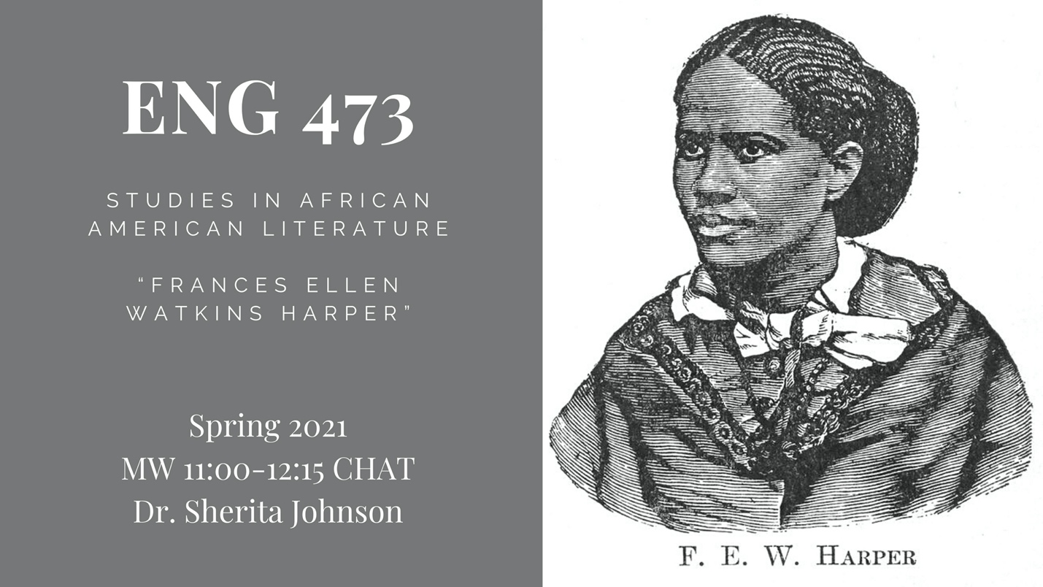ENG 473
Studies in African American Literature
MW 11:00 - 12:15 CHAT
Dr. Sherita Johnson
“Frances Ellen Watkins Harper”
Frances Ellen Watkins Harper (1825-1911) was the most prolific African American writer of the nineteenth century. She wrote and published several collections of poetry, popular short fiction, and one of the first African American novels—Iola Leroy (1892). A leading abolitionist orator and suffragist, Harper’s activism infused her writings about the experiences of the enslaved, exploited, disenfranchised, and discriminated. And, yet, most people today do not even know her name, her legacy discarded. This course will survey Frances Harper’s writings across genres, contextualized by a cultural history of racial and gender inequality, along with readings in literary criticism.
Required Texts:
Frances Smith Foster, ed. A Brighter Coming Day: A Frances Ellen Watkins Harper Reader. New York: The Feminist Press, 1990.
Frances E.W. Harper, Iola Leroy; Or, Shadows Uplifted. Edited by Koritha Mitchell. Ontario, Canada: Broadview Press, 2018.
*This course helps to fulfill the requirements for a minor in Black Studies as well as the “non-traditional (ethnic) literature” requirement for a major in English.

ENG 489
Studies in American Literature
T 1:00-3:45
Dr. Jonathan Barron
ROBERT FROST AND EDNA ST. VINCENT MILLAY
In this class, we’ll be reading two of the most popular poets from the first half of the 20th century. We’ll be asking why they were so popular, and we’ll be discovering that they may not have been all that different. It may seem like Millay, one of the first poets to advocate for women’s rights, a radical devoted to left and liberal social causes, would have little to do with Frost, a well-established poet old enough to be her father; yet this class will bring these two poets together as equally rebellious with regard to their approach to poetry. By reading them together, this class will investigate how beginning in the 1910s their break with literary conventions helped recreate and reimagine what American literature and poetry would become today.

