History Graduate Course Descriptions

Spring 2021
HIS 515
World War I
TR 2:30-3:45
Dr. Andrew Wiest
This course will investigate the most important military/social event of the twentieth century, the Great War. With roots that date back to the age of great empires and repercussions that the world still deals with today, World War I ripped the old world asunder and laid the foundations for something new – at once a brave new world and one darkly sinister. On the battlefront the Great War transformed the way wars were fought – from battles that Napoleon or Robert E. Lee would recognize to battles that spanned a globe and destroyed a generation. As the world burned, societies were forged into something new, from women receiving the vote, to the rise of Fascism, to the coming of modernism. This course will balance the battlefield, the home front, and the humanity of war. Poetry, fiction, and music will also help us envision this important past.
Students will read: Alistair Horne; The Price of Glory: Verdun 1916; G.J. Meyer; The World Remade: America in World War I; Ernst Junger; The Storm of Steel; and Paul Fussell; The Great War and Modern Memory.
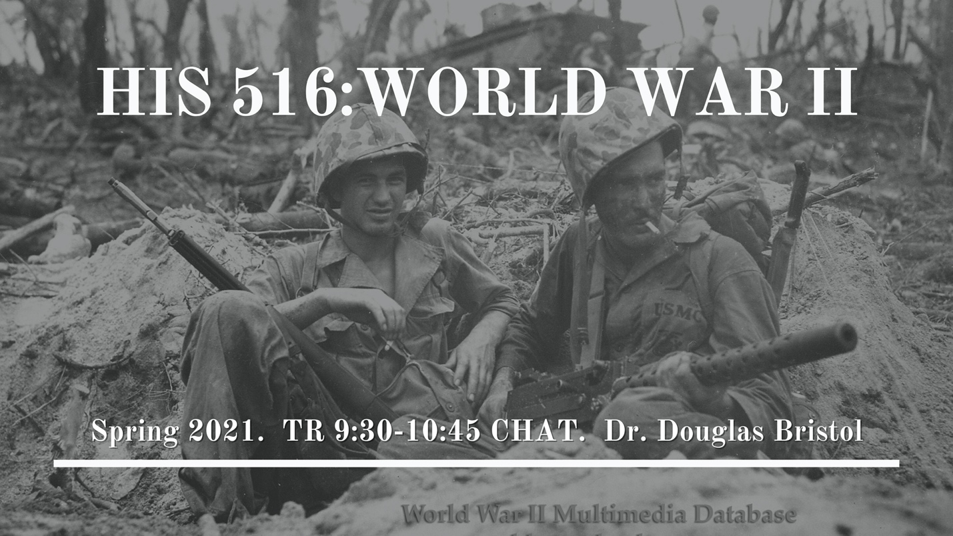

HIS 516
World War II
TR 9:30 - 10:45 CHAT
Dr. Douglas Bristol
HIS 416/516 is an in-depth study of the causes, conduct, and aftermath of World War II. In this class, you will see the development of authoritarian governments and mobile warfare (Blitzkrieg) threaten liberal democracies, which were slow to respond and almost lost the war. You will understand how the Allies won, what the experience of ordinary soldiers was like, and what impact the war had on American society. You will make a group presentation on a controversial command decision. You will write an essay assessing German participation in the Holocaust based on reading Ordinary Men: Reserve Police Battalion 101 and the Final Solution in Poland. You will also write a research paper on a topic of your choice.
NOTE for Graduate Students: You will have your own syllabus and a number of separate meetings to discuss your readings. In addition, you will make a short presentation to undergraduates in the class.

HIS 722
War Historiography
M 6:00-9:00
Dr. Allison Abra
This course will survey the history and historiography of warfare across time and place. The goal of the class is to provide graduate students with a thorough grounding in the classic texts and major debates that have defined the fields of military history and history of war and society. Course readings will come primarily from the required reading list for the comprehensive exam field in war and society, and the class will therefore be of immense value to students preparing such a minor field. However, the readings and discussion will also be relevant to all students with interests in the history of conflict and warfare.

HIS 726
US Historiography Since 1877
W 6-9pm CHAT
Dr. Heather Stur
This graduate seminar examines the historiographical debates over major issues in U.S. history since the end of since the end of Reconstruction. It is a reading-intensive, discussion-based course in which students will read at least one book a week. Grades will be based on class participation, presentations, book reviews, and a major writing assignment. It is a required course for all U.S. MA and PhD students.
Required texts
Eric Foner. A Short History of Reconstruction Harper Perennial Modern Classics 2015. ISBN-13: 9780062370860
Patricia Nelson Limerick. Legacy of Conquest: The Unbroken Past of the American West. New York: Norton, 1987. ISBN-13: 9780393304978
David Roediger, Wages of Whiteness: Race and the Making of the American Working Class (Verso, 2007). ISBN: 9781844671458.
Walter LaFeber. The New Empire: An Interpretation of American Expansion, 1860-1898. 35th Anniversary ed. Ithaca: Cornell University Press, 1998. ISBN-13: 9780801485954
Michael McGerr. A Fierce Discontent: The Rise and Fall of the Progressive Movement in America 1870- 1920. New York: Free Press, 2003. ISBN-13: 9780195183658
John Milton Blum, V Was for Victory: Politics and American Culture during World War II. Mariner Books, 1977. ISBN-13: 978-0156936286
John D’Emilio. Sexual Politics, Sexual Communities: The Making of a Homosexual Minority in the United States, 1940-1970. 2nd ed. Chicago: University of Chicago Press, 1998. ISBN-13: 978-0226142678
Thomas Sugrue. The Origins of the Urban Crisis. Revised ed. Princeton: Princeton, 2014. ISBN-13: 9780691162553
Melvyn Leffler. Origins of the Cold War: An International History. 2nd ed. New York: Routledge, 2010. ISBN-13: 9780415341103
Joanne Meyerowitz. Not June Cleaver: Women and Gender in Postwar America, 1945-1960. Temple University Press, 1994. ISBN-13: 9781566391719
Heather Stur, Beyond Combat: Women and Gender in the Vietnam War Era (Cambridge University Press, 2011). ISBN: 9780521127417
Danielle McGuire, At the Dark End of the Street: Black Women, Rape, and Resistance (Vintage, 2011). ISBN: 9780307389244.
Rebecca Tuuri, Strategic Sisterhood: The National Council of Negro Women in the Black Freedom Struggle (UNC 2018) ISBN: 978-1-4696-3890-4
Timothy B. Tyson, Radio Free Dixie: Robert F. Williams and the Roots of Black Power (UNC 2001). ISBN-13: 9780807849231
Lisa McGirr, Suburban Warriors: The Origins of the New American Right. rev. ed. Princeton: Princeton University Press, 2015. ISBN-13: 9780691165738
Jefferson Cowie, Stayin Alive: The 1970s and the Last Days of the Working Class. New York: New Press, 2010. ISBN-13: 978-1595587077
Sean Wilentz, The Age of Reagan: A History, 1974-2008. New York: Harper, 2008. ISBN-13: 9780060744816

HIS 733
Seminar in Central European History
W: 1:00-3:45 CHAT
Dr. Brian LaPierre
Stalinism
Although it risks falling into the problematic “great-man” theory of history, few historians of modern Russian would disagree with the following statement: Joseph Stalin made the Soviet Union and the communist model it represented. He instituted the USSR’s state-controlled command economy, collectivized its agriculture, and censored its intelligentsia. He unleashed a policy of state terror that executed and incarcerated millions of Soviet inhabitants and created a cult of personality around his supposed universal genius. He expanded the Soviet system into Eastern Europe and East Asia, broke the back of the wehrmacht, and set the Soviet Union on an ultimately self-destructive Cold War competition with American capitalism. Using interpretive models like totalitarianism, neo-traditionalism, revisionism, post-revisionism, and Soviet subjectivity, this course will examine the personality and policies of the great dictator and the inner operation of the social, economic, political and cultural system that he constructed in the Soviet Union and exported abroad. Topics to be examined include mass incarceration, unfree labor, genocide, state terror, nationalism, the origins of the Cold War, WWII on the eastern front, and modernity.

HIS 773
Race & Slavery in the Atlantic World
T 6:00-9:00 CHAT
Dr. Douglas Chambers
The study of race and slavery is of great interest to scholars interested in the Atlantic World, as well as in the history of globalization and of modernism, roughly from 1500 to 1900. This graduate seminar will explore key historiographical themes in the more recent literature, including questions of definition, of diasporas, of the ‘biographical turn’, and of resistance. We will read a dozen books, and occasional essays, with required review essays for each, and scheduled presentations. Class participation and preparation for discussion will be critically important.
Required texts may include:
Toyin Falola and Kevin D. Roberts, ed., The Atlantic World 1450-2000 (Indiana UP, 2008)
John K. Thornton, A Cultural History of the Atlantic World, 1250-1820 (CUP, 2012)
John K. Thornton, Warfare in Atlantic Africa, 1500-1800 (UCL Press, 1999)
Julius S. Scott, The Common Wind: Afro-American Currents in the Age of the Haitian Revolution (Verso, 2020)
Walter C. Rucker, Gold Coast Diasporas: Identity, Culture, and Power (Indiana UP, 2015)
Roquinaldo Ferreira, Cross-Cultural Exchange in the Atlantic World: Angola and Brazil during the Era of the Slave Trade (CUP, 2012)
Trevor Burnard, Thomas Thistlewood and His Slaves in the Anglo-Jamaican World (UNC Press, 2004)
Aisha K. Finch, Rethinking Slave Rebellion in Cuba: La Escalera and the Insurgencies of 1841-1844 (UNC Press, 2015)
John W. Catron, Embracing Protestantism: Black Identities in the Atlantic Word (UP of FL, 2016)

