Summer and Fall 2021 Course Descriptions

Summer 2021

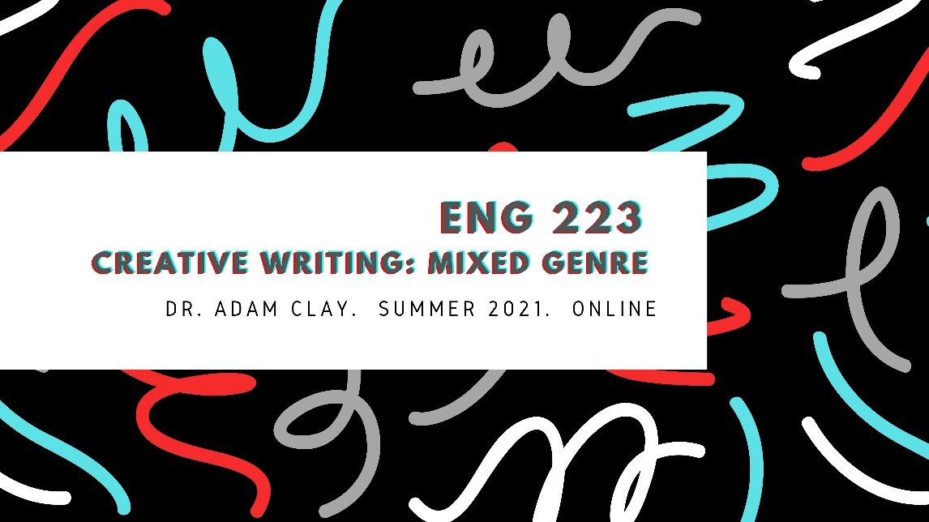ENG 223

Creative Writing 1: Mixed Genre

Dr. Adam Clay

ONLINE
ENG 223 is an introduction to multi-genre creative writing with an emphasis on fiction, poetry, and creative nonfiction. Students will study craft-based guides, read published works, and draft creative work in various genres. The class will place an emphasis on generative writing exercises modeled on published work; students will also take part in peer-review workshops to develop and revise their writing. The class will culminate in the submission of a final portfolio that includes revised creative work, along with a critical introduction reflecting on the writing process as it applies to fiction, poetry, and creative nonfiction.

ENG 319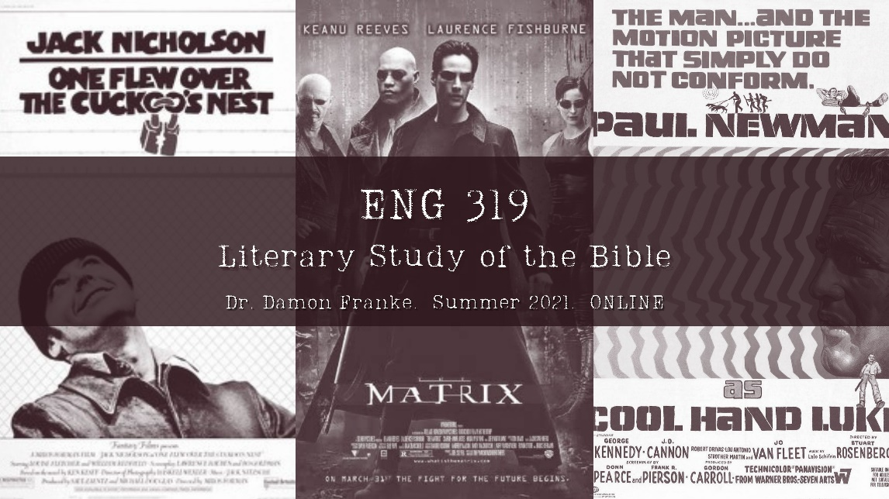

Literary Study of the Bible

Dr. Damon Franke

ONLINE
Course Objectives:
Rich storytelling, vivid imagery, pithy turns of phrase, and philosophical paradoxes characterize the power and style of the Bible. These elements are textual and literary elements of the written word. This course will focus on the analysis of various literary forms in the Bible. The class will examine how narrative, wisdom, prophetic and apocalyptic literature appear in the Old Testament, the Apocrypha, and the New Testament. An important topic throughout our discussion of the Bible will be the nature of canon formation. Students therefore are required to use the Oxford Study Bible with Apocrypha. Students can bring in other versions of the Bible to supplement class discussion. Recent films on reserve at the library will be assigned in order to discuss the diverse manifestations of Christian allegory.
Required Texts:
The following books are available at the university bookstore:
The Oxford Study Bible with Apocrypha
Rental or Streaming Access of the films The Matrix, Cool Hand Luke, and One Flew Over the Cuckoo’s Nest

Fall 2021

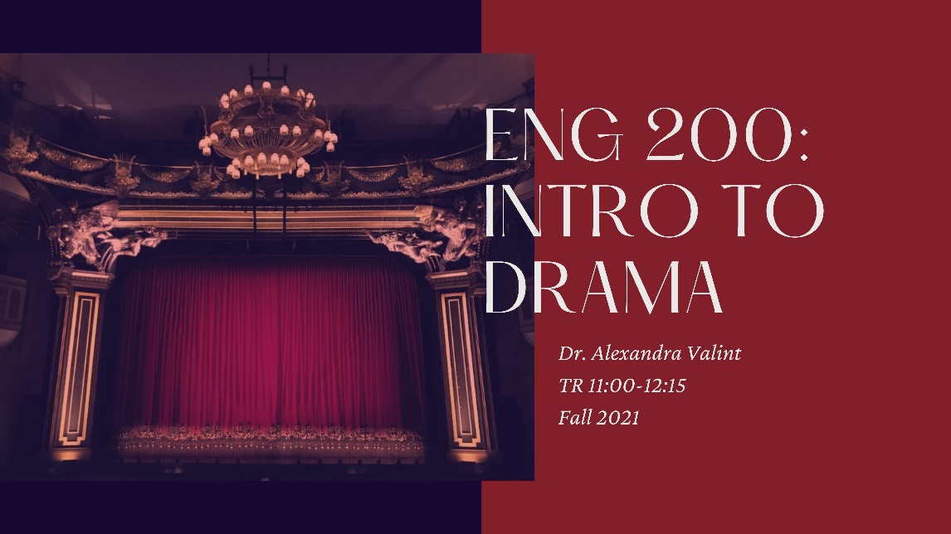ENG 200

Introduction to Drama

Dr. Alexandra Valint

TR 11:00-12:15
The primary goal of this course is to make you more confident, enthusiastic, and sophisticated readers of drama. We will explore a diverse selection of plays, from Ancient Greek tragedy to contemporary Pulitzer-Prize winners. We will pay particular attention to how these plays engage with issues of gender, race, love, and war, as well as to how they represent the struggles of individuals, relationships, and societies. We will practice analyzing and articulating how plays work--how they are structured, how they affect us, what they mean, their limitations and possibilities. Whether you are a seasoned theatre practitioner or a new visitor to the world of drama, you are welcome in this class. Together we will experience the wisdom and wonder of theatre. We will likely read plays by Edward Albee, Aziza Barnes, Euripides, Lin-Manuel Miranda, Lynn Nottage, William Shakespeare, Paula Vogel, Oscar Wilde, and Tennessee Williams.

ENG 201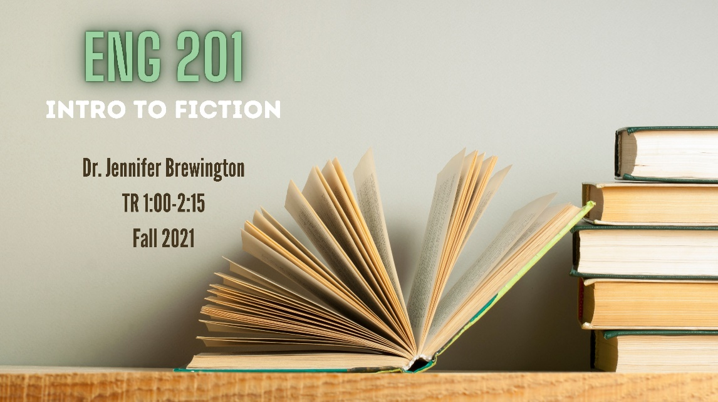

Introduction to Fiction

Dr. Jennifer Brewington

TR 1:00 - 2:15
ENG 201 focuses on the various types and modes of fiction, both short stories and novels. The readings we will explore in this course are considered innovative contributions to fiction. We will look at how writers use techniques like characterization, fictional time and place, and voice to develop a range of storytelling methods. This course will provide students with a strong foundation for understanding the craft of fiction. Students will be asked to engage critically and aesthetically with weekly readings. Authors will include, among others, James Baldwin, Lauren Groff, and Kazuo Ishiguro. Good literature is often subversive, strange, and challenging. We will use this course as a space to find meaning, locate patterns, and draw connections between authors and the stories they tell.

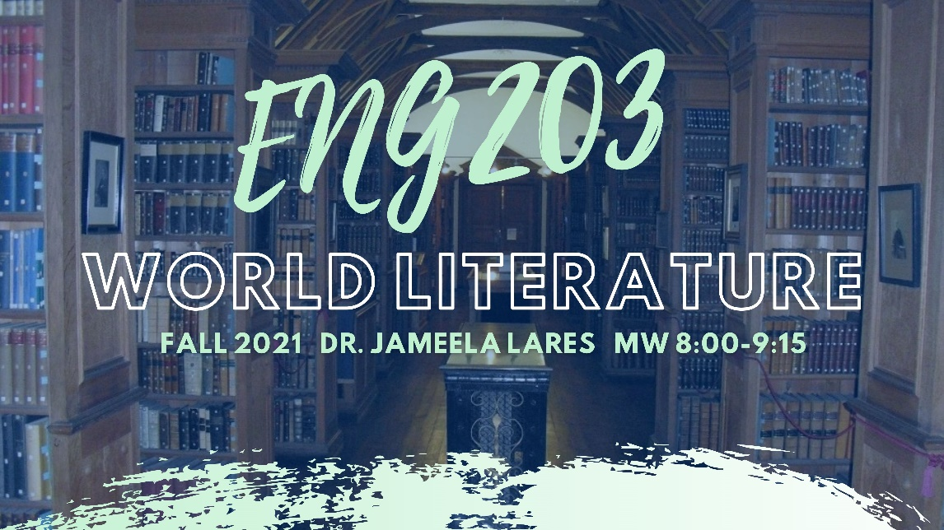ENG 203

World Literature

Dr. Jameela Lares

MW 8:00-9:15
This course is intended to acquaint you with significant figures and works of world literature, beginning with early lyric poetry in China and The Epic of Gilgamesh in Mesopotamia and moving through time and space to the modern age. We will focus how literature is constructed, how it describes the human experience, and how we can talk about its interrelationships with time, place, culture, and other contexts. Texts: The Norton Anthology of World Literature, Shorter Fourth Edition, 2 vols., and the handy Oxford Dictionary of Literary Terms, 4th edition, ed. Chris Baldick.

ENG 221

Introduction to Fiction Writing

TR 9:30-10:45
In this class, you will write your own original fiction. Class sessions will be organized around craft topics, which will include assigned outside readings and writing exercises. You will also write one short story or novel chapter. Craft topics will include: character, dialogue, setting, structure, style, revision, and more.

ENG 223

Creative Writing

TR 11:00-12:15
ENG 223 is an introduction to multi-genre creative writing with an emphasis on fiction, poetry, and creative nonfiction. Students will study craft-based guides, read published works, and draft creative work in various genres. The class will place an emphasis on generative writing exercises modeled on published work; students will also take part in peer-review workshops to develop and revise their writing. The class will culminate in the submission of a final portfolio that includes revised creative work, along with a critical introduction reflecting on the writing process as it applies to fiction, poetry, and creative nonfiction.

ENG 222/322/422

Poetry Writing

MW 1:00-2:15

Dr. Angela Ball
Fall 2021's English 222/322/422, Poetry Workshop I, II, and III, will be a class that welcomes poets of all levels of skill and experience, from "none" on up. We will advise each other on how poems might become even more interesting. With the help of our text, Gregory Orr's A PRIMER FOR POETS AND READERS OF POETRY, we will experiment with many forms and subjects. The class will celebrate poetry's possibilities: among them, its ability to translate personal chaos into art that helps us understand others and ourselves, demonstrating that individuals are all essential parts of a shared wholeness. There will be laughter.

ENG 301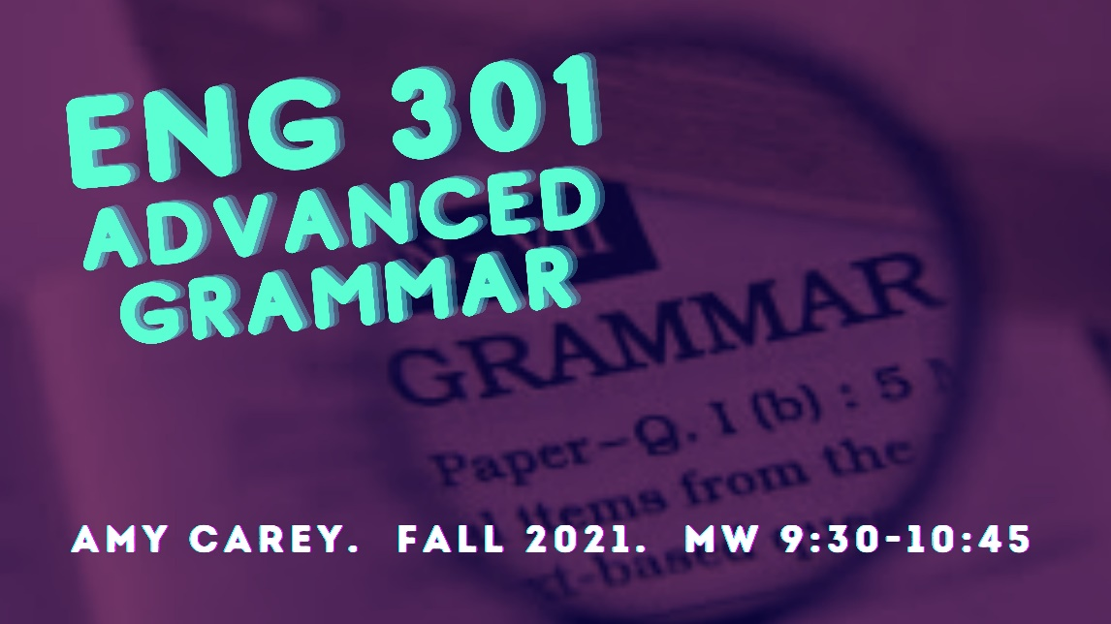

Advanced Grammar

Ms. Amy Carey

MW 9:30-10:45
A study of the structures, origins, power, and rhetorical nature of language and the effects of different approaches to grammar. This course is designed for both English and English Licensure students and will fulfill the language elective requirement for licensure students. Students will analyze standard and rhetorical features of English language and grammar, also considering how history, culture, and systems of power have traditionally defined grammatical standards and how those standards are continually changing and adapting. Participants will gain confidence in their own mastery of advanced English grammar; they will also deepen their ability to analyze its rhetorical effects and communicate that analysis to others through Field Notes assignments and a final research project. This course will use a rhetorical framework for studying both prescriptive and descriptive grammar structures and apply that framework to students’ own writing.

ENG 311

Survey of Contemporary Literature

Illness and Disability Memoirs

Dr. Emily Stanback

TR 1:00-2:15
Illness and disability memoirs have become incredibly popular in recent decades, detailing from a first-hand perspective experiences of everything from depression to autism to cancer to paralysis. In When Breath Becomes Air, for example, neurosurgeon Paul Kalanithi describes the shift from doctor to patient after his diagnosis with stage IV cancer in his late 30s. In Girl, Interrupted, Susannah Kaysen uses medical documents and reconstructed memory to scrutinize her time in McLean Institution and her diagnosis, at 18 years of age, of borderline personality disorder. The first-person narratives in Alice Wong’s Disability Visibility depict several dimensions of what it means to be disabled in the 21st century—what it means to be Black and disabled, what it means to be a disabled parent, what it means to be a disability activist.
Why have these authors—and countless others—turned to the written word to articulate their embodied experiences? Why have countless readers returned again and again to memoirs such as these? Why has this genre become so popular at this particular moment in literary history?
In this course we will consider what it means to write the ill or disabled bodymind, and what it means to read the ill or disabled bodymind. We will discuss how illness and disability memoirs can allow individuals to give voice to how their evolving bodymind moves through time and space, to articulate their experience as a patient under medical treatment, and to explore how their relationships and sense of self have been shaped by experiences of illness and disability. Importantly, we will also discuss how memoirs can also allow individuals to resist the narratives constructed about illness and disability by medical professionals and by society at large.

ENG 321/421

Fiction Writing II and III

Dr. Olivia Clare

TR 9:30-10:45
In this class, you will write your own original fiction and workshop one another’s fiction. In addition to honing your craft, you will be working on your workshop skills. Craft topics will include: character, dialogue, setting, structure, style, revision, and more. You may turn in either short stories or novel chapters.
Recommended Text:
- Writing Fiction, 10th Edition, Janet Burroway, Elizabeth Stuckey-French, Ned Stuckey-French
- Short stories and novel excerpts to be distributed in class

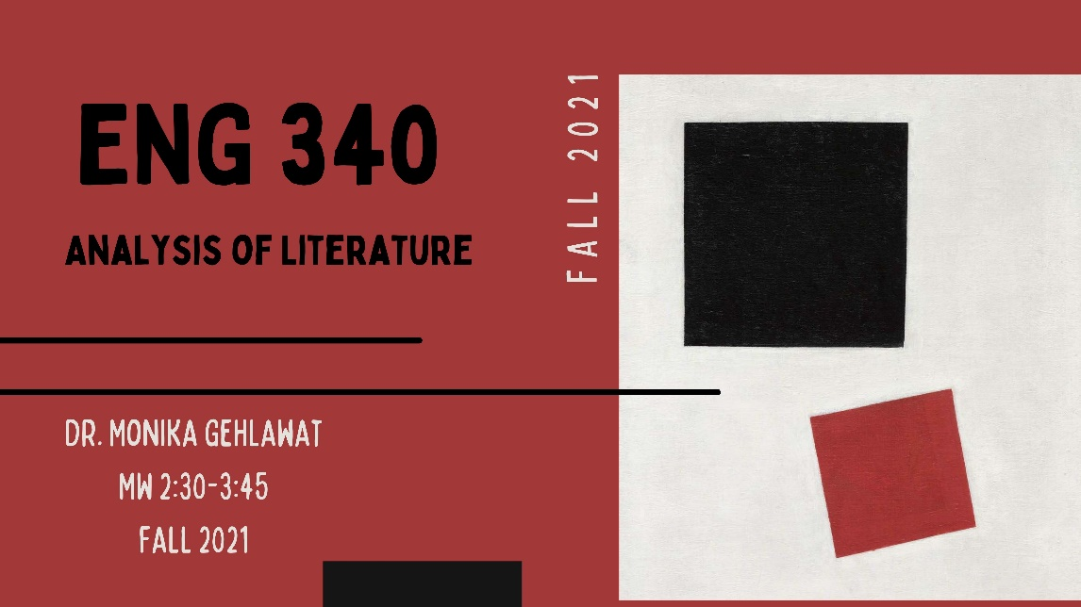ENG 340

Analysis of Literature

Dr. Monika Gehlawat

MW 2:30-3:45 (H001)
This course serves as a gateway to the English major and introduces students to key concepts and methods for analyzing literature. We will begin by studying the basic principles of close reading through the study of the classic American novel The Great Gatsby by F. Scott Fitzgerald. Then we will learn about various theoretical approaches to critique and interpret literature and culture more broadly. Theories of Psychoanalysis, Marxism, Feminism, and Ecocriticsm, to name but a few, will be studied. Students will also learn how to construct sophisticated arguments and conduct independent research, and will submit two research papers, one that focuses specifically on The Great Gatsby and a final essay that applies a specific theoretical model to a primary text (literary or cultural) of the student’s choosing. This seminar is a robust, discussion-based opportunity to cultivate critical thinking skills that will be beneficial for literary study and cultural analysis.

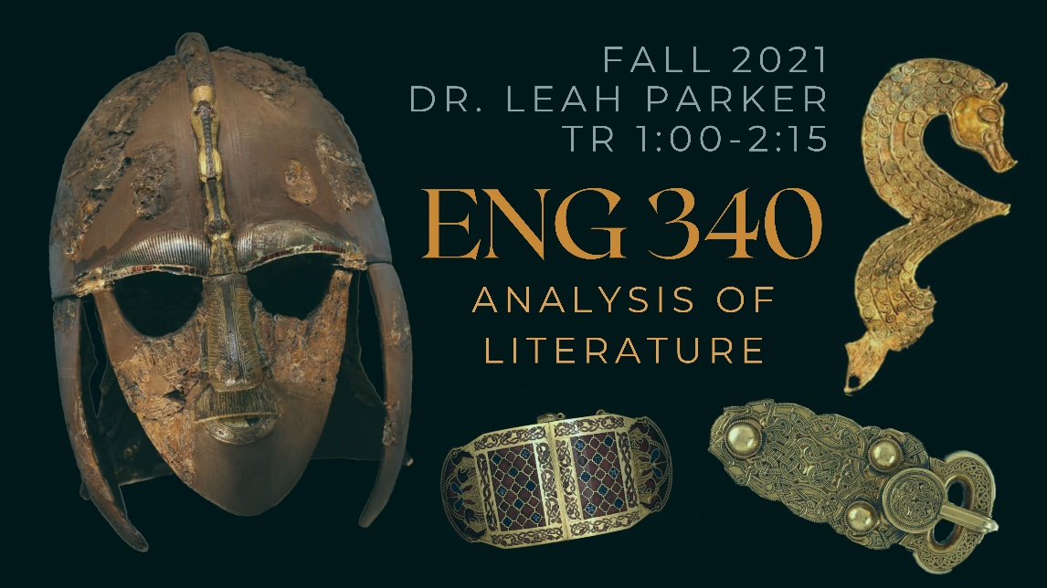ENG 340

Analysis of Literature

Dr. Leah Parker

TR 1:00-2:15
In this section of ENG 340 Analysis of Literature, we will engage with that most infamous of Old English poems—Beowulf—as our constant companion through the historiography of English studies, movements in critical theory, and the core English-major skills of literary analysis. We will read multiple translations of Beowulf, from J. R. R. Tolkien to Maria Dahvana Headley, and trace evolving approaches to the poem from the traditional to the cutting-edge. Not only will successful students have an intimate familiarity with Beowulf by the end of this course—yes, even the ‘dull’ third quarter about feuds and grudges—they will also be prepared to apply their expertise in literary analysis and critical theory to remaining upper-level coursework in the English major.

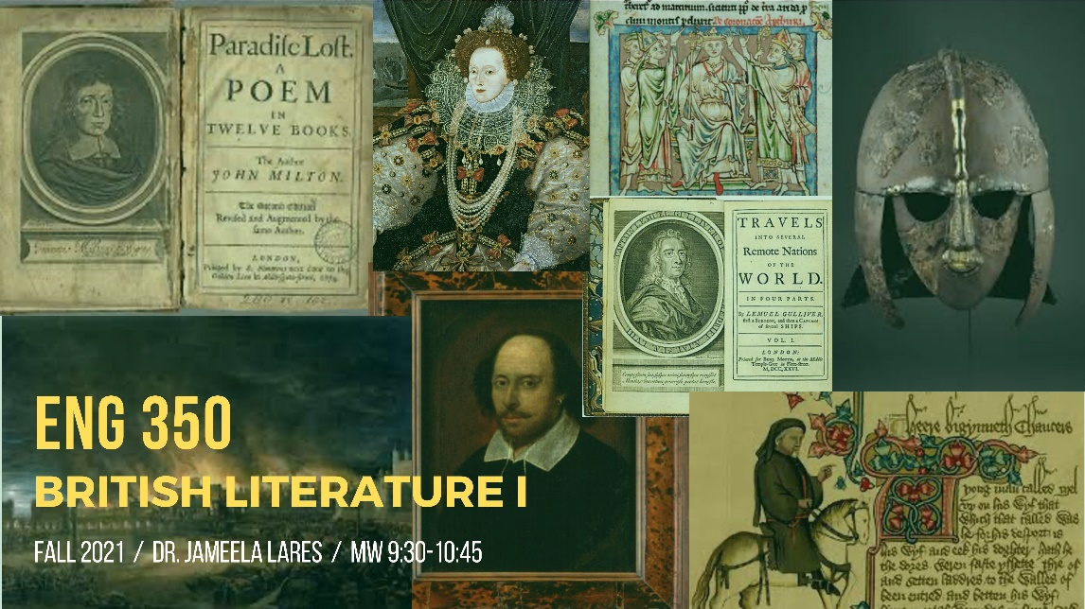ENG 350

British Literature I

Dr. Jameela Lares

MW 9:30-10:45
A survey of major works of British literature from the beginnings in Old English poetry and prose through the Anglo-Norman, Middle English, and Renaissance periods and into the middle of the eighteenth century. We will focus not only on significant authors, texts, and genres but also on helpful strategies for reading and discussing them.
Texts:
- Norton Anthology of English Literature, 10th edition, vol. 1
- Oxford Dictionary of Literary Terms, 4th edition, ed. Chris Baldick.

ENG 371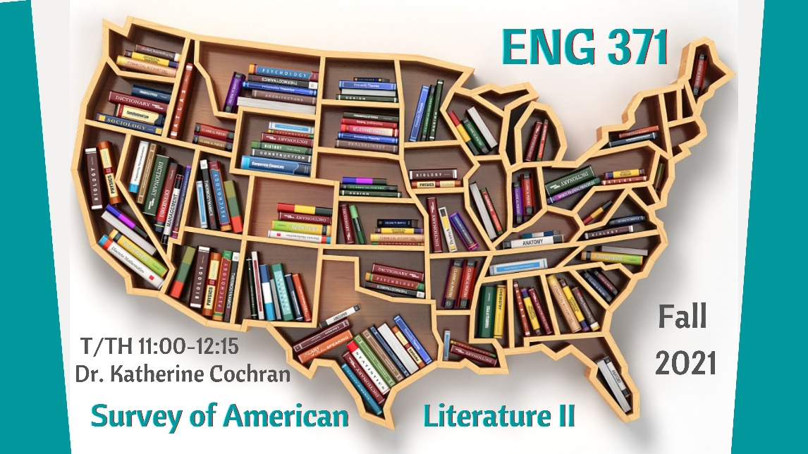

Survey of American Literature II

Dr. Kate Cochran

TR 11-12:15
The 300-level ENG survey courses offer students an understanding of literary works in their historical and cultural contexts. As such, each course introduces students to a broad spectrum of literature: students will read a diversity of genres, forms, and writers—both canonical and nontraditional—and they will be introduced to the key figures, concepts, and movements that define literary periods. In this course, we’ll be examining some major figures and texts of American literature since 1865. We begin with one of the most iconic American novels, Mark Twain’s Adventures of Huckleberry Finn (1884), and conclude with a newer novel by a celebrated contemporary writer, Jesmyn Ward’s Salvage the Bones (2007). In between, we’ll be looking at poetry, stories, and plays from some significant American authors representing a variety of experiences and viewpoints, including Walt Whitman, Charlotte Perkins Gilman, Eugene O’Neill, Zora Neale Hurston, William Faulkner, Maxine Hong Kingston, Junot Diaz, Yusef Komunyakaa, and Natasha Trethewey. Students will complete daily work, three tests spaced throughout the semester, and two writing assignments.
Required texts:
- Robert Levine, ed, Norton Anthology of American Lit, Shorter 9th ed, Volume II: 1865-Present
- Jesmyn Ward, Salvage the Bones

ENG 372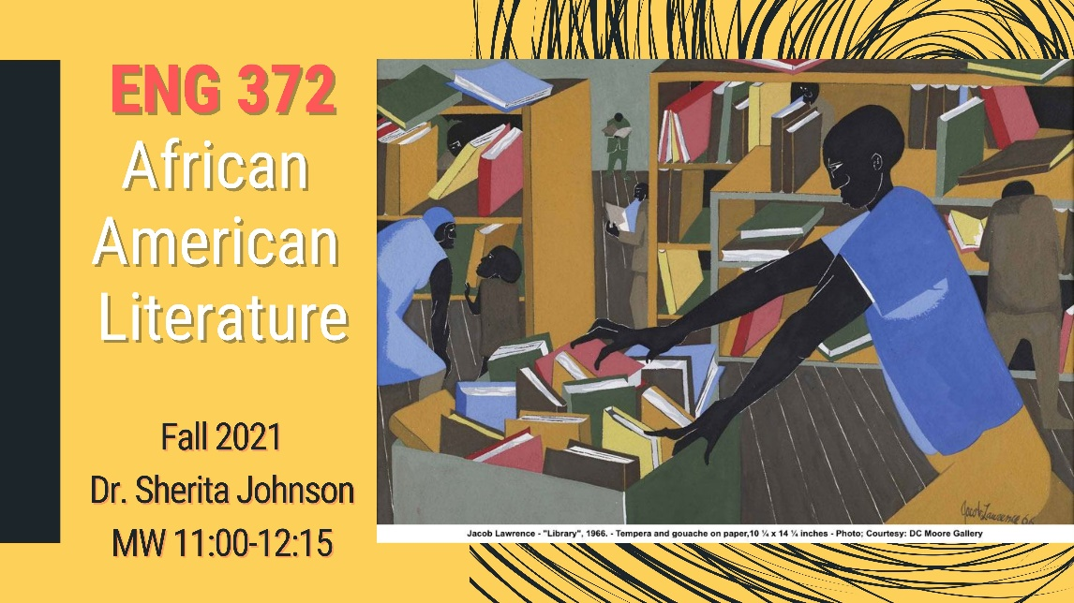

African American Literature

MW 11:00-12:15

Dr. Sherita Johnson
ENG 372 concentrates on the experiences of African Americans, those who were enslaved and/or struggled to be free, as expressed through their poetry, fiction, autobiography, essays, and orations as well as other vernacular forms (e.g. folk tales and music—religious, secular, and work songs). Starting from the colonial era progressing to the dawn of the 20th century, we will examine over 150 years of African American oral and written traditions.

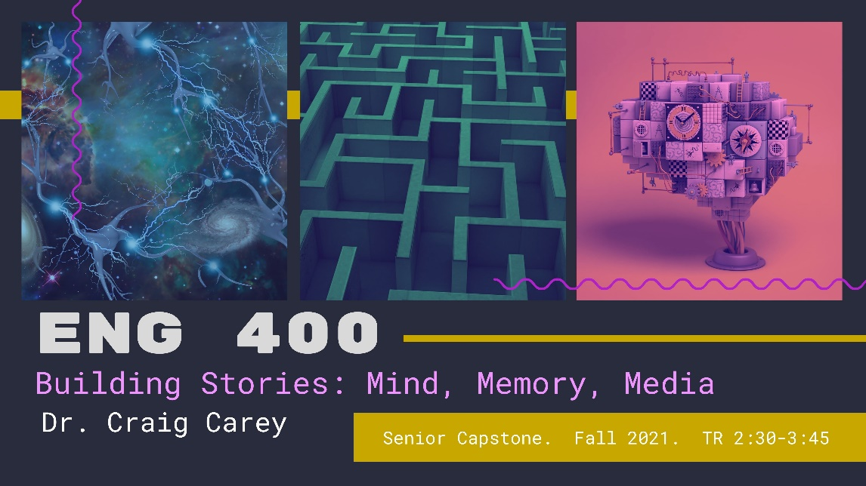ENG 400

Senior Capstone

Building Stories: Mind, Memory, Media

Dr. Craig Carey

TR 2:30-3:45
Stories are the architecture of our lives. As Joan Didion once wrote, “We tell ourselves stories in order to live,” and it is through stories that we give shape to “the shifting phantasmagoria which is our actual experience.” In this seminar, we’ll explore and reverse-engineer stories by analyzing the narrative architecture of novels, films, short stories, graphic novels, experimental theater, interactive texts, and other media formats. Through medium-specific literary analysis, we’ll investigate how stories construct different models of the mind and memory, drawing on the affordances of different media to traverse the labyrinth of human experience from different perspectives. Subtopics of the course will include amnesia, forgetting, erasure, dreams, fantasy, trauma, performance, worldbuilding, puzzles, play, deception, and more. Course requirements will include participation, discussion posts, an oral presentation, building your own interactive story, and a seminar paper.
Possible texts will include:
- Short stories by Jorge Luis Borges, Julio Cortázar, Kelly Link, and Ted Chiang
- Interactive texts such as Meanwhile (Jason Shiga), Her Story (Sam Barlow), and If Found (Dreamfeel)
- Award-winning graphic novels like Alison Bechdel’s Fun Home: A Family Tragicomic, Gabriel Ba and Fabio Moon’s Daytripper, and Nick Sousanis’s Unflattening
- Genre-bending literary novels including Tom McCarthy’s Remainder, Emily St. John Mandel’s Station Eleven, and Susanna Clarke’s Piranesi
- Arthouse films such as Eternal Sunshine of the Spotless Mind, Mulholland Drive, and Synecdoche, New York

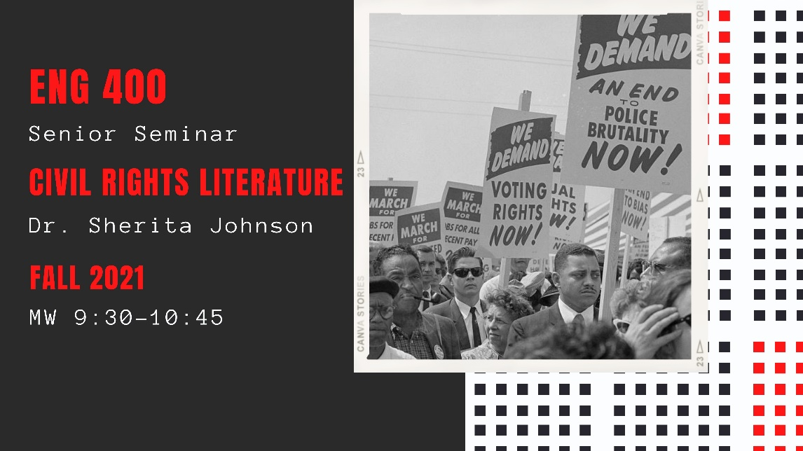ENG 400

Senior Seminar

“Civil Rights Literature”

Dr. Sherita L. Johnson

MW 9:30-10:45 (Hoo2)

Reading Civil Rights literature requires an understanding of laws, racial politics, people, places, events, and texts that document a long history of inequality in the U.S. Though antagonistic race relations appear rooted in the South, the struggle for African Americans’ civil rights has always drawn a national audience and federal intervention. What we learn about these experiences will be useful to understand other groups’ struggles for justice and equality, and, hopefully, you will gain a greater appreciation for the rights we might take for granted as U.S. citizens today. Our study will begin in the late 19th century with the birth of Jim Crow as witnessed by writers of political fiction and extend the timeline to lyrical meditations on citizenship in the 21st century. Selections will reveal themes of agency and resistance, migration, integration, separatism, violence, suffrage, white privilege, coalition building, education, and religion. The fundamental objectives of this course are not only to identify the writers and analyze the narrative structures used to address civil rights, but, ultimately, we will examine the “culture of segregation” that serves as an impetus for the development of this body of literature until even now.
Readings may include the following publications:
· Julie Buckner Armstrong and Amy Schmidt, eds. The Civil Rights Reader: American Literature from Jim Crow to Reconciliation (2009)
· Albion W. Tourgée, Bricks Without Straw (1880)
· Anne Moody, Coming of Age in Mississippi (1968)
· James Baldwin, The Fire Next Time (1963)
· Claudia Rankine, Citizen: An American Lyric (2014)
· Ta-Nehisi Coates, Between the World and Me (2015)

ENG 401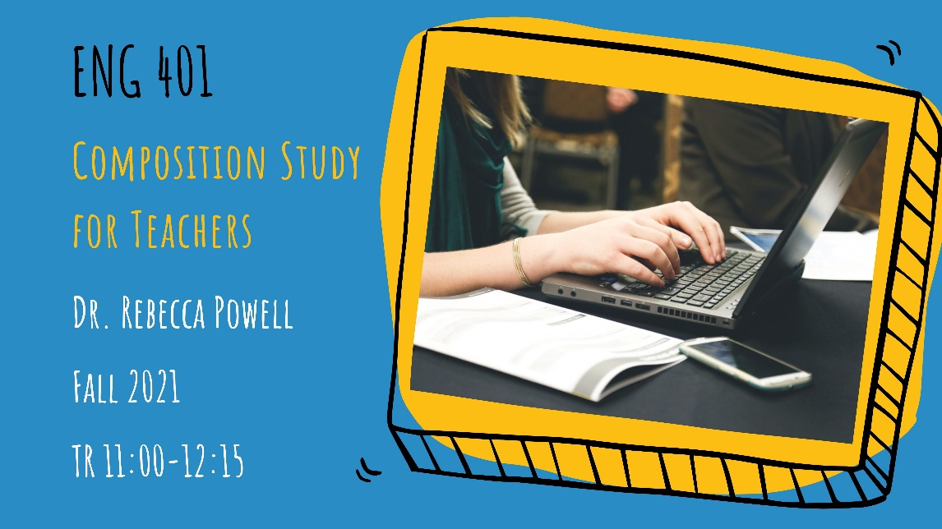

Composition Study for Teachers

Dr. Rebecca Powell

TR 11:00-12:15
This course invites you to study and research how writing is at work in the world, how it moves through your life and communities, how people and institutions deploy writing to include and exclude, and finally, but perhaps most importantly, how to transform and utilize that knowledge in your teaching and professional endeavors. To do this, we’ll research the role of writing in our culture, education, and communities, examine our own writing processes, study the literature on the writing experiences and processes of adolescents, and design lesson plans, activities, and assessments that reflect the labors of our studies.
In this course, we define writing broadly, drawing on composition and literacy studies to expand our definitions of composing beyond the page to the digital and visual. We’ll work together to see how this expansive definition of writing will inform our pedagogy and practices and how it does, or does not, show up in education discourses about writing, including the professional statements of the National Council of Teachers English and the Mississippi Career and College Ready Standards. This course is appropriate for elementary and secondary teacher candidates.

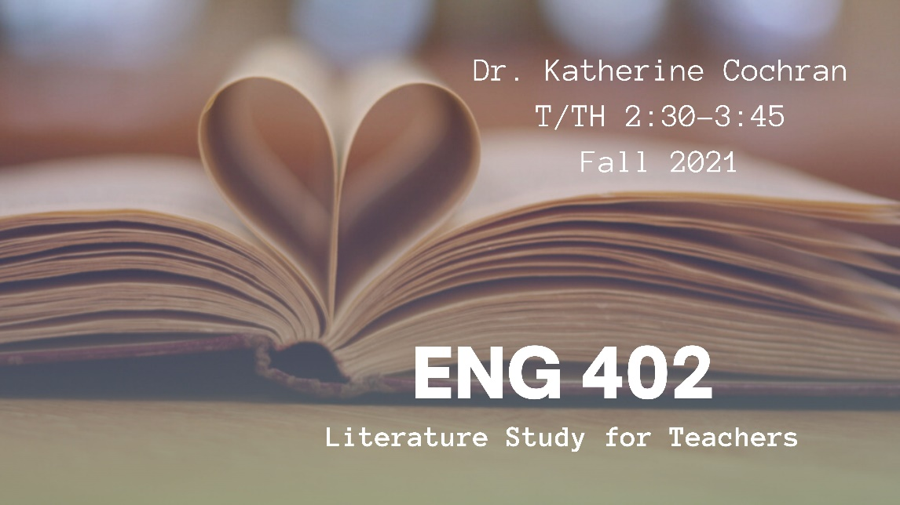ENG 402

Literature Study for Teachers

Dr. Kate Cochran

TTh 2:30-3:45 (H001/G001)
This course is designed to examine both theoretical and practical problems in the teaching of literature. Through reading poems, short stories, memoirs, and novels as our primary texts, we will become acquainted with textual and generic issues while our secondary text offers pedagogical and methodological guidance for instructors charged with teaching literature. Students will practice class activities, create a book talk, complete a multigenre research project, take a final comprehensive essay exam, and observe a class video, including writing a reflection on the observation. As a required course for English Licensure students and an elective course for Elementary Education students at the undergraduate level, this course seeks to help students understand the current theories and processes of teaching literature. Students will learn about themselves as readers and will work together to further deepen their understanding of how students learn.
Required texts:
- Richard Beach et al, Teaching Literature to Adolescents, 3rd edition
- Ray Bradbury, Fahrenheit 451
- Tae Keller, When You Trap a Tiger
- Lois Lowry, The Giver
- Daniel Nayeri, Everything Sad Is Untrue
- Marjane Satrapi, Persepolis: The Story of a Childhood
- Elie Wiesel, Night

ENG 410

Cross-Cultural Encounters

Dr. Ery Shin

MW 1:00-2:15
This course examines the idea of ethnicity on a world stage, thinking through race and its relations with gender, sexuality, class, religion, citizenship, and all the other ways by which an individual comes into focus before the public. It not only crosses national boundaries, but also genres in this pursuit. From South Africa’s psychiatric wards to Oakland’s freeways—from spiritual memoirs to bilingual poetry—this lecture-seminar series delves into those liminal social spaces dividing the powerful from the abject.
Sample reading/viewing list: Tommy Orange’s There There; Sonsyrea Tate’s Little X: Growing Up in the Nation of Islam; Gloria E. Anzaldúa's Borderlands/La Frontera: The New Mestiza; K. Sello Duiker’s The Quiet Violence of Dreams; Raoul Peck’s I Am Not Your Negro

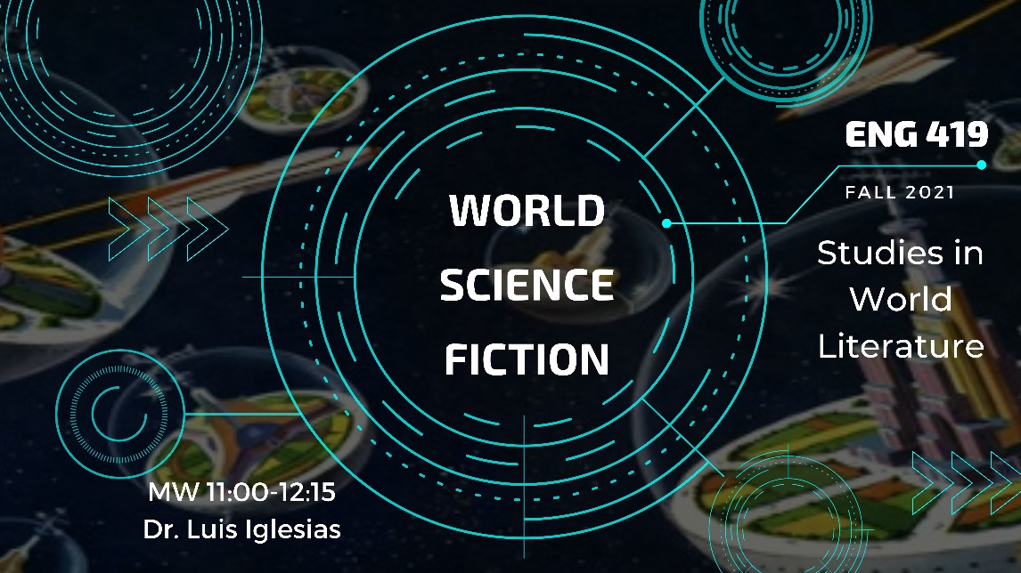ENG 419

Studies in World Literature

World Science Fiction

Dr. Luis Iglesias

MW 11:00-12:15 (H001)
Over its history, the genre of Science Fiction has been predominantly an Anglo-American tradition that arose out of the West’s Age of Enlightenment and Scientific Revolutions. However, the 21st Century has seen the rise and increasing popularity of Science Fiction written by writers of color and from non-Western nations. This course will read and explore the expansive reach of Global Science Fiction, examining the cultural and national inflections made visible through a body of diverse works including novels, short stories, and films by writers and film-makers from around the world.
Among the readings:
Lagoon (2014), Nndeki Okorafor (Nigeria)
The Three-Body Problem (2008) Liu Cixin (China)
Super, Extra, Grande (2016) YOSS (Cuba)
Frankenstein in Baghdad (2013), Ahmed Saadawi (Iraq)
Central Station (2018), Lavie Tidhar (Israel)
District Nine (2009), Neill Blomkamp

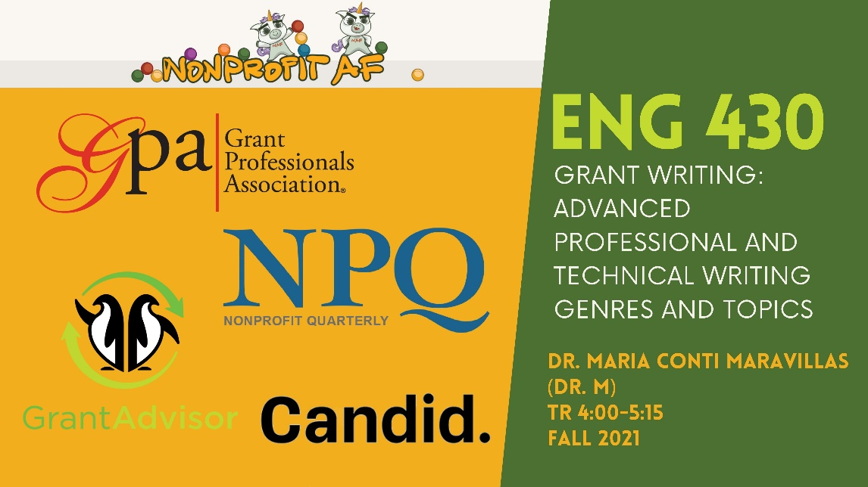ENG 430

Grant Writing: Advanced Professional and Technical Writing Genres and Topics

Dr. Maria Conti Maravillas (Dr. M)

TR 4:00-5:15
What can grant funding do for the organizations and causes that matter to you?
What makes an effective grant proposal?
This interactive course provides a step-by-step process for writing grant proposals. You will learn how to identify needs, research relevant sources of funding, and write grant proposals that are tailored for specific audiences. As you develop your proposal, you will receive individualized feedback on your work and engage meaningfully with the work of others. This course is part of the Professional Writing and Public Discourse concentration. After completing this course, you will be able to list experience with grant writing on your resume.
The ability to write grants is a highly marketable skill that is especially relevant for students interested in the arts, education, nonprofit work, library science, social work, healthcare, and the sciences. Even if you do not expect to write grant proposals in the future, the skills from this hands-on course can be applied to other writing contexts across a range of professional careers. Questions are welcome! Email Dr. M at m.contimaravillas@usm.edu.

ENG 445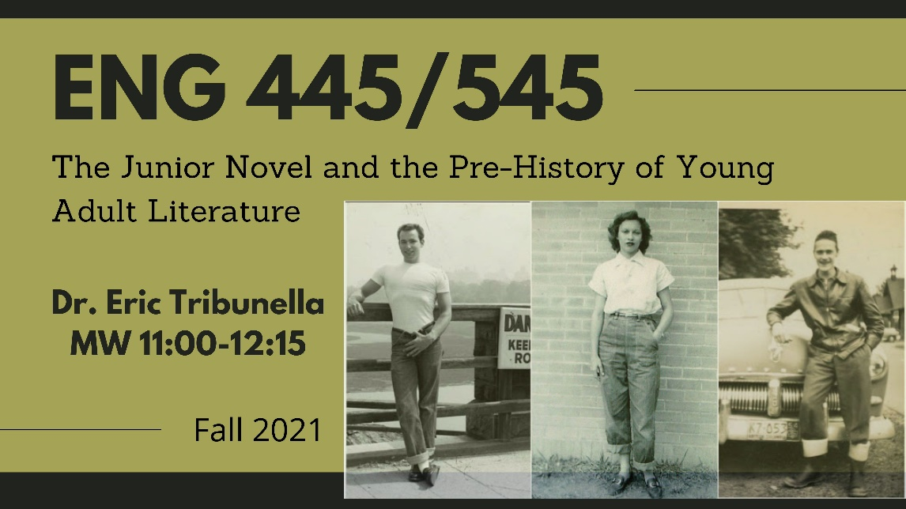

The Junior Novel and the Pre-History of Young Adult Literature

Dr. Tribunella

MW 11:00-12:15
Before the development of Young Adult (YA) literature in the late 1960s, the so-called "junior novel" was written for and marketed to young people who were thought to have outgrown children's books and to be looking for alternatives to adult fiction. The standard history of YA literature suggests that it offers grittier and more sophisticated fare than its predecessor, while the junior novel tends to be dismissed as hokey and benign. We will reconsider this history of YA literature by reading a selection of junior novels and noting the complex ways they represent American youth culture, placing these works in conversation with the history of adolescence and the American teenager, and concluding with two landmark novels that represent the turn to contemporary YA fiction. Readings will include junior novels of different genres: adventure, historical fiction, romance, science fiction, the career novel, and the sports story.
Possible titles may include:
1. The Tattooed Man (1926), Howard Pease
2. Let the Hurricane Roar [Young Pioneers] (1933), Rose Wilder Lane
3. Sue Barton: Student Nurse (1936), Helen Boylston
4. Iron Duke (1938), John Tunis
5. Seventeenth Summer (1942), Maureen Daly
6. Hot Rod (1950), Henry Gregor Felsen
7. To Tell Your Love (1950), Mary Stolz
8. Tunnel in the Sky (1955), Robert Heinlein
9. South Town (1958), Lorenz Bell Graham
10. The Outsiders (1967), S.E. Hinton
11. The Contender (1968), Robert Lipsyte

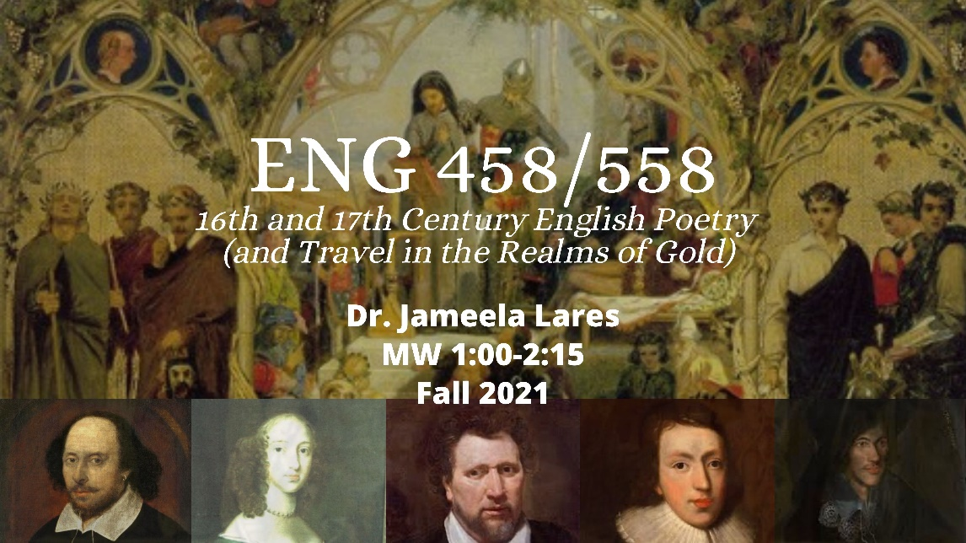ENG 458

16th and 17th Century English Poetry (and Travel in the Realms of Gold)

Dr. Jameela Lares

MW 1:00-2:15
The sixteenth and seventeenth centuries were remarkable for English poetry. This period was the Renaissance, the age of such poets as Wyatt, Surrey, Spenser, the Philip and Mary Sidney, Wroth, Shakespeare; Donne, Herbert, and other metaphysicals; Cavendish, Philips, and Milton. Our seminar will look at as many poets and forms as possible, along with key Renaissance ideas that inform the poetry. In these two centuries, English was coming into its own as a fully functioning language while English poets were nativizing foreign texts, meters, and forms, so we will also be looking at such translations as Chapman’s Homer that so dazzled John Keats. Cheap, used copies of the main course texts should be plentiful.
Requirements: regular reading, posting of discussions, and class participation; an oral presentation on an English Renaissance poet, the facilitation of a discussion, a short poem written in a Renaissance form, and a seminar paper on a topic related to the course but of particular interest to the student.
Combined with ENG 558.
Required texts:
- Greenblatt, gen ed., Norton Anthology of English Literature, 10th ed., vol. B.
- Rivers, Classical and Christian Ideas in English Renaissance Poetry, 2nd ed.
- Online resources as necessary.

ENG 465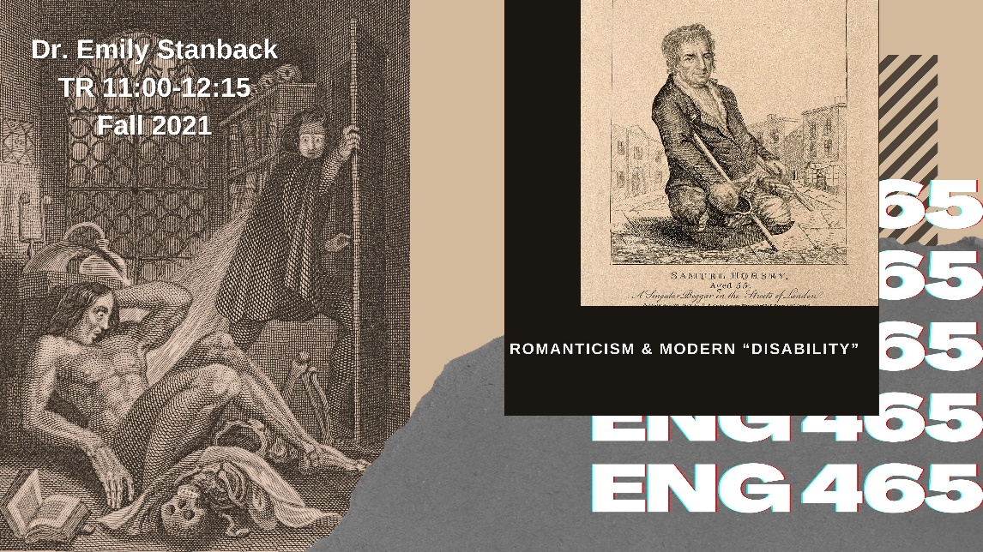

Romanticism & Modern “Disability”

Dr. Emily Stanback

TR 11:00-12:15
Many of the most enduring characters from Romantic-era literature, from Coleridge’s Ancient Mariner to Frankenstein’s Creature, are characterized by the kinds of bodies and minds that we would call “disabled.” Many Romantic-era authors also lived with conditions that, then and now, were pathologized by medicine—and most explicitly claimed the importance of these embodied states to their lives and writing. For example, Samuel Taylor Coleridge wrote letters and poetry about a wide range of chronic bodily and mental symptoms, Mary Prince spoke movingly about her rheumatism, Thomas De Quincey minutely tracked his “crazy body,” and Charles Lamb wrote about his stuttering, limping, and experience of madness.
This course seeks to explore the ways in which disability influenced Romantic-era literature and culture, as well as the extent to which conceptions of “disability”—in the modern sense of the word—developed during the era. Mindful of intersectionality, we will also consider how experiences of, and literary depictions of, disability can be shaped by race, gender, and class.
We will consider primary texts by authors including Coleridge, Prince, De Quincey, Lamb, Mary Shelley, Lord Byron, Mary Wollstonecraft, John Keats, Dorothy Wordsworth, and John Clare. We will also look at relevant medical texts and contexts.

ENG 477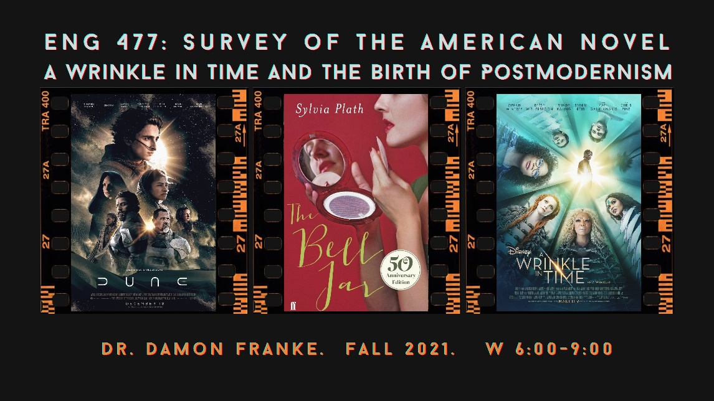

Survey of the American Novel

A Wrinkle in Time and the Birth of Postmodernism

W 6:00-9:00

Dr. Damon Franke
*This course is taught on the Gulf Park campus.
Course Description: When does postmodernity start? Is it 1945? 1962? 1989? 2001? This course will examine paradigmatic shifts in American sociopolitical issues exemplified by literature, film, song, television, and philosophy. The following topics in the new ways we think speak to the advent of postmodernity in post-WWII America as something that can be localized around 1960. The course will follow four short units and two longer units that tie together a new way of thinking with a literary work. Our course title draws its name from the Young Adult sci-fi adventure A Wrinkle in Time, which will emblematize the idea of a time shift or “paradigm change” made famous by Kuhn’s Structure of Scientific Revolutions. The rise of the military-industrial complex and fears of fascist coups are dramatized by The Man in the High Castle. In one of our long units, Friedan’s The Feminine Mystique and Cosmo-founder Helen Gurley Brown’s Sex and the Single Girl foster a provocative discussion of the disillusionment of domesticity vis-à-vis the potential for careers for women as we read the phenomenal Revolutionary Road and Sylvia Plath’s loosely autobiographical The Bell Jar. For our other long unit, the highly anticipated adaptation of Dune will appear during the fall semester as it sparks our discussion of environmental thought and the seminal Silent Spring. The outrageous and profound One Flew Over the Cuckoo’s Nest will be read in light of Foucault’s first book Madness and Civilization. Another unit will focus on the Civil Rights Movement by listening to Dylan’s The Times They Are a-Changin’, watching an episode of Alfred Hitchcock Presents, and reading Pynchon’s novella “The Secret Integration” in light of MLK’s letters and speeches. Many of the works we will read have recently been adapted to the screen, and group work will be done on nostalgic and revisionist films of the period such as American Graffiti, Hairspray, Animal House, The Sandlot, Hidden Figures, Green Book, and Whatever Happened to Baby Jane?
Course Texts at Bookstore:
Rachel Carson’s Silent Spring, Philip K. Dick’s The Man in the High Castle, Madeleine L’Engle’s A Wrinkle in Time, Frank Herbert’s Dune, Ken Kesey’s One Flew Over the Cuckoo’s Nest, Sylvia Plath’s The Bell Jar, and Richard Yates’s Revolutionary Road

Additional Course Offerings in FALL 2021:
ENG 221
Fiction Writing I
TR 9:30-10:45

ENG 222/322/422
Poetry Writing I/II/III
MW 1:00-2:15
Dr. Angela Ball

ENG 333
Technical Writing
Multiple offerings both in person and online

ENG 351
British Literature II
TR 1:00-2:15
Dr. Charles Sumner

ENG 370
American Literature I
MW 2:30-3:45
Dr. Luis Iglesias

