Summer and Fall 2021 Course Descriptions

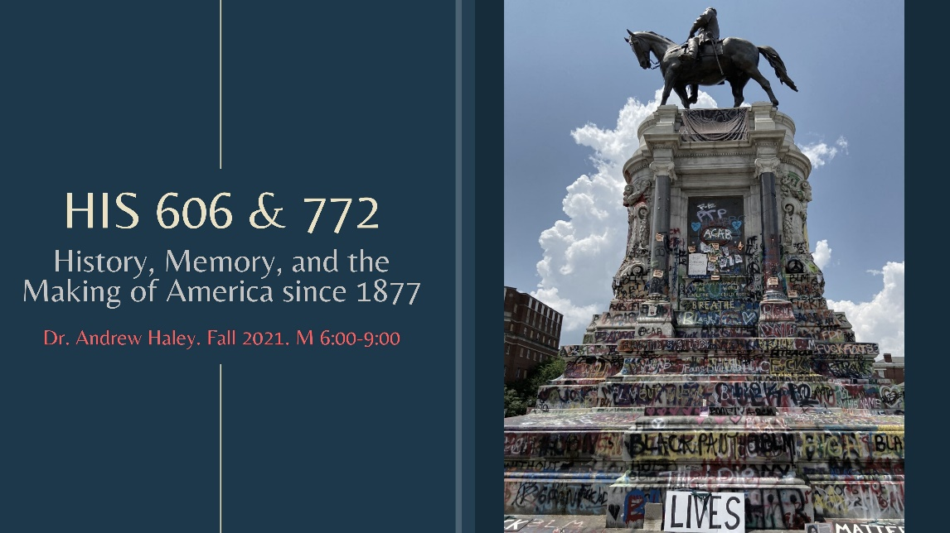HIS 606 (6805) or HIS 772 (3296)

History, Memory, and the Making of America since 1877

Cross listed as both Preservation Heritage II and U.S. HIS since 1877

Dr. Andrew Haley

M 6:00-9:00
“History, Memory, and the Making of America since 1877” is a graduate reading and discussion seminar that examines how American have thought about and celebrated their past. The course examines popular discourse as well as debates over museums and monuments and will be of interest to graduate students studying American history or public history.
The course begins with a brief survey of the major methodological and practical challenges that have bedeviled efforts to commemorate the past. We will then examine case studies that delve into mythmaking and American nationhood, the creation of distinctive regional histories, the fraught history of race, and how we think about, and memorialize, war and terrorism. Beyond the assigned reading and class participation, students will be required to submit four essays that raise questions about the week's readings and a final project that explores and critiques a public memorial. The class will include visits by museum and preservation professionals and, if circumstances permit, a field trip.
Reading List:
Introduction
History, Memory, and Public Life
Anna Maerker, Simon Slight, and Adam Sutcliffe
Routledge, 2018
9781138905849

Making the Past
Mystic Cords of Memory
Michael Kammen
Vintage, 1993 (Reprint)
978-0679741770

Clio's Foot Soldiers
Lara Leigh Kelland
UMass, 2018
9781625343437

Spaces
Monument Wars
Kirk Savage
UC Press, 2011
9780520271333

Domesticating History
Patricia West
Smithsonian, 1999
9781560988366

Regions
Imagining New England
Joseph Conforti
UNC, 2001
9780807849378

Where These Memories Grow
W. Fitzhugh Brundage, ed.
UNC, 2000
9780807848869

California Vieja
Phoebe S. Kropp
UC Press, 2008
9780520258044

Race
Learning from the Germans
Susan Neiman
Picador, 2020
9780374184469

What Can and Can’t Be Said
Dell Upton
Yale, 2015
9780300211757

War and Society
The Good War in American Memory
John Bodnar
Johns Hopkins, 2010
9781421405827

The Holocaust in American Life
Peter Novick
Mariner Books, 2000
978-0618082322

Heritage Industry
The Wages of History
Amy M. Tyson
U Mass, 2013
9781625340245

Desire and Disaster in New Orleans
Lynnell L. Thomas
Duke, 2014
9780822357285

Contemporary History
Memorial Mania
Erika Doss
Chicago, 2010
9780226159416

HIS 710

Philosophy and Methods of History

Dr. Courtney Luckhardt

T 2:30-5:50
This seminar is designed to introduce graduate students to the philosophical and practical foundations of historical method. Our coverage is not comprehensive, but we will familiarize ourselves with some of the innovative and diverse approaches that have shaped historical work over the past several decades. As we read these works, we will consider how and why historians investigate, interpret, and write about the past as well as contest one another’s findings. Together we will expose some of the underlying, unspoken assumptions and preoccupations that we bring with us to and which persist in the discipline. Students are required to complete several written and oral assignments to hone their critical thinking, writing, and presentation skills.

HIS 711/712

Research Seminar in American and European History

Dr. Susannah Ural

T 2:30-5:30
This course focuses on the craft of historical research and writing at the graduate level. It is specifically designed to help you complete two thesis chapters or your dissertation prospectus. All 711/712 students have at least one year of MA studies behind them, so I assume you already understand the basics of good grammar, clear writing, proper citations, and the importance of making a clear argument that weaves throughout a written work. There is a difference, though, between knowing what is needed and creating that yourself. It’s a skill we all develop over time, and this course is designed to help you with that process. Students will spend the majority of class time presenting and respectfully critiquing each other's small assignments; I'll be helping with those critiques, too. You will revise according to feedback received in class & then upload your assignment into Canvas about two days later almost every week. I’ll return these to you graded before or during our next class period. All assignments are designed as parts of your thesis. By focusing on manageable pieces of your work, we will have your thesis abstract, title page, bibliography, and one chapter done by the end of October and a second chapter done by early December, along with a clear plan to move forward in the spring. If you come to class with your introduction completed (according to your advisor), you’ll write two additional chapters. This course is also open to PhD students ready to craft their dissertation prospectus and you’ll receive a separate version of the syllabus to ensure that you’ll have a prospectus ready to send to your committee by the end of the semester.

HIS 725

U.S. Historiography I Seminar

Dr. Kyle F. Zelner

T 6:00-9:00

^{Reg. Code: 3298}
Historiographic study, or the study of the study of history, is an incredibly important part of being a historian. Historians do not begin a single project without first learning what came before—what other historians have said on the topic, how they said it, and what the state of the field is at the moment. As beginning professional historians, students will be expected to talk about the historical debates surrounding their topics and how their work intersects with those debates. Students will be expected in their classes, and especially during their comprehensive exams, not only to know what happened in the past and why, but who argued what and the methods they used to come up with those arguments. This course will start you down the historiographical road. We will examine some of the main debates in early American history as a way to “jump start” each student’s historiographical knowledge. Once students have successfully completed this course, they will know some of the important highlights of the field—but also come to the realization that they have just started what will likely be a lifelong task.
Students in the class will read deeply and widely on each debate and will come to class prepared to debate the topic at hand. NOTE: Students should come to the first class before purchasing any books for the various weeks, as we will choose individual books for the course during the first class meeting.
Assignments:
Students will write numerous book reviews, write a short historiographical paper, lead a few and participate in all class discussions, and write a comprehensive exam-type answer for their final exam.
Some of the topics we will explore:
- Indians, Contact, and Ethnohistory
- The Puritans of Colonial New England
- The Colonial South and Slavery
- Coming of the Revolution
- Women in the Early Republic
- The Market Revolution
- The Second Great Awakening
- Antebellum Slavery
- The Civil War: Who Fought and Why?

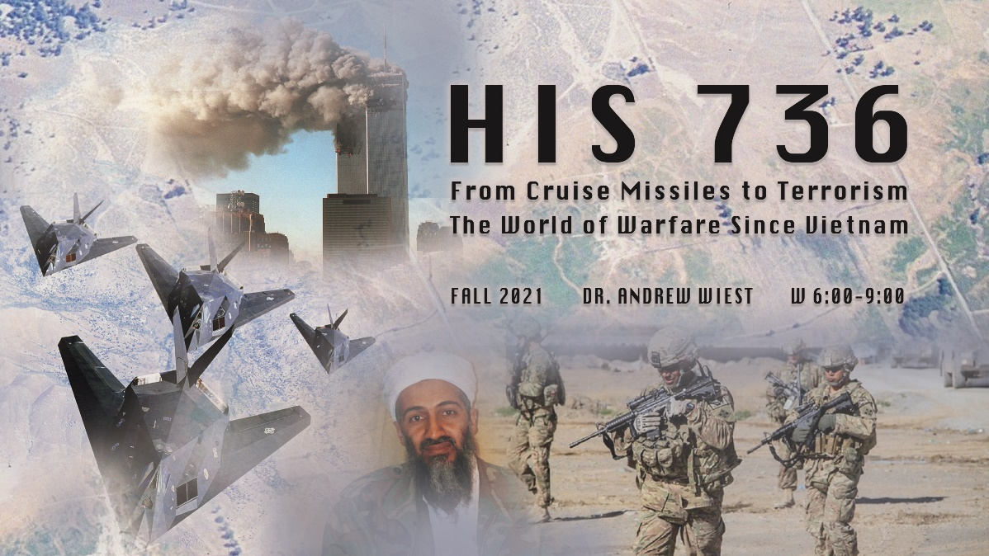HIS 736

Graduate Seminar/Modern War and Society

From Cruise Missiles to Terrorism; The World of Warfare Since Vietnam

Dr. Andrew Wiest

W 6:00-9:00
This class will investigate the trends in warfare since the close of the Vietnam War. Utilizing a series of readings from the latest historiography, this class will investigate how the west, still focusing on the Cold War, was involved in a revolution in military practice based on the ever expanding miracles of weapons technology. Focus will be placed on the crumbling of the Westphalian military system and the dawn of 4th generation conflict. A close investigation will focus attention on the Arab-Israeli wars, both Gulf wars, the Russian war in Afghanistan, terrorism, and the ongoing Global War on Terror.

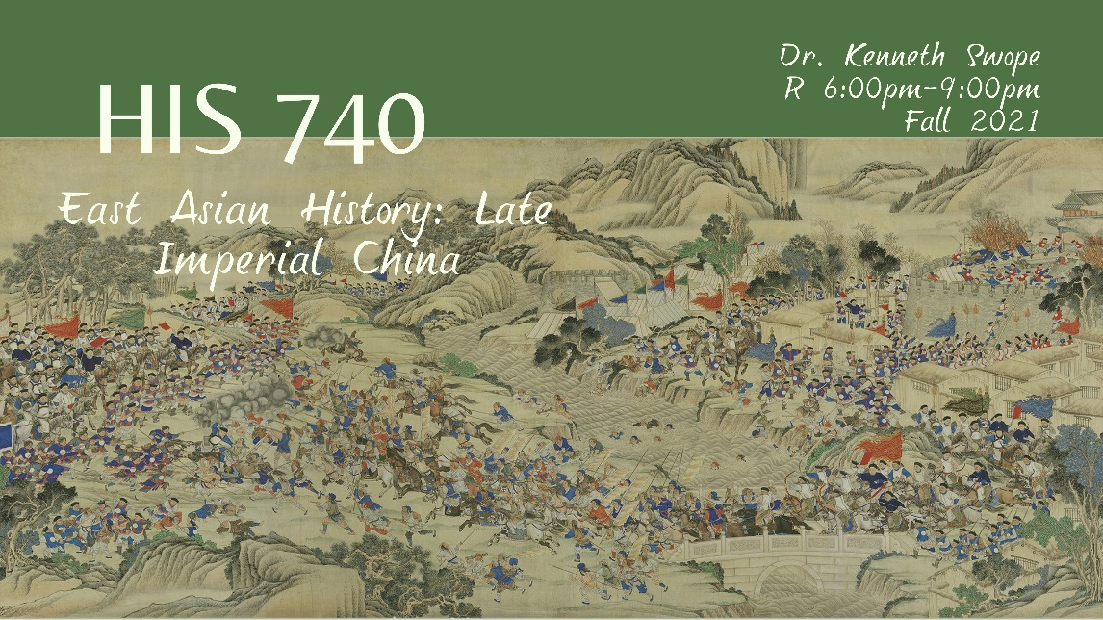HIS 740 (listed as HIS 692 H001)

East Asian History: Late Imperial China

Dr. Kenneth Swope

R 6:00-9:00
The underlying goal of this course is to introduce you to recent historical monographs pertaining to the study of empires and imperialism in late imperial China (1368-1911). This sub-field is one of the most dynamic in Chinese history with a veritable explosion (pun intended) of works published in the past two decades. Taken as a whole such works not only vastly expand our knowledge of the military past of China and its neighbors, but also contribute significantly to broader debates in the field of military history such as the “Military Revolution” debate popularized by Geoffrey Parker and others. They also make use of a wide variety of newly available primary sources and methodologies to illuminate how the process of Chinese imperialism has been unfolding over the past several centuries and is not a recent phenomenon. By the end of the course you should be familiar with some of the major debates in the field today and have a general sense of how these issues and theories pertain to both China and other fields of study. Finally, you should also gain a sense of how the experience of China in the nineteenth century shaped self-perceptions and worldviews of the Chinese people in subsequent decades how these still affect international relations today.

HIS 796

Practicum in the Teaching of History in Colleges and Universities

Dr. Kyle F. Zelner

R 2:30-5:30

Reg. Code: 3292
Required for all first-time teaching and graduate assistants and optional for others, this class is designed to encourage graduate students to think about the major issues of teaching at the college level, both as teaching assistants and as independent instructors. Different faculty members will visit to lead discussions on a different topic each class period. The course covers basic issues of teaching and learning strategies, classroom philosophy and management, technology in the classroom, testing and other assignments, issues of diversity, effective classroom presentation, and how to construct one’s own course.
Required Text:
Barbara Gross Davis, Tools for Teaching, 2nd ed. Wiley: Jossey-Bass; 2009.
Assignments:
Students will engage in weekly discussions, write several short reaction papers, and design and execute a sample lecture for an introductory History class.

