Summer and Fall 2021 Course Descriptions

HIS 101

World Civilization I

Dr. Susannah Ural

TR 1:00-2:15 (H004)
This class examines world cultures from 4,000 B.C.E. through 1500 C.E. You don’t need to become an expert on all of world! But if you learn the people, ideas, and events that shaped this period, and how to analyze their culture and experiences, you’ll make better decisions, more informed decisions, when you face similar situations in your own life. They may be centuries removed from you, but every culture we study will offer lessons in the abuses of leaders or government, minority demands for rights, threats of conflict, economic growth and instability — all issues we struggle with today. You’ll attend weekly class meetings, take regular short quizzes on the material, complete writing assignments, and take several exams. Points are also tied to regular attendance and in-class participation in discussions.
HIS 101 will address the following learning objectives of the GEC:
- Students will evaluate major developments in world history, the historical roots of contemporary global cultures, or the literary, philosophical, or religious contributions of world cultures.
- Students will develop a topic and present ideas through writing in an organized, logical, and coherent form and in a style that is appropriate for the discipline and the situation.
- Students will use Standard English grammar, punctuation, spelling, and usage.
- Students will comprehend and proficiently interpret text.

HIS 101

World Civilization I

Dr. Courtney Luckhardt

HYBRID
Asynchronous online coursework and in person Friday meetings: H010 (F 9:00-9:50), H011 (F 10:00-10:50), H012 (F 11:00-11:50)
In this course, we trace the story of civilization from prehistory through the fifteenth century. Through a kaleidoscope of kings and slaves, warriors and philosophers, farmers and merchants, we will focus on four themes that intersect in all the societies we study this semester.
1) religious development and syncretism
2) elite power and political organization
3) technological innovations
4) trade and economic development
To focus on these themes and questions, we will be close reading primary sources (that is, texts produced by the societies we are studying, not by modern scholars) from many different civilizations. We will learn history by doing it – this means that students will learn to read and interpret primary evidence and come to their own conclusions about pre-modern societies.
This class is a hybrid online and in-person course; students will watch video lectures during the week and then meet on Fridays for 50 minutes for in-person discussion, activities, and writing. There is extra support for student success built into the class, and so students with an ACT of 19 or below are encouraged to enroll in this section.

HIS 102

World Civilizations from 1500

Dr. Allison Abra

TR 5:30-6:45 (H004)
How did we get to where we are today? This course is designed to help us better understand the world in which we now live by examining some key global events and developments since 1500. Our goal will be not only to study important figures, societies, and events on their own terms, but to begin thinking about the world as a global network of social, cultural, economic, and political connections. We will examine a wide array of materials and sources including historical documents, film, music, etc., all of which will help us to flush out the issues, people, and events which have shaped the modern world over the last five hundred years.

HIS 201

Dr. Kevin Greene

US to 1877

MW 9:30-10:45
This course will function as a survey of major themes in the history of the United States to 1877. By examining a combined collection of primary historical sources (letters, journals, speeches, oral interviews and newspapers) and secondary materials we will explore many themes in United States history including industrialization, political movements, immigration, labor, social reform, race, class, gender, and the evolving nature of the U.S. federal government. Rather than focusing solely on the effects of key individuals in U.S. history, which is important, this course will also examine the history of everyday individuals from a variety of backgrounds whose lives were an integral part of this country’s complex historical landscape. Central to our investigation in this course are questions concerning inherent complexities and contradictions in our grand American experiment.

HIS 307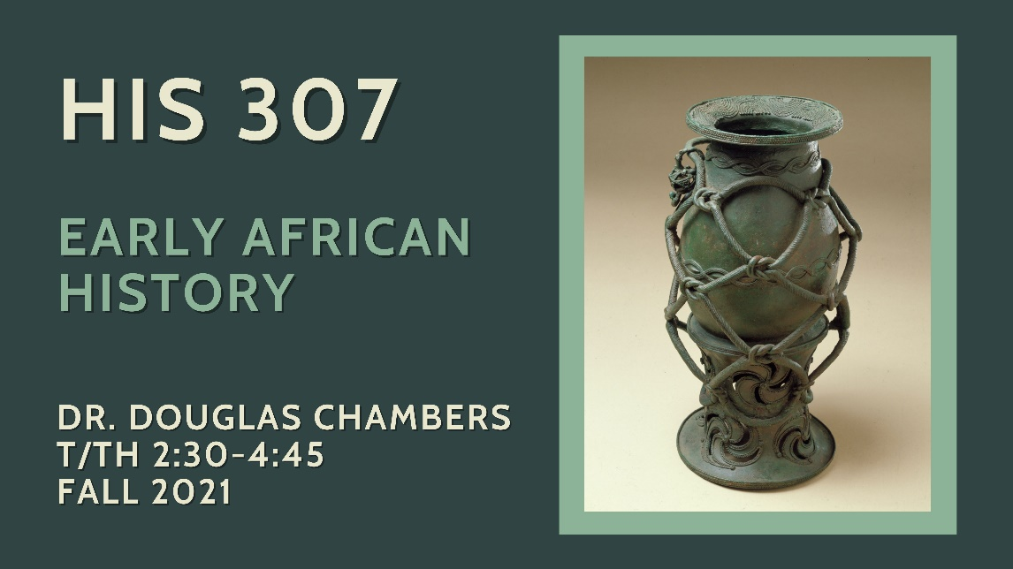

Early African History

TR 11:00-12:15

Dr. Douglas Chambers
This course is a general survey of Sub-Saharan African history, from ancient civilizations to the classical era and beyond, including the importance of Islam in African history, and of Africans in the Atlantic World Diaspora. We will explore key themes in the changing experience of the continent and its peoples through the early nineteenth century. You will gain a basic working knowledge of particular regions as well as of general themes and long-term changes over time.
Required Texts
- Robert Harms, Africa in Global History (New York: W.W. Norton, 2018).
- D. T. Niane, Sundiata: An Epic of Old Mali (Essex, England: Longman, 1994).

HIS 333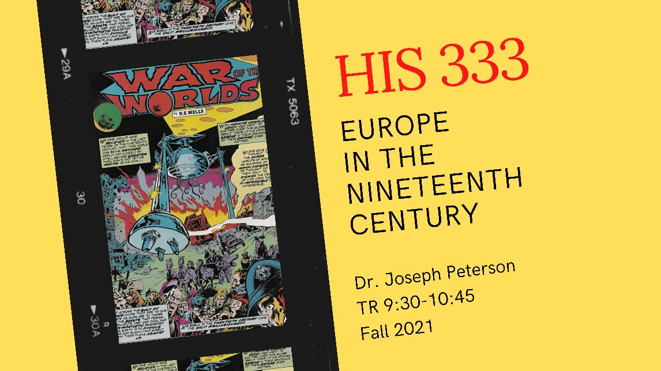

Europe in the 19th Century

Dr. Joseph Peterson

TR 9:30-10:45
Steamships, railroads, and Women’s Suffrage… Human Rights, the Eiffel Tower, and the scramble for Africa… Impressionism, germ theory, dynamite, and the Boy Scouts… the first bicycles, the first department stores, the first machine guns… the first hipsters, the first human zoos and concentration camps, and the first science fiction… The first age of mass literacy, mass advertising, and mass politics… The first recorded use of the word “socialism,” of the word “antisemitism,” of “feminism,” “nationalism,” “dystopia,” “agnosticism,” and “homosexual.” Why are so many of the issues and questions raised by nineteenth-century Europeans still with us today? Why does an age so seemingly distant and innocent—so “Victorian”—still feel so modern? We cannot begin to understand our present without understanding its origins in the nineteenth century.

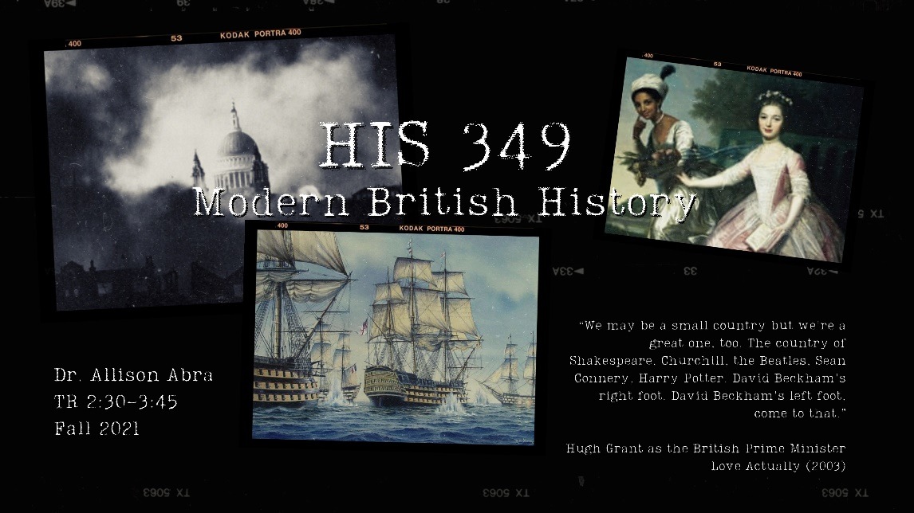HIS 349

Modern British History

Dr. Allison Abra

TR 2:30-3:45
“We may be a small country but we're a great one, too. The country of Shakespeare, Churchill, the Beatles, Sean Connery, Harry Potter. David Beckham's right foot. David Beckham's left foot, come to that.”
Hugh Grant as the British Prime Minister
Love Actually (2003)
As the words of Hugh Grant’s fictional Prime Minister eloquently and comically demonstrate, Great Britain has had a profound impact on the world during the last several centuries. The country has produced artistic and political giants, launched industrialization and modern liberal democracy, and forged an Empire on which “the sun never set.” As this the latter example demonstrates, Britain’s history has not always been benevolent or proud. Yet it remains a rich and important field for the student of history.
This course is concerned with the social, political, cultural, imperial, and military history of modern Britain, from the early eighteenth century through to the present day. Using an array of both primary and secondary sources, we will examine many facets of British society, from high politics to popular culture. We will also consider the impact of Britain’s empire, both at home and throughout the world. Finally, we will look at issues such as race, class, and gender, and attempt to better understand what it meant to be British across the modern period.

HIS 370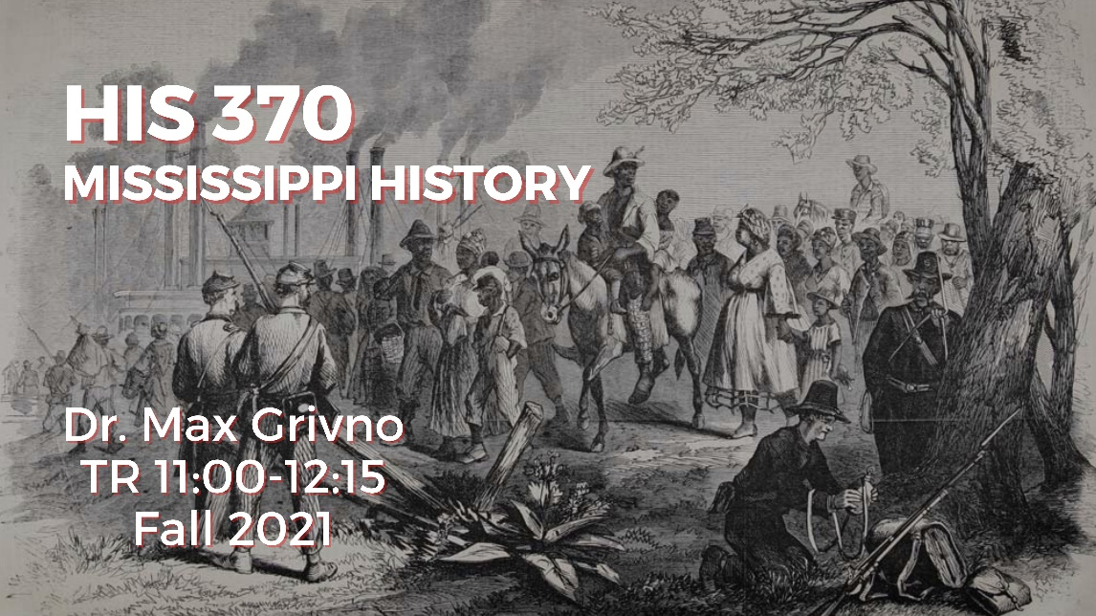

Mississippi History

TR 11:00-12:15 CHAT

Dr. Max Grivno
“The past is never dead,” William Faulkner once wrote. “It’s not even the past.” Mississippians live in the shadow of the past, one that offers sources of immense pride and a strong identity, but one that has also left painful legacies. This course explores the complexities of Mississippi History from the beginnings of human migration to the Gulf South through the Civil Rights Movement. It is designed to give social studies licensure students a solid foundation for teaching Mississippi Studies, but it will be of interest to students interested in Native American history, slavery and the Old South, the Progressive Era, and the Civil Rights Movement.
I have divided the class into three sections. The first, “Chiefdoms, Empires, and Confederacies,” begins with an examination of the earliest inhabitants of present-day Mississippi and traces the evolution of human societies during the Paleo-Indian, Archaic, Woodland, and Mississippi periods. It explores the rise and fall of the Mississippian chiefdoms and considers the impact of the De Soto expedition of 1539-42. It then moves to a discussion of the Natchez, Chickasaw, and Choctaw confederacies and their struggles to maintain their independence in the face of encroachment from the English, the French, the Spanish, and later the Americans.
The second section, “The Rise and Fall of the Old South,” opens with the War of 1812 and proceeds to the expulsion of native nations and the dramatic expansion of cotton production during the “Flush Times” of the 1830s. It also examines why Mississippi’s slaveholders took the desperate gamble of seceding from the United States and explores the effects of the Civil War, Emancipation, and Reconstruction in Mississippi.
The final section, “The Long Struggle” traces the state’s history from the violent overthrow of the Reconstruction governments through the present. It is framed around questions of race and citizenship and considers how the World Wars, the Great Depression, and the Freedom Struggle transformed Mississippi—altering its economy, destroying legal segregation, and changing the state’s politics, all while leaving persistent pockets of poverty, poor education, and public health problems.

HIS 400

Senior Capstone

Dr. Kevin Greene

MW 1:00-2:15
History 400 is the capstone course in your study of history at the University of Southern Mississippi. By concentrating on a specific topic, urbanism and urbanization in the twentieth century, this course will simulate a graduate seminar in history. Throughout the semester, we will investigate the rise (and fall, in some cases) of urban spaces and communities throughout the twentieth century. The course will place strong emphases on the processes of historical research, methodology, and historiography, and will culminate with your completion of a 12-15-page, detailed research paper. Near the end of the semester, you will present your research to the class in a formal presentation. In order to pass this course, students must demonstrate mastery in critical reading, advanced research, evidential argumentation, solid writing, and oral presentation proficiency. These are fundamental tools for the study of history and each graduating history major at USM must demonstrate a level of expertise in these elements. This course is one of three Writing Intensive (WI) courses USM history majors must complete-with at least a C-in order to graduate. This is a seminar in professional history that you must take seriously. Your graduation from USM depends on it!

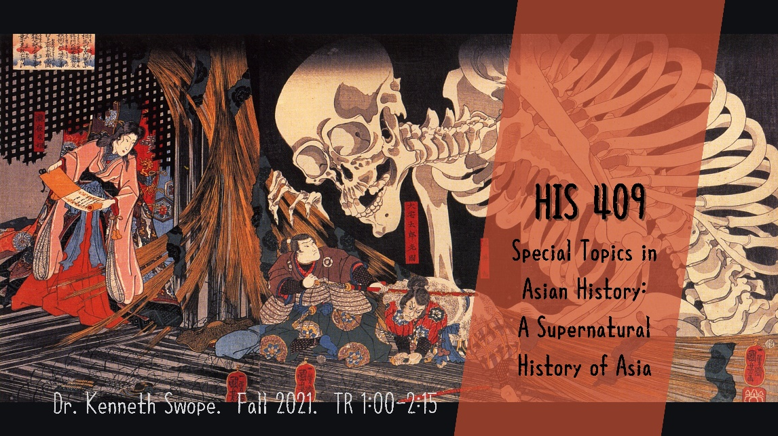HIS 409

Special Topics in Asian History

A Supernatural History of Asia

Dr. Kenneth Swope

TR 1:00-2:15
As a result of exposure to films, manga, anime, and video games among other mediums, the entire world is becoming aware of the rich and varied history of monsters, ghosts, and strange creatures populating the history and folklore of the countries of Asia. This course will explore the historical context of some of these strange denizens, tracing their cultural and historic significance, and examining their appearance in folk tales, novels, films, and other mediums. Students will be asked to complete review/reaction essays, in-class essay examinations, and a larger project on a topic of their choice.

HIS 424

The World in the Twentieth Century

Dr. Matthew Casey

TR 4:00-5:15
It’s impossible to understand the crises we face in the present without looking deeply into the past century. This face to face course will provide a broad overview of the political, economic, social, and cultural processes of the world in the twentieth century. Rather than a simple catalog of well-known events, students will be introduced to methods for analyzing global history that include setting up meaningful comparisons, identifying connections across regions, and studying large trends and their distinct local manifestations. All course readings will be open access texts freely available to students without purchase. Students will be assessed using short essays, in-class examinations, and in-class discussions.

HIS 476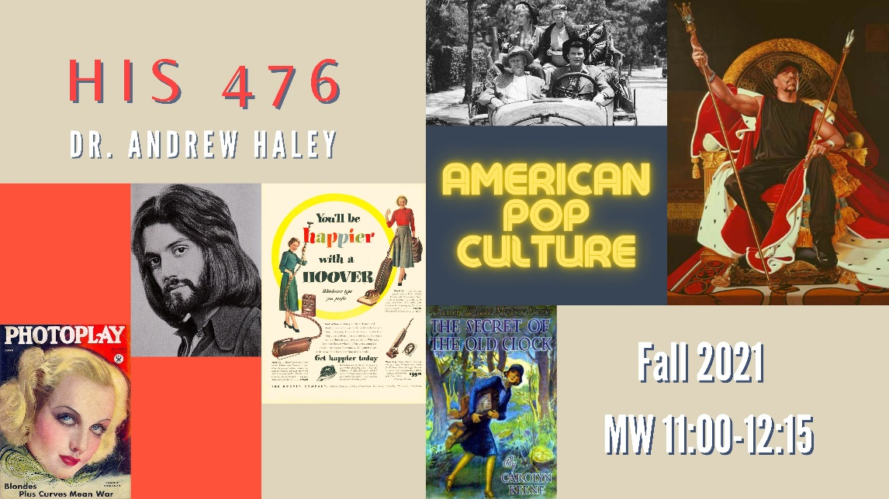

American Popular Culture (Intellectual and Cultural History of the USA)

Dr. Andrew Haley

MW 11:00-12:15
In the early nineteenth century, it was Shakespeare. In the Gilded Age, it was the dime novel. In the fifties, it was television. Today, it is Instagram and SoundCloud. Lawrence Levine defined it as the "folkways of industrial society," but that seems rather pompous. It is Ronald McDonald and Uncle Tom's Cabin, it is Saturday Night Live and the minstrel show, and it is Hello Kitty and Wolfman Jack. Popular culture is the stuff that clutters our closets, hangs on our walls, and gets lost under the couch. It is the stuff we love and the stuff we love to hate. And perhaps, it is also the material that best defines generations, offering historians a glimpse at what mattered to people in the past.
This course explores the history of popular culture in the United States. We will examine music, plays, mystery novels, television, film, fashion, dance, and advertising with an eye to understanding how Americans have for over two hundred years defined themselves and have resisted being defined by others. It is an upper-division seminar. It is recommended, but not required, that you take History 201 and 202 before taking this class so that you so that you have a better understanding of the context in which the events we are studying take place. Each week the instructor will introduce a new era and genre of popular culture in a lecture, and then the class will explore the topic more thoroughly through discussion based on primary source readings and in-class activities. The grade will be based on participation in these conversations and on a series of take-home essays. Jim Cullen’s Popular Culture in American History and Carolyn Keene’s Nancy Drew Mystery Series: The Secret of the Old Clock (original 1930 version) are required; additional readings will be posted online.

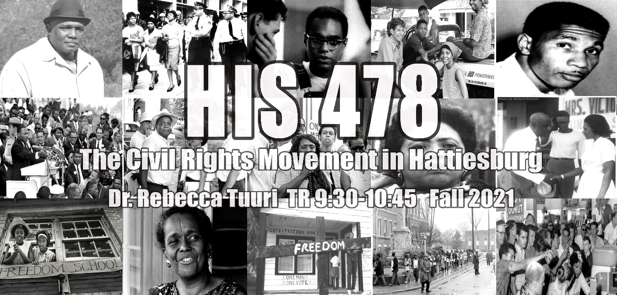HIS 478

Special Topics in African American History

The Civil Rights Movement in Hattiesburg

Dr. Rebecca Tuuri

TR 9:30-10:45
This course will explore the history of the African American Civil Rights Movement from the end of World War II through the end of the Black Power Movement as seen through the lens of Hattiesburg. This class will not only cover the broad national history of the civil rights movement in America but will zoom into our town, which was pivotal in the Movement. We will get to know the living, breathing persons and vibrant spaces of the struggle. This will be a service-learning course where we will be learning not only from our assigned course materials but also from the wisdom of the local community, past and present. We will also utilize primary and secondary sources to learn about the Movement and consider not only how history has been written in secondary sources, but also how it has been publicly remembered.
This class fulfills an upper-level U.S. history major requirement and counts towards the Black Studies minor, Women and Gender Studies minor, and Human Rights minor. This course will also be a service-learning course.

