Summer & Fall 2021 Course Descriptions

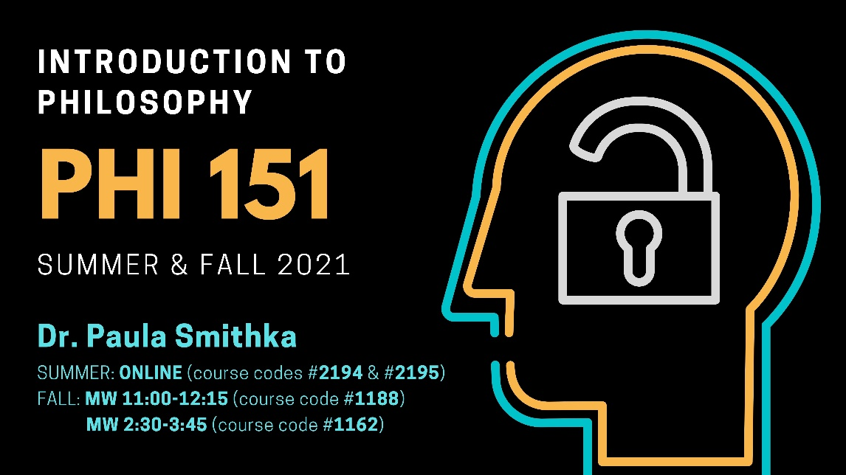PHI 151

Introduction to Philosophy

Dr. Paula Smithka

Summer: ONLINE, course # 2194, H080 and ONLINE, course # 2195, H081

Fall: MW 2:30-3:45, course # 1162 (H001) and MW 11:00-12:15 course #1188 (H002)
Aristotle says, “For it is owing to their wonder that people both now begin and at first began to philosophize”.
Philosophy begins in wonder. It’s about asking fundamental questions—questions like, “Does God exist?”; “What is the nature of reality?”; “Is what I perceive really the way things are?”; “When I say ‘I have a mind’, is the mind the same thing as a brain?”; “Is consciousness physical?”; “What makes an action morally right?”
Study philosophy and unlock your mind!

PHI 171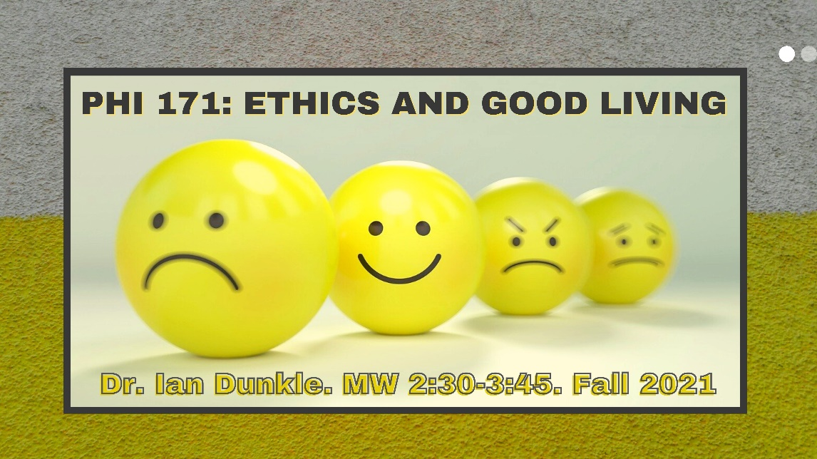

Ethics & Good Living

Dr. Ian Dunkle

MW 2:30-3:45 (H001)
What is it to live well? This is one of the oldest and most foundational questions in philosophy, and for good reason: what could be more important than understanding how to live well?—Maybe, actually living well!—Granted. But how can we hope to live well unless we have at least some idea of what that is?
Answering this question is hard, though, for several reasons, including these: First, it seems to be ambiguous (to live uprightly? to maximize self-interest?). Second, common answers are ambiguous; there are different senses in which something might be good for you. Third, popular opinions on the good life contradict one another (consider what your parents tell you about the importance and non-importance of pursuing a lucrative career). But where else can we get a footing on the question except in popular opinions?
This course explores the central philosophical puzzles and controversies regarding the good life and introduces students to major accounts offered in both the history of philosophy and in contemporary value-theory. Throughout the course students will also develop skills of critical thinking and argument analysis.

PHI 351

Critical Thinking

Dr. Ian Dunkle

MW 11:00-12:15
How is it possible to learn what you don’t already know; how do we acquire knowledge? Sure, you could just find someone who does know and listen passively to what they say. But how will you know that they know what they’re talking about? And even if they do, is having the ability to parrot someone else’s knowledge the same as having that knowledge yourself? Acquiring knowledge seems paradoxical.
The solution: we acquire knowledge by building on prior knowledge through logical inference. The purpose of this course is to study and master the art of advancing knowledge through inference. We will study formal logical inference, informal logical rules and fallacies, statistical inference, and causal reasoning. Unlike in a logic course, our focus will always be on applying these skills to actual questions we all care about.
Note: Inferential skills are crucial to succeeding in standardized tests, especially the LSAT. If you want to target the skills needed to raise your performance on those, this is the class for you.

PHI 453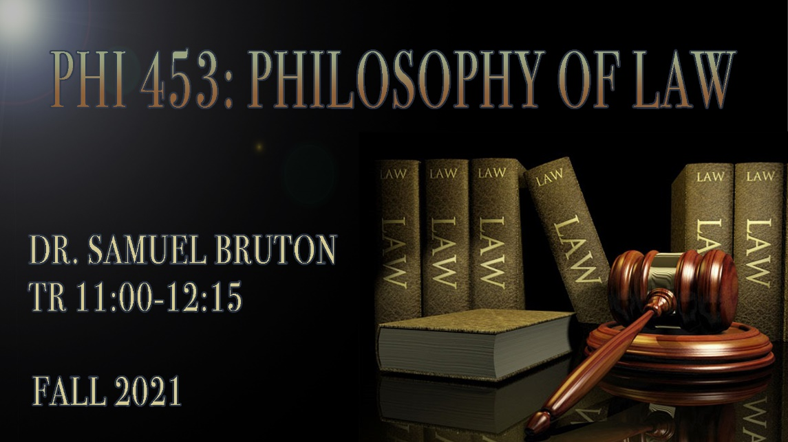

Philosophy of Law

Dr. Samuel Bruton

TR 11:00-12:15
This class introduces students to perennial issues in the philosophy of law: the nature of legal authority, the relationship between law and morality, debates about the appropriate balance between legal regulation and individual liberty, and the justification of punishment. We will study important thinkers such as H. L. A. Hart, Ronald Dworkin, and John Stuart Mill. Also, we will examine contemporary debates about race and the criminal justice system, such as have played a role in recent political activism in America. This course satisfies a required option for Philosophy majors in the Pre-law emphasis track.

PHI 462/562

Evil

Dr. Michael DeArmey

ONLINE
The course is an investigation into the nature of wrong- and evil-doing. What does wrongdoing mean? What kinds of wrongdoing are there? What is evil? What types of evil-doing are there? What motivational factors are involved in people doing evil? Topics include some of the following: Genocide I and II, Torture, Terrorism, Slavery and Child Slavery, Unjust Wars, Earth Destruction, and Totalitarianism. Be prepared for an investigation into the dark side of human experience and behaviors.

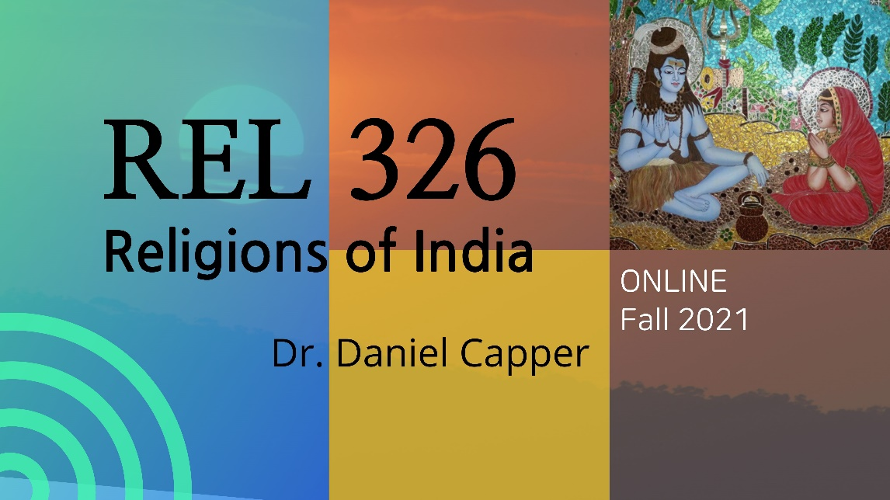REL 326

Religions of India

Dr. Daniel Capper

ONLINE
India, one of the great cradles of religion in the world, offers an unrivaled environment of religious diversity and intensity. This online course studies this environment by examining ancient Indian religion, Zoroastrianism, Hinduism, Buddhism, Jainism, Islam, and Sikhism. Topics include studies in ritual, philosophy, theology, and history from ancient times to the current day. Effort will be made to place the various religions of India in sociohistorical context. Students should finish the class with a much better understanding of the varieties of religious contributions which India has made to world cultures.

