Detailed Instructions for General Education Curriculum (GEC) Assessment Reports
Cycle: 2023-2024
GEC Assessment
The University of Southern Mississippi (USM) conducts annual assessments of the General Education Curriculum (GEC) courses to document support of SACSCOC Principles of Accreditation Section 8: Student Achievement.
Student learning and student success are at the core of the mission of all institutions of higher learning. Effective institutions focus on the design and improvement of educational experiences to enhance student learning and support student learning outcomes for its education programs.
Standard 8.2:
The institution identifies expected outcomes, assesses the extent to which it achieves these outcomes, and provides evidence of seeking improvements based on analysis of the results in the areas below:
Standard 8.2 b:
For collegiate-level general education competencies of its undergraduate degree programs.

Important Updates
- The due date for all 2022-2023 GEC assessment reports is September 1, 2024. All data and supplemental documentation must be entered into Weave by this date. Additionally, you must mark your report as “Complete” in Weave.

GEC Plan and Report Guidelines
Plan Guidelines
- All GEC 01 – GEC 06 courses assess assigned Student Learning Outcomes (SLOs) at the course level.
- Each SLO must have one (1) direct measure
- Measures and targets must apply to all course sections.
- Overall course grades are NOT acceptable measures.

Report Guidelines
All GEC courses must be assessed annually. The following components are required for a complete GEC assessment report:
- Course Description/Summary: GEC courses should include a descriptive summary of the course. The official course description from the bulletin should be included in addition to information that would be helpful for an outside reader to understand the nature of the course. Please include the typical location of delivery (Hattiesburg and/or Gulf Park campus), mode of delivery (face-to-face or online), terms the course is offered (Fall, Spring, Summer, intersession), and an estimate of annual enrollment.
- Outcomes: The appropriate GEC outcomes are used. Outcomes that are specific to the course will be listed first, followed by GEC Outcomes 1 & 2. The type of outcome (“GEC Outcome X”) is listed on the “Outcome Type” title. The name of the GEC Outcome is listed on the “Outcome” title. This way, an overview of the Outcomes and their descriptions are shown on the table of contents when the report is downloaded. Both “Outcome Type” and “Outcome” descriptions are left empty. The assessment coordinator has already set up the Weave projects as such for the 2022-23 cycle.
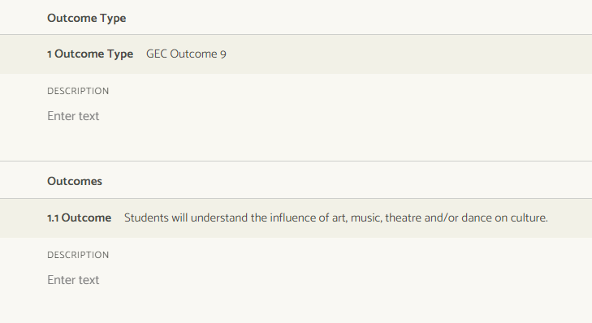
- Measures and Targets: A measure identifies evidence and methods used to determine achievement of outcomes. Measures should be detailed and specific. Measures should be direct (i.e., directly measure/evaluate a student’s work – exams, papers, portfolios, projects, etc.). The Measure title will list the actual measure itself (exam, lab report, final project, etc.). The Measure description will contain the description of how the measure is used to evaluate the outcome: evaluation method, content components, etc. If a rubric is attached as evidence of how a measure is evaluated, the rubric will need to be referenced within the measure. Targets are the quantitative criteria for how success will be measured. The Target description box should be left blank; the target for your measure will be listed in the Target box.
- Findings: Findings are the results of the measures. Courses offered at multiple teaching sites or by multiple delivery modes must report their findings by site/mode and include all sites and/or modes in the findings. Sample size must be included. If sampling is used, a detailed description of the sampling method must be included. All semesters must be included (Fall, Spring, and if applicable, Summer and intersession), and findings should explicitly state what semesters the data is from. After the findings have been entered, change the Target status to “met” OR “not met.”
- Analysis of Findings: The results are analyzed to determine whether or not student learning has been achieved and provide direction for continuous improvement. If a target is “not met,” what can be done to improve student learning? Have actions already been taken to improve student learning? For targets which are “met,” what action plans were implemented that led to this result? What best practices are in place? What challenges remain or have been overcome? Do new targets or measures need to be chosen now that the target has been met? Remember, the goal of assessment is continuous improvement.
  - Stating that the target was “met” and no further action is to be taken is not an acceptable analysis.
- Action Plans: A new action plan is required at least every other year and if a target is not met. Action plans must be entered into Weave for targets that were “not met” or “partially met.” Action plans may be specific to individual student learning outcomes or course-level action plans. An action plan is an organized activity undertaken to help courses more effectively achieve intended outcomes, or an activity developed by faculty to improve the course for the future. The results of action plans should provide evidence of continuous improvement activities and improve student learning. Action plans do not contain vague phrases such as “we will look into this” or “no action required.” If an action plan has been completed and the loop has been closed on a previous report, it no longer needs to be included in the assessment reports.
  - In Weave action plans are tied to measures and/or outcomes. Action plans that are not specific to an outcome should be entered into the Outcome Type “Action Plans.” Please ignore the “budge source” prompt; unfortunately, it cannot be removed from the Weave platform.
  - If an Action Plan was completed in the previous year and discussed in the closing the loop narrative section, it should be deleted from this year’s report. To delete the action plan, select the three dots and delete the section.
- Analysis Document: The Annual Course and Action Plan Analysis document must be completed and included as a project attachment.
- Syllabi and Writing Assignments: A sample syllabus from each type of section offering is required. The writing assignment and its rubric should be included.

Detailed Analysis and Course Impact Reporting
A separate Word document, Annual Course and Action Plan Analysis, will be provided to you. Additional details are included below. This Word document must be completed and attached to your project in WEAVE for your project to be considered complete.
Action Plans and Closing the Loop Narrative
Action Plans found in the Weave report should also be listed in the analysis document. While this may seem repetitive, it is helpful for outside reviewers to view all action plans in one place. Provide any updates to “in-progress” or “ongoing” action plans that are found in Weave. What actions from this plan have already been implemented? Have any changes/improvements been noticed, thus far? What will be done next; what are the next steps in the plan?

Any additional action plans related to GEC outcomes/course curriculum should also be listed. These are action plans that are not listed in the Weave report but are new or ongoing action plans. Provide any updates to “in-progress” or “ongoing” action plans. What actions from this plan have already been implemented? Have any changes/improvements been noticed, thus far? What will be done next; what are the next steps in the plan?
Action plans completed in this cycle (AY 2023-2024) should be briefly mentioned. In the Closing the Loop Narrative, a summary of the results of the completed action plans should be provided. The main goal of this section is to provide evidence of improvement based on the analysis of the results of the action plans. Previously, the course’s findings were analyzed, and that information was used to inform action (action plans) for improvement. Now, it is important to know: was our action plan successful? If not, what new efforts (new action plans) should we implement? To evaluate if an action plan was successful, compare the new assessment report results to the initial results (before action plan).

Sections Offerings and Enrollment Narrative
In previous years, courses have been asked to complete a table with the number of sections offered, number of students enrolled, and the enrollment ratio per semester. This year, the section offerings and enrollment data will be given to you by the Office of Institutional Research. This data originates from HelioCampus; please attach the HelioCampus document as a project attachment in Weave.
A narrative based on the given section offerings and enrollment data is required. Please analyze the enrollment ratio: Are courses at maximum capacity? Is there a need for fewer or more section offerings? Ideally, the enrollment ratio will be between 50-80%. Your school may determine an ideal enrollment ratio.
Course Completion and Persistence
Course completion rates and persistence data along with a narrative related to the topic are required. The narrative should provide context to an outside reviewer. This data is included in the course HelioCampus data provided to you by the Office of Institutional Research.
Please use the data in the Fall 2022-2023 columns to complete the table. The total headcounts, persisted headcounts, and % persistence will need to be calculated using the provided data. A narrative based on course persistence and completion is required. Please include any observations/analysis made about the data.
Course Analysis, GEC Writing Requirement, Sample Syllabi
GEC courses are also required to include an overall course analysis. This analysis should provide additional context to the course as well as provide an overall summary of the strengths and weaknesses observed during the past year.
The GEC Writing Requirement should include an explanation of how this course meets the GEC writing requirement of 2500 words. Include the word or page count of assingments to justify meeting this requirement.
Sample syllabi and writing assignments from each type of section (semester, mode, location) should be included as attachments. List the course sections and types that the syllabi and writing assignments are from.

Resources
If you have any questions regarding the GEC assessment plan and guidelines or Weave, please contact Claire Blackwell (Claire.Blackwell@usm.edu), the Institutional Assessment Coordinator. Additionally, the Office of Institutional Effectiveness website contains resources regarding GEC assessment, navigating weave, and SACSCOC requirements.
Best Practice / Tips
- Enter data into Weave after each semester; do not wait until close to the due date to enter all data.
- Discuss the assessment report with other members of your school. Let faculty know the results of the report and the identified areas for improvement.
Reviewing and Submitting the Report
- Proof-read the report; check for grammatical errors, spelling errors, and typos. Remove any “empty/blank” sections that are not used.
- Use the provided checklist, GEC Complete Report Checklist, to ensure all parts of the report are complete.
- Discuss the assessment report with other members of your school. Let faculty know the results of the report and the identified areas for improvement.
- It is encouraged to compare the report to the Review Committee quality rubric.
- Have the School director and/or dean review the report, if applicable.
- Change the status of the project to “Complete” in Weave.
Thank you for your efforts and commitment to continuous improvement!

