For Faculty: Printing Course Evaluations

Step 1: SOAR 9.2 Navigation

- Click on the compass icon in the upper right corner of the screen.

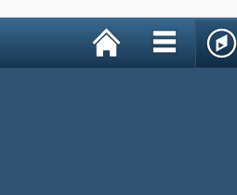

- Select Menu
- Select USM Institutional Research
- Select Process
- Select IR
- Select Print Course Evaluations

Menu -> USM Institutional Research -> Process -> IR -> Print Course Evaluations.

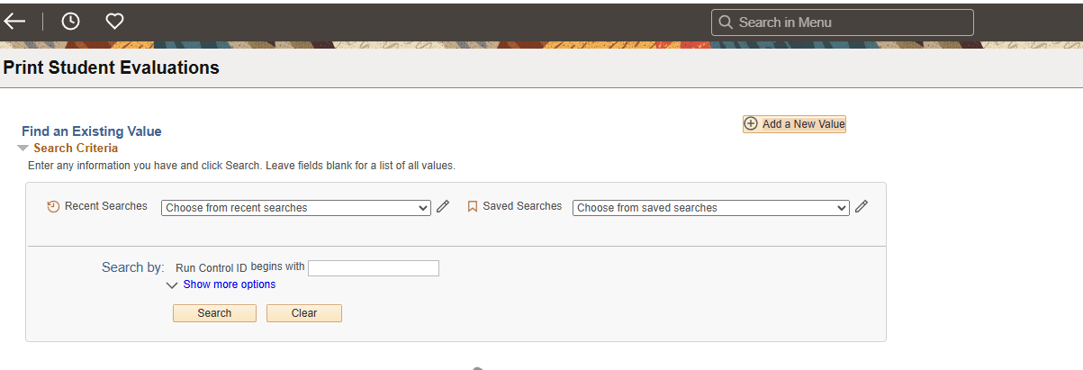

Enter a Run Control ID for any existing ones or click ‘Add a New Value’ to create one.

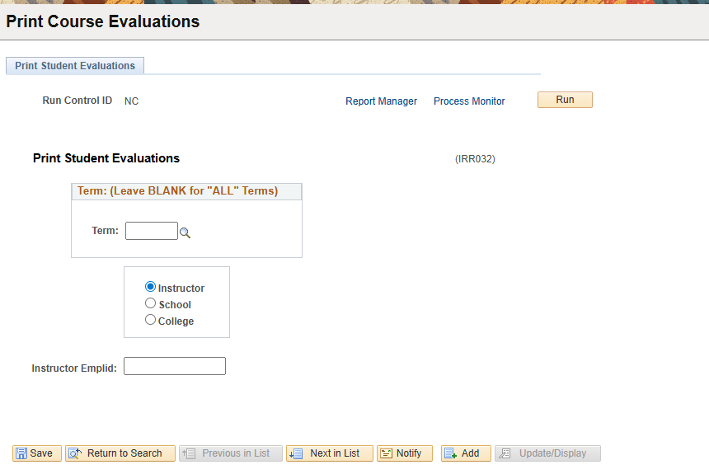

Step 2:

* Leaving the term field blank will give the results for all terms.

Enter a term code. If you do not know the term code, click on the magnifying glass beside the box and a list of term codes will appear. For example, the term code for Spring 2007 is 4075, Summer 2007 is 4078, and Fall 2007 is 4081.

If you do not see the term listed or get a message that the term is not available, then the window for instructors to print their evaluations for that term is not open yet.

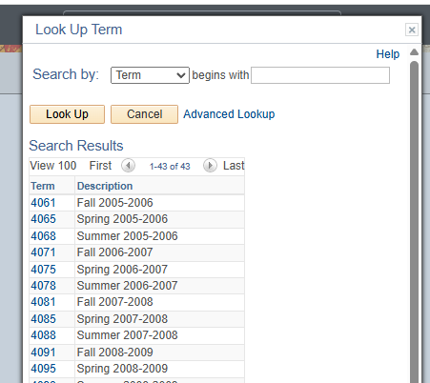

Step 3:
After you enter a term into the box, click the button.

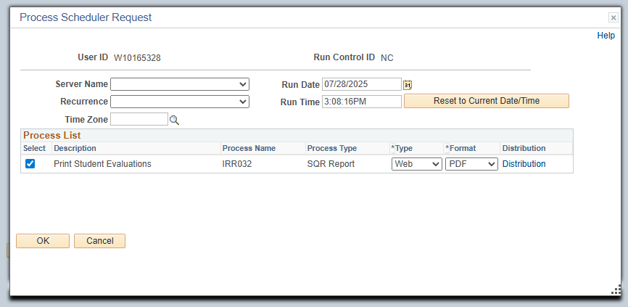

After you click OK, the process is set to run. To check the progress, you can click on “Process Monitor” and below screen will appear.

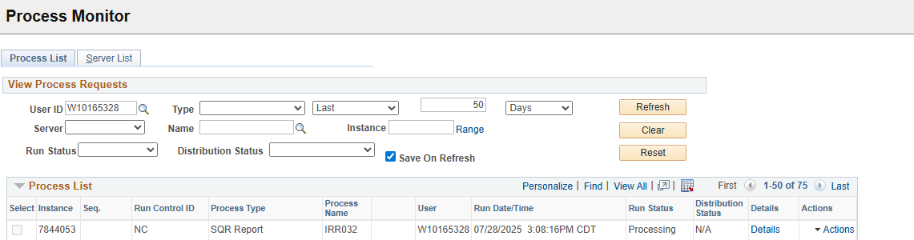

Step 4:
If the Status says Processing just as the screen above indicates, click the button about every 60 seconds until the Status changes to Posted.

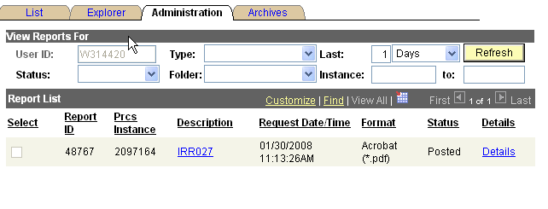

Step 5:
Click on the link. A Process Details panel will appear. The results will be under ‘View Log/ Trace’ panel. Your report is the .pdf link located in the File List. Open the pdf document and print. You will need the acrobat reader software to open the document. Download the acrobat reader from the links below if you need it.

Acrobat Reader Software

For windows

http://www.adobe.com/products/acrobat/readstep2.html

For Apple/Mac computers

http://www.adobe.com/support/downloads/product.jsp?platform=macintosh&product=10

Institutional Research
601-266-6115

