For Faculty: Printing Course Evaluations

Step 1: SOAR Navigation

- Click on the compass icon in the upper right corner of the screen.

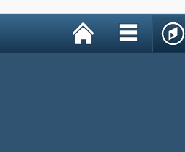

- Select USM Institutional Research
- Select Report
- Select Print Course Evaluations

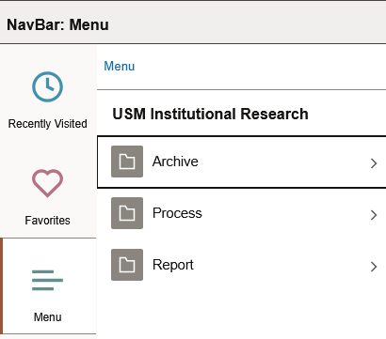

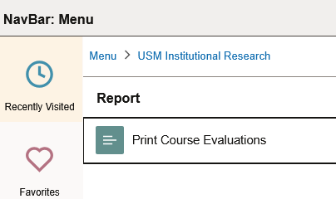
Step 2: Create a run control
- Select Add a New Value
- Enter initials in text box
- Select Add

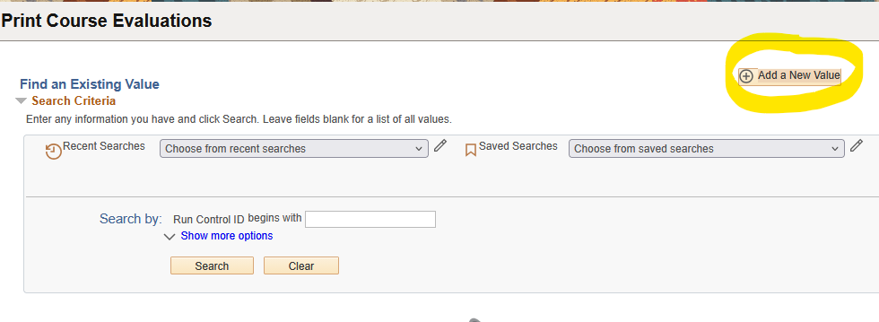
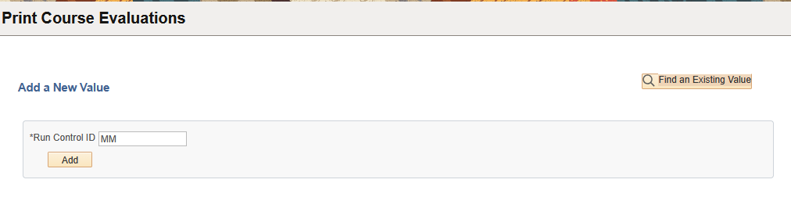

Step 3: Enter in emplid

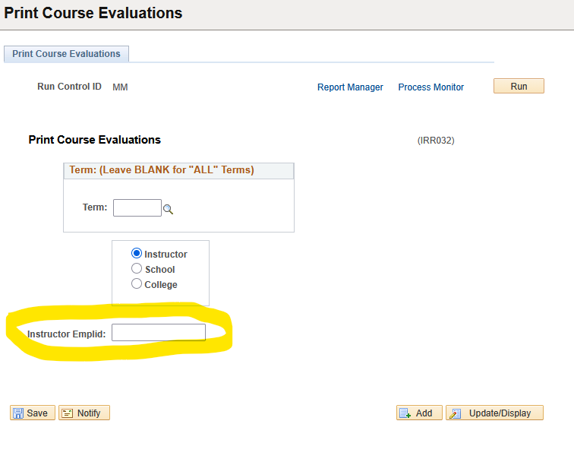

Step 4: Select Run

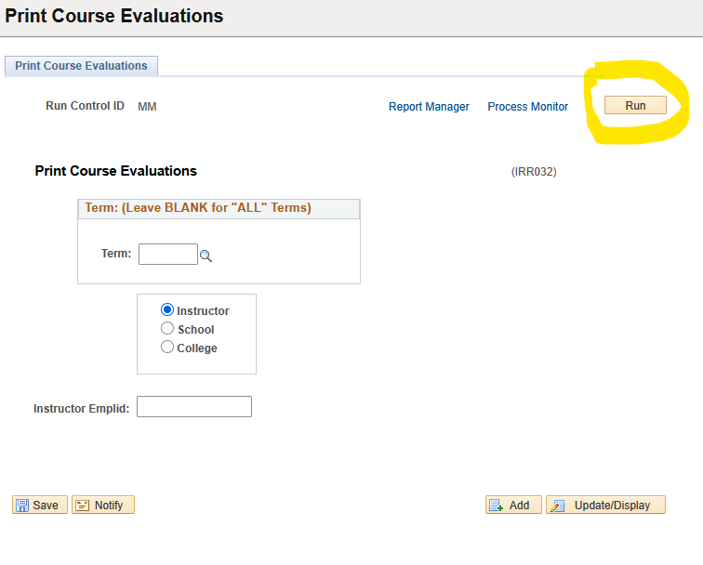

Step 5: Process Monitor

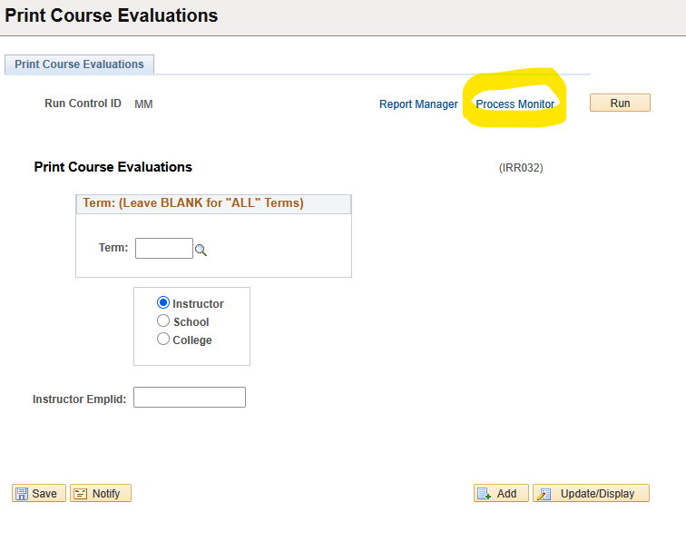

Step 6: Select PDF as format and “OK”

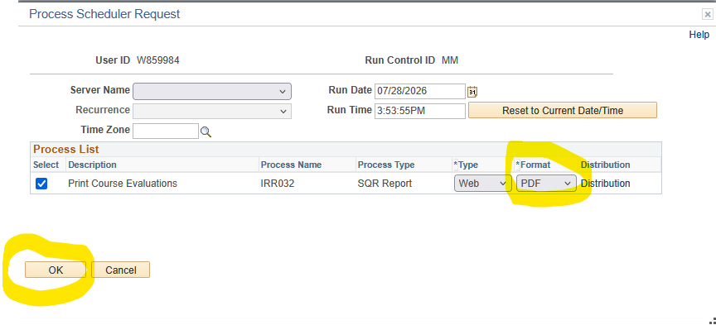

Step 7: Process Monitor (again)

Step 8: Download file (once Run Status = Success and Distribution Status = Posted). If it shows pending, please wait a minute and select refresh until you have success/posted.

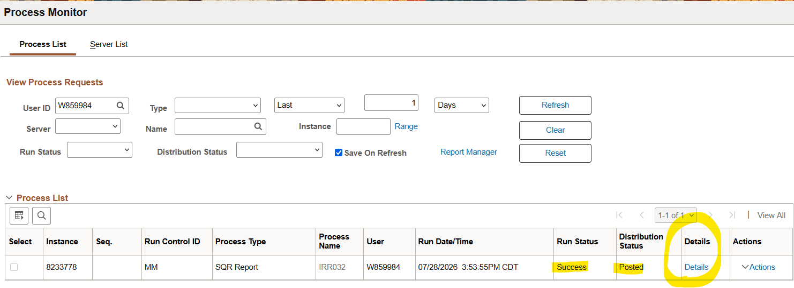
To download the file, you will select the “details” hyperlink.

Step 9: Select View Log/Trace

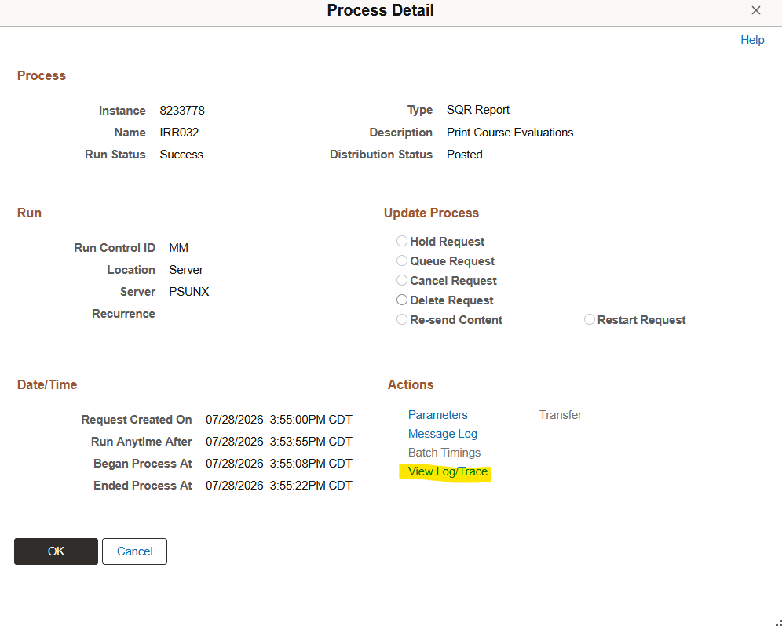

Step 10: Select PDF file

