Student Course Evaluations

Log into SOAR, follow the path shown below, and click on Evaluate My Courses.

Home > Self Service > USM Self Service > Student Course Evaluations > Evaluate My Courses
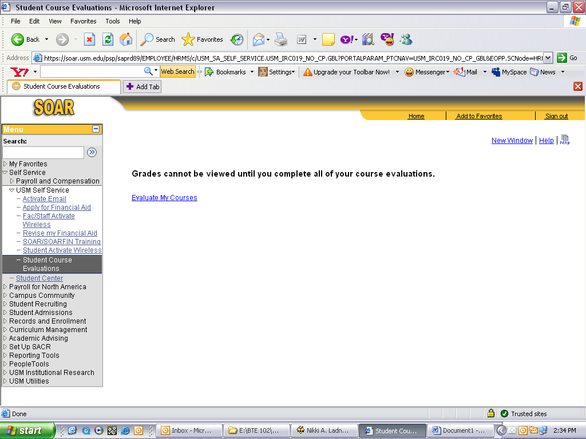

Choose the course that you want to evaluate by clicking on the blue hyperlink. You will then be directed to the online evaluation for that course.

Use the drop down buttons to choose your selections for evaluating the course that is listed on the page. The example indicates that this student is evaluating CSC 511 section H001 and it is the Fall 2007 – 2008 semester
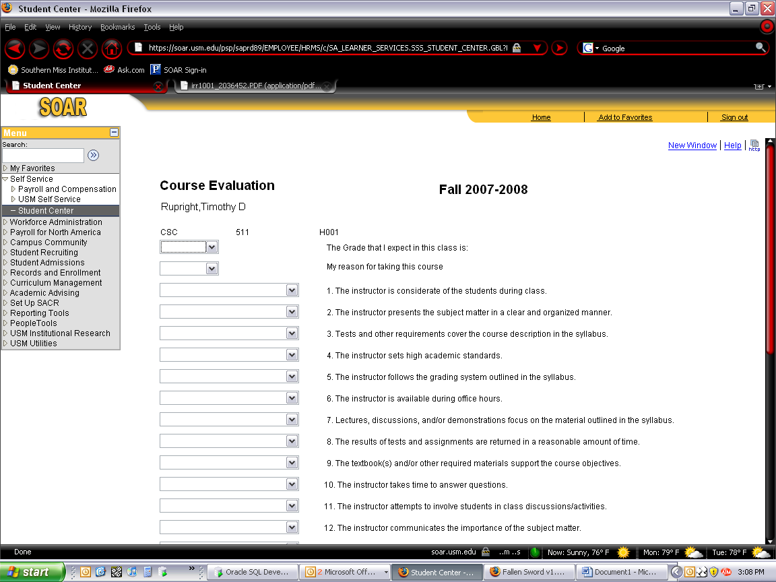

Once you’ve completed all 18 questions and entered any comments you would like to include in the course evaluation, click on the submit button.
