How to Log in and Use Remote Access
- Navigate to vdi.usm.edu |  | 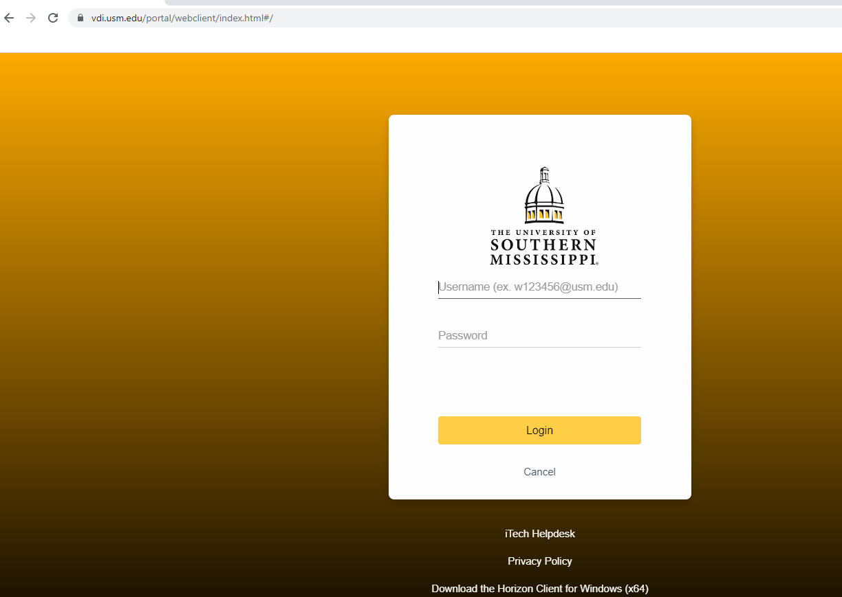
- Enter your credentials  W+ID#@usm.edu and CampusID Password, Then select Login. |  | 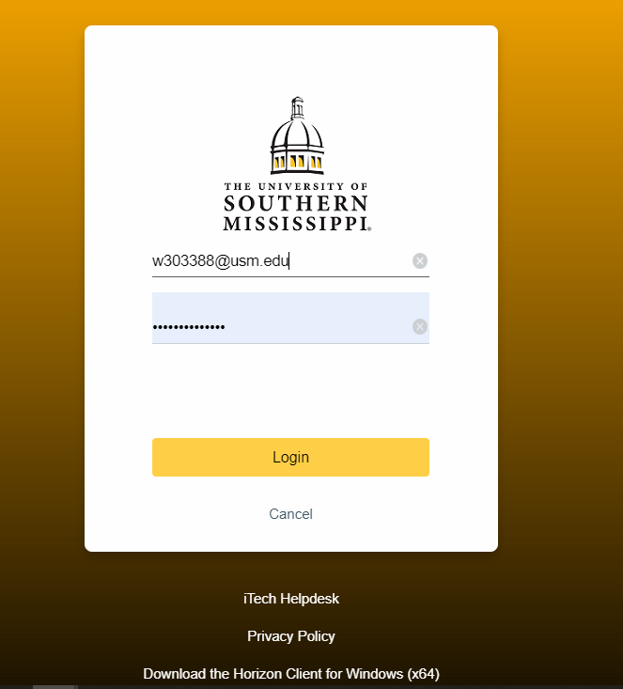
- Select Remote Access |  | 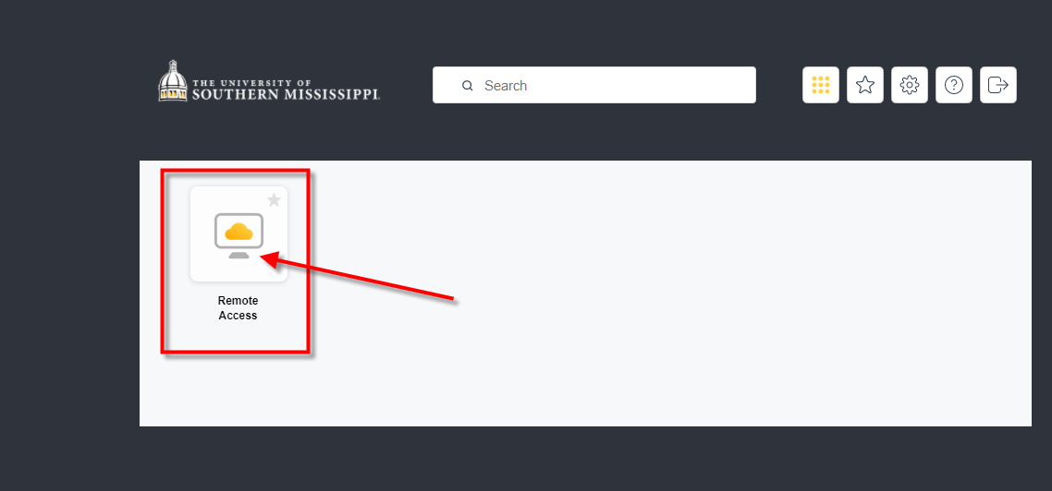
- Once Windows finishes, it will open an available computer for you to use. |  | 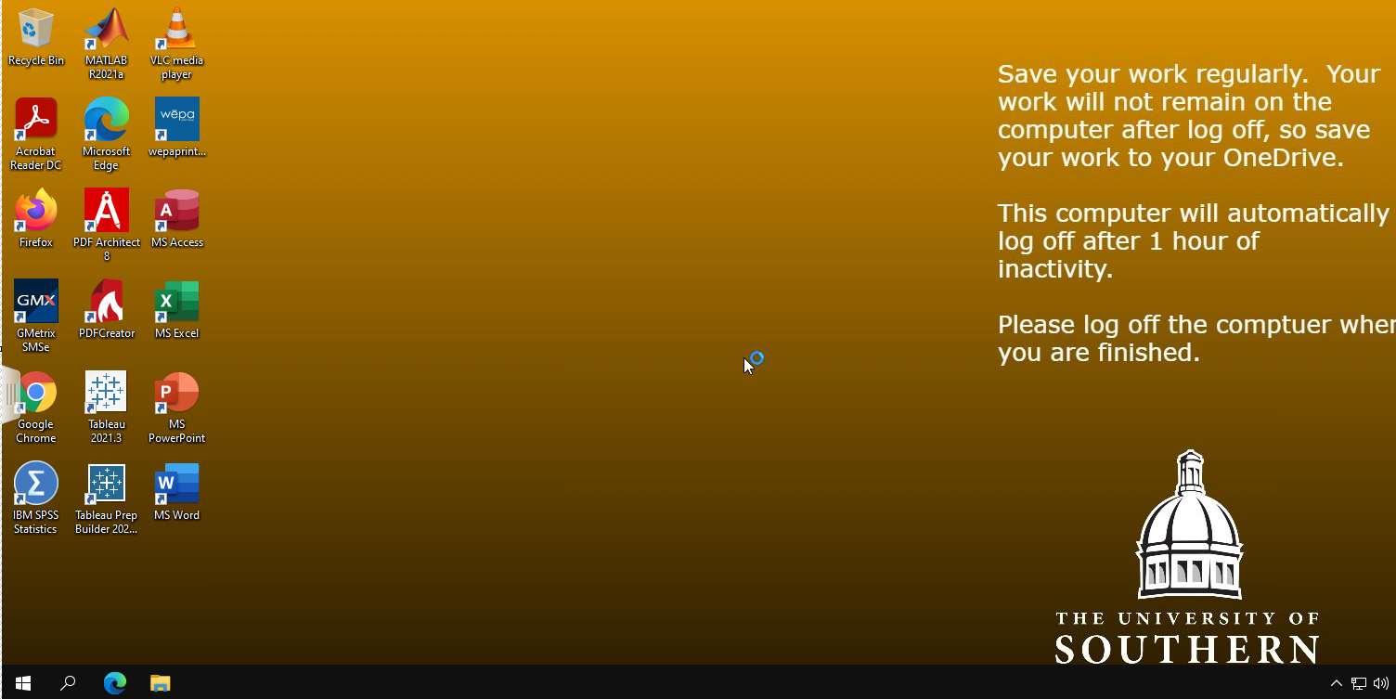
- Once you are done with the computer, make sure to sign out. To do so, select the Windows button, then the person, and then Sign Out. |  | 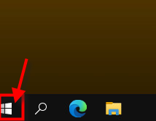  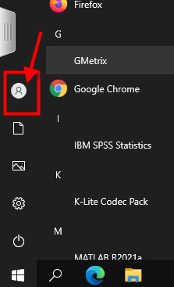  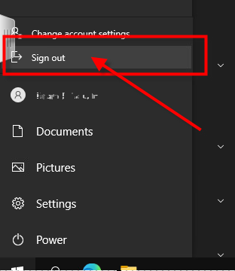
- Select Close |  | 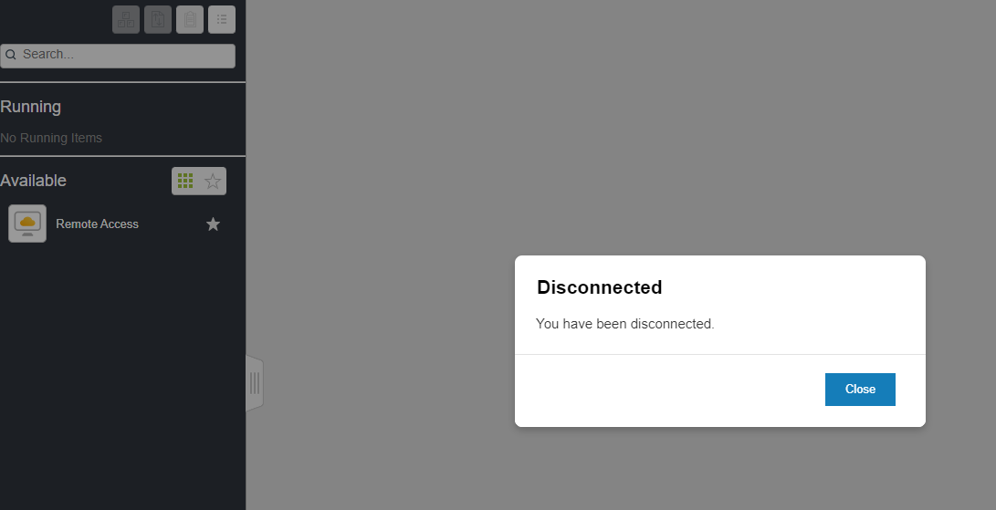
- Additional Assistance | Contact the iTech Help Desk at 601.266.4357 (press 5 for a technician)

