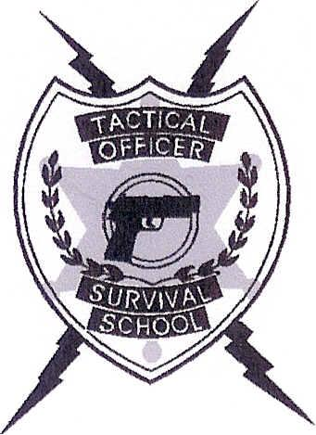
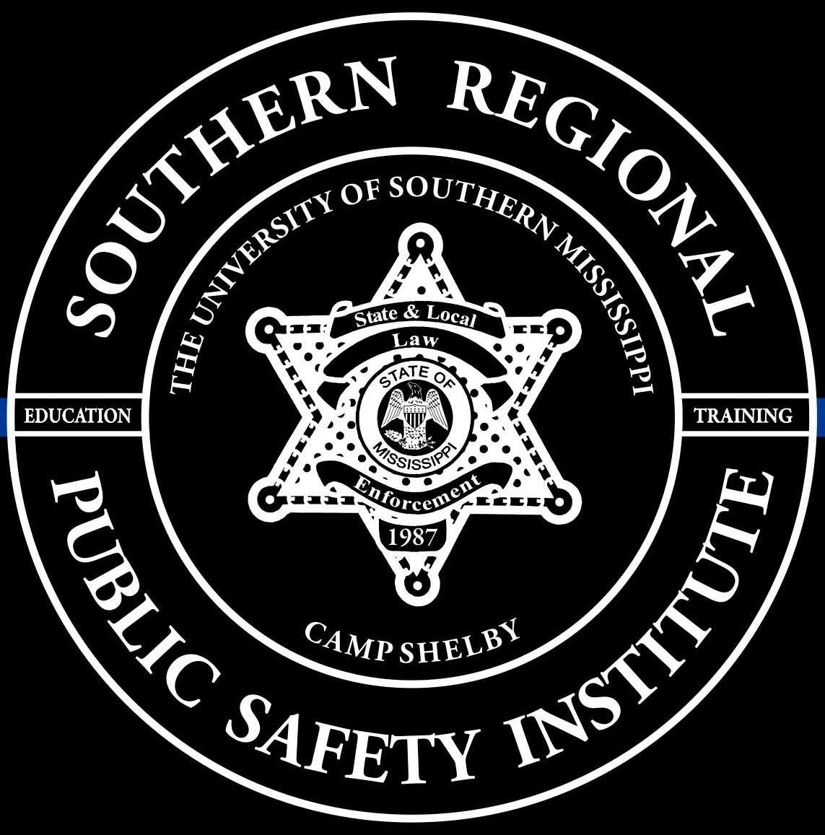
SOUTHERN REGIONAL PUBLIC SAFETY INSTITUTE

AND

TACTICAL OFFICER SURVIVAL SCHOOL

PRESENTS

Firearms Instructor/Combat Handgun
Instructor: Jason “Jabo” Long

STUDENT REGISTRATION FORM

Name ___________________________________ Rank _______________________

Agency ______________________________ Email _________________________________

Address ______________________________________________________________________

Telephone # _______________________________ Fax # __________________________

Circle which class you will be attending:

March 25-26-27-28-29, 2024 or September 23-24-25-26-27, 2024

Commuter Rate: $875 Tuition & Range Fee Included
Non-Commuter Rate: $1250 per officer – Tuition, Range Fee, Lodging, & Meals Included

Check or PO enclosed __________

Make Checks or PO to: Southern Regional Public Safety Institute
118 College Drive, Box 5107
Hattiesburg, MS 39406

Please email registration form to police.academy@usm.edu.
Registration form AND payment/PO must be received before start date of the class.

This class is designed for the officer who wishes to learn how to teach his or her officers to WIN combat confrontations and not just instruct them how to qualify on the firing range.

This instructor certification is recognized by MS BLEOST.

Equipment needed Information requests
Handgun with 1000 rounds ammunition Police.academy@usm.edu Range gear: Eye Protection and Ear Protection Phone: 601-266-6680
Handgun/holster & magazine pouch w/ extra magazines
Rain Gear Lodging Information
Body armor Bed Linens provided
Flashlight (not just weapons mounted light) Towels/wash cloths NOT provided

