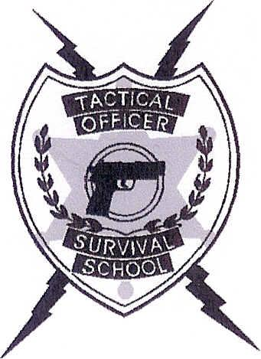
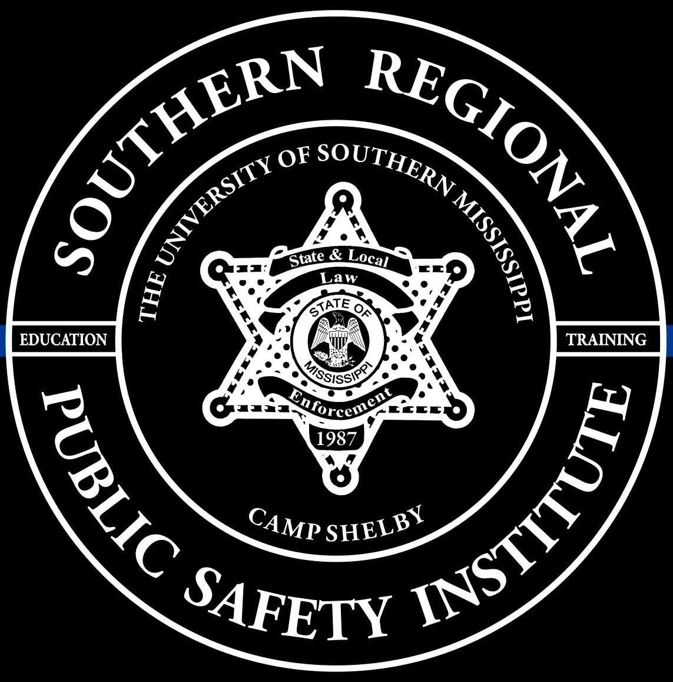
SOUTHERN REGIONAL PUBLIC SAFETY INSTITUTE

AND

TACTICAL OFFICER SURVIVAL SCHOOL

PRESENTS

Firearms Instructor/Shoulder Weapons (Shotgun & Patrol Rifle)
Instructor: Jason Long

STUDENT REGISTRATION FORM

Name ___________________________________ Rank _______________________

Agency ______________________________ Email _________________________________

Address _____________________________________________________________________________

Telephone # _______________________________ Fax # __________________________

Circle which class you will be attending:

April 22-23-24-25-26, 2024 or October 21-22-23-24-25, 2024

Commuter Rate: $875 Tuition & Range Fee Included
Non-Commuter Rate: $1250 per officer – Tuition, Range Fee, Lodging, & Meals Included

Check or PO enclosed __________

Make Checks or PO to: Southern Regional Public Safety Institute
118 College Drive, Box 5107
Hattiesburg, MS 39406

Please email registration form to police.academy@usm.edu.
Registration form AND payment/PO must be received before start date of the class.

This class is designed for the officer who wishes to learn how to teach his or her officers to WIN combat confrontations and not just instruct them how to qualify on the firing range. The class is for shotgun and patrol rifle (can bring sub gun if issued).

This instructor certification is recognized by MS BLEOST.

Equipment needed Information requests
Shotgun: 100 rounds of birdshot – 10 slugs – 10 buckshot Police.academy@usm.edu
Patrol Rifle w/ sling: 500 rounds Phone: 601-266-6680
Handgun with 150 rounds ammunition
Range gear: Eye Protection and Ear Protection
Handgun/holster & magazine pouch with extra magazines Lodging Information
Rain Gear Bed Linens provided
Body armor Towels/wash cloths NOT provided

