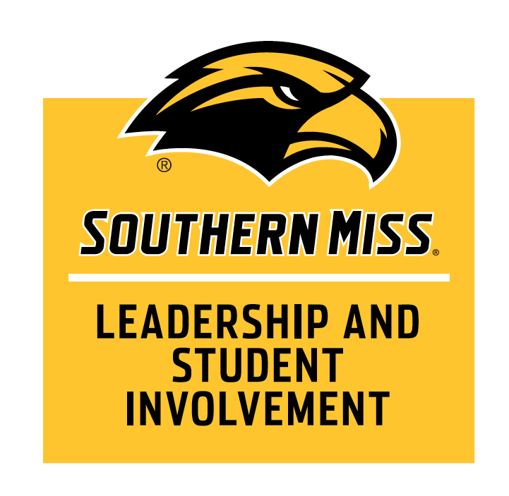

**Helpful Hints**

Register your organization each year by completing the Student Organization Registration Form through Eagle Hub. The registration window will be the second half of each spring semester (typically mid-March through mid-May) to register for the following academic year. If there are any changes to leadership within your organization, those changes need to be completed by the outgoing officer(s) in your organization’s Eagle Hub group. For questions about this process, please email [lsi@usm.edu](mailto:lsi@usm.edu).

The process to request a space for an event, tabling, meeting, etc. for your organization should begin in your student organization group in [Eagle Hub](https://usm.campusgroups.com/web_app?id=25024&menu_id=56133&if=0&). Click on the “Events” tab from your group’s dashboard and follow the prompts to fill out the request. The workflow in the Eagle Hub system will guide you to all necessary campus partners as the request moves through the system. It is imperative that you fill out the form as completely and as detailed as possible so all of the correct partners can be a part of your registration. For questions about this process, please email [lsi@usm.edu](mailto:lsi@usm.edu).

Requests for space on campus should be completed at least two (2) weeks before the requested date for smaller events, tablings, and meetings. Requests for larger scale events (i.e. more than 100 people in attendance, people from outside the university in attendance, events where money is collected, or events where alcohol is served, etc.) should be at least four (4) weeks in advance. Events, tablings, meetings, etc. should not be advertised until you have a confirmation from the Eagle Hub system on your request. It will say “Approved” next to your event once this is complete.

**All on-campus events are required to use Eagle Dining for catering services** and to adhere to the University [snack policy](https://usm.policystat.com/policy/12282841/latest/). For more information, email [LSI@usm.edu](mailto:LSI@usm.edu) or visit our website for specific policies.

The [sign policy](https://usm.policystat.com/policy/8175728/latest/) is strictly enforced throughout campus – **read the policy before making and/or copying any signs**. All events should be confirmed before any campus advertising can begin.

Fundraising on campus **must have an educational or philanthropic benefit** and cannot compete with any existing campus vendors (Eagle Dining or Barnes and Noble). Absolutely no gambling or gambling terminology (i.e. raffles) are permitted to occur on campus.

**The Office of Leadership and Student Involvement**

Student Activities Hub, Union 110

Box #5048, Phone: 601.266.4403, Website, [www.usm.edu/lsi](http://www.usm.edu/student-activities)

*Throughout the year, policies and procedures may change. Please visit [www.usm.edu/lsi](http://www.usm.edu/student-activities) for the most current policies.