The information in this brochure is specific to The
University of Southern Mississippi and is slightly different
from a local municipality/city, but this can be helpful if
taken as guiding behaviors for police officers, as well as
If you have questions,
CALL, EMAIL OR REQUEST A VISIT WITH THE
UNIVERSITY POLICE OR DEAN OF STUDENTS.
Rusty Keyes,
Chief of University Police
Bond Hall
118
College Drive #
5061
Hattiesburg, MS 39406
rusty.keyes@usm.edu
Office: 601.266.4946
Dispatch: 601.266.4986
Sirena Cantrell,
Associate Vice President
for Student Affairs/Dean of Students
R.C. Student Union 220
118
College Drive #
5204
Hattiesburg, MS 39406
Office: 601.266.6028
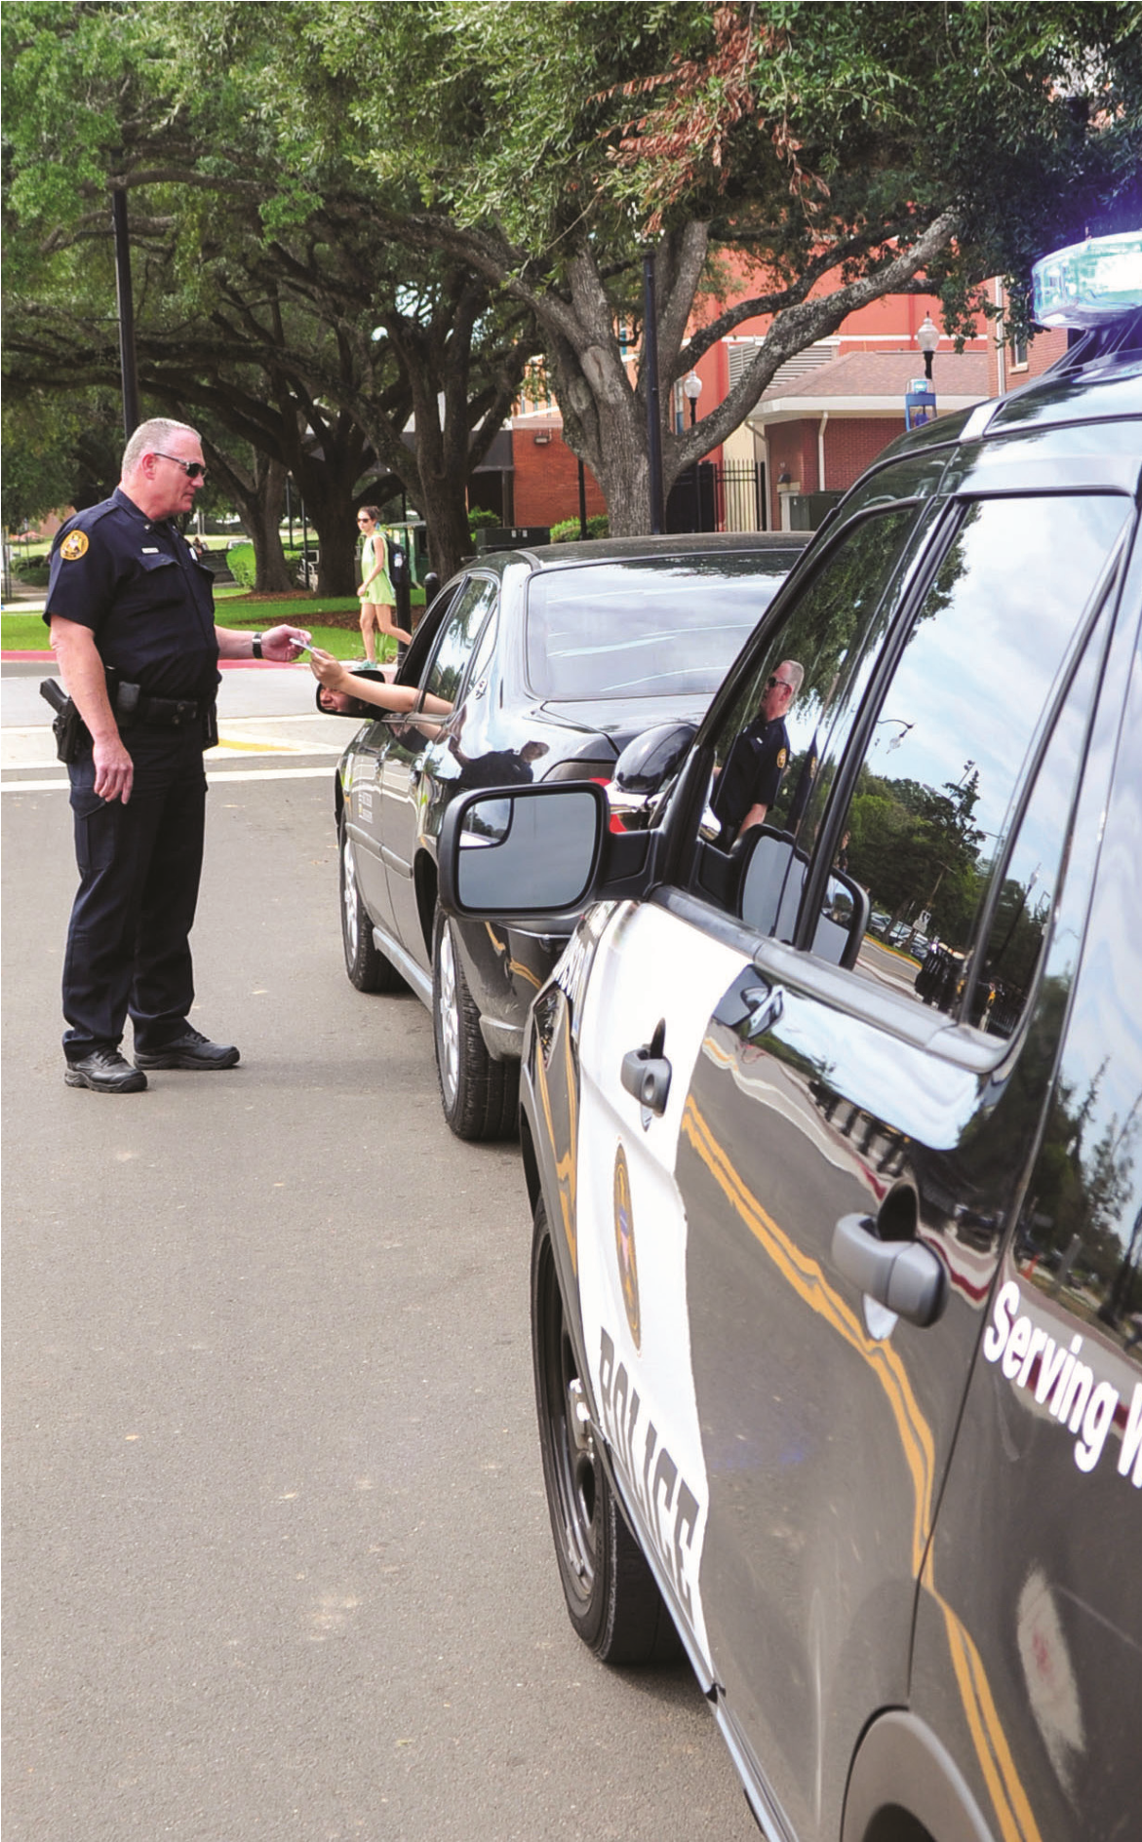

citizens, when they come in contact with each other. The set of presenting circumstances will impact situations and scenarios in different ways. Various situations will impact how the police will act, as well as what tactics they will use. The important thing for consideration for police officers and the general public is to present a workable attitude and tolerance for each other. At all times, remember that the police officers are sworn to uphold the law and serve the public. Remember, ATTITUDE, TOLERANCE and RESPECT are the essentials for best outcomes.
Helpful Hints
REGARDING
POLICE PROCEDURES
UNIVERSITY POLICE DEPARTMENT
UNIVERSITY POLICE DEPARTMENT
118
5061
College Drive #
Hattiesburg, MS 39406
OFFICE OF THE DEAN OF STUDENTS
R.C. Cook Union 220
118 College Drive #5204
Hattiesburg, MS 39406
Phone: 601.266.6028
Fax: 601.266.6401

E OE / F/ M / V E T S / DIS A BILI T Y U C 8 2 19 0

The mission of The University Police Department is to enhance the quality of life on campus by working cooperatively within the framework of the United States Constitution to enforce the laws, preserve the peace, reduce fear, and provide for a safe environment for students, faculty, staff, visitors and all other stakeholders that visit our University.
The purpose of this brochure is to inform all persons of expectations regarding traffic stops and filing of reports of complaints. Our police department is accredited by the Commission on Accreditation for Law Enforcement Agencies and functions to serve all people within the jurisdiction of the University with respect, fairness and compassion.
If you are pulled over, the police will do the following:
ASK for your identification. You know who you are, but the police officer may not.
USE a flashlight to illuminate the interior of the vehicle as a safety precaution. As the officer approaches your car, he or she is not sneaking up on you. The officer is following his or her police training to minimize his or her exposure to traffic and to unknown danger from inside the vehicle.
BACK UP each other or support another officer’s calls; therefore, several officers may appear on the scene. Do not feel threatened or intimated by this police operation. Service and protection are our primary goals. The officer’s supervisor may arrive on the scene to observe his or her actions.
REMAIN in the car for a period of time while checking your automobile registration and driving status. This may take a while to complete the procedure of the department.
MAINTAIN a professional demeanor and may not be as talkative or friendly as you expect. The officer is not being mean or disrespectful to you. Know that the officer may be dealing with other pressing matters or assignments and that you are not being mistreated.
ASK observers who gather around to move back or disperse. These are tactics and strategies to ensure safety and are precautionary measures; the officer is following standard procedures. The officer is not attempting to hide, cover up or violate citizens’ and students’ rights. He or she is simply trying to maintain control and prevent further problems. Remember that interfering with the police in this situation is a crime. Observers should be a part of the solution and not the problem.
The officer has a reason for stopping you. He or she may have reason to suspect that you are in violation of the law, a Student Code of Conduct violation, the Creed at Southern Miss, or may be aware of a crime or an emergency in a nearby area. Traffic and equipment violations are the most frequent reasons for stopping vehicles, as well as vehicle matches in crime investigations.
The officer is required to follow police and safety procedures during vehicle stops. The officer’s focus is on the protection of the motorist and his or her safety since officers are sometimes injured or killed in the line of duty.
If you are issued a ticket, are detained or arrested, and you disagree or have objections, questions or protests, DON’T ARGUE AT THE SCENE. You will have the right to state your objections in court, through the campus appeal process or the UPD complaint process.
University Police Expectations
IF AN OFFICER APPROACHES YOU WHILE YOU ARE ON FOOT, YOU SHOULD DO THE FOLLOWING:
- Don’t run.
- Be calm.
- Present a good attitude.
- E stablish eye contact with the officer to better communicate.
- Listen.
- Give identification, if asked.
- Be cooperative.
- Follow directions. • Answer truthfully.
- Ask questions, if desired.
- Don’t yell, curse or threaten the officer.
If an officer stops you in your vehicle, you should do the following:
- Stay in the car unless instructed otherwise.
- E stablish eye contact with the officer to better communicate.
- If dark, turn on the interior lights of the automobile.
- Listen and remain calm.
- Be cooperative.
- Keep hands on the steering wheel.
- P rovide license, proof of insurance and vehicle registration, if asked.
- Answer truthfully.
- Don’t resist.
- Don’t yell, curse or threaten the officer.
- Ask questions, if desired.
- Y ou have the right to contest state citations before the judge and campus citations before the dean of students.
To file a complaint,
CALL THE UNIVERSITY POLICE DEPARTMENT AT
601.266.4986. ASK TO SPEAK WITH THE CHIEF OF POLICE OR THE SUPERVISOR ON DUTY, IF YOU
OBSERVE or witness questionable police action;
WISH to speak with a supervisor or Chief of Police
Rusty Keyes;
WANT to know police procedures; or
DESIRE an explanation of University Police procedures and policies.

