Online Permission to Add (or Drop) After the Deadline

Instructions for Students Using the Special Permission for adding or dropping a course after the deadline

Log into your SOAR account
Self Service > Student Center > My Classes > Add/Drop (Select the appropriate action)
Select the term of the class you want to add or drop (should be the current term).

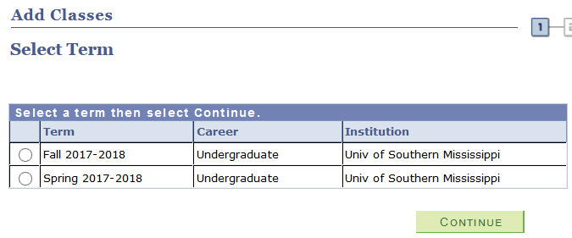
If you know the Class #, then you can type it in the box. If not, please use the Class Search feature to find the course you wish to add.
If you are dropping, you can select the course you wish to drop from your schedule.

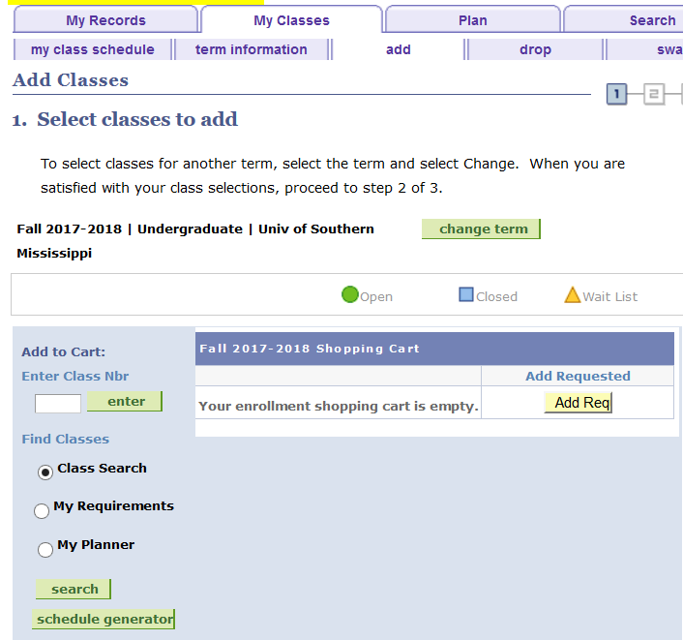

Once you have clicked “Finish Enrolling”, you will receive an error. If a special permission is allowed according to the published deadlines, the Special Permission button will appear as shown below.
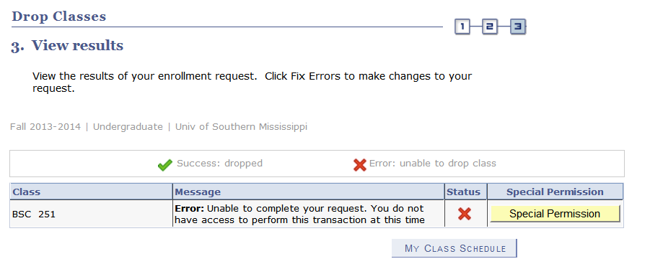

To make a special request to add after the deadline, click the special permission button. BEWARE: Turn off your Pop-Up Blockers.

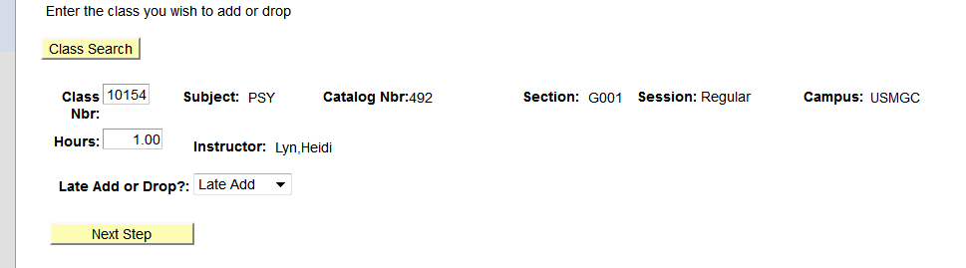

If the class is a variable hour course, you must indicate the appropriate hours.
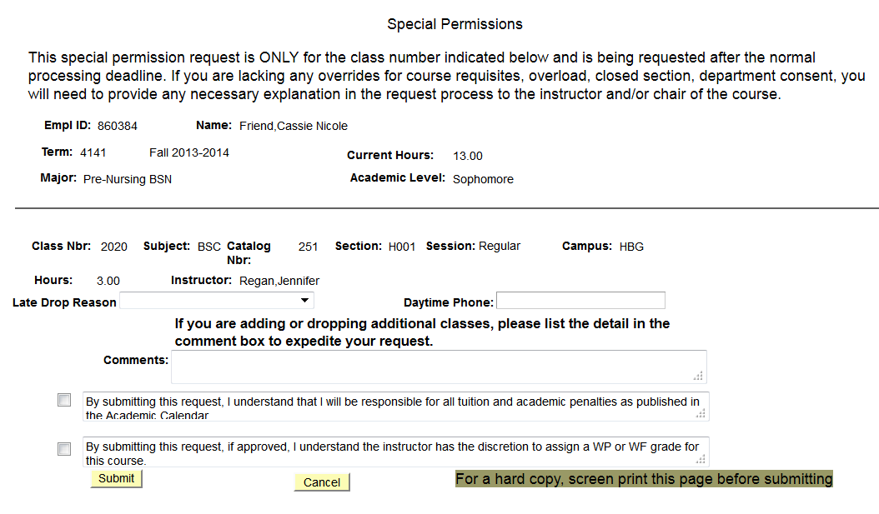
Students enter the appropriate reason for the late change in schedule, as well as providing a daytime phone in case further discussion is needed, and comments to provide additional reasoning.

All blanks MUST be filled in and the ‘understanding statements’ checked, in order for the request to be submitted. The request is NOT official until the student has clicked SUBMIT.

Students receive the following panel next for further instructions. An email is sent immediately ONLY to the instructor (and Teacher Assistants/Proxy if applicable).
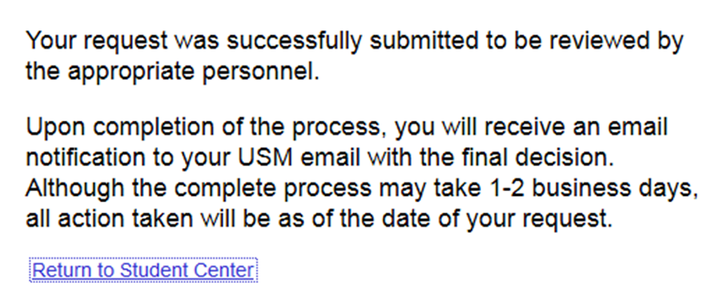

No further action is needed by the student. Students should not assume that making a ‘Special Request’ is automatically granted. Any questions regarding the request should be directed to the instructor of the course.

