Director: Degree Application
Step | Action
In SOAR, navigate to Compass > Menu > Worklist > My Worklist – Detail View
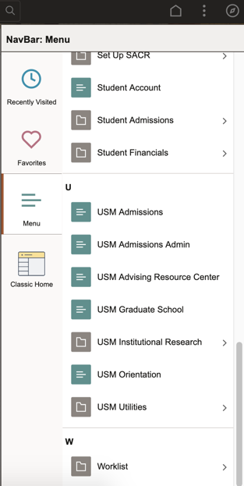

Your Worklist will display important details:
- The student who submitted the item.
- The date the item was submitted.
- The item that was submitted.
Click the USM_APP_DEG link.
b.
a.
c.
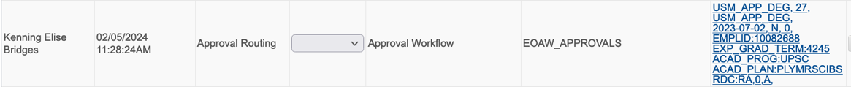
Student Name
- Comments: optional…unless you are denying.
- Select Approve.
*TIP: Use the “Generate DPR” button to easily access the student DPR.
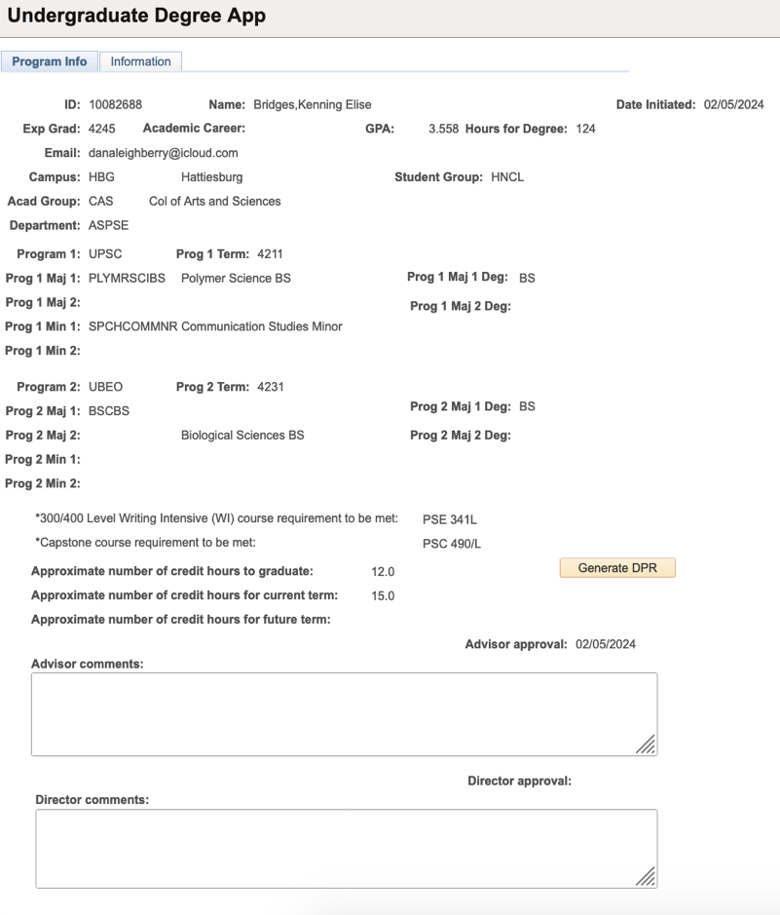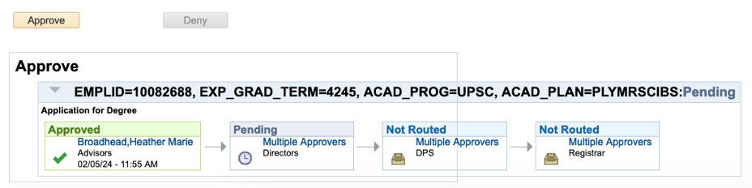

a.

You will see the Pending box change to Approved with green highlights and a check mark to confirm your processing.
