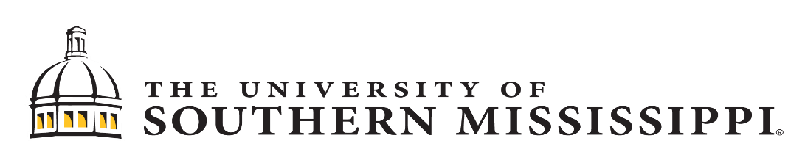

Disclosure Requirements

Financial Conflict of Interest (FCOI)
Purpose: As described in USM policy and Faculty Handbook, all faculty are required to complete an annual Financial Conflict of Interest Disclosure Form. To read more about FCOI, please click here.
FCOI Disclosure/Addendum Form
Due Date: September

Export/Import Controls
Purpose: All University personnel are required to comply with U.S. laws and regulations that regulate the transfer of items, information, technology, software, and funds to destinations and persons outside of the U.S., as well as to non-U.S. citizens in the United States. These laws and regulations are collectively referred to as “Export Controls.” To read more about Export/Import controls, please click here.

Permission to Engage in Outside Employment
Purpose: As described in USM policy, IHL and Faculty Handbook, all faculty engaged in outside employment are required to complete an annual permission form. To read more about permission to engage in outside employment, please click here.
Outside Employment Application

ORA Other Support/Improper Influence

Purpose: Grants and contracts require disclosure of collaborations, external appointments, or other relationships to ensure there is no scientific, budgetary, or commitment overlap. Check guidelines for these and other sponsors when preparing proposals.

Links: National Institutes of Health and related FAQs
National Science Foundation and related FAQs
Department of Energy contracts and grants (page 91)
Department of Defense
NASA (sections 2.15 and 2.16)

Due Date: Generally with each grant proposal and progress report.

