Document filename | FY18 Pcard_Manual.docx
Document Version | 2.01
Last Modified | 05-04-2018
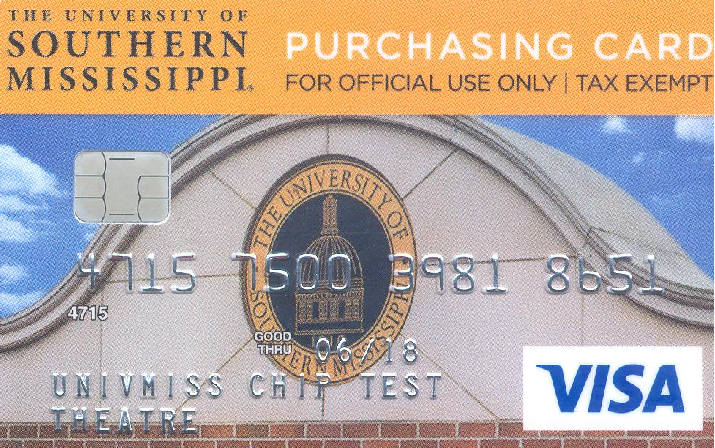
PROCUREMENT CARD

Procurement Card Program
Policies and Procedures Manual

Table of Contents

Contents
1. Introduction 4
1.1 Purpose 4
1.2 Benefits 5
2. How to Become a PARTICIPATING DEPARTMENT 5
3. How to Become a Cardholder 6
4. how to become a Cardholder’s Reconciler (Proxy) 7
5. PARTIES INVOLVED 7
6. RESPONSIBILITIES 8
6.1 Cardholder 8
6.2 Reconciler (Proxy) 9
6.3 Approver 11
7. CHANGE IN Reconciler (Proxy) 11
8. CHANGE IN APPROVER 11
9. OVERSIGHT FOR THE PROCUREMENT CARD PROGRAM 12
9.1 Department of Procurement and Contracts SERVICES 12
10. OBTAINING A PROCUREMENT CARD 12
10.1 General 12
10.2 Setting Up Your Department 13
10.3 Budget Limitations 13
10.4 Separation of Duties 13
10.5 Cardholder Eligibility 13
10.6 Cardholder Liability 14
11. APPLYING FOR A PROCUREMENT CARD 14
11.1 Cardholder Purchase Limits 15
11.2 Cardholder Travel 15
11.3 Card Security 15
11.4 Secondary Usage of the P-Card 16
11.5 Lost, Misplaced, or Stolen Procurement Cards 16
11.6 Cardholder Termination 16
12. Items that require Prior approval before purchase 17
12.1 Food and Drink purchases 17
12.2 Printing, Special Printed Items & social media Ads 18
12.3 Apparel Purchases 18
12.4 Gift Cards 19
12.5 Signing of Contracts, Maintenance Agreements, Terms & Conditions 19
12.6 Non-Monetary Awards 20
12.7 Conferernce Registration fees 21
13. PROCUREMENT CARD VIOLATION POLICY 21
Procedure for Policy Violations 21
Sample Cardholder Violations (include, but are not limited to): 22
14. COMPLETING A PROCUREMENT CARD TRANSACTION 23
14.1 General 23
14.2 Business Account Set-up 23
14.3 Taxes 24
14.4 Contractual Services 25
14.5 Approved P-Card Expenses for Travel 25
14.6 Placing Your Order 26
14.7 Billing Instructions 26
14.8 Shipping Instructions 26
14.9 Acceptable Documentation 27
14.10 Receiving Your Shipment 28
14.11 Returns, Damaged Goods, Credits 28
14.12 Order Entry, Reconciliation and Approval within P-Card Solutions Management Software 29
14.13 RecordS Retention 30
14.14 Disputed/Fraudulent Transactions 31
14.15 Erroneous Declines 32
14.16 Controls 32
14.17 Department Control Environment 32
14.18 Canceling an Account 32
14.19 Changes to an Account 33
14.20 Renewal of Existing Procurement Cards 33
14.21 Regions Bank Customer Service 33
15. WHO TO CALL? 34
16. GUIDANCE IN THE PROCUREMENT FUNCTION 36
17. Frequently Asked Questions (FAQ’s) 37
17.1 What types of items are considered equipment? 37
17.2 What items are available on the state contract? 37
17.3 Can I buy food or drink on the procurement card? 37
17.4 Can I use my procurement card to buy stamps or to mail a letter from the United States Post Office? 37
17.5 Can I use the procurement card to purchase software? 37
17.6 Can I pay for film processing with my procurement card? 37
17.7 Can I purchase jump drives or key drives? 37
17.8 Can I buy subscriptions to scholarly journals? How about single, back issues? 37
17.9 Can I use the card to make copies and obtain binding services? 38
17.10 May I reorder using the original UC approval? 38
17.11 Can I use the card to buy t-shirts for my department? 38
17.12 Can I use the card to buy trophies, plaques or awards? 38
17.13 Can I pay to place a job advertisement in a scholarly journal? 38
17.14 Can I use the card to pay for memberships in professional organizations? 38
17.15 Can I use the card to pay for gas? 39
17.16 Who do I contact with questions about SOARFIN? 39
17.17 Who should I contact if the card is stolen or lost? 39
17.18 How can I obtain a Visa Procurement Card? 39
17.19 What do I do if a Vendor charges sales tax? 39
17.20 Do I have to break out shipping and others expenses? 39
17.21 When are transactions required to be completed in SOARFIN each month? 39
17.22 What do I do with my original receipts after I have uploaded them into SOARFIN? 40
17.23 What do I do if I was charged more than once for the same order? 40
17.24 Will my account remain open if I do not use the card? 40
17.25 What do I do if I lose a receipt or do not receive one with my order? 40
17.26 What account code(s) should I use? 40
17.27 Where can I print tax exemption information? 41
17.28 How will the Receiving Department know where to deliver my items if there is no purchase order associated with the delivery? 41
17.29 Can I purchase from international Vendors? 41
17.30 May we use the P-Card for team building activitIes? 41
Attachments 42
FIGURE PC-1 [Procurement Card Application] 43
FIGURE PC-2 [Procurement Cardholder Agreement] 44
FIGURE PC-3 [Personal Receipt of Procurement Card] 45
FIGURE PC-4 [Cardholder Update Form] 46
FIGURE PC-6 [Procurement Card Restrictions] 48
FIGURE PC-7 [Procurement Card Allowables] 50
FIGURE PC-8 [Equipment ITEMS and Exceptions] 51
FIGURE PC-9 [Procurement Card Sign Out Sheet] 52
FIGURE PC-10 [Delegation of Authority for VISA Procurement Card] 53
FIGURE PC-11 [Food Purchase Form] 54
FIGURE PC-12 [Apparel Purchase Form] 55
FIGURE PC-13 [Missing Document Affidavit] 56

Introduction
The Procurement Card Program offers the university a way of doing business by providing Visa credit cards to end users in the departments. The cards provide an easy and familiar purchasing method that will greatly improve customer service by reducing order time for small dollar purchases up to $5,000 per single transaction for both commodities and services.
The program helps to lower the overall administrative costs for processing small dollar purchases from order through payment. For every purchase that is made using the card, the processing time and effort the department, Purchasing, and Office of the Controller put forth individually to pay for that order reduces. As participants in this P-Card Program, you are part of an on-going effort to meet the goals of reduced administrative costs for the purchasing of commodities and services, increased customer service, and establishing appropriate oversight for differing types of purchases. You can help the University achieve the Program goals by using the P-Card in accordance with the Program Policies, and by encouraging participation in the Program among both employees and Vendors. Finally, remember you are representing the University each time you use the Procurement Card. You are acting as an agent of the University, and as such you must be aware of the Procurement Code of Ethics; see Code of Ethics on page 16.

Purpose
The purpose of this guide is to establish policies and procedures under which departments of Southern Miss must control the use of the P-Cards issued to their authorized employees for the purchase of commodities and services on behalf of the University. This guide is intended to accomplish the following:
Ensure purchases made with the P-Card are completed by Federal, State and University policies and procedures.
Ensure appropriate internal controls are established within each department using P-Cards.
The P-Card Program utilizes both internal management controls and the SOARFIN management tool to ensure the P-Cards are used in accordance with Southern Miss policies and procedures.
Ensure the University bears no legal liability for inappropriate use of Southern Miss P-Cards.
All transactions using the Southern Miss P-Card must benefit and support the University’s mission of education, research, and public service. Use of the P-Card for personal purchases is strictly prohibited. Procurement Services is responsible for monitoring the effectiveness of the P-Card Program and user compliance with the procedures outlined in this manual. The P-Card represents the University’s trust in you and your empowerment as a responsible employee of the University to safeguard and protect the University’s assets. As a Cardholder, you assume the responsibility for the protection and proper use of the P-Card.

Benefits
Cardholders — Each Department’s Cardholders will be able to review their credit card transactions within SOARFIN each month instead of statements from the Bank. Additional bank statement access may be granted upon request from the Cardholder. The P-Card Program will significantly reduce the workload and processing costs related to the purchase and payment of ordered goods.
The University — A built-in card feature makes the program easy to control and manage. It also reduces processing costs at all levels by reducing the number of invoices and checks processed and empowering the individual to make purchases and allocate expenses as needed. It will allow Procurement Services and Accounts Payable to focus on higher yield, value-added activities.
Vendors — The P-Card is welcomed by Vendors who accept credit cards. Vendors will receive a cash payment from Regions within 48 to 72 hours of the transaction. Vendors will experience a reduction of credit risk, reduced billing and collection costs, a reduction in the time and cost associated with credit checks, and possibly increased sales opportunities.

How to Become a PARTICIPATING DEPARTMENT
Designate a Proxy/Reconciler to act as a liaison for the department by dealing with the Cardholders, Vendors, Procurement Services, and Visa.
Identify which Signature Authority will be responsible for approving Cardholder purchases when more than one Signature Authority exists in Eagle Vision for a single budget string.
Establish departmental controls and procedures to safeguard the Card and the P-Card Program.
      - Lock up P-Card when not in use. (Cardholder’s purse or wallet is not considered secure long-term storage)
      - Prepare filing system to accommodate the following:
        - Monthly Signature Reports
        - Supporting documentation
        - (Optional) Copies of Procurement Card Application (Figure PC-1)
        - (Optional) Copies of Cardholder Agreement (Figure PC-2)
        - (Optional) Copies of Cardholder Update Form (Figure PC-4)
        - (Optional) Copies of Reconciler (Proxy) Update Form (Figure PC-5)
        - (Optional) Copies of Procurement Card Sign Out Sheet (Figure PC-9)
        - (Optional) Copies of Delegation of Authority Form (Figure PC-10)
        - Copies of Telephone log for all telephone orders (a log that contains basic information such as the date, time, Vendor, name of person taking the order, phone number, description of item(s), quantity, pricing, and total amount.)

How to Become a Cardholder
You must already have access to SOARFIN. You may do this by completing SOARFIN Budget Training with the Controller’s Office.
You must complete the Procurement Card Application (Figure PC-1). Completed forms should be sent to the P-Card Administrator at pcard@usm.edu or Box 5003.
Your application must list a default budget string and be signed by an individual listed as a Signature Authority (SA) in Eagle Vision (EV) for that default budget.
You must complete online P-Card Audit and Compliance training and receive a test grade of 86% or above. To retain your p-card, online P-Card Audit and Compliance training must be renewed annually with a test grade of 86% or above.
You must complete SOARFIN P-Card Reconciliation training.
P-Card will not be issued until all above training is completed.
You and your Signature Authority must sign the Cardholder Agreement (Figure PC-2) before issuance of the P-Card.
You must sign a Personal Receipt of P-Card (Figure PC-3) at the time your P-Card is issued.
You must review and understand departmental internal controls and procedures to safeguard the Card and the P-Card Program.
The University P-Card, issued in your name, is the property of Southern Miss and must be used for official university business purchases only.

how to become a Cardholder’s Reconciler (Proxy)
You must already have access to SOARFIN. You may do this by completing SOARFIN Budget Training with the Controller’s Office. You will not be able to log in and work transactions until this has been completed.
Reconciler (Proxy) designation is assigned on the Procurement Card Application (Figure PC-1) by the Cardholder or by completing the Reconciler (Proxy) Update Form (Figure PC-5). Completed forms should be sent to the P-Card Administrator at pcard@usm.edu or Box 5003.
You must complete online P-Card Audit and Compliance training and receive a test grade of 86% or above. To remain a Reconciler (Proxy), online P-Card Audit and Compliance training must be renewed annually with a test grade of 86% or above.
You must complete SOARFIN P-Card Reconciliation training.
You must review and understand departmental internal controls and procedures to safeguard the Card and the P-Card Program.

PARTIES INVOLVED
Approver — The University Official who has fiscal responsibility for the budget strings to which VISA transactions are charged. The Approver must review and approve all transactions and documentation listed in SOARFIN and sign monthly signature reports. The Approver will be a designated Signature Authority, in Eagle Vision, and accepts departmental financial responsibility for all purchases made within policy. When more than one Signature Authority exists in Eagle Vision for a single budget string, it will be the responsibility of the department to determine which Signature Authority will approve Cardholder purchases against the budget string. In rare instances, this may also be the Cardholder (ex. When a Cardholder lists a separate Proxy/Reconciler or the Cardholder is the only Signature Authority on a budget).
Budget Manager — A departmental employee who is responsible for oversight of all departmental budgets.
Cardholder — An employee who is approved by a Signature Authority to use the P-Card to execute purchase transactions on behalf of the University. This person is ultimately responsible for all charges against their card and ensuring each purchase complies with all guidelines and policies. In rare instances, this may be the Reconciler and/or Approver (see Approver and Reconciler).
Card Issuer — Regions Bank services include issuing P-Cards to Southern Miss employees, providing electronic transaction authorizations, rectifying fraudulent charges and billing the University for all purchases made on the cards.
Reconciler (Proxy) — The individual designated by the Signature Authority to be responsible for reviewing transactions of individual Cardholders, assuring that the transactions are legitimate business expenses, are classified appropriately, and reconciled in SOARFIN. In rare instances, this may also be the Cardholder (ex. When a Cardholder lists a separate Approver, or the Cardholder is the only Signature Authority on a budget and no separate Reconciler is available).
Procurement Card (P-Card) Administrator — The individual located in the Department of Procurement & Contract Services who coordinates the P-Card Program for Southern Miss and acts as the organization’s liaison with the Bank and the Card Issuer. Responsible for the Cardholder profiles, card issuance, card cancellations, Cardholder training, random transaction audits, transaction declines, and lost or stolen cards. May also review reports.
Signature Authority — The University Official who has fiscal responsibility for the default budget string tied to the Cardholder (This could be the Dean’s Office, Director, Department Head or Budget Manager). The Signature Authority must approve a designated employee’s application for a P-Card, assign a Cardholder Reconciler and designate a default budget string for purchases on the P-Card. Transaction authority is delegated to the Cardholder by Signature Authority approval of the transaction(s) in question. In rare instances, this may also be the Cardholder (ex. When a Cardholder lists a separate Proxy/Reconciler or the Cardholder is the only Signature Authority on a budget).
SOARFIN Software — The provider of the management software for the P-Card Program. Functionality includes on-line reconciliation.
Vendor — The Vendor from whom a Cardholder is making a purchase.

RESPONSIBILITIES

Cardholder
The P-Card may not be used for incidentals while on business travel. Incidentals include, but are not limited to, entertainment, cash, services, and other categories as included in the P-Card Restrictions (Figure PC-6). The Cardholder must:
Ensure the P-Card is used for legitimate business purposes only.
Ensure that P-Card transactions comply with University purchasing policies, procedures, and state bid law.
Maintain the P-Card in a secure location at all times. (Cardholder’s purse or wallet is not considered secure long-term storage).
Adhere to the purchase limits and restrictions of the P-Card and ensure the total amount of any single transaction does not exceed $5,000.00, including freight.
Obtain all itemized sales slips, register receipts, P-Card slips and provide them to their Reconciler for reconciliation within 48 hours of each purchase.
Attempt to resolve disputes or billing errors directly with the Vendor and notify the P-Card Administrator of any dispute that will not be resolved before month end closing.
Ensure that an appropriate credit for the disputed item or billing error is issued and a note is added to each SOARFIN transaction to cross-reference the charge and credit transaction numbers.
Ensure tax is not charged on the purchase.
Only accept credit to the P-Card; never accept cash or account credit.
Immediately report a lost or stolen card to Regions Bank at 1-888-934-1087 (24 hours a day, 365 days a year).
At the first opportunity during normal business hours notify Cardholder Reconciler (Proxy) of any fraudulent transaction or a lost/stolen P-Card.
Return the P-Card, with Cardholder Update Form (Figure PC-4), to Signature Authority or P-Card Administrator upon terminating employment with the University or transferring between Departments within the University.
Understand that improper use of the card may result in disciplinary action, up to and including termination of employment (see Section 14.16. - Controls).
Recertify online Audit and Compliance training annually.

Reconciler (Proxy)
Each Signature Authority/Department must designate one or more Cardholder Reconciler (Proxy) for their department. The Cardholder Reconciler (Proxy) must receive and pass online Audit & Compliance training before being assigned as a Reconciler (Proxy) for any Cardholder. Responsibilities include:
Review Vendor receipts for inappropriate purchases or uses of the P-Card
Review Vendor receipts to ensure that they are itemized, and no tax charged.
Ensure that all itemized receipts and supporting documentation is uploaded to SOARFIN transactions before month end close.
Ensure that all Cardholder transactions are reconciled within SOARFIN before month end close.
Contact departmental Budget Manager to research and rectify any budget issues or errors during reconciliation.
Ensure that all transactions sent to the Dean’s Budget after monthly closing are cleared from Dean’s budget by completing an Interdepartmental Invoice (II). The processed II and all supporting receipts/documentation must also be uploaded to the SOARFIN Transaction.
Attach all appropriate documentation to the Monthly Signature Report. Ensure Monthly Signature Reports are reviewed and signed by the Cardholder and Signature Authority.
Ensure that SOARFIN Monthly Signature Report and Procurement Card Sign Out Sheet (Figure PC-9) for Cardholders are filed according to departmental internal controls and procedures to safeguard the Card and the P-Card Program.
Attempt to resolve any dispute(s) with the Vendor that was not resolved by the Cardholder.
Notify P-Card Administrator of any fraudulent transaction or a lost/stolen P-Card.
Request that the P-Card Administrator updates or cancels a Cardholder’s card (e.g., terminated employees, employees transferring to other departments, loss of P-Card privileges), as approved by the Signature Authority, utilizing the Cardholder Update Form (Figure PC-4).
Collect canceled cards from Cardholders and shred them or forward them to the P-Card Administrator. Canceled cards should be cut in half before forwarding them to the P-Card Administrator.
Contact P-Card Administrator to assist Cardholders with erroneous transaction declines and emergency transactions.
Ensure that an appropriate credit for disputed items or billing errors are issued and a note is added to each SOARFIN transaction to cross-reference the charge and credit transaction numbers.
Ensure that all Cardholders and Reconciler (Proxy) forms are filed according to departmental internal controls and procedures to safeguard the Card and the P-Card Program.

Approver
Designated Approvers are Signature Authorities who have fiscal responsibility for the budget strings to which VISA transactions are charged. They are responsible for approval of transactions against departmental budgets. Responsibilities include:
Ensure that all Reconcilers / Cardholders have received appropriate training regarding their responsibilities.
Maintain expertise in processing requirements to serve as a source of information for department users.
Communicate problems encountered to the P-Card Administrator.
Review and approve Cardholder transactions within SOARFIN to ensure that all purchases are appropriate and that prohibited items have not been purchased.
Ensure that proper controls are in place.
Ensure that all proper and completed documentation is uploaded to SOARFIN transactions and attached to the Cardholder Monthly Signature report.
Sign the Cardholder Monthly Signature report for all reconciled Regions Bank transactions each month.
Assign an alternate Approver in their absence. This person must be set up as a Signature Authority within Eagle Vision for the budget used.

CHANGE IN Reconciler (Proxy)
To add, update, or cancel a Cardholder’s assigned Reconciler (Proxy) (e.g., terminated employees, employees transferring to other departments, loss of P-Card privileges), please complete and forward the Reconciler (Proxy) Update Form (Figure PC-5) to the P-Card Administrator.

CHANGE IN APPROVER
If an Approver is added, transfers to another department, or separates from the University, you must notify the Controller’s Office to update this information within Eagle Vision.

OVERSIGHT FOR THE PROCUREMENT CARD PROGRAM
The Department of Procurement and Contract Services has responsibility for managing the P-Card program. All departments may be subject to random and surprise audits from the University's Office of Internal Audit and/or the Office of the State Auditor.

Department of Procurement and Contracts SERVICES
Review Department approved Procurement Card Applications (Figure PC-1) for completeness of required information.
Request issuance of P-Card from Regions Bank based on completed applications.
Provide in-class and online training for Cardholders, Reconcilers (Proxies), and Approvers before releasing P-Cards to Cardholders.
Have Cardholder and Signature Authority sign the Cardholder Agreement (Figure PC-2) to signify agreement with the terms of the P-Card Program.
Handle transaction declines, Cardholder information changes, Reconciler (Proxy) changes, and canceled cards.
Review and adjust Cardholder monthly spending limits as needed on an annual basis.
Secure revoked P-Cards and submit information to Regions Bank to cancel cards.
Provide 100% audit of monthly credit card transactions within SOARFIN for all new Cardholders for three consecutive months.
Provide random audit of monthly credit card transactions for all other Cardholders within SOARFIN.
Download VISA transactions.
Notify Cardholder and Reconcilers (Proxies) of the month end closing date.
Complete remittance voucher for monthly Regions Bank payment.

OBTAINING A PROCUREMENT CARD

General
For efficiency in administration and management, only approved and trained Cardholders are authorized to make purchases of materials, supplies, and services directly from the Vendor for dollar value purchase of $5,000.00 or less including freight. All University policies and procedures for the expenditure of funds must be followed.

Setting Up Your Department
The organizational structure within your department already exists for setting up your P-Card(s). Signature Authorities have some liberties available to them within program parameters when setting up their respective P-Card Programs. Employees who are currently responsible for placing orders should be Cardholders in the P-Card program. Those employees who are responsible for reconciling transactions within SOARFIN should be Reconcilers (Proxies). An Approver must be set up as a Signature Authority in Eagle Vision for the budget string used to reconcile the transaction within SOARFIN.

Budget Limitations
Each Signature Authority has the ability to adjust the spending limits of each P-Card, either by using the standard limits, or adjusting them based on the budget limitations of their unit/department.

Separation of Duties
Separation of duties must be followed in the P-Card Program, as with any other financial transaction.
The Cardholder placing the order and reconciling the transaction should not be the same individual who ultimately approves the transaction within SOARFIN and signs as Signature Authority on the Monthly Signature Report. In other words, a Cardholder who reconciles his/her transactions cannot also act as the Approver for those transactions.
Additionally, the Cardholder placing the order and approving the transaction in SOARFIN should not be the same individual who reconciles the transaction within SOARFIN. For auditing purposes, these duties must be kept separated.

Cardholder Eligibility
The criteria to receive a P-Card are as follows:
Individual Applicant must be employed full-time or part-time by Southern Miss.
Grad students, student workers, and contractors are not eligible.
Applicant must already have SOARFIN access. They may do this by completing SOARFIN Budget Training with the Controller’s Office. A P-Card will not be issued until this has been completed.
Applicant must complete SOARFIN P-Card Reconciliation training.
An applicant’s request for a P-Card must be approved by the Signature Authority of the applicant’s assigned default budget.
The applicant must complete and pass online training with a score of 86% or above. Each applicant must sign a Cardholder Agreement (Figure PC-2) and Personal Receipt of Procurement Card (Figure PC-3) before receiving the P-Card.

Cardholder Liability
The P-Card is a corporate VISA charge card which will not affect the Cardholder’s personal credit. However, it is the Cardholder’s responsibility to ensure that the card is used within the stated guidelines of the P-Card Program, as well as Policies and Procedures relating to the expenditure of University funds. Failure to comply with program guidelines may result in permanent revocation of the card, notification of the situation to management, and further disciplinary measures that may include termination. The P-Card must never be used to purchase items for personal use or non-University purposes even if the Cardholder intends to reimburse the University. A Cardholder who makes an unauthorized purchase with the P-Card, or uses the P-Card inappropriately, will be subject to disciplinary action including possible card cancellation, termination of employment, and criminal prosecution. If a University employee is in a position to obligate the University, that employee is entrusted with the responsibility of protecting the University from harm.

APPLYING FOR A PROCUREMENT CARD
        - The Signature Authority will decide who should receive a Card. The Approver will forward a Procurement Card Application (Figure PC-1) to authorized user applicants.
        - The prospective Cardholder will complete the application for a P-Card. A default budget (Fund- Department-Program-Project (if applicable)) must be assigned, and spending limits must be defined.
        - The Signature Authority with budgetary responsibility for the budget string will approve the monthly spending limit for the Cardholder.
        - The Cardholder and Signature Authority must sign the Procurement Card Application (Figure PC-1) and the Cardholder Agreement (Figure PC-2).
        - The signed and approved Procurement Card Application (Figure PC-1) should be forwarded to the P-Card Administrator in Procurement Services.
        - The P-Card Administrator will review the Procurement Card Application (Figure PC-1) and, if in order, transmit the information to the Bank upon verification that the applicant has completed required SOARFIN Budget Training with the Controller’s Office.
        - Upon completion of P-Card Reconciliation training and P-Card online Audit and Compliance training, the Cardholder will be asked to sign the Personal Receipt of P-Card (Figure PC-3) before receiving the P-Card.

Cardholder Purchase Limits
Standard Purchase limits are as follows:
Monthly Spending Limit – up to $20,000
Daily Spending Limit – up to $10,000
Single transactions Limit – up to $5,000, including freight charges
      - All single transactions over $5,000 0 require a PO.
      - All individual equipment purchases of $1,000 or more require a PO.
      - Some equipment items under $1,000 still require a PO for purchase, please see Equipment Items and Exceptions (Figure PC-8) to determine the correct form of payment.
Cardholder monthly purchase limits as noted on the Procurement Card Application (Figure PC-1) should be carefully decided upon according to the funding source and monthly spending requirements. Cardholder monthly limits may be monitored by the P-Card Administrator and adjusted as deemed necessary.

Cardholder Travel
The Procurement Card may not be used for travel-related expenses. The only exemptions are car rentals with state contract Vendors and conference registration fees. (See Section 14.5 – Approved P-Card Expenses for Travel for more information.)

Card Security
Each department must determine how to secure their cards (Cardholder’s purse or wallet is not considered secure long-term storage). The P-Card numbers, expiration dates, and CVV numbers should be protected, just as any blanket or department purchase order number would be. All but the last 4-digits of P-Card numbers appearing on documentation (e.g., receipts, statements) that will be stored for record retention purposes should be blackened out prior to storage. The individual’s name that appears on the card bears the responsibility for all purchases made with that particular card. Under no circumstances should the entire P-Card number ever be emailed to an individual or Vendor.

Secondary Usage of the P-Card
It is the stance of the Department of Procurement and Contract Services that a Cardholder should not share his/her P-Card with another individual. Having said this, there may be extreme circumstances in which Cardholders may require secondary user assistance when making purchases. In such cases, the Cardholder remains directly responsible for the proper use of the card in accordance with established procedures and guidelines. Therefore, the Cardholder must take great care in explaining the proper use of the P-Card to the secondary user. The Cardholder must also ensure that they maintain proper documentation pertaining to secondary use should they be audited. Please note: The Department of Procurement and Contract Services will not dictate what constitutes an “extreme circumstance.” The Cardholder assumes any and all liability for secondary use against the P-Card.
A copy of the Delegation of Authority Form (Figure PC-10) must be on file for any secondary use of the P-Card. The Delegation of Authority is an agreement that the secondary user must be asked to read and sign in order to formally use the University’s P-Card. In addition, a Procurement Card Sign-Out Sheet (Figure PC-9) should be used to track the use of the P-Card by a secondary user.
The original Delegation of Authority Forms (Figure PC-10) must be forwarded to the P-Card Administrator for auditing purposes and must be renewed yearly. It will be the sole responsibility of the Cardholder to ensure that new forms are signed and forwarded to the P-Card Administrator each fiscal year, and, as new secondary users are established. Procurement may request copies of sign-out sheets randomly throughout the year for audit purposes.

Lost, Misplaced, or Stolen Procurement Cards
Cardholders are required to immediately report any lost or stolen P-Card directly to Regions Bank at 1-888-934-1087 (24 hours a day, 365 days a year). The Cardholder must also notify his/her Reconciler (Proxy) and the P-Card Administrator about the lost or stolen card at the first opportunity during normal business hours. (See Section -14.14 Disputed/Fraudulent Transactions for how to rectify any fraudulent transactions that have posted to your account.)

Cardholder Termination
A P-Card account must be closed if a Cardholder: (a) transfers to a different department, (b) terminates employment or (c) for any of the following reasons which may also subject Cardholder to disciplinary action in accordance with University Policies and Procedures:
The P-Card is used for personal or unauthorized purposes.
The P-Card is used to purchase alcoholic beverages or any substance, material, or service which violates policy, law, or regulation pertaining to The University of Southern Mississippi.
The Cardholder splits a purchase to circumvent the State of Mississippi bid law or the limitations of the P-Card.
The Cardholder uses another Cardholder’s card to circumvent the purchase limit assigned to either Cardholder or the limitations of the P-Card.
The Cardholder fails to provide the Reconciler (Proxy) with required itemized receipts in a timely manner.
The Cardholder fails to provide, when requested, information about any specific purchase.
The Cardholder does not adhere to all of the P-Card policies and procedures.

Items that require Prior approval before purchase

Food and Drink purchases
Generally, ALL Food/Drink purchases are prohibited with the P-Card; however, special exceptions require prior written approval from Procurement, a fully signed and certified Food Purchase Form (Figure PC-11), and itemized receipts. All documentation, including but not limited to the above, must be uploaded for each transaction.
Approved Blanket Food Purchase forms must be renewed each Fiscal Year (July 1).
On-site (Hattiesburg/GP Campuses) food/catering purchases over $125 require prior written approval from Aramark before requesting approval, from the P-Card Administrator for use of the P-Card. This will be enforced, so please plan ahead.
On-site snack food purchases (no more than $125) do not require prior Aramark approval before requesting approval from the P-Card Administrator for use of the P-Card.
On-site and off-site food purchases (all campuses) must comply with the University Catering Policy (ADMA-PUR-008), University Snack Policy (ADMA-PUR-009), Hospitality Policy – Allowable (ADMA-PUR-002), and Hospitality – Prohibited (ADMA-PUR-003) before they will be allowed for purchase with a P-Card.
Departments that require food and drink purchases as a requirement for children and animals must identify themselves to the P-Card Administrator so that this can be documented. Also, include this information in the comment section of each SOARFIN transaction.

Printing, Special Printed Items & social media Ads
The University requires that the purchase of printed items follow a specific set of policies and procedures. Therefore, printing is not an allowable purchase on the P-Card without prior approval from the Office of University Communications (UC). All printing must go through the Office of UC. UC provides the tools through which the University’s values, mission, accomplishments and more are shared with the world. With the institution’s image always in mind, UC manages and protects the Southern Miss brand through communicating and ensuring adherence to USM graphic standards and its writing styles guide.
UC written approval and a copy of the approved graphic/logo/design/ad must be uploaded to the transaction with your itemized receipt. Transactions without this documentation will be recycled.
All reprints/reorders require reapproval from UC to ensure the order/ad has not changed.

Apparel Purchases
Based on apparel guidelines set forth by the Internal Revenue Service (IRS) only clothing items that comply with the following can be purchased using University funds:
The employee must wear the clothes as a condition of employment, e.g., for identification purposes, for safety, or as protective clothing.
The clothes are not suitable for everyday wear.
The University retains protective clothing and outerwear after termination of employment.
Note: Identification purposes relates to those individuals needing to be identified for a legitimate business purpose. For example, a reason such as “to wear on Fridays” is not sufficient justification to permit the expenditure of University funds for apparel.
Additionally, acceptable apparel purchases must comply with the following University guidelines:
The Department, unit, or event name must be screen printed or embroidered on the garment.
The event should be a University sanctioned student-focused or public-oriented event that would require employees to be identifiable to the public.
The Department or unit would require apparel purchased for events to be turned back in and maintained by the Department after the event.
The Department will be required to maintain inventory records of the items in the event auditors request this.
The final determination of whether the acquisition meets University spending policies will rest with the Procurement Director based on reasonable and acceptable spending practices.
Should your purchase comply with these guidelines, please complete and send completed Apparel Purchase Form (Figure PC-12) to the P-Card Administrator for prior approval of your purchase.
Departments that frequently purchase non-Southern Miss apparel as “part of doing business” (e.g., Theater, Athletics, Band, Chorus, etc.) must identify themselves to the P-Card Administrator so that this can be documented. Also, include this information in the comment section of each SOARFIN transaction.
The University is encouraged to purchase all Southern Miss apparel from the contracted apparel provider (Barnes & Noble). All specialty printed apparel displaying Southern Miss or Athletic branding must have prior written approval from UC. A copy of the approval and copy of the approved graphic/logo/design/ad must be uploaded in SOARFIN.
Under no circumstances will the purchase, cleaning, or servicing of personal apparel be allowed on the P-Card.

Gift Cards
Gift cards are only an allowable purchase for IRB approved research projects and must follow proper steps, based on policies and procedures. All prior approved documentation must be uploaded to the SOARFIN Transaction in order for the charge to be approved.

Signing of Contracts, Maintenance Agreements, Terms & Conditions
It is imperative that Cardholders READ BEFORE SIGNING any and all documentation pertaining to purchases. Cardholders are authorized to sign for receipt of items and processing of payment against the P-Card ONLY.
All contracts and maintenance agreements that require a signature must be reviewed and approved (signed) by the Director of Procurement and Contract Services. Only those persons so delegated in writing by the President are authorized contract signature authority for the University. The only persons so authorized to sign commitments on behalf of the University are the V.P. of Research, the Provost, the V.P. of Finance and Administration, and the Director of Procurement and Contract Services.
Any sales receipt, invoice, pick-up slip, etc., that contains verbiage regarding the acceptance of additional terms and conditions must either be stricken through before signing or not signed at all. If striking through the language is not acceptable to the Vendor, the Cardholder may not proceed with the purchase until it is reviewed and approved by the Director of Procurement and Contract Services. In the absence of the Director of Procurement and Contract Services you should request a review from the Office of the General Counsel.
All fully signed contracts, maintenance agreements, and terms and conditions signed by Director of Procurement and Contract Services must be uploaded to the transaction.
Any transactions that contain contracts, maintenance agreements, and/or terms and conditions that have been signed by any individual, other than the Director of Procurement and Contract Services, will be denied.

Non-Monetary Awards
Awards must result from a contractual obligation (enrolled in, entered in, participated in, etc.) of the following criteria:
Exists prior to an individual's performance (not to be confused with work-related service),
Is based on predetermined objective standards, and
Is subject to a stated maximum amount
Examples of an award are as follows: recognition for some special achievement, special skill, special acknowledgment, special recognition, or an award in a contest.
Nonmonetary award items such as a graduation cord, trophy, plaque, or nameplate that is under $25, can be purchased without additional review or the use of Southern Miss Foundation funds or Office of Research Administration funds (grants).
In the event the Cardholder is purchasing nonmonetary award items such as diploma frames, photo frames, or extravagant award items with a cost above $25, the award payment must be processed using Southern Miss Foundation or Office of Research Administration funds (grants) if allowable.
For more guidance, please contact Tax Compliance (6-4102) or review the Tax Compliance information on the Office of the Controller’s website.

Conferernce Registration fees
(See Section -14.5 Approved P-Card Expenses for Travel )

PROCUREMENT CARD VIOLATION POLICY
The P-Card is a corporate charge card. It is the Cardholder’s and Department’s responsibility to ensure that the card is used within the stated guidelines of the P-Card Program as well as policies and procedures relating to the expenditure of University funds. These Procurement Policies and Procedures include IRS Guidelines, State Bid Guidelines, and Spending Policies. The P-Card must never be used to purchase items for personal use or non-University purposes even when the Cardholder intends to reimburse the University.
More information:

Procedure for Policy Violations
      - Any transactions that have not been reconciled and/or any recycled transactions that have not been fully corrected before monthly close will be sent to the respective dean/VP’s budget failure default (BFD) budget of each violating Cardholder. It will then be up to the Cardholder to clear this transaction from their dean’s budget.
      - Clearing of transactions from the dean’s budget does not absolve the Cardholder from ensuring that all required documentation is uploaded to the SOARFIN transaction and that their Signature Authority has signed off on their monthly signature report. NOTE: For auditing purposes, both still must occur each month.
      - Below is a sample listing of violations that would cause the transaction to be sent to the Cardholder’s BFD or immediately suspended if the original transaction is not worked or the recycled transaction is not corrected before monthly close. A Cardholder has a maximum of three (3) times that their transactions are sent to the BFD, per fiscal year, before the card is suspended for 30 days. Upon reinstatement, should a fourth (4th) violation occur, a Violation Notice will be issued to the Cardholder.
Copies of an issued Violation Notice will also be forwarded to the Vice President of Finance and Administration, the Internal Auditing Department, the Purchasing Department, and the Cardholder's supervisor. The Violation Notice serves as a final warning; if another violation occurs on a particular card, the card will be revoked. Mandatory retraining and a memo from the Director, Dean, or appropriate Vice President will be required to reinstate a Cardholder.
Note: Transactions that have not been approved by the P-Card Administrator before the month-end closing are still subject to auditing after closing. Transactions that are not corrected by the next month’s closing will also be subject to this violation policy and Cardholders will have a maximum of three (3) times to be notified of after-close violations before the card is suspended for 30 days.

Sample Cardholder Violations (include, but are not limited to):
VIOLATION
Not properly cross-referencing original and credit transaction numbers when reconciling.
Itemized Receipt and/or justification for purchase (business purpose statement) is missing.
Failure to upload Permission to Travel (PTT) that has been approved by Travel for Conference Registration.
Charging International Conference Registration fees to the P-Card.
Sales tax was paid and a full credit was not obtained.
Purchase of Restricted Item(s).
Failure to acquire and upload required prior approvals.
Failure to upload supplemental documentation requested by P-Card Administrator.
Incremental / Split Transaction used to circumvent the limitations of the P-Card including the use of another Cardholder’s P-Card.
Failure to reconcile all transactions before close.
State Competitive Bid Law Violation (Purchases over $100 must be purchased from State Contract and can only be purchased from another Vendor after verifying that the item(s) cannot be found on the state contract or the identical item(s) are less than the state contract rates. A note must be added to the transaction advising if these item(s) have been reviewed against the state contract and whether they were not found or found for less.
Personal Purchase. (possible card suspension)
Failure to upload receipts before the close deadline.
Failure to upload receipts by post-close deadline. (Immediate suspension of card)
Department of Procurement and Contract Services reserves the right to require retraining or to revoke cards for repeat violations.

COMPLETING A PROCUREMENT CARD TRANSACTION

General
Determine whether the P-Card is the most appropriate process to use for the purchase:
Check the list of Procurement Card Restrictions (Figure PC-6) to make sure it is not a restricted item.
Determine if the intended transaction is for travel. If so, the transaction must follow Section 14.5 - Approved P-Card Expenses for Travel guidelines.
Identify whether a State Contract is available that could apply to your purchase. State Contract information is available on MS DFA’s website or by contacting the Buyer who is responsible for the item(s) you wish to purchase. All University contracts must be honored.
Determine whether any pre-approvals are required before purchase may be made (see Section 12 - Items that Require Prior Approval before Purchase for more information).
Sales and Use Tax: The Cardholder should advise the Vendor of our tax-exempt status and should monitor the purchases to verify that no tax is charged (see Section 14.3 - Taxes for more information).
Determine if the intended transaction is within the single transaction limit, and ensure it does not exceed any other monthly authorized P-Card transaction limits.

Business Account Set-up
Only business accounts may be utilized for Southern Miss purchases.
Official Southern Miss credentials must be utilized for the set-up of Business Accounts.
Usage of the following will convert business purchases to a personal purchase and lead to the possible loss of P-Card privileges. Note: Cardholders may also be held personally liable for these purchases.
- Adding personal information to business account setups (phone number, address, email, etc.)
- Utilizing personal accounts for Southern Miss purchases (online, local, etc.)
- Utilizing or Linking Personal Items with Southern Miss Business accounts (Discount Cards/Reward Points (Ex. Office Depot); Shopping Club memberships (Ex. Sam’s); Amazon Prime Accounts; etc.)
- Shipping to non-Southern Miss locations (Ex. personal addresses, 3rd party addresses)
Neither Procurement nor Tax Compliance assists with the set-up of business accounts. It is solely the Cardholder’s responsibility to contact the Vendor in order to determine said Vendor’s respective requirements and procedures for account setup and tax exemption.
Below are the only University-wide accounts for P-Cards at this time. If you do not see not see instructions listed for your Vendor, cardholders must contact the Merchant directly.
- Walmart - Tax Exemption #5870
- Office Depot – Contact P-Card Administrator for instructions.
- Amazon – Please contact Amazon directly for Business Account setup.

Taxes
Per Section 27-65-105(a) of the Mississippi Code of 1972, Annotated, state agencies are exempt from state sales tax. This section provides that sales of tangible personal property or services made to the United State Government, the State of Mississippi and its departments, institutions, counties and municipalities or departments or school districts of said counties and municipalities are exempt from sales taxes. As a prerequisite to exemption, the sale of property or charge for services must be sold directly to, billed directly to and paid for directly by the exempt entity. Invoices and receipts should be reviewed to ensure that the Vendor did not charge sales tax.
The tax exemption letter and certificate for Southern Miss may be found on the Controller’s website. Please keep in mind that while the information is public, it is up to you to be mindful stewards of this information and ensure proper use of Southern Miss’ tax exemption status while the procurement card is in your care.
Should tax be assessed on a transaction, it is solely the Cardholder’s responsibility to promptly contact the Vendor for credit of any sales tax paid.
In cases where the credit cannot be obtained from the Vendor, the Cardholder or their Department must reimburse the P-Card for any assessed tax. Reimbursement may be completed by making a deposit at the Business Services Office and uploading a copy of the deposit slip to the original transaction.
NOTE: The University of Southern Mississippi tax exemption letter and certificate may only be used for official Southern Miss business. Misuse of The University’s tax exemption letter or certificate, in any way, may result in penalties assessed against the University and/or loss of our tax exemption status.

Contractual Services
Payments in advance of goods and/or services not yet received are generally prohibited; however, the convenience of having a P-Card program allows for orders to be placed in advance of items shipping or services being rendered, such as online purchases. Although this convenience comes with added oversight, the advantages often outweigh the additional steps required to remain compliant.
Please do not give your card number to a Vendor for a recurring monthly charge. You may use your card for payment of these services as long as you are invoiced and have control over the payment process. We do not want Vendors to have the ability to charge our card monthly without prior knowledge.

Approved P-Card Expenses for Travel
    - Rental of vehicles using the procurement card must be for official University business. It is very important that you list any additional drivers when renting a vehicle. When using your procurement card to rent the vehicle, you will be considered the primary driver. If you allow someone else to drive the vehicle, they need to be listed on the paperwork as well. Only those directly carrying out University business are allowed to be listed as additional drivers. Non-employee spouses, family members, or other non-employees are not allowed to be listed as additional drivers.
    - If you rent a Full-Size Car, Luxury Car or Sport Utility Vehicle (SUV), A WAIVER IS REQUIRED. The waiver must be uploaded to your SOARFIN transaction when submitting it for payment. The Waiver Request Form is found on the P-CARD website.
    - For more information regarding rental vehicles on the P-Card, please see “SOARFIN Vehicle charges not allowed on P-Card” found on Travel’s “Vehicle Rental Information” web page.
    - Conference registration fees (DOMESTIC ONLY) are allowable on the procurement card. However, you must first process a Permission to Travel and send it to the Travel Office for approval before you pay your registration fees with the P-Card. The approved Permission to Travel must be uploaded with an itemized receipt in SOARFIN for the registration fees. For instructions or restrictions on charging registration fees to the P-Card, click here.
All other travel charges are not allowed on the P-Card.

Placing Your Order
Determine the items to be ordered, pricing for each, and Vendor.
Call, visit, email, or fax your order to the Vendor that you selected.
Identify yourself as a University of Southern Mississippi employee. State that you are making a tax-exempt purchase using a University VISA Procurement Card (P-Card). For telephone or fax orders, state the Cardholder name, VISA account number, and expiration date. Remind the Vendor that VISA regulations stipulate that Vendors are to ship orders before processing transactions for payment. Confirm the pricing, availability, and expected ship date. Fax or email tax exempt certificate to the Vendor if necessary. The Tax-exempt Certificate is available on Tax Compliance’s Sales Tax Exemption Certificate web page.

Billing Instructions
Identify the Southern Miss billing address associated with your card to the Vendor. No personal information should be used for Southern Miss purchases.
An Itemized Receipt is required for all P-Card Purchases. Emphasize to the Vendor that an itemized receipt should be emailed to you immediately upon processing the payment (preferably), included with the shipment or mailed to YOUR department billing address, not to the University’s Accounts Payable office. Receipts can also be faxed to your department fax number.

Shipping Instructions
It is very important to provide clear and specific shipping and mailing instructions to the Vendor to ensure receipt of your order. Always ask how the order will be shipped. All orders are to be delivered directly to Receiving and should be addressed as follows:
The University of Southern Mississippi
ATTN: Your Name/ USM Receiving
Your Building Name and Room Number
2609 W. 4th Street
Hattiesburg, MS 39406
If the purchase is made by fax, retain a copy of the order form and fax confirmation for your records. If the purchase is made over the internet, print a copy of the summary page for your records. Some internet Vendors will email an itemized receipt to you.
Ask the Vendor to provide a “priced packing list” with each shipment.
Provide the Vendor with your name, department name, phone number, and complete delivery instructions.
Retain a copy of the P-Card sales slip and original itemized receipt for each in-person purchase that requires shipping to the university.
After the order is placed, provide all transaction information to the Reconciler.
Goods ordered and paid using the Southern Miss P-Card may only be shipped to the Southern Miss Receiving, department's campus address/business address, satellite campus, or off-campus leased facility. Goods may not be shipped to or received at a non-Southern Miss off-campus address (e.g., Cardholder's home, etc.).

Acceptable Documentation
Each transaction on the P-Card must be represented by an itemized receipt or another acceptable form of documentation that verifies the date of purchase, the Vendor name, itemized list of each item purchased, dollar amount of each item, total transaction amount, whether shipping and taxes were or were not assessed, and that payment has been rendered for this purchase. For record keeping purposes, the following items should be maintained:
Itemized sales receipts
Itemized paid invoice (with payment information or zero balance)
Itemized priced packing slips
Credit card slips and itemized invoice
Itemized order confirmation
Other information related to the purchase
When an itemized receipt is not available, itemized supporting documentation must be secured. In many cases, when placing orders by telephone or fax, the packing slip may provide the itemization needed.
When ordering on the Internet, a print screen of the order request before submission may provide necessary supporting documentation because the confirmation/receipt may not have detailed price information.
If documentation has been lost or misplaced, contact the Vendor for a duplicate copy. If a duplicate copy is impossible to obtain, complete a Missing Document Affidavit (Figure PC-13) and forward it to the Reconciler (Proxy) for uploading to your transaction. NOTE: Repeated use of this method may subject the Cardholder to loss of privileges. Each department will be required to maintain a file of all documentation associated with the P-Card activity.

Receiving Your Shipment
Open and inspect all shipments promptly.
Make sure the Vendor correctly filled your order and that all items are in good condition. Verify that you have received all of the items in the quantities specified on your P-Card receipt or priced packing list. Mistakes or damages should be reported to the Vendor immediately.
Verify that sales tax was not charged. Southern Miss is not liable for sales tax in the state of Mississippi. The University’s tax liability in other states differs from state to state. Sales tax charges will be monitored and questioned. If you are charged sales tax in error, request a credit.
Save the P-Card sales slip, itemized receipt or priced packing list, and shipping documentation.
Always retain boxes, containers, special packaging, packing slips, etc. until you are certain you are going to keep the goods. Most items cannot be returned without the original packing materials. Also, most Vendors have a thirty-day return policy. After that period, you may not be able to return your items, or you may be charged a restocking fee.
Forward the required documentation to your Reconciler (Proxy) within 72 hours of the purchase transaction.

Returns, Damaged Goods, Credits
The Cardholder is responsible for working with the Vendor for the return of incorrect, duplicate, or damaged merchandise purchased with a P-Card.
Read all enclosed instructions carefully. Often a customer service telephone number and other instructions are included on the packing slip or receipt for returns.
Many Vendors require a "Return Merchandise Authorization Number" (RMA) before they will accept a return. If you fail to obtain this return authorization from the Vendor when it is required, the package may be refused or no credit issued to your account.
In some cases, there may be a restocking fee. If the Vendor is responsible for the error or problem, you should not have to pay this or any other fee. However, if they are not responsible, they may subtract the restocking fee from your credit or you may have to pay it. You may use the P-Card to pay this fee as long as it does not exceed any of your limits. Documentation regarding the restocking fee must be uploaded your transactions.

Order Entry, Reconciliation and Approval within P-Card Solutions Management Software
The University implemented the SOARFIN P-Card Management system in November of 2017 to help Cardholders manage their P-Card transactions online, as well as, to improve the functionality of processing those transactions to the General Ledger (G/L) each month. All Cardholders at Southern Miss are required to process and manage their P-Card Transactions with this tool.
Cardholders and Reconcilers (Proxies) are required to complete training to learn how to use the SOARFIN program.
The billing cycle for all purchases with a University issued P-Card is from the first to the last day of each month. The Controller’s Office sets a date each month for all financial transactions from the prior month to be entered so that the prior month can be closed in SOARFIN. Procurement Services will generally set the deadline to manage all P-Card transactions in SOARFIN approximately two (2) days prior to the deadline established by the Controller’s Office. This is necessary to allow time to resolve budget check issues for transactions that post late in the billing cycle. The Controller’s Office generally sets the deadline for the close of financials on or around the 5th working day of each month. Therefore, the deadline for P-Card transactions will generally close the 3rd working day of each month at 5 pm, in order to meet the Controller’s deadline. Once the Financial Close date is known, the P-Card Administrator will send an e-mail to all Cardholders and Reconcilers notifying them of the deadline to have all P-Card transactions reconciled in SOARFIN.
There are five (5) processes that must be completed in SOARFIN for every P-Card transaction.
      - Expense Account(s) and budget strings must be assigned;
      - Itemized receipt(s) and any other required documentation (prior approvals, supplemental documentation requested by P-Card Administrator, etc.) must be uploaded;
      - The Signature Authority must approve the transaction;
      - Monthly Signature Reports should be printed each month. Original receipts and all other documentation (approvals, forms, ads, graphics, etc.) should be stapled to the signature report. The report should then be signed by both the Cardholder and Approver. All signed reports and backup documentation should be filed away for auditing purposes. Do not send to Procurement and Contract Services; and
      - The P-Card Administrator will provide a full audit of monthly P-Card transactions within SOARFIN for all new Cardholder for three (3) consecutive months and provide a random audit of monthly credit card transactions for all other Cardholders within SOARFIN.
The above items should be accomplished prior to the deadline established in order to manage the prior month’s transactions in SOARFIN. Online training manuals are available on the Department of Procurement and Contract Services website for individuals who may need a refresher on how to reconcile or approve a transaction within SOARFIN.
It is important to understand that until an expense account is assigned and a receipt has been attached, the transactions may not be sent to workflow for approval from the appropriate Signature Authority. Therefore, Cardholders and Reconcilers (Proxies) should not wait until the last minute to assign accounts and upload receipts.
It is also important to understand that while you can log in and upload receipts, as well as approve transactions after the close process has been run, you cannot assign an expense account after that point. The system expenses the transaction to a dummy account code and your Dean’s/VP’s default budget string once the close process is run. The only way to correct the expense account at that point is with an Interdepartmental Invoice (II). The processed II and all supporting receipts/documentation must also be uploaded to the SOARFIN Transaction.
Cardholders with issues outstanding after the SOARFIN closing deadline will then be subject to the terms outlined in the Violation Policy. (see Section 13 – Procurement Card Violation Policy)

RecordS Retention
All but the last 4-digits of P-Card numbers appearing on documentation (e.g., receipts, statements) that will be stored for record retention purposes must be blackened out prior to attachment to Monthly Signature Report.
      - GRANT-RELATED MONTHLY SIGNATURE REPORTS
Monthly Signature Reports that solely contain grant-related financial source documents must be retained for ten (10) years.
      - NON-GRANT-RELATED MONTHLY SIGNATURE REPORTS
Monthly Signature Reports that solely contain non-grant-related financial source documents must be retained for three (3) years
      - CO-MINGLED MONTHLY SIGNATURE REPORTS
Departments will be allowed discretion when determining the optimal “co-mingled” option for their respective area. They will have the option of separating the non-grant-related financial source documentation from the grant-related financial source documentation and shred said non-grant-related source documentation after the required three (3) year retention period or they may retain the entire report for the required grant-related retention period of (10) years.

Disputed/Fraudulent Transactions
If there is a discrepancy within your SOARFIN P-Card transaction, you should first contact the Vendor to try to resolve the problem. If it is resolved, verify that the correction/credit has been posted to SOARFIN and reference the original transaction number that corresponds to the corrected/credit transaction.
If it is found that a transaction is fraudulent:
The Cardholder must notify his/her Reconciler (Proxy) and the P-Card Administrator of the fraudulent transaction at the first opportunity during normal business hours.
The Reconciler (Proxy) must reconcile all fraud charges, as if they were normal charges, so that the P-Card Administrator can close out the month. Please assign the charge(s) to an account code and budget string that can carry the charge(s) until the credit(s) have been issued.
If any of the fraudulent charges have posted to the Cardholder’s account, Regions Bank will cancel the old card, issue a new card, and open a fraud case. Once the case is open, Regions will send case documentation to the P-Card Administrator in the next week or so.
The P-Card Administrator will provide initial information on the fraud case documentation and forward to the Cardholder to complete and sign.
The completed fraud case documentation should then be sent back to the P-Card Administrator and also uploaded to any transaction that pertains to the fraud or closing of the old P-Card.
The P-Card Administrator will verify fraud case documentation for completeness before forwarding to Regions Bank.
Upon receipt of the case documentation, Regions Bank will start working to recover all fraudulent charges.

Erroneous Declines
A situation may occur in which a Vendor receives a transaction-declined message at the point of sale when processing a P-Card transaction. If you do not know the reason for the decline, contact the P-Card Administrator for assistance. If the purchase is being made outside of normal business hours, the employee must find an alternate payment method or cancel the purchase and contact the P-Card Administrator during normal hours.

Controls
The University’s P-Card program uses both internal management controls and management reports designed to ensure the proper use of P-Cards. Procurement Services, Accounts Payable, and Internal Auditing use both internal management controls and management reports to monitor card use for compliance with University policies and procedures and state law. Personal use of the P-Card is not allowed. All purchases made on the P-Card must be for Official University business and misuse of the P-Card may result in revocation of the card, disciplinary action up to termination, and possible filing of criminal charges.
P-Cards are immediately canceled and destroyed if the P-Card Administrator is notified that:
Cardholder terminated employment
Cardholder no longer requires a P-Card
Cardholder reports the loss or theft of P-Card
Cardholder misuses the P-Card

Department Control Environment
Each department is responsible for establishing an appropriate internal control environment for University P-Card responsibilities, including approvals, audit ability, adjustments, record keeping, reporting, reconciliation, segregation of duties, and supervision.

Canceling an Account
When a Cardholder leaves a department or separates from the University, the Signature Authority or Approver must provide immediate notification to the P-Card Administrator. The Cardholder is required to return the card and all current outstanding documentation on the account to the assigned Reconciler prior to final separation. The Cardholder is responsible for ensuring all SOARFIN transactions are reconciled prior to final separation. The Signature Authority or Approver shall shred the P-Card and send a completed Cardholder Update Form (Figure PC-4) to the P-Card Administrator requesting that the card is canceled.

Changes to an Account
All changes to a Cardholder’s information must be promptly reported to the P-Card Administrator, including changes to name, campus location, campus telephone number, Reconciler (Proxy), or default budget string, by submitting a completed Cardholder Update Form (Figure PC-4) to the P-Card Administrator.

Renewal of Existing Procurement Cards
A new P-Card will automatically be sent to the P-Card Administrator within a month of the current card’s expiration date. Cardholders will be contacted to pick up their new card at that time.

Regions Bank Customer Service
Regions Customer Service is available 24 hours a day, 365 days a year, at 1-888-934-1087 for reporting a lost or stolen card.

WHO TO CALL?
Regions Bank Customer Service Representative
Lost or Stolen Cards - 1-888-449-2273
VISA Program Procurement Card Team
Saundra Garnand, Procurement Card Administrator (All Campuses)
Telephone: 601.266.6711, Fax: 601.266.5182
saundra.garnand@usm.edu
    - P-Card Training/Testing
    - Download VISA Transactions
    - Audit Daily Transactions
    - Establish New Accounts / Account Changes
    - Declines
    - Lost or Stolen Card Notification
    - Cancellations
Paula Cassidy, Procurement Card Administrator (GCRL)
Telephone: 288.818.8001, Fax: 228.818.8023
paula.cassidy@usm.edu
    - P-Card Training/Testing
    - Audit Daily Transactions
    - Establish New Accounts / Account Changes
    - Declines
    - Lost or Stolen Card Notification
    - Cancellations
Cathy Catchot, Back-up to Procurement Card Administrators (GCRL)
Telephone: 228.872.4245, Fax: 228.872.4219
cathy.catchot@usm.edu
    - P-Card Training/Testing
    - Audit Daily Transactions
    - SOARFIN Inquiries
Jo Berry, Back-up to Procurement Card Administrators (All Campuses)
Telephone: 601.266.4131, Fax: 601.266.5182
sandra.berry@usm.edu
    - Audit Daily Transactions
    - SOARFIN Inquiries
Sheila Sims, Manager Accounts Payable & Travel
Telephone: 601.266.4131, Fax: 601.266.5182
shelia.sims@usm.edu
    - Prepare Statement for ACH Payment
    - Receive, Review, & Reconcile Regions Bank Master Statement
    - Audit VISA Accounts
    - Notify Accounting that the Master Statement is ready for payment
Steve Ballew, Director of Procurement & Contract Services
Telephone: 601.266.4131, Fax: 601.266.5182
steve.ballew@usm.edu
    - Approval of Contracts
    - Approval of Terms and Conditions
P-Card Program web address: https://www.usm.edu/procurement-contract-services/about-0
P-Card Email address: pcard@usm.edu

GUIDANCE IN THE PROCUREMENT FUNCTION
The use of the University VISA Procurement Card at the Cardholder level includes responsibilities and accountability. The Procurement function is being conducted in a decentralized manner by an increasing number of individuals. The following code of ethics, modeled after the National Association of Educational Procurement’s Code of Ethics, is being offered to provide guidance in the procurement function.
CODE OF ETHICS
Give first consideration to the objectives and policies of my institution.
Strive to obtain the maximum value for each dollar of expenditure.
Decline personal gifts or gratuities in connection with the procurement function.
Refrain from entering into purchasing contracts with students, faculty, and staff or members of their immediate families unless full disclosure of the background facts is presented in writing to the Procurement Department.
Grant all competitive Vendors equal consideration insofar as state or federal statute and institutional policy permit.
Conduct business with potential and current Vendors in an atmosphere of good faith, devoid of intentional misrepresentation.
Demand honesty in sales representation whether offered through the medium of a verbal or written statement, an advertisement, or a sample of the product.
Receive consent of originator of proprietary ideas and designs before using them for competitive purchasing purposes.
Make every reasonable effort to negotiate an equitable and mutually agreeable settlement of a controversy with a Vendor.
Accord a prompt and courteous reception insofar as conditions permit to all who call on legitimate business missions.
Cooperate with trade, industrial and professional associations, and with governmental and private agencies for the purposes of promoting and developing sound business methods.
Foster fair, ethical, and legal trade practices.

Frequently Asked Questions (FAQ’s)

What types of items are considered equipment?
Special Inventory Items define what is considered equipment; however, if there is some question as to whether what you are buying is or is not equipment, we recommend that you contact Property Control for a concise answer to this question.

What items are available on the state contract?
Go to the State Contract Website (State Contract Listing) to see all items that are available.

Can I buy food or drink on the procurement card?
Yes. However, along with prior email approval, the Food Purchase Form (Figure PC-11), must be completed and submitted with the itemized receipt. Also, food can only be purchased for official university purposes. See University Catering, Hospitality and Snack Policies on Department of Procurement & Contract Services website.

Can I use my procurement card to buy stamps or to mail a letter from the United States Post Office?
The procurement card can be used at any Federal Post Office to purchase stamps, mail packages or purchase box rentals. The Postmaster will not allow a Visa card to be used as a method of payment for postage that is to be applied to a postage meter.

Can I use the procurement card to purchase software?
Yes, the single use software can be purchased using the procurement card. However, software license agreements cannot be purchased on the card.

Can I pay for film processing with my procurement card?
An exception has been made by the Office of Procurement and Contract Services to allow Cardholders to use the procurement card to pay for film processing.

Can I purchase jump drives or key drives?
Yes. These items are not considered equipment by Property Control.

Can I buy subscriptions to scholarly journals? How about single, back issues?
Yes, you may buy a subscription if it is being used for official University business. You may also purchase single back issues of any journal. Your official Southern Miss credentials must be used for all subscriptions. Use of personal information, in any way, will invalidate the purchase and restitution must be made to the card.

Can I use the card to make copies and obtain binding services?
Yes, but ONLY after receiving written approval from University Communications or the Copy Center. All copy and printing services must have approval from University Communications uploaded to the transaction. You are also required to use the Copy Center for such work if they are capable of meeting your requirements.

May I reorder using the original UC approval?
No, University Communications requires that all reorders be resubmitted to their office for approval.

Can I use the card to buy t-shirts for my department?
All apparel purchases must adhere to apparel purchase guidelines and attain prior email approval from the P-Card Administrator by submitting an Apparel Purchase Form (Figure PC-12).

Can I use the card to buy trophies, plaques or awards?
See Section 13 – Procurement Card Violation Policy)

Can I pay to place a job advertisement in a scholarly journal?
Yes. To ensure consistency in advertising vacant positions, all ads posted to external publications must include the exact language from the Human Resources Job Applicant System approved job postings. Feel free to shorten for size accommodation by lifting specific text; making sure not to change the verbiage. You are encouraged to include only the summary statement. Please refer applicants to the active link to apply and to learn more about the position. Currently, all PeopleAdmin postings are listed in HigherEdJobs at no cost to the Departments. All fees associated with other Vendors are the responsibility of the hiring department, and a copy of the ad must be uploaded to your SOARFIN transaction.

Can I use the card to pay for memberships in professional organizations?
Yes, but only if the membership promotes the advancement of the University’s mission. Your official Southern Miss credentials must be used for all memberships. Use of personal information, in any way, will invalidate the purchase and restitution must be made to the card.

Can I use the card to pay for gas?
No, the procurement card may not be used to purchase gas unless special permission is given, in advance, by the P-Card Administrator. All university owned vehicles should have a Fuelman card associated with it. This card should be used to fuel these vehicles. If a rental vehicle is used, the individual must pay for the gas and be reimbursed through Travel.

Who do I contact with questions about SOARFIN?
See Section 15 - Who To Call?

Who should I contact if the card is stolen or lost?
Cardholders are required to immediately report any lost or stolen P-Card directly to Regions Bank at 1-888-934-1087 (24 hours a day, 365 days a year). The Cardholder must also notify his/her Reconciler (Proxy) and the P-Card Administrator about the lost or stolen card at the first opportunity during normal business hours. (See Section – 14.14 Disputed/Fraudulent Transactions for how to rectify any fraudulent transactions that have posted to your account.)

How can I obtain a Visa Procurement Card?
You must follow the steps described in Section 3 - How to Become a Cardholder at the beginning of this manual.

What do I do if a Vendor charges sales tax?
The Cardholder is responsible for obtaining credit from the Vendor for the amount of the tax. The University’s Tax Exemption Letter is located on the USM Tax Compliance website. If there is a problem obtaining credit for the tax charged, please contact Procurement Services for assistance.

Do I have to break out shipping and others expenses?
Shipping expense is only required to be broken out when utilizing Grant funding (GRxxxxx) and purchasing equipment.

When are transactions required to be completed in SOARFIN each month?
The billing cycle for all purchases with a University issued P-Card is from the first to the last day of each month. The Controller’s Office sets a date each month for all financial transactions from the prior month to be entered so that the prior month can be closed in SOARFIN. Procurement Services will generally set the deadline to manage all P-Card transactions in SOARFIN approximately two (2) days prior to the deadline established by the Controller’s Office. This is necessary to allow time to resolve budget check issues for transactions that post late in the billing cycle. The Controller’s Office generally sets the deadline for the close of financials on or around the 5th working day of each month. Therefore, the deadline for P-Card transactions will generally close the 3rd working day of each month at 5 pm, in order to meet the Controller’s deadline. Once the Financial Close date is known, the P-Card Administrator will send an e-mail to all Cardholders and Reconcilers notifying them of the deadline to have all P-Card transactions reconciled in SOARFIN.

What do I do with my original receipts after I have uploaded them into SOARFIN?
Itemized paid invoices/receipts are uploaded to SOARFIN, Monthly Signature Reports should be printed at the end of each month. Original receipts and all other documentation (approvals, forms, ads, graphics, etc.) should be stapled to the signature report. The report should then be signed by both the Cardholder and Approver. The final signed report and backup documentation should then be filed away for auditing purposes. Do not send to Procurement and Contract Services.

What do I do if I was charged more than once for the same order?
Notify the Vendor and have them issue a credit for the duplicate order. You will need to process both charges. When the credit is issued, you will need to upload the credit receipt in SOARFIN and add a note within each P-Card transaction to cross-reference the charge and credit transaction numbers (See Section 14.11 - Returns, Damaged Goods, Credits)

Will my account remain open if I do not use the card?
If you have 12 months of inactivity, the card is automatically canceled on the 13th month.

What do I do if I lose a receipt or do not receive one with my order?
If you lose a receipt or do not receive one with your order, contact the Vendor for a replacement copy. If the Vendor is not able to supply a replacement, please complete the Missing Document Affidavit (Figure PC-13).

What account code(s) should I use?
A complete listing of available account codes has been provided on the Office of the Controller website. Please be sure to check with your Budget Managers to ensure that the selected account code has been set up on the budget string used for your transaction.

Where can I print tax exemption information?
A link to the Tax Exemption Certificate is provided in the USM Tax Compliance section of the Office of the Controller website.

How will the Receiving Department know where to deliver my items if there is no purchase order associated with the delivery?
See Section 14.8 – Shipping Instructions

Can I purchase from international Vendors?
Yes. Please note that currency conversion fees from Regions Bank may apply for an international purchase.

May we use the P-Card for team building activitIes?
Social team building activities including, but not limited to, dinners, lunches, trampoline parks, zoos and laser tag are not allowed on the P-Card. Personal or foundation funds should be used for these activities.

Procurement Card

Attachments

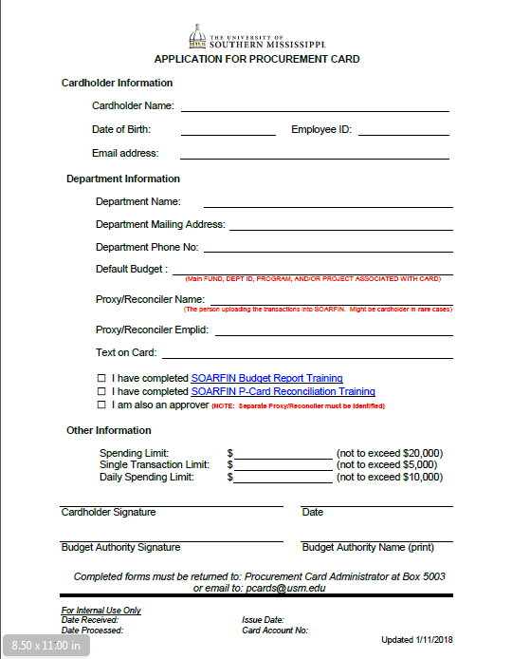
FIGURE PC-1 [Procurement Card Application]

FIGURE PC-2 [Procurement Cardholder Agreement]
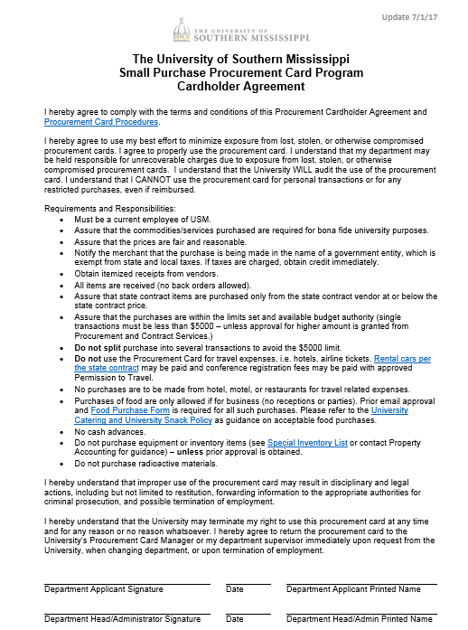

FIGURE PC-3 [Personal Receipt of Procurement Card]
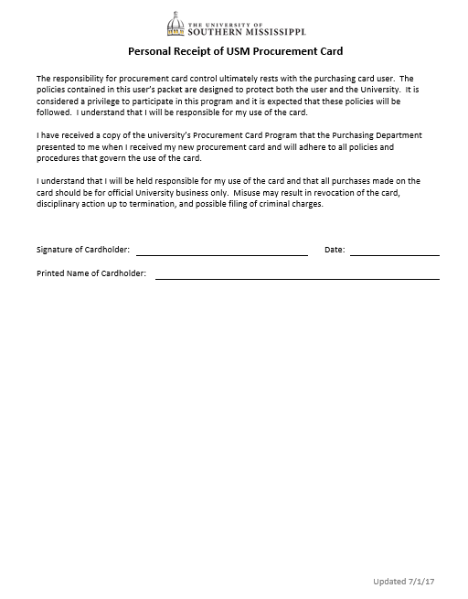

FIGURE PC-4 [Cardholder Update Form]
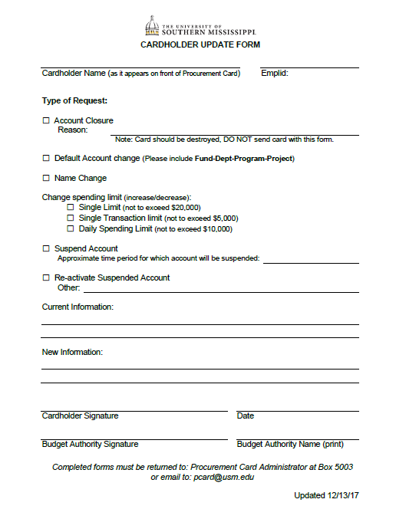
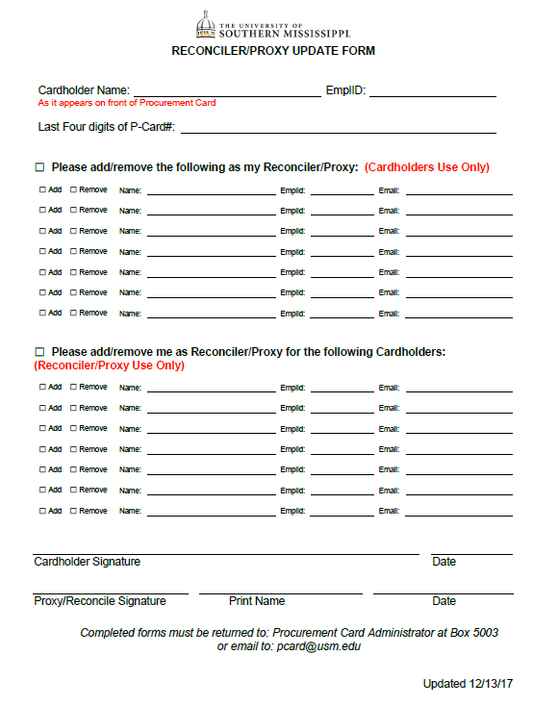
FIGURE PC-5 [RECONCILER (PROXY) UDATE FORM]

FIGURE PC-6 [Procurement Card Restrictions]

Prohibited Purchases
The following purchases are prohibited with the Procurement Card:

- Ammunition, Firearms
- Alumni Gifts
- Amazon Prime Accounts – (Free 2-day shipping provided on order over $49 with business account)
- Apparel that will not remain the property of USM (Must be purchased with Grant or Student/Participation Fees and prior approval from P-Card Administrator required)
- Cash Advances
- Catering – (Prior approval required from Aramark and P-Card Administrator)
- Cellular Phones and Service
- Coffee, Cream, Sugar, Soft Drinks, Cups, Napkins, etc. – (When intended predominantly for consumption by University employees)
- Conference Registration – (For foreign travel only)
- Contracts/Consulting for Professional Services
- Donations/Contributions/Sponsorships
- Entertainment or Related Expenses – (Related to receptions, retirements, department Christmas parties, and the like are NOT allowable)
- Equipment Purchases not on the Equipment Exception Listing – (See Figure PC-8 – Equipment Items and Exceptions)
- Gasoline
- Gift Cards
- Greeting, Holiday, Thank You Cards
- Items for non-University Purposes
- Items on backorder
- Leases
- Legal Services
- Maintenance or Service Agreements
- Meals for University Travel
- Money Orders
- Party Supplies / Holiday Decorations and Supplies
- Personal Expense / Purchases including, but not limited to:
- Apparel (T-shirts, stoles, robes, etc.)
- Appliances
- Awards
- Commodities
- Floral Arrangements
- Framing Services
- Laundry and Cleaning
- Memberships
- Subscriptions
- Pre-paid Services
- Printing – (Requires prior UC / Copy Center approval)
- Prizes / Gifts / Awards / Plaques, or other taxable expenses when not justified as benefiting the University. (Must comply with Tax Compliance Nonmonetary Awards guidelines.)
- Purchases over $5,000 without prior Procurement & Contract Services’ approval
- Radioactive, explosive or other hazardous material
- Sales Tax
- Sam’s Club Memberships
- Snacks – (Must be for official Southern Miss business purpose and requires pre-approval from P-Card Administrator)
- Social Team Building Expenses – Dinners, Lunches, Trampoline Parks, Zoo, Laser Tag, etc. (Personal or foundation funds should be used)
- Splitting transactions to bypass the bid process, state contracts or credit limits
- Travel related expenses – (Except auto rentals through state contract Vendor and conference/registration fees)

FIGURE PC-7 [Procurement Card Allowables]

Allowable Purchases

The following purchases are allowable with the Procurement Card:

- Admission or entry fees for academic student trips – (social functions prohibited)
- Advertisements
- Job Ads – (Departments are responsible for ensuring HR guidelines are followed, and copy of the ad must be upload to the transaction)
- Social Media Ads – (Requires prior UC approval and copy of the ad must be upload to the transaction)
- Apparel and Uniforms that will remain the property of USM – (Must have prior approval from P-Card Administrator. See Section 12.3 - Apparel Purchases)
- Auto Rentals – (state contract Vendors only)
- Commodities
- Conference/Registration Fees – (For domestic travel only with Permission to Travel)
- Equipment – Qualifying Items that Total $999.99 or less (See Figure PC-8 – Equipment Items and Exceptions)
- Equipment Rental
- Exhibition Booth Rental
- Floral Arrangements for Official University Functions Only – (i.e., Commencement)
- Food/Snacks – (Must have prior approval from P-Card Administrator).
- Framing Services for Official University Purpose Only – (Must include description of item being framed)
- Memberships Dues – (University and Department only)
- Photographic Film and Slide Processing
- Postage and Shipping Expenses – (USPS, FedEx, UPS, etc.)
- Prizes / Gifts / Awards / Plaques, or other taxable expenses that benefit the University – (Must comply with non-monetary award guidelines.)
- Promotional Items with printing – (i.e., Pens, USB thumb drives, cups; must include written UC approval and copy of the approved artwork)
- Rental Equipment
- Reprints (journals)
- Services
- Software – provided you are not signing a Licensing Agreement
- Space Rental at Conferences/Conventions
- Student Events – (Such as Orientations, Receptions, Residence Hall programs, Recruitment, and Homecoming with supporting documentation – refer to University Expenditure Guidelines)
- Subscriptions/Publications – (University and Department only)

FIGURE PC-8 [Equipment ITEMS and Exceptions]

EQUIPMENT THAT MUST BE TAGGED AND INVENTORIED
A. Equipment with a cost of $1000 or More
B. EXCEPTIONS to the $1000 rule (ALL considered inventory and must be tagged):
- WEAPONS
- CAMERAS and CAMERA EQUIPMENT WITH A COST OF $250 or More
- TWO WAY RADIO EQUIPMENT
- TELEVISIONS WITH A COST OF $250 or More
- LAWN MAINTENANCE EQUIPMENT
- CELLULAR TELEPHONES
- MAJOR COMPUTER COMPONENTS:
  - PRINTERS AND MULTI-PURPOSE MACHINES WITH A COST OF $250 or More
  - EXTERNAL HARD DRIVES
  - CPU's
- IPOD’S WITH A COST OF $250 OR MORE
- CHAINSAWS
- AIR COMPRESSORS
- WELDING MACHINES
- GENERATORS
- MOTORIZED VEHICLES
C. Former Exception Items Now Only Subject to the $1000 Rule:
- RECORDERS
- MP3 PLAYERS
- TYPEWRITERS
- APPLIANCES (AIR CONDITIONERS, REFRIDGERATORS, MICROWAVES, ETC...)
- VCR'S
- STERLING SILVER
- SCANNERS
- DICTATING EQUIPMENT
- ANTIQUES
- MODEMS

FIGURE PC-9 [Procurement Card Sign Out Sheet]

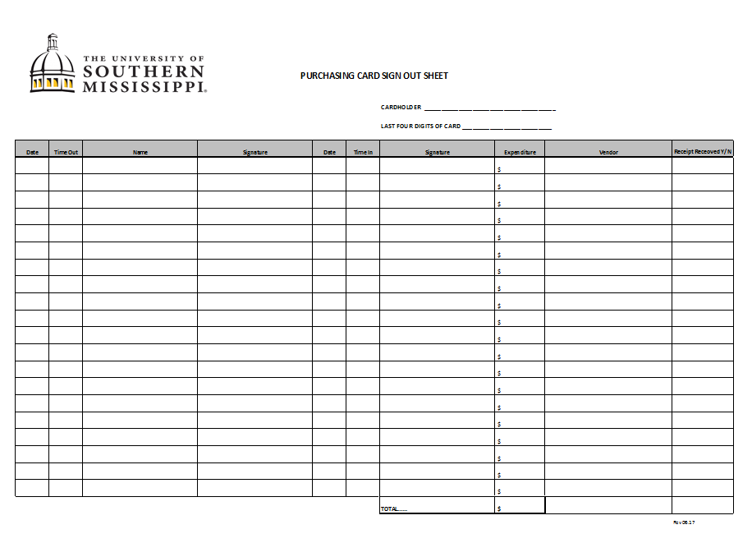

FIGURE PC-10 [Delegation of Authority for VISA Procurement Card]
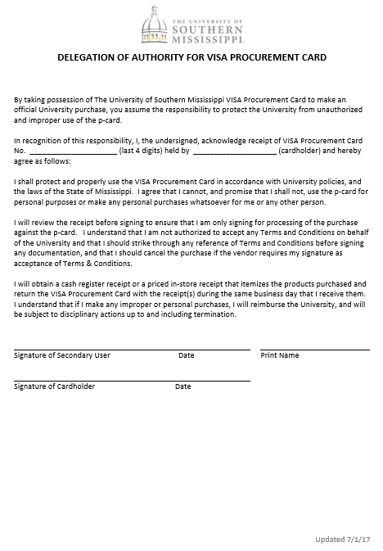

FIGURE PC-11 [Food Purchase Form]
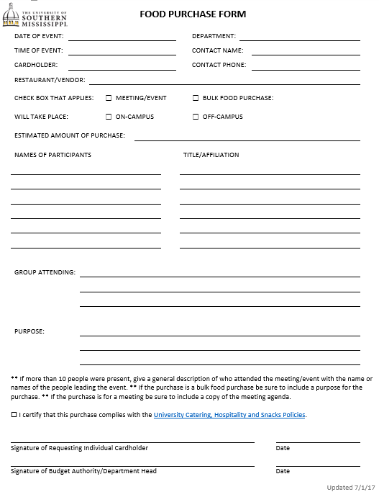

FIGURE PC-12 [Apparel Purchase Form]
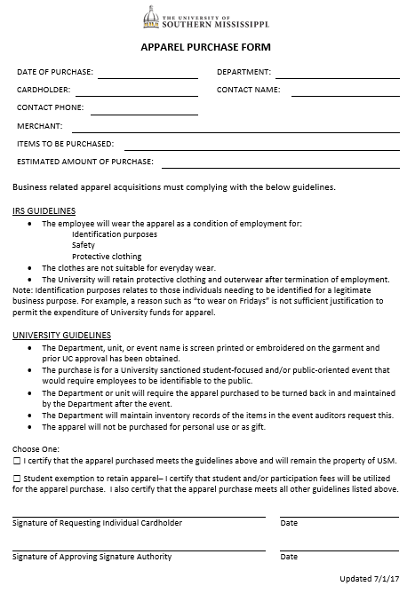

FIGURE PC-13 [Missing Document Affidavit]
