Economic Impact of the
2015 USM-MSU Football Game

Prepared for the:
The University of Southern Mississippi Athletics Department

Prepared by:
Venkatesh Kaza, Graduate Research Assistant
Daniel Cook, Graduate Research Assistant
Dr. Shannon Campbell, Principal Investigator
Dr. Chad Miller, Co-principal Investigator

January 2016

Acknowledgements
The lead researchers want to express appreciation to the following individuals who contributed to the 2015 USM-MSU Football Game Economic Impact Study.

The University of Southern Mississippi Department of Economic Development
Trent Lott National Center

Tasha May, Marketing Coordinator
Emily Adcock, Graduate Assistant
Tiffany Aultman, Graduate Assistant
Mihail Brinza, Graduate Assistant
Alicia Frazier, Graduate Assistant
Sean Moody, Graduate Assistant

The University of Southern Mississippi

Chad Driskell, Vice President of External Affairs
Brent Jones, Senior Associate Athletic Director of External Affairs
The Institutional Review Board, Approval #15090103

TABLE OF CONTENTS

Executive Summary..…………………………………………………………………………..4
Introduction………...………………………………………………………………………….5
Methodology and Data………………………………………………………………………....6
Survey Instrument……………………………………………………………………...6
Input-Output Analysis………………………………………………………………….7
Multiplier Effect……………………………………………………………………….7
Game Day Attendance…………………………………………………………………8
Demographics………………………...………………………………………………………...8
Age…...………………………………………………………………………………...8
Local Versus Non-Local Residents..…………………………………………………..9
Education Level.…….………………………...………………………………………10
Fan Identification………………...…………………………………………………...11
Ticket Holders………………………………………………………………………...12
Primary Reason for Visiting…………………………………………………………..13
Economic Impact……………………………………………………………………………..15
Average Spending…………………………………………………………………….16
Regional Purchase Coefficient………………………………………………………..17
Local Earnings………………………………………………………………………...17
Where People Stayed…………….…………………………………………………...18
Mode of Transportation...……………………………………….…………………….20
Jobs Supported………………………………………………………………………..21
Comparison Between 2010 and 2015 Impact Studies………………………………..23
Spending by Local Residents………………………………………………………....23

Conclusion…………………………………………………………………………….……...24
Works Cited…………………………………………………………………………………..25
Appendix A-Survey Instrument……………………………………….……………………...26
Appendix B-Promo Material………………………………………………………………….30
Appendix C-IRB Approval …………………………………………………………………..32

EXECUTIVE SUMMARY
The University of Southern Mississippi (USM) hosted the Mississippi State University (MSU) football team in Hattiesburg, Mississippi on September 5, 2015. The two Mississippi schools had not played since 1989, so it was anticipated to be a major event. It set a new attendance record in M.M. Roberts Stadium of 36,641 with an estimated additional 3,000 attendees outside the stadium. To gauge the economic impact to the community, the USM Administration and Athletics commissioned the USM Trent Lott National Center to conduct an impact study. This study included intercept interviews and electronic surveys of spending patterns at the game. The data was analyzed using EMSI Input/Output Economic Impact Models.
Most respondents (73%) resided outside of the Hattiesburg Metropolitan Statistical Area (MSA). These non-residents spent an estimated $2,759,743 across 10 industry sectors which generated an additional multiplier effect of $1,054,093 in direct, indirect, and induced earnings in the local economy. This was nearly double the average spending by visitors to the region in a typical day. This helped support 72 jobs in the region with average earnings of $14,612 each. USM Athletics reported total combined ticket sales of $1.137 million dollars in sales. The average amount spent per person was $95.37. Thirty-seven percent of survey respondents indicated that they stayed in the Pine Belt area for the game and resulted in an estimated 1,499 hotel rooms (or 89% of the total rooms in the region) booked because of the football game.

Introduction
This report quantified the economic impact of The University of Southern Mississippi playing Mississippi State University in football in Hattiesburg, Mississippi on September 5, 2015. The University of Southern Mississippi averages six to seven home football games every year which contribute financially to the economy of both Hattiesburg and to the state of Mississippi. The University of Southern Mississippi, M.M. Roberts Stadium, “The Rock,” has an official capacity of 36,000. According to the National Collegiate Athletic Association, average attendance for a USM home football game was 22,739 in 2014.
This study measured the impact of the USM-MSU football game in terms of jobs, labor income, and total economic output. For the purposes of this study, the research team defined economic output as the total value of all goods and services produced within the local economy of Hattiesburg Metropolitan Statistical Area.
In general, college football is a popular spectator sport in the United States. In 2014, there were 767 college and university football programs across all NCAA and NAIA divisions, an all-time high. Colleges and university administrators site various reasons for offering football programs as part of their overall academic mission. The rationale for football programs vary including increasing student enrollment, connecting alumni, creating a more vibrant on-campus experience, increasing the institution’s profile, and ability to attract research grants (National Football Foundation & College Hall of Fame, 2014). According to the National College Athletic Association (2014), over 49 million people attended college football games in 2014. The USM research team analyzed spectator survey results and estimated an overall economic impact of $1.05 million for the Hattiesburg MSA.

METHODOLOGY AND DATA
The economic impact analysis required primary data to be collected regarding spectator spending habits in the local economy. Visitor’s total spending, adjusted for regional purchasing coefficient, contributed to direct, indirect, and induced spending. A survey was administered to collect spending habits, and the information was used to calculate the overall economic impact.
Survey Instrument
Before data collection began, a survey was developed to gather average spending of game day participants using both an online link and a printed version (see Appendix A). The research team developed a quick-access link using a QR code accessible for mobile phone technology. The researchers determined the need to gather a minimum of 400 survey responses from an estimated attendance level of 35,000 with confidence level of 95%. A total of 660 surveys were collected which exceeded the minimum quantity. The survey questions sought to gather attendance, spending habits, home location, and demographic information that can be used by university administrators and local businesses to make informed decisions about future games.
The survey was distributed to game day spectators by student workers before, during, and after the game through random selection and voluntarily participation. If spectators were in a group, only one person was asked to complete the survey on behalf of the group. Physical handbills containing both the link to the website and QR code were provided allowing participants to complete the survey electronically. Respondents also had the option of completing a physical printed survey if they preferred. After responses were collected, the team calculated the multiplier effect using the Economic Modeling Specialists International (EMSI) software. EMSI generates the direct, indirect, and induced impact of the game including the aggregate change in the local economy.
Input-Output Analysis
Input-output analysis is based on the principle that industry sectors are interdependent. One industry purchases inputs from other industries and households (i.e., labor) then sells outputs to other industries, households, and government. Additional induced impacts occur when workers involved in direct and indirect activities spend their wages on consumer goods produced or sold in the region and local economy. Therefore, economic activity in one sector impacts other sectors.
The initial effect is comprised of jobs stimulated in the economy (EMSI). The direct, indirect, and induced effects all result in the spinoff jobs. The direct effect flows out of the initial impact. Those industries become more active. This is supply chain activity. As the supply chain industries increase production, they increase their employment. The indirect effect is a secondary supply chain effect — these jobs are added to the supply chains of companies. The induced effect is much broader, as evidenced by employees who spend their personal income in the local economy (EMSI).
Multiplier Effect
The total impacts of an increase or decrease in the output of an industry are predicted based on the direct economic impact in a specific industry. Input-output analysis estimates direct, indirect, and induced economic impacts commonly referred to as multiplier effects. The input category of the model is visitor spending in various industry sectors, and the output category is analyzed in terms of additional salaries and employment supported in the local economy.

Game Day Attendance
The USM Athletic Department provided data regarding ticket sales for the football game to determine spectator attendance to be 36,641. Additionally, the research team sought to estimate the number of attendees who remained outside the stadium during the game. At the end of the first quarter of play, the research team conducted a head count tally of people tailgating outside the stadium. Four research assistants divided the University campus into quadrants and counted the number of people in each quadrant. This generated an estimated 3,000 participants.
DEMOGRAPHICS
The research team gathered demographic data to determine more detailed information about spectator spending habits. Sporting event planners can use demographic data to develop marketing strategies targeted at increased spending resulting from the event and in the local economy. This section analyzed age, population, education, and fans associated with USM.
Age
The age demographics of the 660 survey respondents aligned with national expectations for college football for age categories of 18 to 24 years old and 25 to 34 years old (Table 1). According to the National Football Foundation (2013), 39% of spectators range from 35 to 54 years old nationally which is lower than the USM-MSU game which represented 48% of spectators. Spectators who represented ages 55 and older were 31 percent nationally as compared to 22% who attended the USM-MSU game.

Table 1
Age Demographic
Age Category | USM-MSU Football Game  Percent of Spectators | National Average  Percent of Spectators
18 to 24 years old | 11% | 12%
25 to 34 | 19 | 18
35 to 54 | 48 | 39
55 or older | 22 | 31
Figure 1. Age of Survey Participants. Source. USM Survey Instrument. National average reported by National Football Foundation²
Local Versus Non-Local Residents
A total of 660 surveys were collected of which 73% of respondents indicated they reside outside of Hattiesburg MSA and 27% reside in the region. Proportionally, these percentages generated an estimated 28,938 non-local visitors who attended the football game. Visitors from outside the region bring with them dollars spent in the local economy as a result of special events like football games. Ticket sales verified 36,641 people inside of the stadium, with an additional 3,000 people who tailgated and did not attend the game. Twenty-seven percent of people in attendance, or 10,703, were from the Hattiesburg MSA (Table 2). Ticket holders were classified in two categories: season ticket holders and regular ticket holders. Based on the spending category they will have costs and benefits associated with each.
Table 2
Origins of Surveyed Game Day Participants
 | Total Surveyed | % of Total | Total all Attendees
Non-local participants | 482 | 73 | 28,938
Local | 178 | 27 | 10,703
Total | 660 | 100 | 39,641

Education Level
Survey responses indicated a broad spectrum of educational backgrounds among the participants. Forty-six percent of respondents have a four-year college degree, and 39% of people have a graduate level of education (Figure 1). Comparing these percentages to 20.4% of adults in Mississippi and 29.6% of adults in the United States who possess at least a 4-year degree, the game attracted a more educated crowd. Nationally, 32% of college football fans are college graduates. Following the college degree and post-graduate classifications, participants with a high school diploma made up six percent, and the remaining one percent indicated, “Other.” These results appear to support the possibility of game day visitors representing university alumni.

Figure 1. Education Level. Source. USM Survey Instrument.

Fan Identification

Survey participants were asked how they identify themselves in relation to USM, and they had the option of choosing all categories that applied to them. Responses indicated a strong affiliation with USM: 59% are USM alumni, 28% are USM fans, 13% are USM students/faculty/staff, and 12% are USM students’ parents. Only 17% of respondents indicated no affiliation to the University: MSU fan (11%), and general college fan (6%).

Figure 2. Affiliation with USM. Source. USM Survey Instrument.

Ticket Holders
The number of tickets purchased represented 45.1% season ticket sales and 54.9% general admission ticket sales (Figure 3). There are 2,773 season ticket accounts representing 13,835 current season ticket holders. The cost of season tickets ranges from $120 to $260 depending on seat location. As noted earlier, actual ticket sales reported by The USM Athletic department generated $1.137 million, however survey results indicated that ticket sales generated $854,304 in revenue for the University. The more conservative figure was used in the impact analysis.

Figure 3. Season Ticket Holders. Source. USM Survey Instrument.

Non-season ticket holders were asked to describe the type of general admission ticket they purchased or received according to one of the following categories:
- Your purchase
- A business gift
- A gift from family and/or friends
- A purchase by your firm or organization
Respondents indicated they purchased general admission tickets themselves, making up 58.4% of total responses (Figure 4). This group of ticket holders are a potential audience for season ticket sales, particularly since the average number of Golden Eagle home games that people plan to attend this season is four. The second largest category, 29.6%, was a gift from family and/or friends. Providing group discounts might generate additional revenue for ticket holders that want to attend games as a group. The remaining 12% of ticket sales were business-related purchases.

Figure 4. Reason for Purchase. Source. USM Survey Instrument.

Primary Reason for Visiting
The USM-MSU football game was the primary reason that 96% (633) of respondents were in the Hattiesburg MSA. The remaining 4% of participants indicated that the game was not their primary reason for traveling to the Pine Belt but to visit friends and family or conduct business. The results revealed that the highest percentage of 82.2% (32,506) in attendance were from Mississippi particularly in south Mississippi. Targeted marketing initiatives should be focused along Interstate 20 and south (Figure 5).
There were 7,135 out of state visitors. The states with the next highest attendance were Alabama and Louisiana with 4.24 % and 4.09%, respectively. Texas brought in 2.72% of visitors, Georgia had 1.81% of overall visitors, 1.66% represented Florida, and 1.51% of visitors from Tennessee, and Missouri and Illinois each had 0.3% of the attendance for the game. The remaining states: California, North Carolina, Arkansas, Michigan, Indiana, Ohio, and Virginia each had 0.15 % of the overall attendance (Table 3). Out of state targeted marketing for game day ticket sales should be concentrated to the gulf coast region, Houston, Dallas, Memphis, and Atlanta markets.
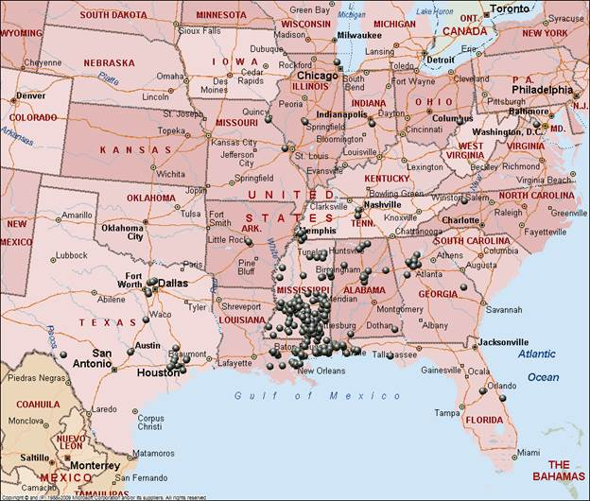
Figure 5. Home zip codes of survey respondents. Source. MapQuest.com
Table 3
Number of Respondents by State

State | No of Survey Respondents | % of Total
MS | 543 | 82.20%
AL | 28 | 4.24
LA | 27 | 4.09
TX | 18 | 2.72
GA | 12 | 1.81
FL | 11 | 1.66
TN | 10 | 1.5
IL | 2 | 0.30
MO | 2 | 0.30
VA | 1 | 0.15
NC | 1 | 0.15
OH | 1 | 0.15
IN | 1 | 0.15
MI | 1 | 0.15
AR | 1 | 0.15
CA | 1 | 0.15
Total | 660 | 99.88

ECONOMIC IMPACT
The game generated an economic impact of $1.05 million to the Hattiesburg MSA. Out-of-town visitors were asked to estimate their spending in ten categories which were used to calculate average spending per person. These averages per category were then multiplied by the estimated number of out-of-town attendees and yielded an overall average of game day spending. The economic impact was subsequently calculated to provide a quantitative measure of new economic activity directly and indirectly generated in the Hattiesburg MSA. Money spent by visitors attending the USM-MSU football game was converted into jobs supported in the region. These jobs included:
- Direct – 66 jobs [The effect of new supply chain purchases by the initially changed industries. This change is due to inter-industry effects].
- Indirect – 1 jobs [The subsequent ripple effect is a secondary supply chain of buying and selling that results from the initial change. This change is due to inter-industry effects.]
- Induced – 5 jobs [This change is due to the impact of the new earnings, investment, and government created by the initial, direct, and indirect changes. Induced effects enter the economy as employees spend their paychecks in the region, businesses invest to grow their operations, and government spends more to support the changes.]
The impact of the football game was estimated based upon out-of-town visitor spending habits which resulting in the equivalent of 72 jobs supported in the local economy.
Average Spending Per Out-of-Town Visitor
Overall, 28,938 visitors spent an average of $95.37 per person of which $29.52 was for ticket sales (Table 4). Survey respondents indicated spending an average of $24.27 per person for food and beverage sales and $9.61 per person for lodging accommodations. Retail shopping and USM merchandise contributed $13.85 per person. Transportation and parking averaged $10.78 per person and all other spending averaged $7.34 per person. The average spending is then adjusted with a Regional Purchase Coefficient of 65% to account for immediate leakage of sales from the region thus resulting in $2,759,743 used as the input variable for calculating the economic impact.
Table 4
Spending by Out-of-Town Visitors Based Upon Survey Responses
Industry Sector  NAICS | Description | Per Person (Average) $ | Total Spending $ | Local Spending*** (65%)
711310 | Ticket Sales | $29.52* | 854,303.60** | 854,303.60
451110 | USM Merchandise | 8.10 | 234,294.61 | 152,291.50
722511 | Food and Beverage Full Service Restaurants | 12.75 | 369,006.61 | 239,854.30
722513 | Food and Beverage Limited Service Restaurants | 11.52 | 333,401.65 | 216,711.07
721110 | Lodging | 9.61 | 277,957.34 | 180,672.27
453220 | Retail Shopping | 5.75 | 166,503.42 | 108,227.22
447110 | Transportation (gas, vehicle rental, etc) | 6.39 | 184,907.09 | 120,189.61
812930 | Parking | 4.39 | 126,995.20 | 82,546.88
713990 | Recreation/Entertainment | 2.75 | 79,608.66 | 51,745.63
812990 | All Other Spending | 4.59 | 132,764.85 | 86,297.15
 | Total | $95.37 |  | $2,759,743.03
*Note. Average spending for ticket sales is based upon self-reported information provided by survey respondents.
**Note. Assumed 100% of all USM ticket sales remained in the region.
***Note. A regional purchase coefficient of 65% was used to adjust for leakages from the region.

Regional Purchase Coefficient (RPC)
The Regional Purchase Coefficient (RPC) is the proportion of regional demand fulfilled from regional production and is an important consideration for measuring the true economic impact of visitor spending. When visitors purchase goods and services from local establishments, which is new money that stimulates regional economic activities through linkages of tourism with other sectors of the economy, some of the spending immediately leaks from the region. As Stynes (1997) indicated, “Generally, only sixty to seventy percentage of tourist spending appears as final demand in a local region” (p. 17). For the purposes of this study, only sixty-five percent (65%) of the total estimated spending was used in the I/O model.
Local Earnings Generated
The game day visitor spending generated $2,064,344 in sales across 10 industry sectors and served as the input variables. The result generated output categories of direct, indirect, and induced aggregate earnings of $1,206,941 for workers in the Hattiesburg MSA. A total of 80 jobs were supported in the region with average wages of $15,138 (Table 5).
Table 5
Local Earnings Created as a Result of Visitor Spending
 |  | INPUT |  | OUTPUT
 |  |  | Direct |  | Indirect | Induced
Visitor spending | $2,759,743
Local earnings |  |  | $120,433 |  | $19,481 | $163,627
Aggregate Effect on Earnings |  |  |  |  |  |  | $1,054,093

The game provided a noteworthy increase in retail sales in two industry categories of restaurants and hotel accommodations. Average daily sales in local restaurants are $710,017 and in hotels are $66,745 (Table 6). The football game created a result was a 48% one day increase in restaurant sales and 31.6% one day increase in hotel sales. These numbers would be expected to return to normal levels after the game so any increased employment was temporary.

Table 6

Comparison of Average Daily Sales to Game Day Sales for Restaurants and Hotels
Industry | Daily Sales | Sales as Result of Game
Restaurant | $710,017 | $369,007
Hotels | $66,745 | $277,957

Source. Regional Industry Sales on a Daily Basis Comparison Source: EMSI Sales & Exports

Where People Stayed
Thirty-seven percent (244) of survey respondents planned to spend the night in the Hattiesburg MSA. When asked where they planned to stay, 139 respondents indicated plans of staying in a hotel or motel and 104 planned to stay with friends or relatives (Figure 6).

Figure 6.Where Respondents Stayed. Source. USM Survey Instrument.

When asked how many nights they planned to stay during their visit to the Pine Belt, 48% of survey participants indicated they stayed one night and 31% stayed for two nights (Figure 7). The number of people who stayed for three nights accounted for 11%.

Figure 7. Number of Nights Spent in the Pine Belt. Source. USM Survey Instrument.
The research team identified 18 hotels and motels listed online in Hattiesburg totaling 1,677 room capacity. The accommodation prices ranged from $48 to $149 per night.
- Courtyard – 84 rooms
- Residence Inn - 84
- Hampton Inn - 153
- Hilton Garden Inn - 90
- Fairfield Inn - 79
- Holiday Inn Suites - 138
- La Quinta Inn,- 84
- Baymont Inn and Suites - 92
- Quality Inn & Suites - 82
- Microtel Inn & Suites - 78
- Sleep Inn & Suites - 62
- Days Inn - 58
- Candlewood Suites - 109
- Intown Suites of Hattiesburg - 58
- Motel 6 - 117
- Econo Lodge - 67
- Deluxe Inn - 88
- Magnuson Hotel - 154 rooms
Assuming that visitors stayed all nights concurrently, the football game generated 1,500 room nights of stay (or 89% occupancy rate). When extrapolating the data for the five day period surveyed, the results were:
- One-night stay generated 747 room night occupancy
- Two-night stay generated 476 room night occupancy
- Three-night stay generated 169 room night occupancy
- Four-night stay generated 18 room night occupancy
- Five-night stay generated 90 room night occupancy
Mode of Transportation
Modes of transportation were categorized into five areas to determine how people got to and from the game: car, public transit, taxi, charter bus, or other. Additionally respondents who drove a vehicle were asked where they parked: on campus (61%), in a private parking lot (21%), or on a city street (10%). Two percent used public transit to the USM-MSU football game, and the remaining 6% used other modes. Most parking lots on campus were reserved for Eagle Club members who had the opportunity to include parking as part of their game day package fees. Non-reserved parking was available at various places on campus for a fee of $10 per vehicle. Survey respondents indicated spending an average of $2.75 per person or $126,995 for all attendees (Figure 8).

Figure 8. Location of Parking. Source. USM Survey Instrument.

Jobs Supported by Industry Sector
The multiplier effect to the local economy supported the equivalent of 72 jobs as a result of sales generated by the football game. The majority of jobs supported fell into the industry sector of Arts, Entertainment, and Recreation (NAICS 71) with 34 jobs supported, 14 jobs in Accommodation and Food Services (NAICS 72), and 10 jobs in Retail Trade (NAICS 44) (Table 7).
Table 7
Industry Sectors Supported
NAICS | Industry | Change in Jobs
44 | Retail Trade | 10
52 | Finance and Insurance | 1
53 | Real Estate and Rental and Leasing | 1
54 | Professional, Scientific, and Technical Services | 1
56 | Administrative and Support and Waste Management and Remediation Services | 1
61 | Educational Services | 1
62 | Health Care and Social Assistance | 1
71 | Arts, Entertainment, and Recreation | 34
72 | Accommodation and Food Services | 14
81 | Other Services (except Public Administration) | 7
90 | Government | 1
Source. EMSI Economic modeling input-output scenario.

Prevalent jobs were classified into Standard Occupation Codes (SOC Codes) and supported by game day spending were in the categories of Arts, Design, Entertainment, Sport, and Media (SOC 27), Food Preparation and Service (SOC 35), and Sales and Related Occupations (SOC 41) with 27, 16, and 10 jobs supported, respectively (Table 8).
Table 8

Occupation Categories Supported by Game Day Spending
SOC | Occupation | Change in Jobs
11-0000 | Management Occupations | 2
13-0000 | Business and Financial Occupations | 1
25-0000 | Education, Training, Library Occupations | 1
27-0000 | Arts, Design, Entertainment, Sports, and Media Occupations | 25
35-0000 | Food Prep and Service Occupations | 16
37-0000 | Building, Grounds, Cleaning, Maint Occ | 3
39-0000 | Personal Care and Service Occupations | 8
41-0000 | Sales and Related Occupations | 10
43-0000 | Office and Admin Support Occupations | 3
49-0000 | Installation, Maint, and Repair Occupations | 1
53-0000 | Transport/Material Moving Occupations | 1

Comparison to a 2010 USM Football Impact Study

On October 30, 2010, graduate students in the Master of Science of Economic Development (MSED) program conducted an economic impact study of the USM versus University of Alabama Birmingham (UAB) football game. Findings from visitor spending generally correlate with this study (Table 8). This was a 1pm game and had an attendance of 26,415 and 172 survey respondents. Sixty-two percent of respondents were from outside of the Hattiesburg MSA. The major difference was the reported amount paid for tickets in which survey respondents indicated spending an average of $73.47 in 2010 as compared to $29.52 for 2015.

Table 8

Comparison Between 2010 and 2015 USM Football Games
 | 2010 Game | 2015 Game
Tickets | $73.47 | $29.52
Parking | $9.76 | $10.78
Restaurants | $13.81 | $12.75
Grocery | $8.88 | $11.52
Lodging | $4.05 | $9.61
Merchandise | $4.28 | $13.85
Total | $124.98 | $95.37

Spending by Local Residents

Spending by an estimated 10,703 local residents was not used for calculating the overall economic impact due to the assumption that local dollars do not generate new income for the region (Crompton, 2001). It is noteworthy to consider input from local residents regarding their spending activity directly attributable to the USM-MSU football and resulted in slightly more than a $1 million dollars remaining in the local economy (Table 9).

Table 9

Local Resident Spending
Industry Sector  NAICS | Description | Per Person (Average) $ | Total Spending  $
711310 | Ticket Sales | $35.80 | 315,972
451110 | USM Merchandise | 7.09 | 86,656
722511 | Food and Beverage Full Service Restaurants | 9.29 | 136,481
722513 | Food and Beverage Limited Service Restaurants | 17.20 | 123,312
721110 | Lodging | 2.26 | 102,805
453220 | Retail Shopping | 4.80 | 61,583
447110 | Transportation (gas, vehicle rental, etc) | 2.20 | 68,390
812930 | Parking | 1.90 | 46,970
713990 | Recreation/Entertainment | 3.26 | 29,444
812990 | All Other Spending | 4.23 | 49,104
 | Total | $88.03 | 1,020,718

CONCLUSION
The direct, indirect, and induced economic impact of the USM-MSU football game was approximately $1.05 million in earnings, and it supported the equivalent of 72 jobs averaging $14,612 each within the Pine Belt area. Local resident spending that remained in the area was estimated at slightly more than $1 million dollars. Of the attendees, 54.9% were non-season ticket holders. Nearly 59% of general admission tickets were purchased by individuals rather than businesses. USM Alumni composed 59% of the people at the game with another 28% of people who indicated being USM fans. The largest age group was between the ages of 35 and 54 accounting for 48% of the survey participants. These results indicate Golden Eagles’ home football games have a positive impact on the local economy generated through visitor spending at restaurants, retail stores, hotels/motels, and other venues.

WORKS CITED

Kim, Sungsoo and Miller, C. (2014). Impact Study of the 34th Mistletoe Marketplace. Trent Lott National Center for Economic Development and Entrepreneurship. Hattiesburg, MS

Mississippi Development Authority. (2014). Travel and Tourism Economic Contribution Report. Mississippi Development Authority. Jackson, MS

National College Athletic Association. (2014). 2014 National College Football Attendance. Retrieved from: http://fs.ncaa.org/Docs/stats/football_records/Attendance/2014.pdf

National Football Foundation & College Hall of Fame. (2013). Passion for College Football Remains Robust. Retrieved from: http://www.footballfoundation.org/tabid/567/Article/53380/Passion-for-College-Football-Remains-Robust.aspx

(2014). College Football Maintains Impressive Ratings and Attendance Figures. Retrieved from http://www.footballfoundation.org/News/NewsDetail/tabid/567/Article/51405/college-football-maintains-impressive-ratings-and-attendance-figures.aspx#sthash.EmJsg6hc.dpuf

SouthernMiss Football (2015). Panoramic Photo Set to Be Taken During Southern Miss-Mississippi State Football Game. Retrieved from: http://www.southernmiss.com/sports/m-footbl/spec-rel/082815aac.html

Stynes, D. J. (1997). Economic impacts of tourism: a handbook for tourism professionals. Urbana, IL: University of Illinois, Tourism Research Laboratory, 1-32.

APPENDIX A

THE SURVEY INSTRUMENT

Please take a few minutes to complete the following questions. Your participation is very valuable because you are one of the individuals selected to assist with this important research. Your participation is voluntary. All information that you provide will be anonymous, confidential, and reported only in the aggregate. If you have any questions or concerns regarding your inputs for this survey, please contact Daniel Cook, GraduateAssistant (Daniel.J.Cook@eagles.usm.edu) or Venkatesh Kaza, Graduate Assistant (Venkatesh.Kaza@eagles.usm.edu) at The University of Southern Mississippi. {Estimated time to respond is 3 to 4 minutes.}
(IRB Protocol #15090103)

Note:This survey is for those 18 years of age or older.

1. Are you a season ticket holder ?

2. If the answer is No for Question 2, is the ticket for today's game...?

3. How many years have you been a season ticket holder?

4. How many Golden Eagle games do you plan to attend this season?

5. With whom did you come to today's game?

Family only

Family and friends

Friends only

Organization

6. How many people (including yourself) are in your immediate group? T( his is the number if people for whom you typically pay the bills. (e.g., your family or close friends)

7. How did you travel to The Rock today?

Car, parked in

USM parking lot

Public bus (Metro, Hub City
Transit)

Car, parked in private parking lot

Taxi

Car, parked on street

Charter bus

Other

8. What is your home zip code?

9. Are you spending one or more nights away from home in the Pine Belt Area because of the Golden Eagle's game?

10. Where are you staying?

11. How many nights do you plan to spend in the Pine Belt area?

0 1 2 3 4 5

12. Was the Golden Eagles game the primary reason for your trip?

13. What was the primary reason for your trip?

14. In order to estimate the economic impact of the Golden Eagles, we need to know the amount of money you spend before, during, and after a game. For the following categories, please estimate how much your party will spend in total as a result of attending in the Pine Belt Area?

Lodging Expense (hotel, motel, condos, etc.) $

Food and Beverage at restaurants $

Food and Beverage (bought at other places) $

Ticket sales $

Transportation(Gas, Vehicle Rental) $

Retail Shopping (Souvenirs, gifts etc.) $

USM merchandise $

Parking $

Recreation (Entertainment) $

All other spending $

15. What is your age?

under 25 25-34 34-54 55 and over

16. What is the highest level of education you have completed?

Less than High school

2-year College Degree

4-year College Degree

Higher than College Degree or Graduate
Degree

Other

17. How do you identify yourself ?

USM student/faculty/staff

USM parent of current student

USM alumni

USM fan

General college fan

MSU fan

18. Please describe the importance of the Golden Eagles either to you personally or to the
Community

19. If you are interested in entering a chance to win a $50 gift card from Barnes & Noble, please provide your name and phone number.

Name

Phone Number

Thank you for participating in this survey.

APPENDIX B

PROMO MATERIAL

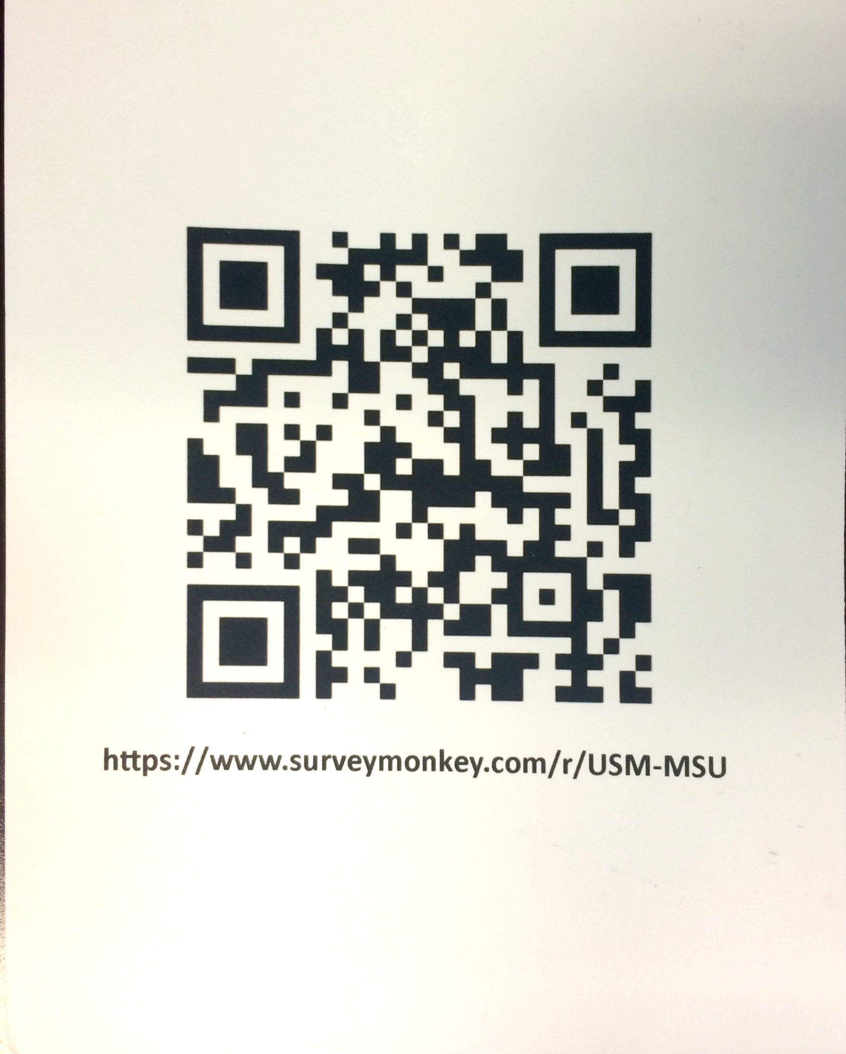

APPENDIX C

IRB INFORMATION

INSTITUTIONAL REVIEW BOARD
118 College Drive #5147 | Hattiesburg, MS 39406-0001
Phone: 601.266.5997 | Fax: 601.266.4377 | www.usm.edu/research/institutional.review.board

NOTICE OF COMMITTEE ACTION

The project has been reviewed by The University of Southern Mississippi Institutional Review Board in accordance with Federal Drug Administration regulations (21 CFR 26, 111), Department of Health and Human Services (45 CFR Part 46), and university guidelines to ensure adherence to the following criteria:

• The risks to subjects are minimized.
• The risks to subjects are reasonable in relation to the anticipated benefits. • The selection of subjects is equitable.
• Informed consent is adequate and appropriately documented.
• Where appropriate, the research plan makes adequate provisions for monitoring the data collected to ensure the safety of the subjects.
• Where appropriate, there are adequate provisions to protect the privacy of subjects and to maintain the confidentiality of all data.
• Appropriate additional safeguards have been included to protect vulnerable subjects.
• Any unanticipated, serious, or continuing problems encountered regarding risks to subjects must be reported immediately, but not later than 10 days following the event. This should be reported to the IRB Office via the “Adverse Effect Report Form”.
• If approved, the maximum period of approval is limited to twelve months.
Projects that exceed this period must submit an application for renewal or continuation.

PROTOCOL NUMBER: 15090103
PROJECT TITLE: Economic Impact Study of USM/MSU Football Game PROJECT TYPE: New Project
RESEARCHER(S): Shannon Campbell, Ph.D., Chad Miller, Ph.D., Venkatesh Kaza, Daniel Cook COLLEGE/DIVISION:
DEPARTMENT: Trent Lott National Center FUNDING AGENCY/SPONSOR: N/A
IRB COMMITTEE ACTION: Expedited Review Approval PERIOD OF APPROVAL: 09/02/2015 to 09/01/2016 Lawrence A. Hosman, Ph.D.
Institutional Review Board

According to the Mississippi Development Authority (2014), travel and tourism expenditures by visitor totals $254m per year or $697,825 per day in the Hattiesburg MSA.

